M7 — AI Coach
Module Specification
Trading Journal App · v1.0 · July 2026 · Status: ready to break into tickets
Field | Value
Module ID | M7
Track / owner | Intelligence & Engagement track — new owner, first of four modules (M7 → M8 → M9 → M10)
Depends on | M0 Foundation & Shared Contracts · M3 Trade Data Core (Trade, AggregateSnapshot) · M4 Strategy & System Builder (Strategy, TradingSystem) · M5 Trade Logging & Planning (JournalEntry, JournalTag, ChecklistCompletion)
Blocks | Nothing downstream strictly requires M7 to function, but M10 (streaks and badges) reads Insight and ReviewSummary engagement data as one of its gamification signals — see Section 12.
Scope in | Pattern-based insights grounded in a trader's own facts and journal, evidence-linked to specific trades, weekly and monthly narrative reviews, a read-only Q&A chat, and per-trader coach preferences
Scope out | Computing P&L, session, R-multiple or outliers (M3) · defining a strategy or rule check (M4) · journaling a trade (M5) · rendering dashboards (M6) · streaks and badges (M10)

Purpose
M7 is the first module in this product that generates language instead of arranging numbers M3 already computed. Every sentence it produces — an insight, a review paragraph, a chat answer — must trace back to a trade or journal entry a trader can independently verify. M7 has one hard rule it never breaks: it interprets, it never invents, and it never writes back into a trade, strategy or journal entry.

Components in this specification
- Stories
- Data flow and schema
- UI screens
- Detailed description and business logic
- Flowcharts
- Test plan
- Quality benchmarks
- Security constraints
- Error handling
- External dependencies
- Performance and scalability
- Module relationships
- Data policies (EU and US)
- Documentation

1. Stories
Fourteen stories. Eleven map directly onto the five UI screens in Section 3; US-12, US-13 and US-14 describe cross-screen grounding, read-only and privacy guarantees.
ID | Story | Acceptance criteria | Pri
US-01 | As a trader, I want a feed of insights about my own trading patterns so I don't have to spot them myself. | M7-S01 lists every active Insight for the trader, generated on the weekly cadence (Figure 7.1). | Must
US-02 | As a trader, I want to see how confident the coach is in an insight so I know how much weight to give it. | Every insight card in M7-S01 shows a confidence badge derived from sample size and consistency, not sentiment (Section 4.1). | Must
US-03 | As a trader, I want to dismiss an insight I don't find useful so I stop seeing it. | Dismissing an insight in M7-S01 or M7-S02 sets its status to dismissed and removes it from the feed immediately. | Should
US-04 | As a trader, I want every insight to show the exact trades it's based on so I can verify it myself. | M7-S02 lists every EvidenceLink for the insight, each opening the referenced trade in M5-S04. | Must
US-05 | As a trader, I want to mute an entire pattern type, not just one instance of it. | Muting a pattern from M7-S02 suppresses new insights of that kind for a fixed window, visible and reversible from M7-S05 (Section 4.3). | Should
US-06 | As a trader, I want a written weekly review of how I did, in plain language. | M7-S03's weekly view is generated once per week from a frozen stat snapshot and any insights from that period. | Must
US-07 | As a trader, I want a monthly review that steps back further than the week-to-week noise. | M7-S03's monthly view follows the same generation rule as weekly, on a monthly cadence. | Should
US-08 | As a trader, I want to ask my own questions about my trading history and get a grounded answer. | M7-S04 answers a free-form question with evidence chips citing the specific trades the answer is based on (Figure 7.2). | Must
US-09 | As a trader, I want the coach to tell me when it doesn't have enough evidence, instead of guessing. | When grounding data is insufficient, M7-S04 returns an explicit no-evidence response rather than a speculative answer (Figure 7.2). | Must
US-10 | As a trader, I want to control how often the coach generates new insights. | M7-S05's insight frequency setting (Daily/Weekly/Off) governs the next generation cycle, never retroactively. | Should
US-11 | As a trader, I want to control how often I get a written review. | M7-S05's review cadence setting (Weekly/Monthly/Both/Off) governs future ReviewSummary generation only. | Should
US-12 | As a trader, I want the coach's claims to be traceable to my own data at all times, never invented. | Every Insight, ReviewSummary reference and coach ChatMessage carries at least one EvidenceLink or an explicit no-evidence response — there is no ungrounded output path (Section 4.7). | Must
US-13 | As a trader, I want the coach to never edit or create a trade, strategy, or journal entry on its own. | M7's API surface exposes no write endpoint to any M3, M4 or M5 table, enforced at the service boundary (Section 8). | Must
US-14 | As a trader, I want my chat questions and the coach's answers kept private to me, not used to train a shared model without consent. | ChatSession and ChatMessage data is scoped to the owning trader and excluded from cross-trader model training by default (Section 13). | Must

Ticket-splitting note
US-01, US-04 and US-13 are the smallest shippable slice — a read-only insight feed with a verifiable evidence trail and a hard-enforced no-write boundary, reading only what M3 and M5 already provide. Reviews, chat, and preference controls can all layer on afterward.

2. Data flow and schema
Six entities. M7 owns all of them, and none of them are a financial statistic in their own right — every number a sentence references is sourced from M3 or M5 at generation or request time, never recomputed by M7.
Entity | Purpose | Key fields
Insight | A single pattern-based claim about a trader's own trading, generated on a cadence. | id · user_id · kind (pattern|risk_flag|improvement) · headline · body · confidence (medium|high) · status (new|seen|dismissed|saved) · period (date range covered) · generated_at
EvidenceLink | One trade that supports a specific Insight or ChatMessage claim. | id · insight_id (nullable) · chat_message_id (nullable) · trade_id · relevance_note
ReviewSummary | A generated narrative for a fixed period, frozen at the moment it's written. | id · user_id · period_type (weekly|monthly) · period_start · period_end · narrative · stat_snapshot · insight_ids[] · generated_at
ChatSession | One ongoing Q&A thread between a trader and the coach. | id · user_id · title · created_at · last_message_at
ChatMessage | One message in a ChatSession, from the trader or the coach. | id · session_id · role (trader|coach) · text · created_at
CoachPreference | A trader's controls over how often the coach speaks up. | id · user_id · insight_frequency (daily|weekly|off) · review_cadence (weekly|monthly|both|off) · muted_patterns[] (kind + expires_at) · include_chat_in_review (bool)

2.1 How data moves
Generation. Insight generation runs on a fixed cadence (Section 4.1), scanning M3 facts and M5 journal entries for candidate patterns; each candidate that clears the confidence bar is frozen with its supporting EvidenceLinks before being written, and checked against any active mute (Figure 7.1).
Review. A ReviewSummary is generated once per period on its own cadence, combining a frozen stat_snapshot of that period's M3 figures with any Insights generated during it (Figure 7.3).
Chat. A trader's question in M7-S04 triggers a live, per-request search across M3, M4 and M5 for grounding data; the coach's answer either cites the resulting EvidenceLinks or explicitly declines (Figure 7.2) — chat is the only part of M7 that runs synchronously per request rather than on a cadence.
Reading elsewhere. M7 is a near-terminal node — only M10 (streaks and badges) reads from it, and only Insight/ReviewSummary engagement metadata (Section 12), never the narrative text or evidence itself.
The one rule that keeps this clean
M7 interprets, it never invents. Every Insight, ReviewSummary reference and chat answer traces back to an EvidenceLink pointing at a real trade or journal entry — if the evidence isn't there, the correct output is silence or an explicit “not enough data,” never a plausible-sounding guess (Section 4.7).

3. UI screens
Five screens, built as a working mockup in M7_UI_Mockups.html — open it in any browser.
ID | Screen | States built
M7-S01 | Insight feed | Empty · Has insights
M7-S02 | Insight detail | Active · Dismissed
M7-S03 | Weekly / monthly review | Weekly · Monthly
M7-S04 | Ask the coach | New session · In conversation
M7-S05 | Coach settings | Default · Saved

3.1 Rules that apply to every screen
- Trader-owned, trader-facing. All five screens belong to the trader's own app, gated by ordinary account auth (Section 8) — there is no staff-only surface in M7.
- Every claim is traceable. Anywhere the coach makes a specific claim, there's a visible path to the evidence behind it — a chip, a row, a link — never just prose asserted on its own.
- Nothing here writes to another module's data. M7 can create an Insight, a ReviewSummary, a ChatSession/ChatMessage, or a CoachPreference, and nothing else.
- An empty state explains what's coming, not just that nothing's there yet — especially M7-S01, where a genuinely new account needs to understand insights aren't broken, just not ready yet.

4. Detailed description and business logic
The rules below are the module's real content. Section 4.7 is new to this module and, once M7 ships, the one every future language-generating module should be checked against.
4.1 Confidence and pattern detection
Rule | Decision
Confidence reflects sample size and consistency, not sentiment | A Risk flag and an Improvement are scored on the same scale — how many trades support the claim, and how consistent the effect is across them — never on whether the finding is good or bad news.
A minimum evidence threshold gates every insight | A candidate pattern with too few supporting trades is discarded before it's ever written, not shown at low confidence — “medium” and “high” are the only confidence levels a trader ever sees (Figure 7.1).
Correlation is reported, causation is not claimed | An insight can say two things co-occur (“size increases after a loss”); it never asserts why, since M7 has no mechanism to establish cause.

4.2 Evidence freezing
Rule | Decision
Evidence is captured at generation time | An Insight's EvidenceLinks are fixed the moment it's generated; the set of trades cited never silently grows or shrinks afterward.
A later trade edit doesn't rewrite an existing insight | If a cited trade is edited in M5 after the fact, the existing Insight's text and evidence stay as generated — the next generation cycle is what picks up the change, not a live rewrite (Section 9).

4.3 Muting and dismissal
Rule | Decision
Dismiss is instance-scoped, mute is pattern-scoped | Dismissing an Insight only removes that one instance; muting (available from the same insight, or from M7-S05) suppresses every future insight of that kind for a fixed window.
Every mute has an expiry | There is no permanent mute in v1 — a muted pattern type always resurfaces after its window, so a trader doesn't lose visibility into a real, ongoing pattern indefinitely.

4.4 Reviews
Rule | Decision
A review is generated on a fixed schedule, never on demand | Weekly and monthly ReviewSummary generation both run on their own cadence (CoachPreference.review_cadence); opening M7-S03 always reads the latest already-generated review, never triggers a fresh one.
The stat snapshot is frozen | stat_snapshot captures the relevant M3 figures at generation time, the same pattern M6 uses for a Report's view_snapshot (M6, Section 2) — re-reading an old review later shows the same numbers even if M3's live data has since moved on.
A review may reference insights, never invent new claims | The narrative can cite existing Insights generated during that period; it cannot introduce a pattern that wasn't already surfaced as its own Insight.

4.5 Chat
Rule | Decision
Chat is synchronous and per-request | Unlike Insight and ReviewSummary generation, a chat answer is composed live in response to a single question — it still must ground itself in a fresh search of M3/M4/M5, not a cached answer (Figure 7.2).
No evidence, no claim | If a search returns nothing that grounds a confident answer, the coach responds that it doesn't have enough data — this is a designed, expected response, not an error state (Section 9).
Chat is read-only end to end | No phrasing of a question, however direct, can cause the coach to create or edit a trade, strategy, or journal entry — this is enforced at the API layer, not the prompt layer (Section 8).

4.6 Coach preferences
Rule | Decision
Preference changes are never retroactive | Turning insight frequency to Off, changing review cadence, or muting a pattern only affects future generation cycles — nothing already generated is deleted or rewritten.
Turning generation off doesn't delete history | A trader's past Insights and ReviewSummaries remain fully accessible even after disabling future generation — Section 13 covers actual deletion, which is a separate, explicit action.

4.7 AI grounding and evidence rules
Rule | Decision
Every output type has a grounding requirement | An Insight requires at least one EvidenceLink meeting the confidence threshold (4.1); a ReviewSummary requires either a frozen stat_snapshot or a referenced Insight; a coach ChatMessage requires at least one EvidenceLink or the explicit no-evidence response — there is no output path that skips this.
The coach never fabricates a trade, number, or date | Every figure or trade reference in generated text is pulled from a real Trade, JournalEntry, or AggregateSnapshot record at generation or request time — nothing is generated freeform from pattern alone.
Evidence is shown, not just claimed | Section 3's screens always render the evidence trail alongside the claim (M7-S02's evidence pane, M7-S04's evidence chips) — a trader is never asked to trust a claim without a way to check it themselves.
Low-confidence findings are withheld, not hedged | M7 does not show a claim with a disclaimer like “might be true” — if it doesn't clear the confidence bar, it isn't shown at all (4.1); confidence badges exist to compare medium vs. high, not to soften a guess into something publishable.
A generation failure produces no output, not a degraded one | If evidence-gathering fails partway through a generation cycle, that candidate is dropped rather than published with partial or synthetic evidence (Section 9, code INS-002).

Why this section exists at all
M7 is the first module in this product that produces language rather than arranging computed numbers, and language is where invented confidence hides easily — a sentence can sound certain even when the data behind it is thin. Every rule above exists to keep that gap from opening: if it isn't grounded, it isn't said.

5. Flowcharts
Three diagrams: how raw trade and journal data becomes a grounded insight, how a chat answer is grounded or declined, and how a periodic review is assembled. Each is followed by the reasoning behind its branches.
5.1 From trade/journal data to a grounded insight
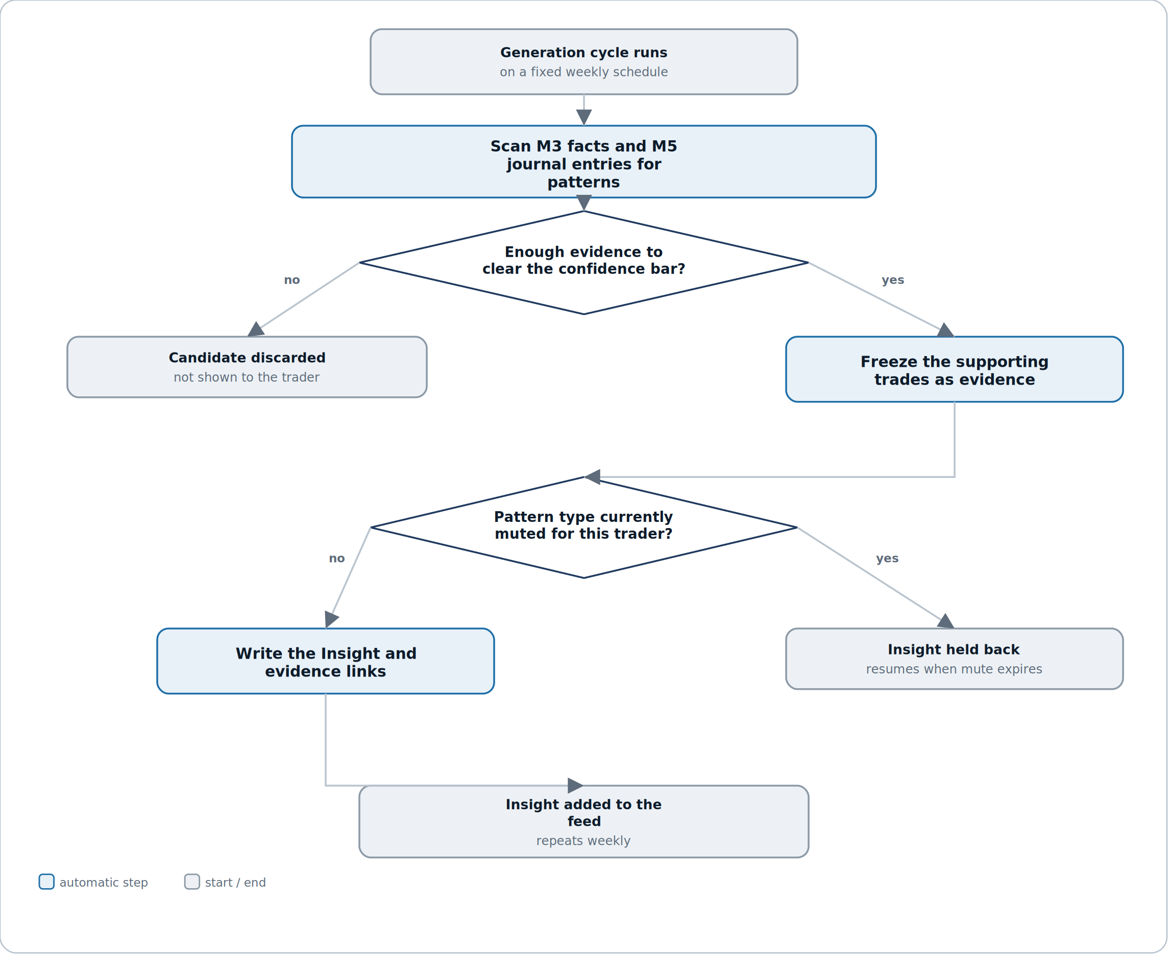
Figure 7.1 — a candidate pattern is discarded, or frozen as evidence, before it's ever written as an Insight.
Reading it. Two gates stand between raw trade history and an insight reaching the feed: whether the evidence clears the confidence bar, and whether that pattern type is currently muted for this trader. A candidate can fail either gate and never appear — there is no partial-credit path.
Why the confidence gate comes before the mute check, not after. Confidence is about whether the finding is real; muting is about whether the trader wants to hear it right now. Keeping them as separate, sequential checks means a muted candidate's evidence is still frozen correctly before the trader's mute preference is even consulted — nothing about the finding itself depends on whether it happens to be muted this cycle.
5.2 Grounding a chat answer
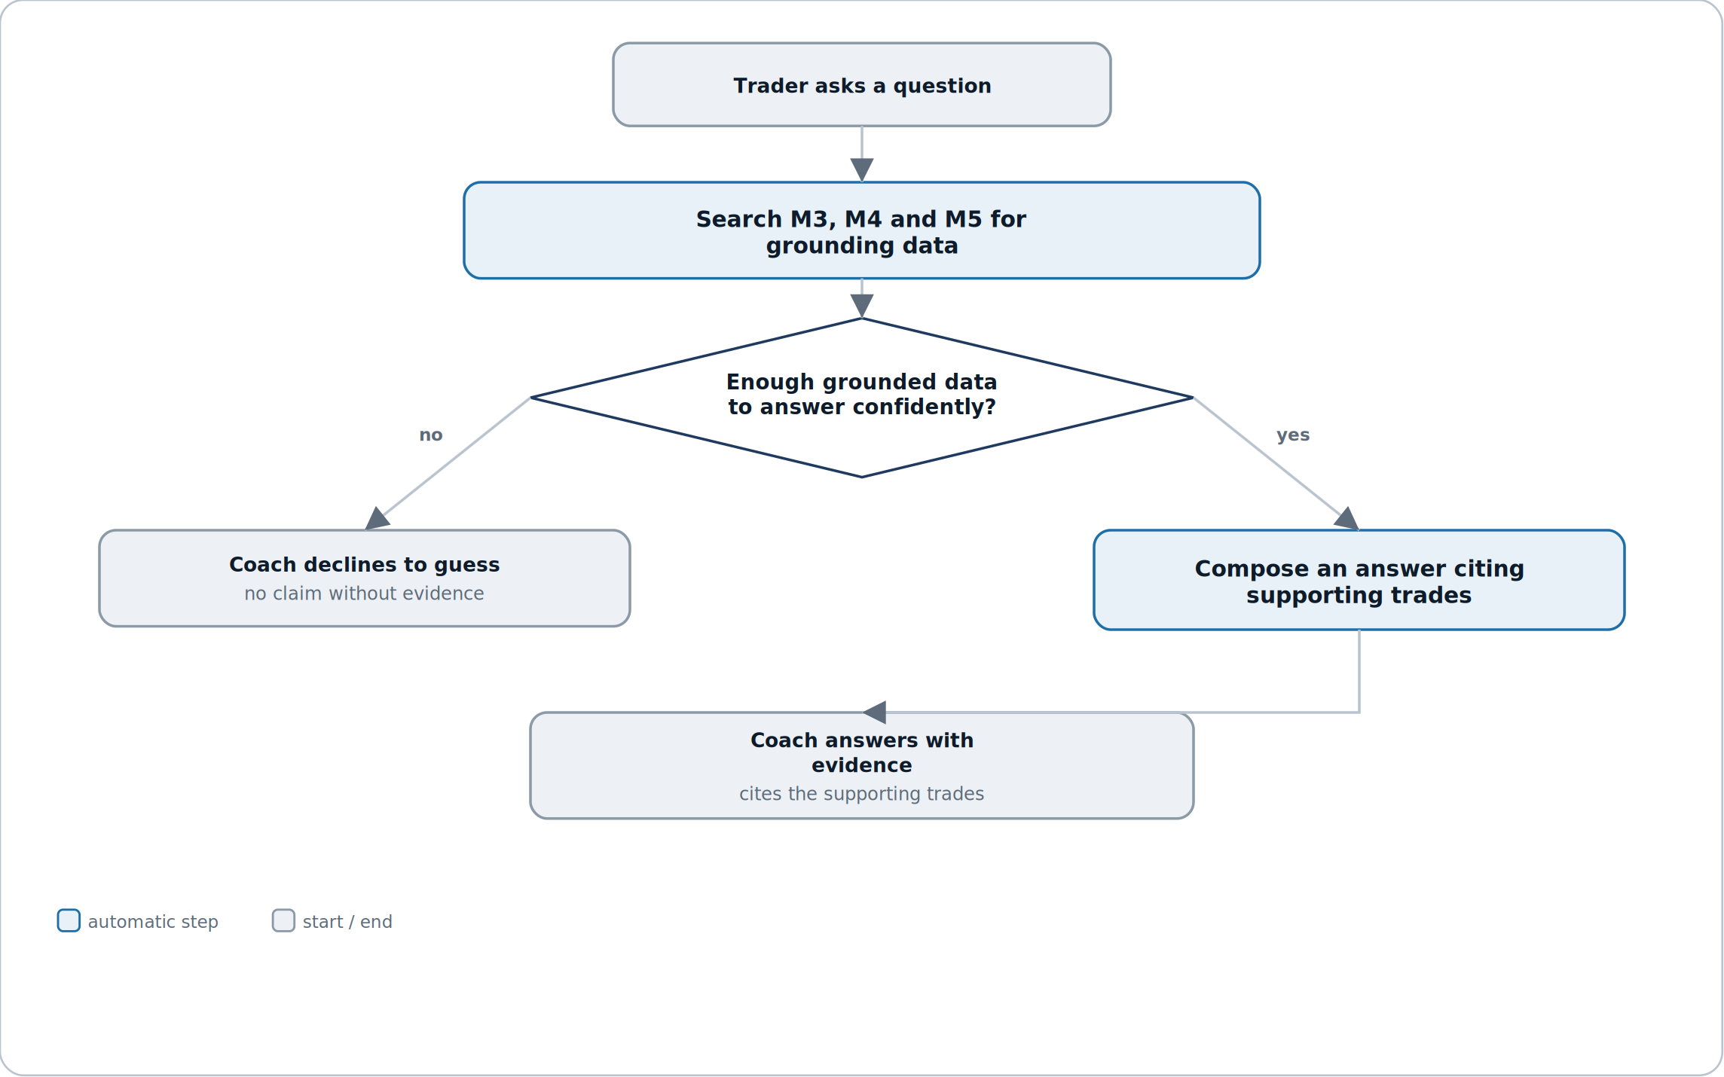
Figure 7.2 — the coach either cites evidence or declines; there is no third option.
Reading it. Every chat question runs the same live search before either branch — there's no shortcut where a common question skips grounding. The two outcomes are structurally distinct: a decline is a complete answer, not a placeholder for one that failed.
Why the decline path is treated as a first-class, designed outcome rather than an error. A trader asking a genuinely novel question, or one with too little history behind it, should get an honest “not enough data yet” rather than the coach reaching for a best guess — Section 4.7's core rule made visible.
5.3 Generating a periodic review
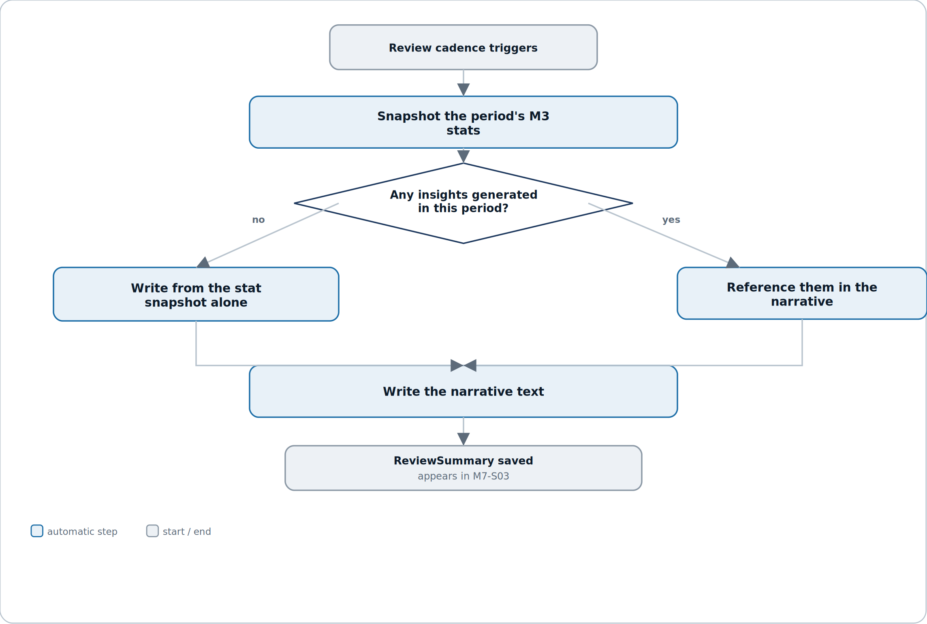
Figure 7.3 — a review is written from the frozen snapshot alone, or from the snapshot plus whatever insights that period produced.
Reading it. The single decision here is simply whether the period had any insights to draw on — a quiet period with no notable pattern still gets a review, just one grounded purely in the numbers rather than referencing a specific finding.
Why the snapshot is taken before the insight check, not after. Even if insight referencing changes later — a pattern gets muted, or dismissed — the numeric core of the review, what actually happened that period, is locked in first and never depends on what else got written.

6. Test plan
The riskiest failure mode in this module is different from M3–M6's: instead of a wrong number, it's a confident-sounding sentence with weak or missing evidence behind it — the kind of bug that looks fine in a demo and only shows up when a trader actually checks the trades a claim points to.
Layer | What it covers | Key cases
Unit | Pure logic with no I/O. | Confidence scoring given a fixture set of candidate patterns · mute-window expiry calculation · evidence-row formatting
Integration | The module against its own store and its data sources. | A generated Insight's EvidenceLinks resolve to real M3 Trade rows in the fixture set · a ReviewSummary's stat_snapshot matches AggregateSnapshot at generation time exactly · a chat answer's evidence chips resolve to the trades actually returned by the grounding search
Contract | What M7 promises other modules. | M7 issues zero write calls to M3, M4 or M5's mutation endpoints under any user action, including every chat phrasing in the adversarial fixture set — verified by call-count assertion
Grounding regression | The core no-invention rule. | 0 instances, across the full regression suite, of an Insight, ReviewSummary reference, or ChatMessage claim with no resolvable EvidenceLink or explicit no-evidence response
Adversarial | Chat robustness. | A fixture set of off-topic, leading, and write-attempting questions (“log a trade for me,” “just guess”) all resolve to a decline or a redirect, never a fabricated answer or a write call
Regression | Insight and review stability. | A fixed fixture set's generated Insights and ReviewSummary narratives are byte-for-byte reproducible given unchanged upstream M3/M5 data and an unchanged generation version

6.1 Manual QA checklist
# | Manual QA checklist item
1 | Every insight card in M7-S01 has a working “View evidence” link that lands on the exact trades cited in its body text.
2 | Dismissing an insight in M7-S01 removes it from the feed on next load without needing a full page refresh.
3 | Muting a pattern from M7-S02, then checking M7-S05, shows the same pattern with a matching expiry date.
4 | M7-S03's weekly and monthly stat snapshots match a manual read of AggregateSnapshot for the exact period boundaries shown.
5 | Asking the same question twice in M7-S04 in one session doesn't silently reuse a stale cached answer if the underlying data has changed.
6 | A chat question with genuinely insufficient history returns the explicit no-evidence response, not a vague or hedged guess.
7 | Turning insight frequency to Off in M7-S05, then waiting past a generation cycle, produces no new Insights while all existing ones remain visible.
8 | No manual testing path — including deliberately adversarial chat prompts — produces a network call to M3's TradeEdit, M4's versioning, or M5's journal-write endpoints.

6.2 Test data
- A seeded account with a genuine, verifiable pattern (e.g. consistent post-loss size increase) planted in the fixture trade data, so generated insights can be checked against a known-correct answer.
- An account with too little history to clear any confidence threshold, to verify the empty state and the chat decline path.
- A trader with at least one muted pattern mid-window, to test mute-expiry and settings-screen consistency.
- Several weeks/months of history with at least one period containing zero insights, to test the review's snapshot-only narrative path.
- A fixture set of adversarial chat prompts (off-topic, write-attempting, leading) for the adversarial test layer.

7. Quality benchmarks
Numbers, not adjectives. Anything unmeasurable is not a benchmark.
Metric | Target | How it is measured
Insight feed load time | M7-S01 fully rendered within 1 s, p95 | Time from navigation to last insight card painted, on a seeded account with a full year of history
Chat response latency | A grounded chat answer returns within 4 s, p95 | Server timing from question submitted to answer rendered, including the grounding search
Generation cycle completion | A weekly Insight generation run for the full trader base completes within its scheduled window with 0 dropped traders | Batch job completion monitoring
Grounding integrity | 0 ungrounded claims across the full regression suite (Section 6) | Automated EvidenceLink-resolution assertion on every generated Insight, ReviewSummary and ChatMessage
Zero-mutation guarantee | 0 write calls from M7 to M3/M4/M5 mutation endpoints across the full regression suite, including adversarial chat prompts | Automated call-count assertion (Section 6)

Why grounding integrity is the number that matters most
M6's zero-mutation guarantee protected against M6 silently becoming a write path; M7's grounding integrity guarantee protects against something quieter and arguably more damaging — a module that starts sounding confident about things it can't actually verify. A dashboard that's slow is annoying; a coach that's wrong and sounds sure of itself erodes trust in every other number the app has ever shown.

8. Security constraints
M7 introduces a new kind of surface this product hasn't had before — free-form trader input in M7-S04 — alongside the same read-only boundary M6 established.
Area | Constraint
Ownership scoping | Every Insight, ReviewSummary, ChatSession, ChatMessage and CoachPreference is scoped to the requesting trader's own user_id — no cross-trader read path exists anywhere in M7.
Read-only enforcement, everywhere | M7's API surface exposes no write endpoint to any M3, M4 or M5 table — enforced at the service boundary, not the prompt or UI layer, so no phrasing of a chat question can bypass it.
Chat input is treated as untrusted | Free-form chat text is never passed through to any downstream system as an executable instruction — it is a question to search grounding data with, never a command.
Evidence resolution is access-checked, not assumed | Every EvidenceLink resolves through the same ownership check as a direct M3/M5 read — there is no shortcut that lets generation code read a trade without the same authorization a trader's own request would require.
Generation runs are isolated per trader | A batch generation cycle processes one trader's data at a time with no cross-trader data ever held in the same working context, preventing any accidental cross-contamination between traders' patterns.

9. Error handling
Every error has a code for logs, a defined system behaviour, and what the trader actually sees.
Code | Scenario | System behaviour | What the trader sees
INS-001 | Insight generation finds no candidate clearing the confidence bar for a trader in a cycle | No Insight written; not an error | M7-S01 shows its normal empty or existing-insights state — nothing new appears
INS-002 | Evidence-gathering fails partway through generation for a candidate | That candidate is dropped, not published with partial evidence | No visible change — the candidate simply never appears, same as INS-001
REV-001 | Review generation fails for a period (e.g. an upstream M3 read timeout) | Generation retried once automatically, then marked failed rather than silently skipped | M7-S03 shows “this period's review couldn't be generated” rather than an old or blank review
CHT-001 | A chat question can't be grounded in any M3/M4/M5 data | Coach responds with an explicit no-evidence message | “I don't have enough data to answer that yet” — a designed response, not an error
CHT-002 | Chat grounding search times out | Request retried once, then fails cleanly | “That took too long — try asking again”
MUT-001 | A trader attempts to mute a pattern type that has no active Insight | Rejected — muting is only offered from an existing Insight or the settings screen's known pattern list | The mute action isn't offered for pattern types with no history
PRF-001 | A CoachPreference save is attempted with an invalid combination (e.g. unrecognized pattern key in muted_patterns) | Save blocked | “That preference couldn't be saved — try again”

Why INS-001 and INS-002 look identical to the trader
Whether a pattern didn't exist or existed but couldn't be safely evidenced, the correct trader-facing outcome is the same: nothing new shown. Surfacing the difference would either expose an internal failure as if it were a finding, or create a habit of explaining absence — neither helps a trader more than simply showing no false claim.

10. External dependencies
Like M6, M7 depends entirely on other modules in this product for its raw material — plus, uniquely among modules built so far, on a language-generation capability of its own.
Dependency | Used for | If it fails | Fallback
M3 Trade Data Core | Trade facts and AggregateSnapshot figures as the grounding source for insights, reviews and chat | No new insights or reviews can be generated; chat answers grounded in M3 data are unavailable | Existing Insights and ReviewSummaries remain fully visible; chat can still answer from M4/M5-only grounding where applicable
M4 Strategy & System Builder | Strategy and rule-check context for pattern detection and chat answers | Strategy-specific insights and chat answers are unavailable | Trade- and session-level insights, unaffected by M4, continue generating normally
M5 Trade Logging & Planning | Journal entries, tags and checklist completions as a grounding source | Journal-derived insights and chat answers are unavailable | Purely financial insights from M3 continue generating normally
Language generation service | Composing Insight bodies, review narratives and chat answers from structured grounding data | No new language output can be generated | Existing Insights and reviews remain visible; M7-S04 shows chat as temporarily unavailable rather than a broken input box
M0 Foundation | Shared data model, design system, error contract | N/A — foundational | N/A

Why the language generation service gets its own row
Every other module in this spec set depends only on this product's own data. M7 is the first to depend on a capability that composes the actual sentences a trader reads — which is precisely why Section 4.7's grounding rules apply to it as a hard constraint on its output, not a style guideline.

11. Performance and scalability
Concern | Position
Scale assumption for v1 | Up to 50,000 trades and years of journal history per trader (matching M3/M5); generation processes traders in bounded batches, not all at once.
Hottest path | M7-S04's live chat response — the only part of M7 that runs synchronously against a trader's full data history per request, rather than on a precomputed cadence.
Generation is inherently batchable | Insight and ReviewSummary generation both run on fixed cadences and can be spread across a processing window; unlike chat, nothing about them requires sub-second response time.
Chat grounding search must stay bounded | A grounding search for a single question is scoped to a bounded lookback window and record count, the same discipline M6's on-demand aggregation applies (M6, Section 11) — there is no execution path that scans a trader's entire history per chat message.
What breaks first | Chat latency under a trader with very long history asking a broad question (“how have I done overall”) — the bounded-scope rule exists specifically to keep this from becoming an unbounded scan.
Growth triggers | Revisit design if chat response latency (Section 7) is sustained above target under real data volume, or if generation batch windows regularly run past their scheduled cadence.

12. Module relationships
M7 sits one layer deeper than M6 — it doesn't just read other modules' data, it interprets it into language, which is a boundary worth stating precisely.
Direction | Module | What crosses the boundary
Consumes | M3 Trade Data Core | Trade facts and AggregateSnapshot figures as grounding data for pattern detection, reviews and chat.
Consumes | M4 Strategy & System Builder | Strategy and TradingSystem metadata and RuleCheck status, for strategy-aware insights and chat answers.
Consumes | M5 Trade Logging & Planning | JournalEntry, JournalTag and ChecklistCompletion as a grounding source for behavioral insights.
Consumes | M0 Foundation | Shared data model, design system, and error contract.
Exposes | M10 Streaks & Badges | Insight and ReviewSummary engagement metadata only (viewed, saved, dismissed counts) — never narrative text or evidence, which stay inside M7.
Emits | — | insight.generated · insight.dismissed · insight.muted · review.generated · chat.message_sent (for the trader's own audit history, and M10's engagement signal only)

The dependency to watch
M7 is the first module whose output another module (M10) reads at all — everything up to this point has been a one-way street ending at M6. Keep that surface as narrow as Section 12 states it: engagement counts only. The moment M10 or anything else starts reading Insight text directly, M7's grounding guarantees become a promise it's making on another module's behalf, which is a much bigger commitment than it looks.

13. Data policies (EU and US)
M7 holds the most sensitive new category of data this product has introduced so far: a trader's free-form questions and a system's interpretive claims about their behavior, not just their raw numbers.
13.1 What we hold and why
Data | Classification | Lawful basis (GDPR)
Insight, EvidenceLink | Personal data — an interpretive claim about the trader's own behavior, derived from their own trade and journal data | Contract — the coaching feature the trader opted into
ReviewSummary | Personal data — a generated narrative referencing the trader's own financial and behavioral history | Contract
ChatSession, ChatMessage | Personal data, and potentially sensitive depending on content — a trader may reference emotional or financial-stress context in a free-form question | Contract; special-category handling (Art. 9) is not triggered by trading data itself, but chat content is treated with the same care as journal free text (M5, Section 13)
CoachPreference | Personal data — low sensitivity, a trader's own settings | Contract

13.2 GDPR (EU / UK)
Obligation | How M7 meets it
Lawful basis (Art. 6) | Contract — insights, reviews, chat and preferences are all direct outputs of features the trader opted into.
Data minimisation (Art. 5(1)(c)) | M7 stores no duplicate financial figures outside a ReviewSummary's frozen stat_snapshot and an Insight's EvidenceLinks — both point at M3/M5 records rather than copying their full detail.
Right of access / portability (Art. 15/20) | Insight, ReviewSummary and ChatMessage content are included in M1's account-wide export in full, since — unlike M6's view preferences — this is generated content a trader may reasonably want a copy of.
Erasure (Art. 17) | On user.deletion_requested from M1, M7 must erase every Insight, EvidenceLink, ReviewSummary, ChatSession, ChatMessage and CoachPreference row for that user.
No training on chat content without consent | ChatSession and ChatMessage content is excluded by default from any process that would use it to improve a shared model across traders; opting in, if ever offered, would require its own explicit, separate consent (Art. 7) — not bundled into the coaching feature's base consent.
Automated decision-making (Art. 22) | M7 generates interpretive content but makes no decision that produces a legal or similarly significant effect on the trader — it surfaces observations for the trader's own judgment, not an automated determination about them.
Security of processing (Art. 32) | Ownership scoping, read-only enforcement and grounding-integrity checks (Section 8) protect both M7's own tables and the interpretive claims it generates from unauthorized access or silent drift.

13.3 United States (CCPA / CPRA and state law)
Requirement | How M7 meets it
Right to know / access | Same account-wide export as GDPR access, via M1, including chat content.
Right to delete | Same erasure flow as GDPR Art. 17, propagated within the account-level grace period.
Sale or sharing of personal information | M7 does not sell or share chat content, insights, or reviews with any third party, and does not use chat content for cross-trader model training by default.

13.4 Retention schedule
Data | Retention | Reason
Insight, EvidenceLink | Life of account + 30-day grace (matches M1–M6) | Generated insights are part of a trader's ongoing coaching history, expected to persist like any other core record
ReviewSummary | Life of account + 30-day grace | Same reasoning as Insight — a trader's own history of periodic reviews
ChatSession, ChatMessage | Life of account + 30-day grace, same as other content | Chat is treated as part of the trader's own record, not a transient log — consistent with the access/portability commitment above
CoachPreference | Life of account + 30-day grace | Low-cost settings expected to persist for the life of the account

The one thing not to get wrong
Chat content sits closer to sensitive than anything M1–M6 have stored — a trader might type something emotionally candid while asking about a bad trading week. Treat ChatMessage with at least the same care M5 gives free-text journal fields (M5, Section 13), and never let it flow into cross-trader analytics or model training without a separate, explicit, opt-in consent.

14. Documentation
Documentation is part of the module, not an afterthought once the code works.
Deliverable | Contents
Module README | What M7 does, the grounding rules in Section 4.7 in full, how generation cadences and the chat path differ operationally.
Contract / API reference | Every field on Insight, EvidenceLink, ReviewSummary, ChatSession, ChatMessage and CoachPreference, and the exact read contract M7 uses against M3, M4 and M5, generated from the agreement in Section 12 and M0.
Decision log (ADRs) | Initial entries: why confidence is scored on sample size/consistency rather than a single statistical test; why chat runs synchronously per-request while insights and reviews run on a cadence; why M10 only ever sees engagement counts, never Insight text.
Runbook | What to do when a generation cycle runs past its window, how to investigate a trader-reported “this insight seems wrong” ticket by tracing it back to its EvidenceLinks, and how to handle a language-generation service outage.
Data inventory & retention register | The tables in Section 13, maintained as living documents, with ChatMessage's sensitivity treatment called out explicitly.
UI mockups | M7_UI_Mockups.html — all five screens with every state.

14.1 Definition of done
M7 is done when all of the following are true:
- Every story meets its acceptance criteria.
- The grounding contract in Section 4.7 is verified against live M3, M4 and M5 data, not just mocks.
- All five screens are built with every state, including the chat decline path and the muted-pattern settings view.
- Every error in Section 9 is reachable and produces the described system behaviour.
- The grounding integrity and zero-mutation guarantees (Section 7) pass their full automated regression suite, including the adversarial chat fixture set.
- Benchmarks in Section 7 are measured on a realistically large seeded account, not assumed.
- README, ADRs, runbook are written; the data inventory is filled in with ChatMessage's sensitivity treatment called out.
- Deletion propagation is verified end to end from M1 through to all six of M7's own tables.
- Demoed to the other module owners, with Section 4.7's grounding rules walked through explicitly — this is the module where “looks right” isn't good enough on its own.

End of M7 specification — v1.0. Same 14-component structure as M1–M6, with a new grounding discipline (Section 4.7) this module adds to the pattern — the first module in the Intelligence & Engagement track, with M8 next.

