Area:

Arial 1.3em

Titolo voce menù:

Arial 1.6em

Menù:

Arial 14px

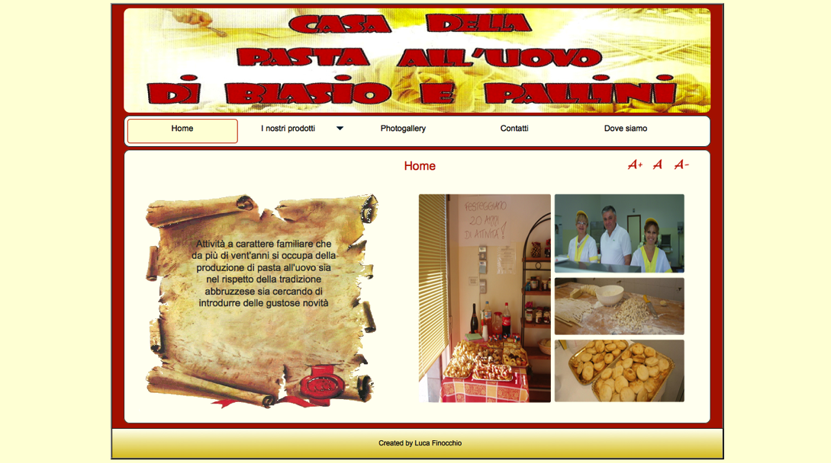

Footer:

Arial 0.8em

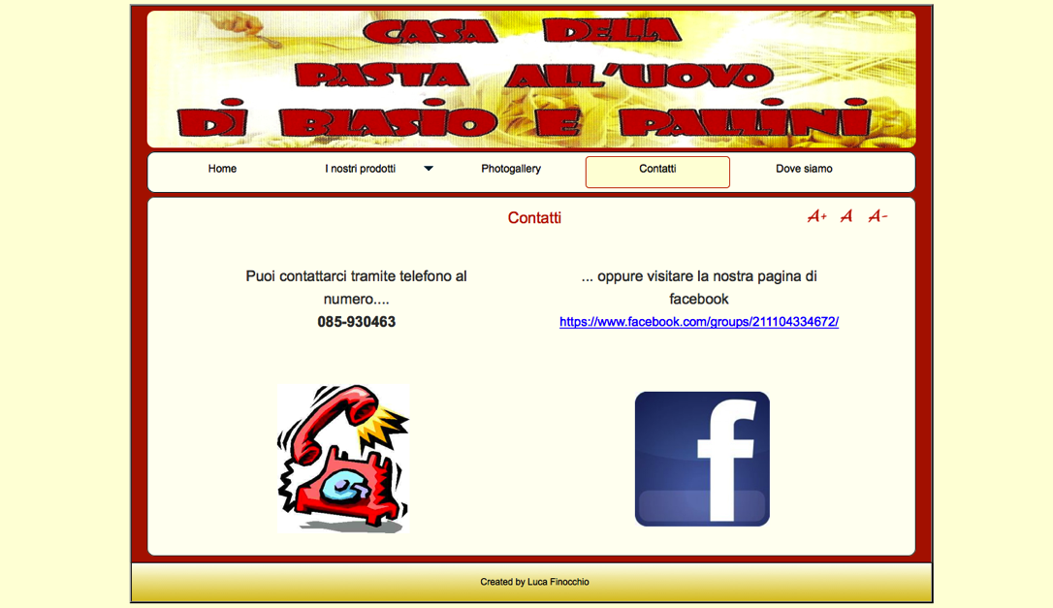

Numero:

Arial 1.5em bold

Link:

Arial 1.3em

Aree:

Arial 1.5em

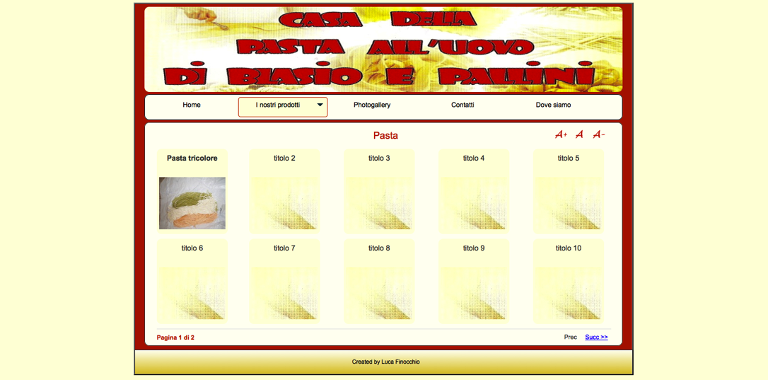

Pagination:

Arial 13px

Titolo area:

Arial 1.2em **bold**