Web Data Extraction Based on Tree Structure Analysis and Template Generation

Haikun Hong
School of Software Engineering
Beijing University of Posts and Telecommunications
Beijing, China
kevin8167@gmail.com
Xiaoxin Chen
School of Software Engineering
Beijing University of Posts and Telecommunications
Beijing, China
Xiaoxinchen1989@gmail.com
Guoshi Wu
School of Software Engineering
Beijing University of Posts and Telecommunications
Beijing, China
buptsse.gwu@gmail.com
Jing Li
School of Software Engineering
Beijing University of Posts and Telecommunications
Beijing, China
lijing@email.buptsse.cn

Abstract—This paper studies the problem of extracting data from large numbers of semi-structured web pages. The fact that many websites have enormous pages generated dynamically from a underlying structured source like a database makes it feasible to induct a common template for similar web pages and then extract data accordingly. Previous work on this problem has limited practical utility because of either requiring significant human efforts or basing on several brittle assumptions. We propose a three-step approach, including template generation, template detection and data extraction, with a little human intervention in template edit. The core algorithm is based on two highly efficient tree structure analysis techniques. Experimental results show that our approach can extract web data in a high accuracy and flexibility.
Keywords- Data Extraction, Information Extraction, Template Generation, Tree Structure

Introduction
World Wide Web, as the largest database, often contains various data that we would like to consume for our needs. The problem is that this data is in most cases mixed together with formatting code - that way making human-friendly, but not machine-friendly content. Doing manual copy-paste is error prone, tedious and sometimes even impossible.
Websites like ebay.com and amazon.com are data-intensive, and data records on them are usually dynamically rendered from a structured database and presented to users in semi-structured web pages. As shown in Fig. 1, the two pages are similar in page structure except that Fig.1 (A) has two more data items, Series and Description, than Fig.1 (B). Another problem is that web pages usually contain an enormous amount of redundant information such as websites’ title, navigation and Ads links, along with the real interesting and valuable data. These features make it feasible and necessary to replace large human efforts by developing a wise data extraction system. In recent years, some value-added services, e.g., comparative shopping and domain search have motivated the research of data extracting technology [1, 2, 3, 4, 5, 6, 7, 12, 13]. We will introduce several good works [1, 2, 3, 4, 5, 6] among them.
Web-Harvest [1] offers a way to collect desired web pages and extract useful data from them by leveraging well established techniques and technologies for text/xml manipulation such as XSLT, XQuery and Regular Expressions. To use Web-Harvest, users have to manually write configuration files for each website’s pages, which is almost impossible for common users without related knowledge. Another problem is that the configuration file relies highly on the web structure. Once a change occurs in original web page, the configuration file should be modified accordingly.
Sponsored by the National College Students Innovation Plan Project

(A)

(B)
Fig.1. Sample pages from ebay.com
RoadRunner [2, 3, 4] proposes a novel technique to compare HTML pages and generate a wrapper based on their similarities and differences, in which tag mismatch and string mismatch are applied. This approach takes an unacceptable time consumption when the input pages are different in HTML structure.
[5] achieves a joint optimization of template detection and wrapper generation, which provides the preprocess of web pages’ classification that RoadRunner lacks. But it has another drawback that it makes a brittle assumption that each input page’s tags have been labeled in a certain format by humans.
[6] extracts structured data from semi-structured pages with a tiny amount of human effort based on domain schema. As it extracts data from detail pages of web sites, this work is not generally practical for other domai ns’ pages.
Considering the advantages and disadvantages of the works above, we develop a data extraction system based on template generation and detection. In our system, pages and templates are represented in tree structures. Two mature tree structure analysis techniques from [7, 9, 10, 11] are extended and applied in similarity calculation and Seed Tree generation respectively. We test our system using a large set of miscellaneous web pages. The results approve that our system is accurate, efficient, and widely-adapting compared with prior works.
The rest of this paper is organized as follows. Section 2 gives an overview of our system. Section 3 presents rules of the preprocessing and representation of pages. The Template Generation algorithm is detailedly discussed in Section 4. Section 5, 6 states the process of template detection and data extraction respectively. Experiment results and analysis are provided in Section 7. Finally, Section 8 concludes this paper.

System overview
The flowchart of our system is shown in Fig.2, which is improved based on the system in [5].
In the beginning, the training pages are cleaned and parsed into DOM trees for further process later.
Secondly, the DOM trees will be fed to tree clustering module which adapts the Extended Simple Tree Matching (ESTM) Algorithm to calculate similarities among trees. DOM trees in the same cluster will be processed to generate a Seed Tree that represents all the trees in the cluster.

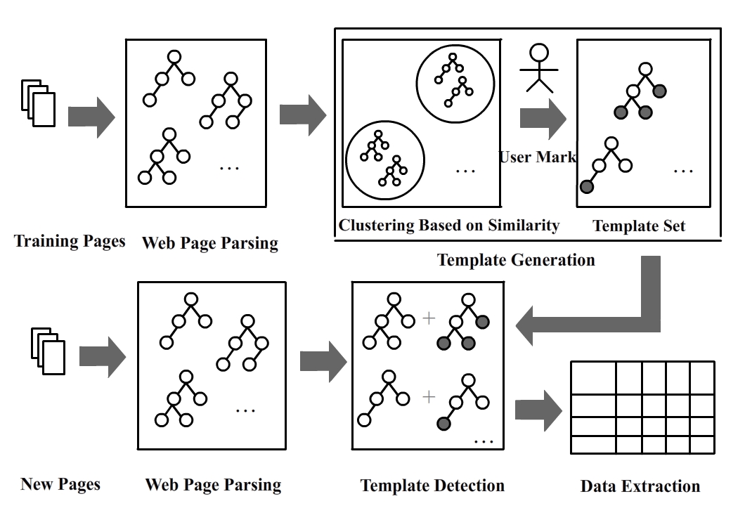
Fig.2. System Overview
Thirdly, the Seed Tree will be presented to users as a normal page for selecting their interesting data records. The final output is a template for data extraction which is stored in a template set.
When a new page is introduced in the system, it will be cleaned and parsed into DOM tree as well. Then the template detection module will choose a template matching it most based on the similarity.
Ultimately, data records on that web page are extracted successfully and presented in a structured format.

data preprocessing and representation

Transform HTML to XML
Html found on Web is usually dirty, ill-formed and unsuitable for further processing. For any serious consumption of these documents, it is necessary to first clean up the mess and bring the order to tags, attributes and ordinary text. There are several mature html parsers can do the job such as HtmlCleaner, NekoHTML and JTidy. In this work we choose the HtmlCleaner for use. HtmlCleaner is an open-source html parser written in Java which can reorder individual elements and produce well-formed XML documents.

Build Document Object Model (DOM) Tree
The DOM views XML documents as a tree-structure. All elements can be accessed through the DOM tree. Their content (text and attributes) can be modified or deleted, and new elements can be created. The elements, their text, and their attributes are all known as nodes. The nested structure of XML elements corresponds to the relationship of parent and child among DOM nodes. In our system we use dom4j [8] to parse the XML documents.

template generation algorithm
The Template Generation (TG) algorithm is the core part of our system. Given a set of DOM trees, our TG algorithm selects a tree as a Seed Tree (ST) randomly. Then TG calculates the similarity between ST and every other tree in the set. A DOM tree with similarity less than a given threshold t will be put into the same cluster. Then a new ST is produced based on it and the former ST using Partial Tree Alignment algorithm. This process continues until there is no DOM tree within the threshold. After a final ST is completed, all the clustered DOM trees will be removed. Then TG will select a new ST and repeat the above steps. The cycle will stop when no DOM tree is left.
After a ST generated, we present the user a visual page like a normal web page to select the data records he/she wants. Thus, a template has been generated by now.

Similarity Calculation Using Extended STM Algorithm
Simple Tree Matching algorithm is firstly used to identify syntactic differences between two programs in [9].
STM evaluates the similarity of two trees by producing the maximum matching through dynamic programming with complexity O(n1×n2), where n1 and n2 are the sizes of trees A and B respectively. No node replacement and no level crossing are allowed.
Let A and B be two trees and i ∈ A, j ∈ B are two nodes in A and B respectively. A matching between two trees is defined to be a mapping M such that for every pair (i, j) ∈ M where i and j are non-root nodes, (parent(i), parent(j)) ∈ M. A maximum matching is a matching with the maximum number of pairs.
Let A = <Ra, A1, A2,…, Am> and B=<Rb, B1, B2,…, Bn> be two trees, where RA and RB are the roots of A and B, and Ai, Bj are the ith and jth first-level sub-trees of A and B respectively. When RA and RB contain identical symbols, the maximum matching between A and B is Ma,b +1, where Ma,b is the maximum matching between <A1, A2,…, Am> and <B1, B2,…, Bn>. Ma,b can be obtained by the following dynamic programming scheme:
- If the maximum matching between Am and Bn, is larger than any maximum matching between Am and Bi (1≤i<n), then Ma,b is the maximum matching between <A1, A2,…, Am-1> and <B1, B2,…, Bn-1> plus the maximum matching between Am and Bn.
- Otherwise, Ma,b is the same as the maximum matching between <A1, A2,…, Am> and <B1, B2,…, Bn-1>, or between <A1, A2,…, Am-1> and <B1, B2,…, Bn>.

Algorithm: Extended_STM(A, B)
1. if the roots of the two trees A and B are of relation D
2. return 0;
3. else
4. m := the number of first-level sub-trees of A;
5. n := the number of first-level sub-trees of B;
6. Initialization: M[i,0] := 0 for i = 0, …, m;
7. M[0, j] := 0 for j = 0, …, n;
8. low = 1;
9. for i = 1 to m do
10. for k = 1 to low do
11. m[i,k] = m[i-1,k];
12. endfor;
13. j = low;
14. while j < m do
15. M[i,j] := max(M[i,j-1], M[i-1, j], M[i-1, j-1]+W[i, j]);
16. where W[i,j] = Extended_STM(Ai, Bj)
17. j++;
18. if the roots of the two trees Ai and Bj
19. are of relation E
20. then
21. low = j;
22. break;
23. endif;
24. endwhile;
25. for k = j to m do
26. m[i,k] = m[i,k-1];
27. endfor;
28. endfor;
29. endif;
30. return (M[m, n]+1)
Fig.3. The Extended Simple Tree Matching algorithm
We define the relationship between any of two nodes as the following:
E (equal): both the tags’ names and attributes are the same;
D (different): tags’ name and/or attributes are different;
S (similar): other situations.
In the Extended Simple_Tree_Matching algorithm in Fig.3, the roots of A and B are compared first (line 1). If the roots are of relation D, then the two trees do not match at all. If the roots are of relation E or S, then the algorithm recursively finds the maximum matching between first-level sub-trees of A and B and save it in W matrix (line 15). Based on the W matrix, a dynamic programming scheme is applied to find the number of pairs in a maximum matching between two trees A and B.
The original STM algorithm only considers tags and will have an error when there are more than one match for a node that give the maximum result. [7] chooses the earliest node based on the heuristic that if an earlier node x in tree A is to match a later node y in tree B, there is usually some indication (tags) before x. This solution fails when the indication tags are also the same but the contents in both trees are not matched. Thus, we propose another heuristic that the indication tag and node x are usually separated by separators (“:”, “-”, “ ”, and so on). Then we can give the node x a semantic label for further match. This heuristic works well according to our experiments.

Seed Treee Generation Using PTA Algorithm
When a new DOM tree is clustered in, we need to produce a new Seed Tree to represent both the former ST and the new clustered tree. In this work, we apply the PTA algorithm [7] to align trees of different web pages. The PTA algorithm is originally used to align trees of data records on the same web page in [7]. We use an example from [7] to explain the algorithm as the following:
When Seed Tree, denoted by Ts, and Ti (i ≠ s) are matched, some nodes in Ti can be aligned with their corresponding nodes of Ts because they match one another. For those nodes in Ti that are not matched, we want to insert them into Ts as they may contain optional data items. There are two possible situations when inserting a new node Ni from Ti into the seed tree Ts, depending on whether a location in Ts can be uniquely determined to insert Ni. In fact, instead of considering a single node Ni, we can consider each set of unmatched consecutive sibling nodes Nj…Nm from Ti together. Without loss of generality, we assume that the parent node of Nj…Nm has a match in Ts and we want to insert Nj…Nm into Ts under the same parent node. We only insert Nj…Nm into Ts if a position for inserting Nj…Nm can be uniquely determined in Ts. Otherwise, they will not be inserted into Ts and left unaligned. The alignment is thus partial. The location for insertion of Nj…Nm can be uniquely decided:
1. if Nj…Nm have two neighboring siblings in Ti, one on the right and one on the left, that are matched with two consecutive siblings in Ts. Fig.4 (A) shows such a situation, which gives one part of Ts and one part of Ti. We can see that node c and node d (which are consecutive sibling nodes) in Ti can be inserted into Ts between node b and node e in Ts because node b and node e in Ts and Ti match. The new (extended) Ts is also shown in Fig.4 (A). It should be noted that nodes a, b, c, d and e may also have their own children. We did not draw them to save space. This applied to all the cases below.
2. if Nj…Nm has only one left neighboring sibling x in Ti and x matches the right most node x in Ts, then Nj…Nm can be inserted after node x in Ts. Fig.4 (B) illustrates this case.
3. if Nj…Nm has only one right neighboring sibling x in Ti and it matches the left most node x in Ts, then Nj…Nm can be inserted before node x in Ts. This case is similar to above.
Otherwise, we cannot uniquely decide a location for unmatched nodes in Ti to be inserted into Ts. This is illustrated in Fig.4 (C). In this case, the unmatched node x in Ti could be inserted into Ts in two positions, between nodes a and b, or between node b and e in Ts. In this situation, we will not insert it into Ts.
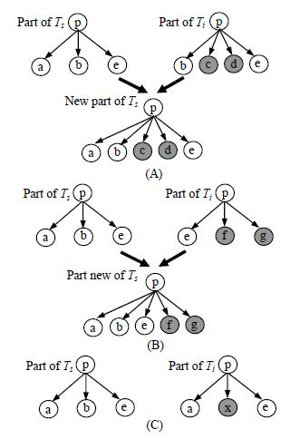
Fig.4. Expanding the seed tree: (A) and (B) Unique expansion; (C) Insertion ambiguity.

template detection
When a new page is input in, they will be parsed into DOM trees first. Our system calculates the similarities between the new DOM tree and templates, and then chooses the most matching template to extract data records accordingly. The core algorithm used to figure out the similarity is Extended STM which is discussed in Section 4.

data extraction
When the matching template has been detected, the corresponding data records on web pages can be easily extracted. In this work, we output the data records in XML format, because of its well compatibility and portability in data storing and transferring. One can also output the records in other format according to his/her need.

experiment

Experiment Set-up
We use a data set of web pages amounting to 3000 pages from ebay.com, yahoo.com, BBC.com and other real-life large-scale web sites. To verify our system, we extract several data items on each page. For example, we choose product name, price and detailed descriptions for e-business websites, and news title, author, date and text for News websites.
All experiments were run on a laptop, with a 1.67GHz Intel Core 2 CPU and 2.0GB RAM.

Experiment Results
The experiment result is shown in Table 1.
Website | Precision (%) | Recall (%)
books.shop.ebay.com | 100 | 100
shopping.yahoo.com | 100 | 100
Amazon.com | 100 | 95.5
Ashford.com | 100 | 100
officedepot.com | 99.83 | 99.62
bbc.com | 97.43 | 92.60
news.yahoo.com | 98.62 | 97.61
rentals.com | 100 | 100
housesforrent.ws/ | 100 | 100
hexun.com | 100 | 100
Finance.yahoo.com.cn | 100 | 100
Average | 99.85 | 98.67
Table 1 Experiment Results
Aiming at verifying our approach for generating and detecting templates, we choose the test set pages whose structures are similar or the same to the training set pages. From Table 1, we can see that for e-business websites, rental websites and finance websites our approach works very well because their data are presented in a nearly uniform format. While for news websites the precision and recall are relatively lower than the results in other domains. By analyzing the structures of web pages, we find that the texts of news usually have different segments, size and may embed images in different places, which all make the pages various in page structure. That is to say, some newly-input pages may not match a proper template, but the experiment results are still acceptable at a degree.

conclusion
In this paper, we propose a novel web data extraction approach. Although the problem has been studied by other researchers before, but their works are more or less limited to real-life application for being based on many restrict assumptions. Without those constraints our approach is more flexible and pragmatic. Our work extracts data records from web pages totally in just three steps: (1) generating templates for pages based on similarities; (2) detecting templates for newly-input pages; (3) extracting data records according to user’s need. Experiment results using a large number of web pages illustrate that our system can extract web data accurately and efficiently.

Acknowledgment
This work is supported by the National College Students Innovation Plan Project named “The Research and Implementation of Knowledge Discovery Algorithm Based on Training Set”.

References
- http://web-harvest.sourceforge.net/
- V. Crescenzi, G. Mecca, and P. Merialdo. Roadrunner: Towards automatic data extraction from large websites. In Proceedings of the 27th International Conference on Very Large Data Bases, pages 109 –118, 2001.
- V. Crescenzi, G. Mecca, and P. Merialdo. Wrapping-oriented classification of Web pages. In Proceedings of the 2002 ACM Symposium on Applied Computing, pages 1108-1112. ACM Press, 2002.
- L. Arllota, V. Crescenzi, G. Mecca, and P. Merialdo. Automatic annotation of data extraction from large Web sites. In Proceedings of the International Workshop on the Web and Databases, pages 7–12, San Diego, USA, 2003.
- S. Zheng, D. Wu, and R. Song. Joint Optimization of Wrapper Generation and Template Detection. In Proceedings of the 13th ACM SIGKDD international conference on Knowledge discovery and data mining, 2007
- A. Carlson, and C. Schafer. Bootstrapping Information Extraction from Semi-structured Web Pages. In Proceedings of the 2008 European Conference.
- Y. Zhai, and B. Liu. Web Data Extraction Based on Partial Tree Alignment. In Proceedings of the 14th international conference on World Wide Web, 2005.
- http://dom4j.sourceforge.net/
- Yang, W. Identifying syntactic differences between two programs. Softw. Pract. Exper., 21(7):739–755, 1991..
- D. C. Reis, P. B. Golgher, A. S. Silva, and A. F..Laender. Automatic web news extraction using tree edit distance. In Proceedings of the 13th International Conference on World Wide Web, pages 502 –511, 2004.
- S.-L. Chuang and J. Y.-j. Hsu. Tree-structured template generation for web pages. In Proceedings of IEEE/WIC/ACM International Conference on Web Intelligence, pages 327–333, 2004.
- C.-H. Chang and S.-C. Lui. IEPAD: information extraction based on pattern discovery. In Proceedings of the 10th International Conference on World Wide Web, pages 681–688, 2001.
- A. Arasu and H. Garcia-Molina. Extracting structured data from web pages. In Proceedings of the 2003 ACM SIGMOD International Conference on Management of Data, pages 337 – 348, 2003.

