Ensamble de nodos y elementos

ndof: dof por nodo (12)

UV(8x1)

for i in range (var_dim[0]): #Velocity is var 0

UV[i,0]=Uglob[ndof*d+i]

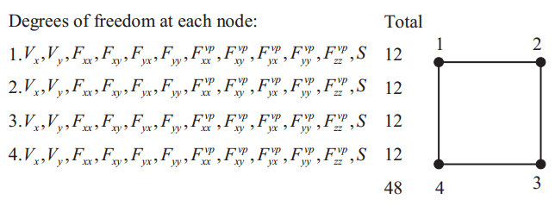

Forma de vectores

#F is [xx xy yx yy zz] , (4.21) in form 2

Fd y Fvpd son las

