Software Requirements Specification
for
CAR RENTAL APP
Version 1.0
Ionica Mihai Luchian
Petrescu Alin
Nicolae Mihai
University of Craiova
March 2021
Table of Contents
Table of Contents ii
Revision History iii
1. Introduction 1
1.1 Purpose 1
1.2 Document Conventions 1
1.3 Intended Audience and Reading Suggestions 1
1.4 Product Scope 1
1.5 References 1
2. Overall Description 2
2.1 Product Perspective 2
2.2 Product Functions 2
2.3 User Classes and Characteristics 2
2.4 Operating Environment 3
2.5 Design and Implementation Constraints 3
2.6 User Documentation 3
2.7 Assumptions and Dependencies 3
3. External Interface Requirements 4
3.1 User Interfaces 4
3.2 Hardware Interfaces 5
3.3 Software Interfaces 5
3.4 Communications Interfaces 5
4. System Features 5
4.1 System Feature 1 .
4.2 System Feature 2 (and so on) .
5. Other Nonfunctional Requirements 8
5.1 Performance Requirements 8
5.2 Safety Requirements 8
5.3 Security Requirements 8
5.4 Software Quality Attributes 9
5.5 Business Rules 9
6. Other Requirements 9
Appendix A: Glossary 9
Appendix B: Analysis Models 9
Appendix C: To Be Determined List 9

Revision History
Name | Date | Reason For Changes | Version
CAR RENTAL APP | 9 MARCH 2021 | CREATION DATE | 0.0 ALPHA

Introduction

Purpose
The purpose of this document is to present a detailed description of the car rental web application. It will explain the purpose and features of the software, the interfaces of the software, what the software will do and the constraints under which it must operate. This document is intended for users of the software and also potential developers.

Document Conventions
IDE – Integrated Development Environment
DB – Database

Intended Audience and Reading Suggestions
- Programmers who are directly involved into the development of the application. Individuals who need to have a better understanding of the project.

Product Scope
The application is a tool that facilitates the interaction between a car rental shop and a potential customer who is in need for a car for a limited period of time.
A customer can specify some criteria like size, seats, price.
An administrator can keep track of the rented cars or add/delete existing models.

References
https://github.com/luchiancode/CAR-RENTAL-APP

Overall Description

Product Perspective
The application was developed for everyone who is in need for a rental car and wants a fast and customer friendly experience by using a web browser. The application is designed to run on the most popular web browsers (Firefox, Chrome, Microsoft Edge etc).

Product Functions
The login system permits two types of authentication:
As a customer, you can rent or do some other features.
As an administrator, you can manage existing car models, or change the number of cars who can be rented.

START ->
SIGN IN AS “ADMIN” OR CUSTOMER
->NO -> REGISTER AN ACCOUNT OR RETRIVE ACCOUNT PASSWORD
->YES ->
-> SIGN AS CUSTOMER ->
->BOOK A CAR
->VIEW OWN BOOKING DETAILS
->EDIT PROFILE DETAILS
->CHANGE PASSWORD
->SIGN OUT
->SIGN IN AS ADMIN->
->UPOAD AND EDIT CAR DETAILS
->EDIT CAR STOCKS
->DELETE CAR DETAILS
->BOOK CAR TESTING
->VIEW AND MANAGE BOOKING DETAILS
->EDIT PROFILE DETAILS
->CHANGE PASSWORD
->SIGN OUT

User Classes and Characteristics
The customers can use the application to find a car which is available for renting.
Which means that they need to have the ability to find a car and then rent it, if it is available.
The administrator can manage the disponible cars in the system.

Operating Environment
The application runs on any operating system which has a web browser.
The following versions of web browsers can access the website:
- Chrome (version 48.0 or higher)
- Firefox (version 62.0 or higher)

Design and Implementation Constraints
The application is developed in ASP .NET CORE. It uses a modular design where every feature is wrapped into a separate module and the modules depend on each other through well-written APIs. There are several APIs available to make plugin development easy.

User Documentation
A SRS documentation will be available to the customer along with a database and a Software requirement specification document.

Assumptions and Dependencies
The application is developed in ASP .NET CORE and therefore being a WEB APPLICATION requires a web browser.
The application fetches the data from the database through the internet, a strong internet connection is required for a proper interaction from the users.

External Interface Requirements

User Interfaces
The page should have a “Home Button” concealed by a logo or a suggestive picture. A log in button should also be visible next to a button for creating an account (“Sign up”). There should also be a section of the page where images of recommended cars are shown. If the user is already logged in then a button for the profile (“My account”) of the current user should be on the opposing side of the Home page button. The website will have a text bar for searching deals or cars. The searching process should be easy, with options for criteria and filters, some of which will be represented by checkboxes.
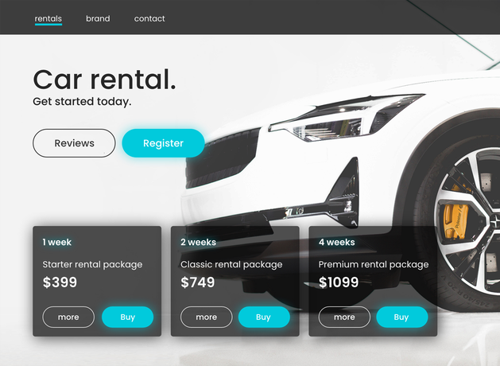

Hardware Interfaces
Not applicable.

Software Interfaces
The web application will modify the database; the database will contain the necessary information about the cars, the cars status and additional information like the specifications of the available cars etc. If the information introduced is not valid (wrong username or unavailable car name etc.) then the user will be prompted by an alert (red text, pop-ups).

Communications Interfaces
The application requires an internet connection to install new plugins, update already installed ones and update some of its components; the updates are made on the local server.

System Features

User Registration
4.1.1 Description and Priority
For the user to have access to all the features the platform provides a registration is required (an account must be created). Guest users cannot rent cars without being registered. High priority.
4.1.2 Stimulus/Response Sequences
The user must fill in the fields for creating an account (First and Last Name, password, password confirmation, email address, date of birth – only adults can create accounts). Some error messages will appear if the username or email address have been already used in a previous registration on the website.
If the user does not fill in all mandatory text boxes an error message will pop up asking them to introduce the necessary information. After all information has been introduced the user will have to click “Register” for the process to end.
4.1.3 Functional Requirements
REQ 1: The sign-up button will prompt the user.
REQ 2: The username text box is used for the desired username.
REQ 3: The First Name box is used to introduce the given name of the user.
REQ 4: The Last Name box is used to introduce the last name of the user.
REQ 5: The Password cassette is used to introduce the desired password of the user.
REQ 6: The e-mail cassette is used to introduce the e-mail of the user.
REQ 7: The age cassette is used to introduce the age of the user.
REQ 8: The phone number cassette is used to introduce the phone number of the user.
REQ 9: The forgot password link is implemented so the user can have a solution for account recovery.
REQ 10: The log in button grants access to the new account just created of the user.
REQ 11: An error message should alert the user when already registered username or e-mail is used to create a new account.

User Log in

Description and Priority
Registering is not enough; the user must be logged in to use the car renting platform. This is a High priority feature.

Stimulus/Response Sequences
The log in button will give the user the possibility to log into the previously created account.

Functional Requirements
REQ 1: The log in button grants the user the possibility to access their created account.
REQ 2: “Username” cassette is used to introduce the username for an account already existing.
REQ 3: “Password” cassette is used to introduce the password for an account already existing.
REQ 4: The “login” button also prompts the user to the main page of the web application.

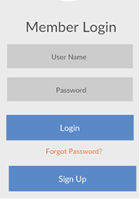

User Information

Description and Priority
The website should provide ways of changing credentials for the user, although this feature should be of medium priority.

Stimulus/Response Sequences
There should be a button on the profile page that allows the user to reset the password and/or the username by introducing the old information and the new, desired credentials.

Functional Requirements
REQ 1: A button for password reset should be visible.
REQ 2: The email address will have a designated text box and will be used to change the password.
REQ 3: Two new cassettes will have to be filled in with the new desired one.
REQ 4: The second text box will be filled with the new desired password.
REQ 5: A submit type button will redirect the user to the main page.
REQ 6: The user will be asked to log in again (with the new credentials).

Car Renting

Description and Priority
For renting a car the user must search through the available cars on the platform, using the search text box and filters; then they must have to select a car from the list at which point they will be redirected to a page that contains information on that car. High Priority.

Stimulus/Response Sequences
The user will be able to choose from a list of available cars.

Functional Requirements
REQ 1: The button “Rent” / “Continue” / “Proceed” should allow the user to open the page containing information on that car (availability etc.)
REQ 2: Next a method of payment will be selected.
REQ 3: The reservation is complete after the payment selection has been made.
REQ 4: The car will be marked as rented in the database.
REQ 5: The car should either be removed from the search lists or be marked as unavailable on the website.

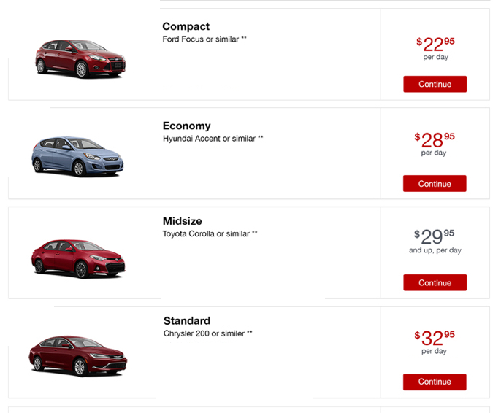

Other Nonfunctional Requirements

Performance Requirements
The application requires 512MB RAM and a 1.0GHz CPU as hardware components and a web browser as a software component.

Safety Requirements
To ensure that no one of the application users loses any data while in usage the developer team updates the application regularly. There is a bug tracker available where users can report any potential bugs they have encountered so that the developers can fix them in the next release.

Security Requirements
A log in functionality is used: a guest that visits the website must log in for renting a car. A username and a password that requires letters and numbers are necessary for creating an account on the platform.

Software Quality Attributes
The application provides the users with both simple and advanced features. Due to its well designed and easy to use interface it can be used by both experts and typical users.
- Classes names are written by using Upper Camel Case.
- Method names and fields names are written using Upper Camel Case.
- Method names are verbs.
- Variables are nouns.
- Commenting code when it is necessary.
- All the methods should have one goal and must be short.
- Intuitive names for variables, classes and functions.
- SOLID principles must be used.
- Easy to maintain
- Easy to test .

Business Rules
Not applicable.

Other Requirements
TBD
Appendix A: Glossary
TBD
Appendix B: Analysis Models
TBD
Appendix C: To Be Determined List

