**Data Description**

**1. Network Data**

Bus stops --- shapefiles

Bus routes --- shapefiles

Runcut file --- CSV

**2. Deployment Plans**

Solution file for each plan --- txt

**3. Supplementary Data**

Refer to notes at the end.

**BEB Specifications**

**Battery Capacity: 400 kWh**

**Maximum Mileage: 62 miles**

**Example Crosswalk**

To demonstate how to extract timestamp, location (bus stops) and traveling distance of each bus, I included the crosswalk procedure here using bus Z1029 in p20.txt (deployment plan under budget $20 M). The following is the runcut of bus Z1029.



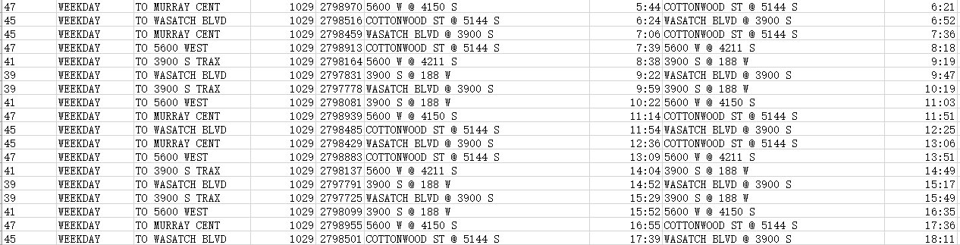

Fig. 1

1. To retrieve the charging timestamp and location (bus stops), we first locate X####_s variables in p20.txt. X####_s indicates whether bus Z#### is charged at sequence s.

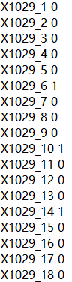

X_1029_1 is equal to 0 which suggests that bus Z1029 is not charged at the first stop after departure during the day (excluding the departure station, which is numbered as 0). By referring to Fig. 1, X_1029_1 is “COTTONWOOD ST @ 5144 S”.

X_1029_6 is equal to 1 which suggests that bus Z1029 is charged at the 6th stop after departure. The stop is “WASATCH BLVD @ 3900 S”

To sum up, variable X####_s in each deployment along with runcut file contain the information of when and where bus Z#### is charged on-route.

2. To retrieve the traveling distances at each stop, we first locate m####_s variables in p20.txt.

m####_s indicates the accumulated mileage of bus Z#### at sequence s.

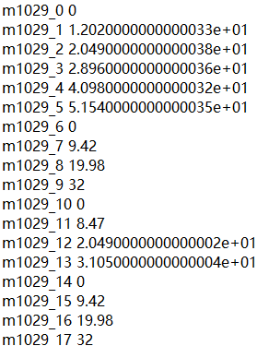

m1029_0 is equal to 0 representing that Z1029 is fully charged at the beginning of the day and ready to depart from “5600 W @ 4150 S”. Later, the traveling distance keeps increasing until gets charged again when m1029_6 is reset to 0. Here, to represent the traveling distance at an on-route charging station (located at bus stops), you can use the accumulated traveling distance before reset, such as m1029_5 to represent the actual value of m1029_6.

By combining steps 1 and 2, we can estimate when and where bus Z#### is charged and how many miles bus Z#### has traveled (i.e., battery consumption by incorporating battery capacity & maximum mileage).

**A few notes:**

1. We assume that (1) battery consumption is linear with traveling distance and (2) no partial charging.

2. In the runcut file, there are only departure and arrival stops because buses generally do not dwell at stops other than terminals. i.e., BEB can not get charged.

3. In-depot charging stations are located at four fixed garages, which only impacts the total cost. We can ignore in-depot charging stations for now.

4. some buses do not require on-route charging, whose daily traveling distance is below 62 miles (Max mileage). i.e., X####_s = 0 for all s

5. In the Supplementary Data folder, many related datasets could potentially help with the visualization. “8. Ei_for_bus.csv” contains the environmental equity attribute associated with each bus. Folder “4. TAZ” contains the shapefiles of traffic analysis zones, which are the basic analysis units of transportation. “5. Marginal_Income.xlsx” and “6. SE_File_v83_SE19_Net19.xlsx” have the socioeconomic data of populations of various income levels.

6. The address of the paper is https://ieeexplore.ieee.org/document/9310704.