 | Studient_name 1  Studient_name 2 | email1@estudiante.uam.es  email2@estudiante.uam.es

1. TEST CASE Accepting and expelling students

  - Use Case: Joint test case of accepting and expelling students
In this use case we accept a student in a course and then we expel it.
Primary actor: Teacher
Stakeholders and goals: teachers who want to admit a student in a course and then expel it.
Preconditions: A student has applied for a course. Then we have accessed the application as a teacher and we have accessed the course.

Main success scenario:
1. Teacher clicks on “Applications”.
2. System changes the visible panel and shows the applications list.
3. We select the student we want to accept
4. The buttons on the bottom are enabled.
5. Teacher clicks on “Accept” button.
6. The list is refreshed (the accepted student dissapears)
7. The teacher clicks on “Back”
8. The course is shown.
9. Teacher clicks on “students”
10. The panel is changed and we see the list of students that have been accepted
in the course.
11. Teacher clicks on a student.
12. The panel is changed to the expeltion/readmission window.
13. Teacher clicks on expel student.
14. The student is expelled.

1.2. Test case design (including expected inputs and outputs):
Preconditions: In this case, only one student has applied. The name of the student is “L A” and the name of the course is “Course 1”. The preconditions are that this course has been created, and that the student has applied for the course. Also, that the teacher has logged in as a teacher and accessed that course. The credentials for the student “L A” are: “l.a@m.es” and “M”. The credentials of the teacher are written in the readme file.

Scenario:
1. Teacher clicks on “Applications”. (Screenshot 1)
2. System changes the visible panel and shows the applications list, which only contains the student L A. (Screenshot 2)
3. We select the student we want to accept, in this case, we click on L A
4. The buttons “accept” and “reject” are enabled. (Screenshot 3)
5. Teacher clicks on “Accept” button.
6. The list is empty now (Screenshot 4)
7. The teacher clicks on “Back”
8. The course “Course 1” is shown. (Screenshot 5)
9. Teacher clicks on “students”
10. We see the list of students of the course, which only contains L A (Screenshot 6)
11. Teacher clicks on L A.
12. The panel is changed to the expeltion/readmission window of L A.
13. Teacher clicks on “expel student” ONCE.
14. The student is expelled, although the button text is not refreshed on version 1 of moon.

1.3. Test execution result
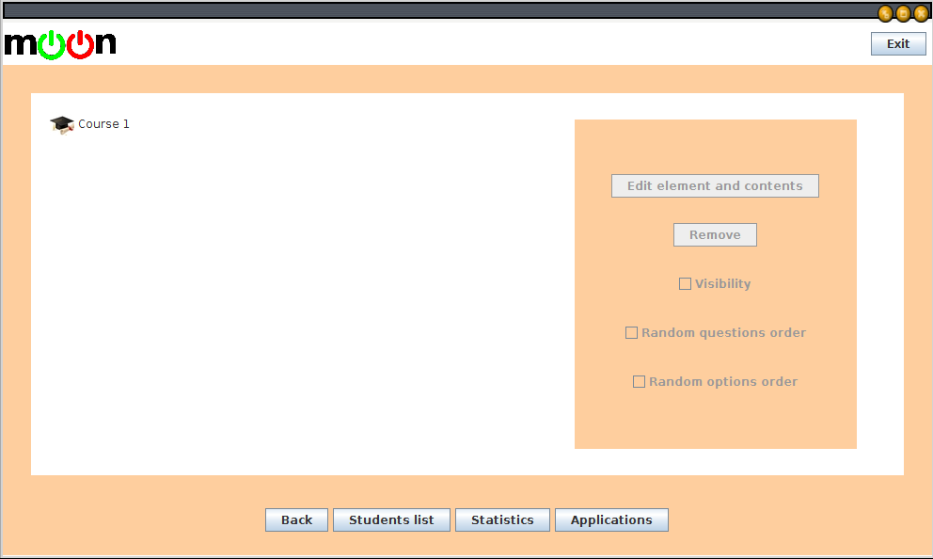
Screenshot 1: This is the course view.

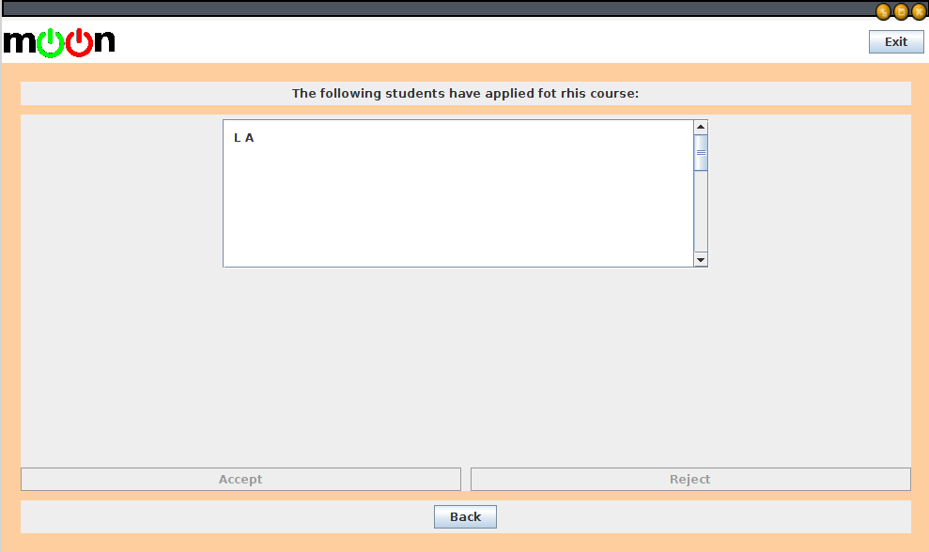
Screenshot 2: This is the list of the students that have applied for the course. In this case, only “L A” has applied for the course.
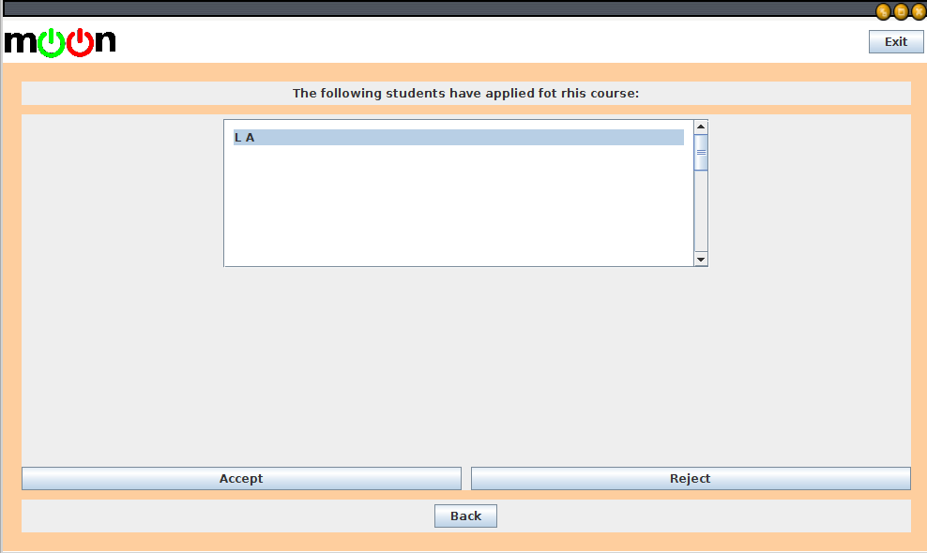
Screenshot 3: when the tacher selects a student on the list, the buttons at the bottom are enabled.(Accept and reject, to accept or reject the student)
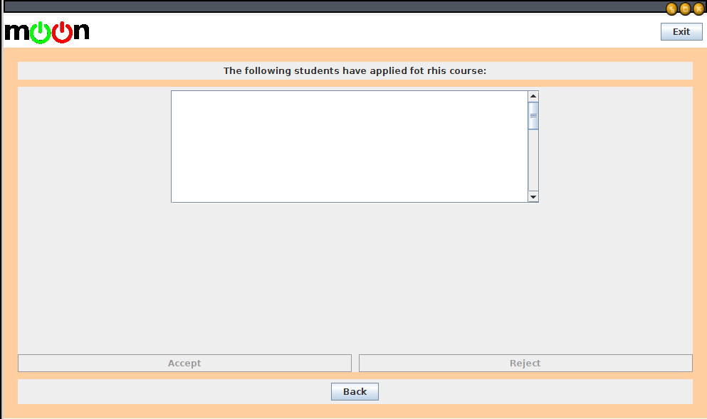
Screenshot 4: when teacher clicks on accept, the student is accepted and the list of students is refreshed, in this case it si empty because no one else appart from L A had applied for the course.
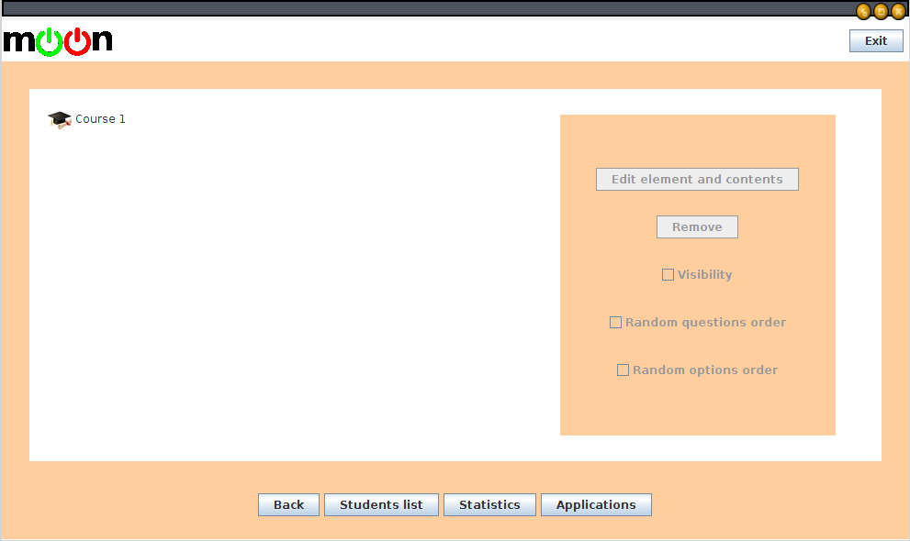
Screenshot 5: when we click on back, we head back to the course.This is the main course window again.
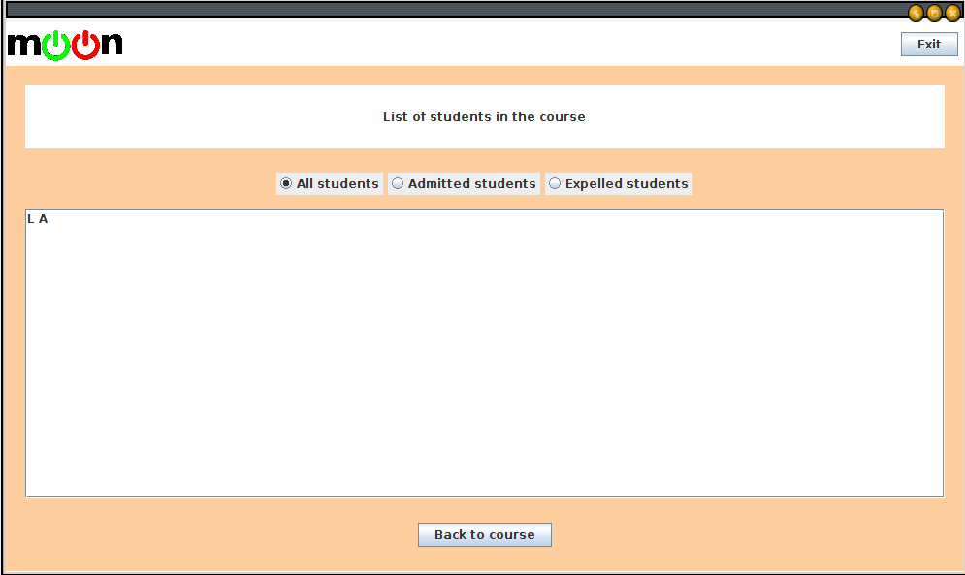
Screenshot 6: when we click on “Student’s list” we are headed to the list of students in the course, which only contains L A.
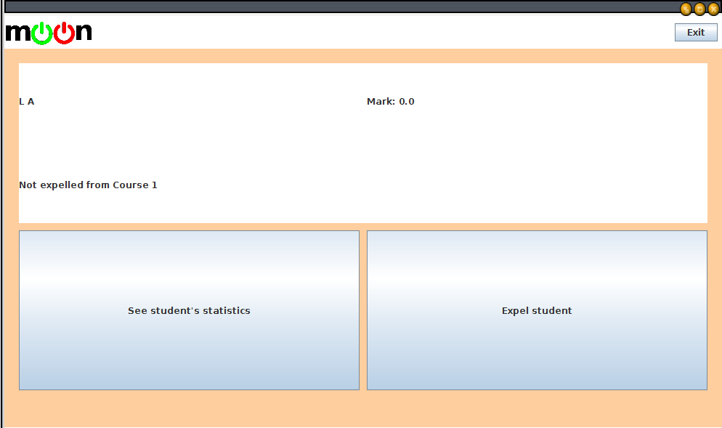
Screenshot 7: When we click a student from the course student’s list, we are taken to this panel, in which we can, among other things, expel the student. It is important to note that, when we click “Expel student”, on version 1 of moon, the panel will not refresh.

IMPORTANT NOTE: the final panel will not refresh on version 1 of moon when “Expel student” is clicked. To check that the expeltion was done right, you should enter the students statistics, click on ‘back to main’, click on the Course again, and click on student’s list. There if you select ‘expeled students’ L A should be displayed.

