Desing document

Padsof
Juan Riera Gomez
Lucia Asencio Matrín

Class Diagram:

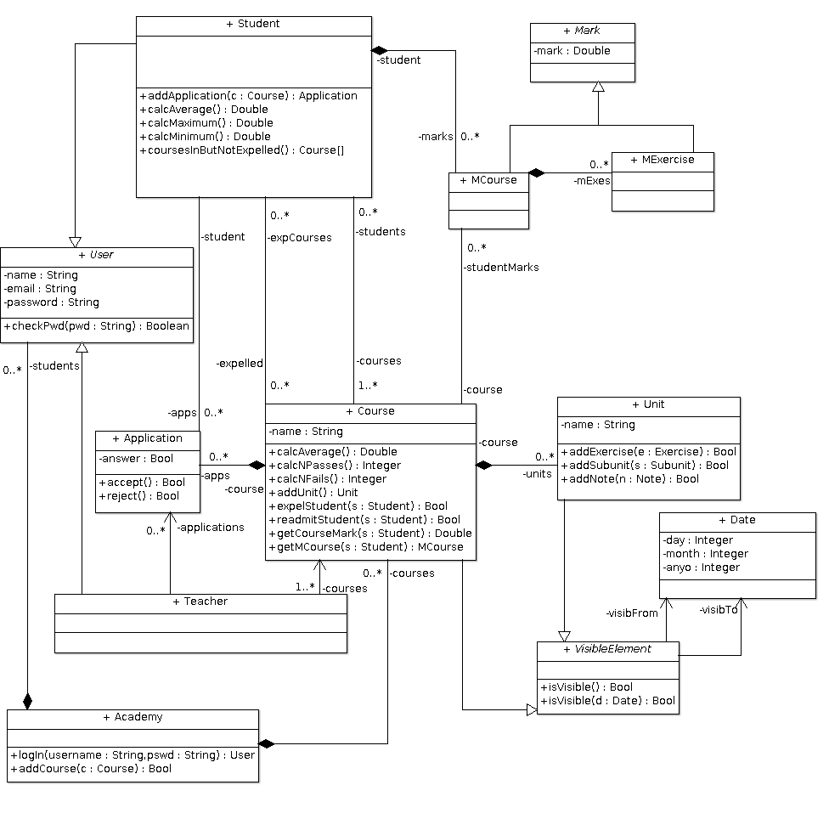
Part 1

Part 2
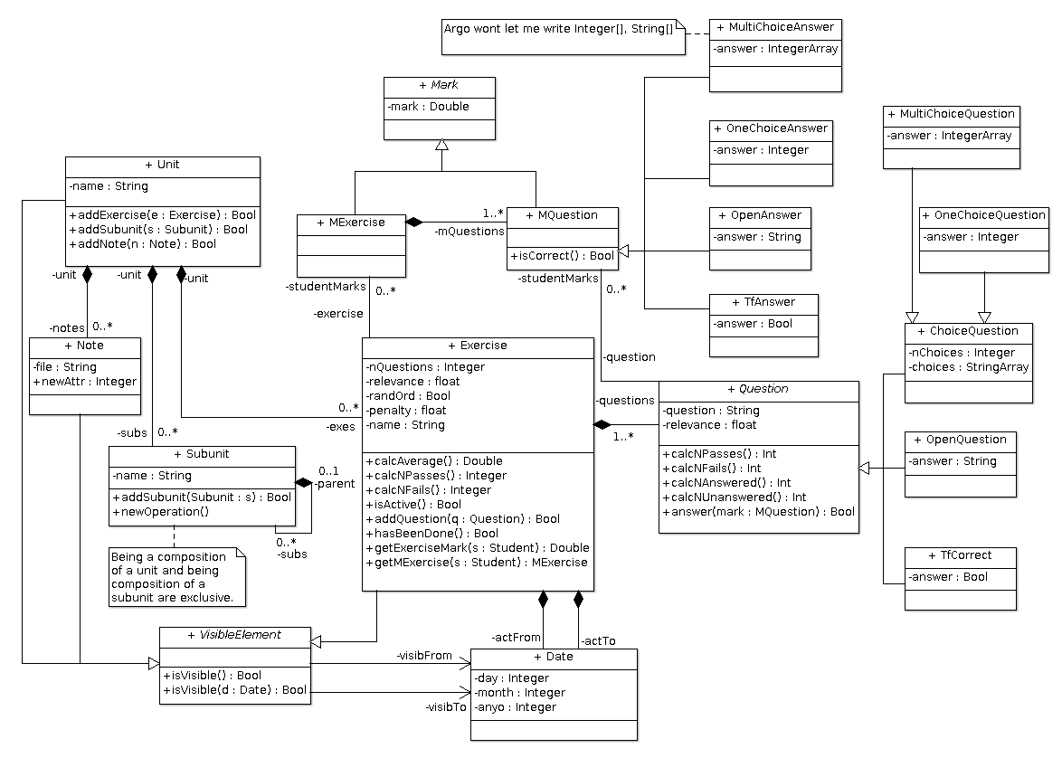
We had to divide the diagram because of its size, which would not fit in this page. Due to this, there are some repeated Classes between both parts.
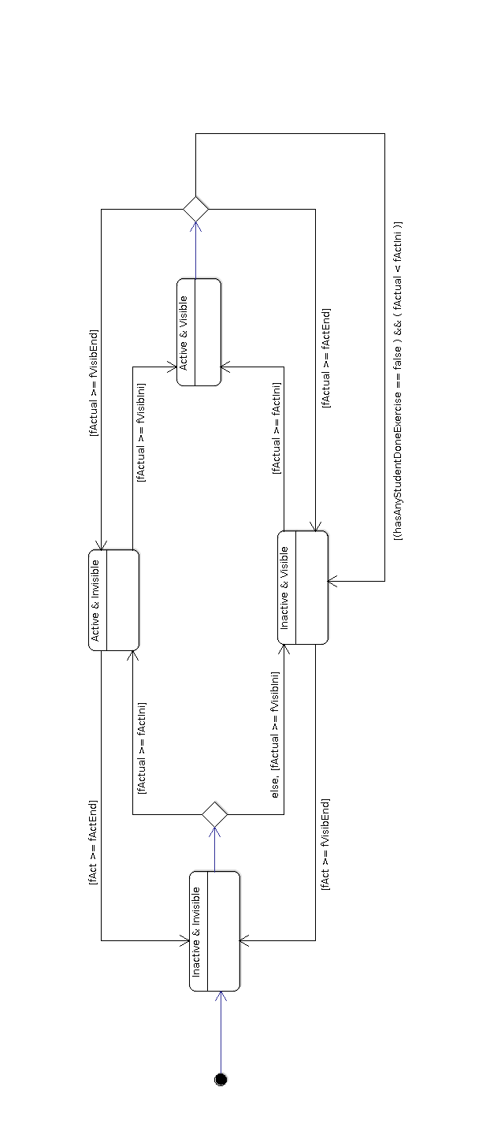
State transition
diagram 1:

Exercise

We restricted the state transition of an exercise to the 4 transitions we thought were more sensible. Therefore, transitions where visibilityEnd was before visibilityIni or activityEnd was before activityIni have been discarded. Also, we discarded the ones where the exercise was never doable (i.e., active and visible): for example, the ones where the exercise went from active to inactive and, afterwards, from visible to invisible.

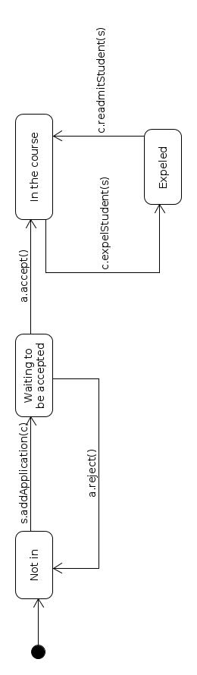

State transition diagram 2:
Possible relations between
a Course and a student

In this diagram:

-a is an application
-c is a course
-s is a student

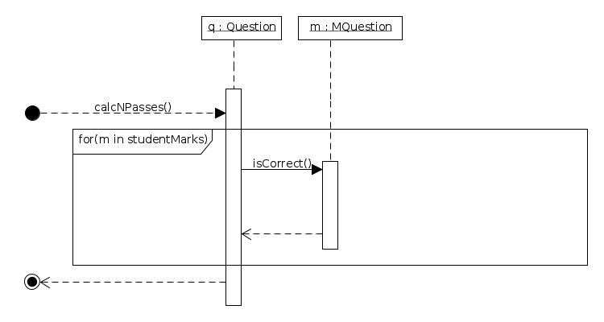
Sequence diagram 1: Calculation of NPasses

The method calcNPasses, calculates the number of students who have answered a question correctly, this means that it will count the elements in studentMarks for which isCorrect() returns ‘TRUE’.

Sequence diagram 2: student solving an exercise

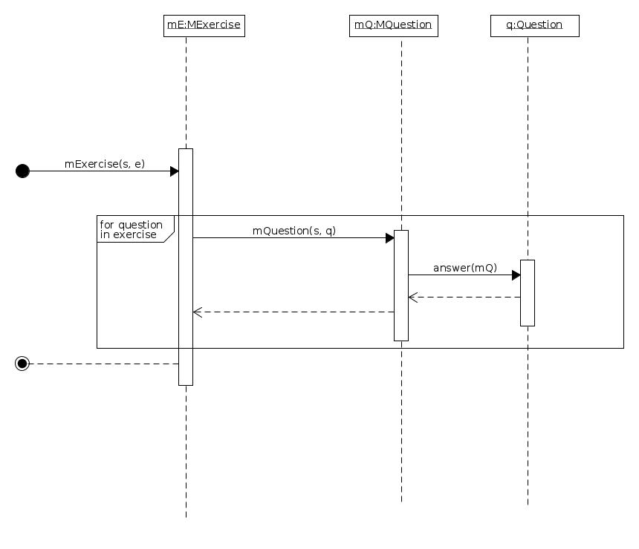
In this diagam:
-s is a students
-e is an exercise

Sequence diagram show how a student solves an exercise. When he presses the “do exercise” button, a new “MExercise” object (instance of the exercise mark class where the student exercise, a new MQuestion object (instance of the question mark class, where the answers and mark for each question will be saved) is constructed.

Traceability matrix associated with the teacher’s requirements

We had too many methods to put them all in one matrix, so we divided it into 8 different tables.

Traceability matrix associated with the student’s requirements

As it had 19 different methods, we divided the matrix in 5 with 4 methods each, so that it was understandable.

