PADSOF Documentation

Lucia Asencio Martín
Juan Riera Gomez

All our code is inside src, including the demonstrator and all the junits.
The demonstrator is a class in moon package.
Inside each package, there is a testing package called “package.tests” which contains the testing of that package.

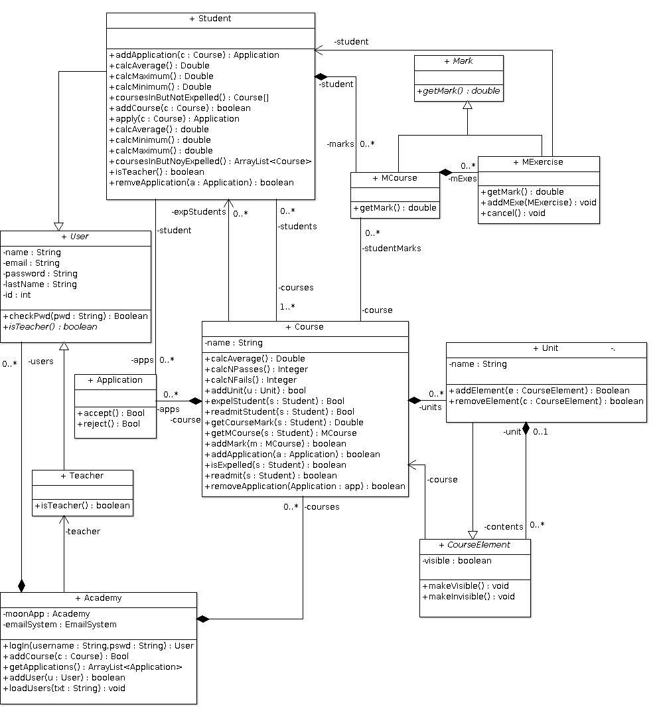
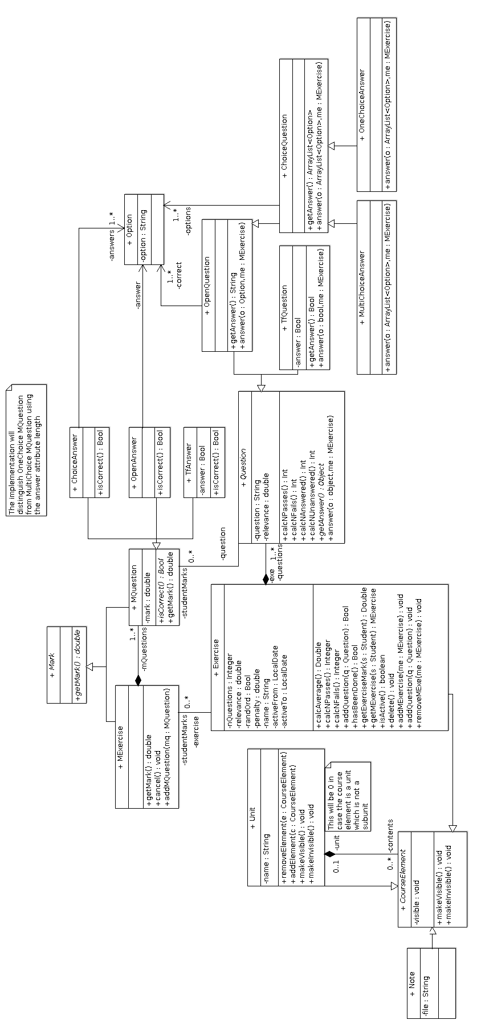
Traceability matrix associated with the teacher’s requirements

We had too many methods to put them all in one matrix, so we divided it into 8 different tables.

Traceability matrix associated with the student’s requirements

As it had 19 different methods, we divided the matrix in 5 with 4 methods each, so that it was understandable.

