CSE 111 Fall 2024: Project Checkpoint 1  
StockSmart: Food Inventory Tracker  
Cheska Cinderella Friend and Lucia Barboza

**PROJECT SYNOPSIS: STOCKSMART**

StockSmart is a kitchen inventory management system designed to assist users in tracking their pantry, fridge, and freezer items. It helps users optimize food usage, reduce waste, and maintain healthier eating habits. The system offers real-time inventory updates, nutritional tracking, and alerts for upcoming expiration dates. By doing so, it ensures efficient grocery management and reduces food wastage, making kitchen management smoother and more organized.

Another feature we added to enhance kitchen management is the shopping list entity. This feature allows users to create and manage shopping lists directly within the system, while also tracking how often certain products are purchased. By monitoring these shopping habits, StockSmart can provide valuable insights and statistics (or "quatrics") about purchasing patterns. This addition not only aids in efficient grocery management but also helps users better plan their shopping trips, ensure they are purchasing the right quantities, and avoid overbuying items they already have on hand. Overall, this feature contributes to a more organized kitchen and smarter shopping practices, ultimately helping users save both time and money.

**UML USE CASE DIAGRAM**

**Main Use Case:**

The primary use case for StockSmart is tracking the inventory of kitchen items. The user logs into the system and can add new items, update existing stock, or remove items that have been used or expired. StockSmart monitors the expiration dates of all items and sends alerts when products are nearing their expiration, helping the user make informed decisions about food consumption. It also tracks the nutritional value of items, ensuring the user is aware of their food choices.

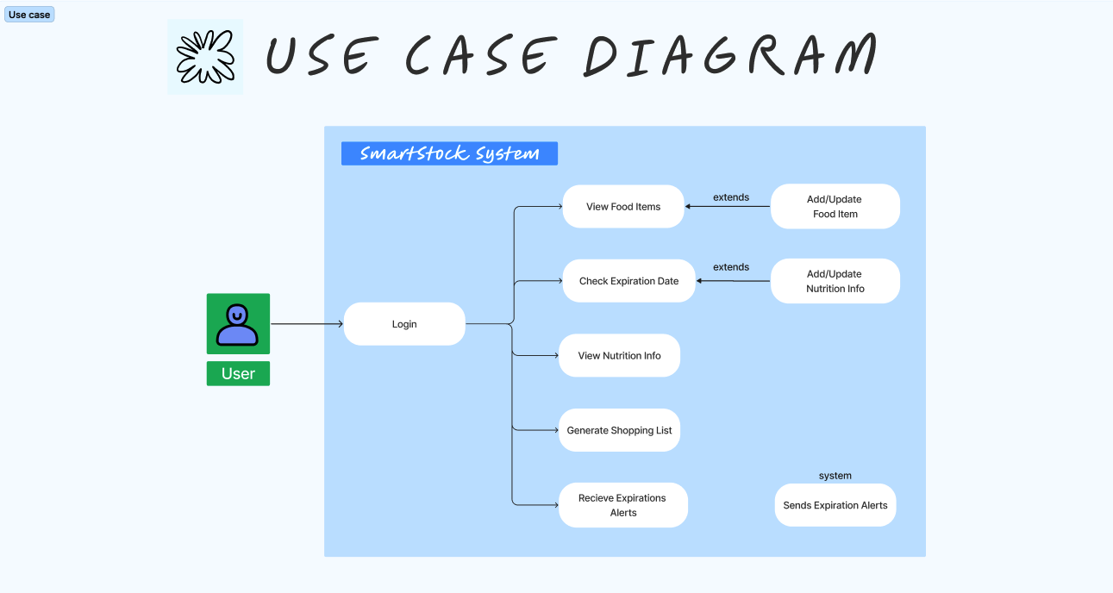

**ER DIAGRAM**

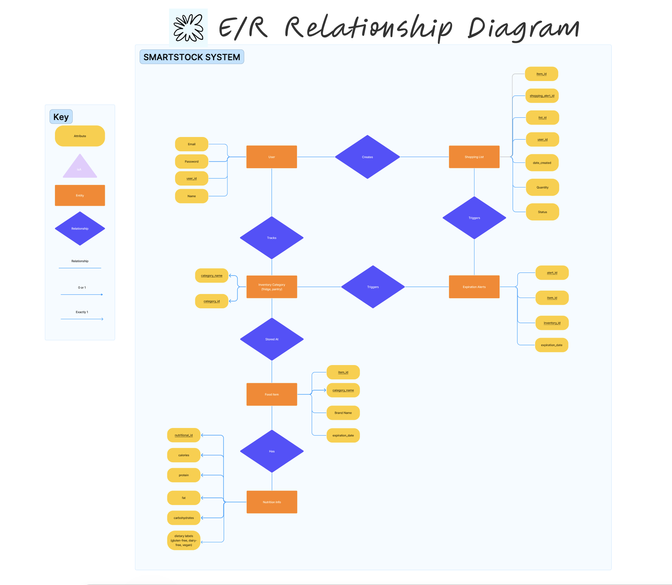

**RELATIONAL SCHEMA**

