CPU_Processor_Test01_22336688_Doc

Initialise all 128 memory locations starting with the last two digits of your StudentID at memory address 0 and increment this number by one for all the remaining memory locations
MW=1, MB=1 MM=1
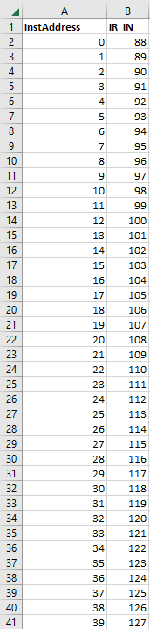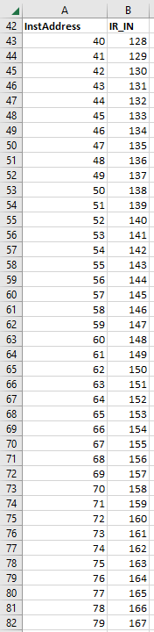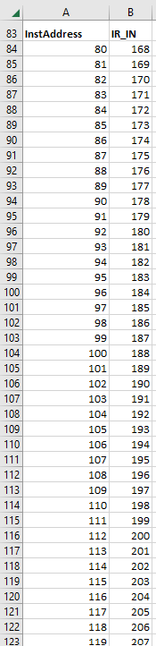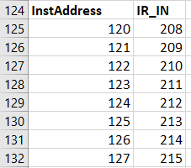

Load the first register in your register-file with the content of the first memory location in your RAM, the second register in your register-file with the content of the second memory location in your RAM Please continue until all 32 registers and the 15 TempReg have a value.
MW=0, MD=0, RW=1
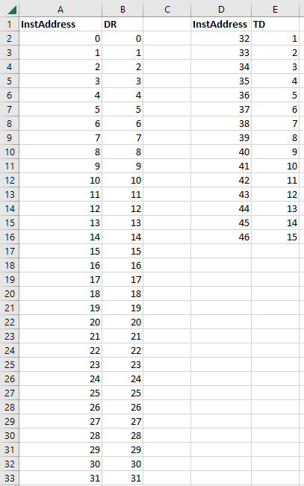

Once all 32 + 15 registers are loaded, use the last digit of your student number to select the source-register A (A address) and the last digit of your student number + 1 to select the sourceregister B (B address)
SA=01000
SB=01001

Use the selected registers on the Port A and Port B to demonstrate all 15 micro-operations of the Datapath. You must use the last digit of your student number + 2 to select the destination-register
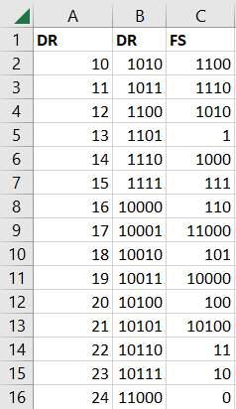
Store the content of these 15 destination-registers in 15 consecutive memory locations in your RAM.
MW=1, MB = 0, MD = 0, RW = 0
10-24 also chosen as the RAM locations
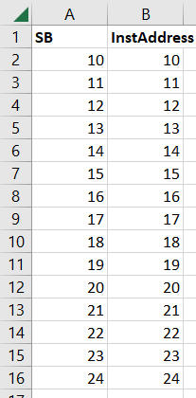
Then, load these 15 consecutive memory locations from your RAM into destination-registers 1 by overwriting the content of destination-registers 1.
MD=1, RW=1, MW=0
