test 3 Score = ______/25

1. A Greek food truck with a limited menu would like to assess the popularity of its couscous salad. In particular, it would like to evaluate the association rule: $\left\{Chicken Gyro\right\} →\left\{Couscous Salad\right\}$. Using this small data set of 12 visitors, do a market basket analysis of this rule.

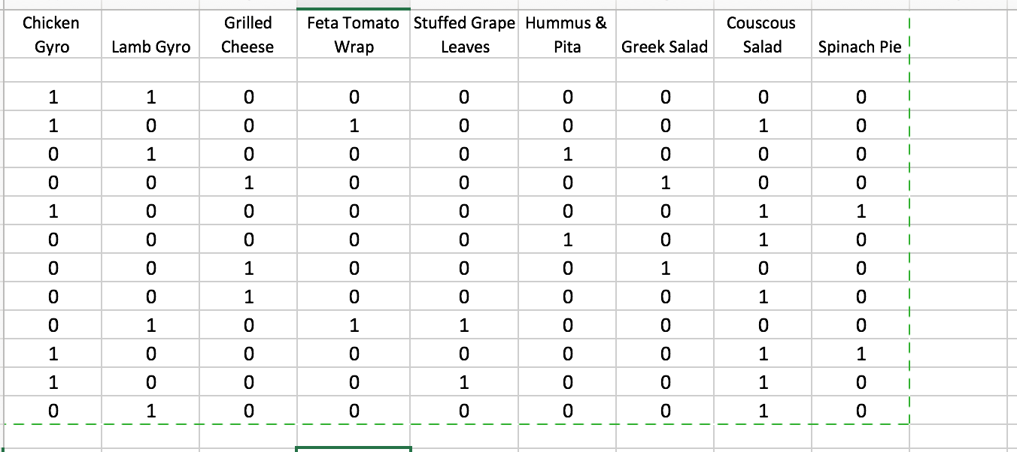

1. Create a column in the table above for ‘Chicken Gyro and Couscous Salad’, as we’ve done in class. (1 pt)
2. Calculate the needed quantities, as we did in the Association Rules activity, and state values below.

Show work for each calculation. (4 pts)

|  |  |
| --- | --- |
| Rule #1 | $$\left\{Chicken Gyro\right\} →\left\{Couscous Salad\right\}$$ |

Chicken Gyro: Number of times purchased:_____________ Support _____________

Couscous Salad: Number of times purchased:_____________ Support _____________

Chicken Gyro and Couscous Salad: Number of times purchased: _____________ Support _____________

Confidence of the Rule:____________________________

Lift of the Rule:___________________________

1. Complete the sentence below, in terms of the Chicken Gyro and Couscous Salad association rule.

*The Lift value means that we are _________times more likely to believe ________________________________________________________________________________________,*

*Compared to _______________________________________________________________________________*

1. A bookstore wondered how much customer wait times would be reduced by having more cashiers. Each hour, they randomly assigned whether to have 2, 3, 4, 5, or 6 cashiers, then they recorded the average wait times for the hour. They ended up with the scatterplot below

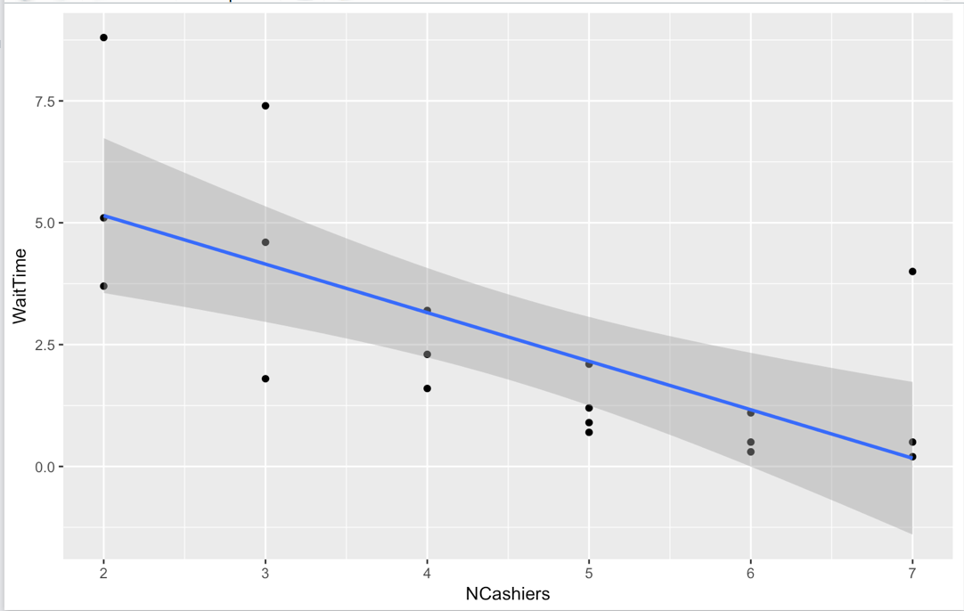

1. The data is in data frame **Wait**. Write the code to make the plot above, using dplyr/ggplot:
2. Looking at the plot, the correlation coefficient is closest to (circle one): **-.9 -.7 -.3 0 .3 .7 .9**
3. The output below is most of the summary of the linear model object **regwait**. Write the line of R code that would create **regwait**.

> summary(regwait)

Residuals:

Min 1Q Median 3Q Max

-2.3515 -1.1099 -0.0641 0.1880 3.8317

Coefficients:

Estimate Std. Error t value Pr(>|t|)

(Intercept) 7.1389 1.2001 5.949 1.59e-05

wt$NCashiers -0.9958 0.2488 -4.002 0.000923

1. Using values in the output above, write the estimated linear regression equation, in terms of this problem, as we’ve done in class:

Predicted Wait Time = __________________________________________________________

1. Using your equation in d, predict Wait Time for a day with 3 cashiers. Show your work below:
2. Finally, using the value of the slope that you wrote down in part d, interpret it in terms of this problem, as we’ve done in class: “For each ….”
3. Visually estimate the mean and standard deviation of the data set below, showing your work on the plot:

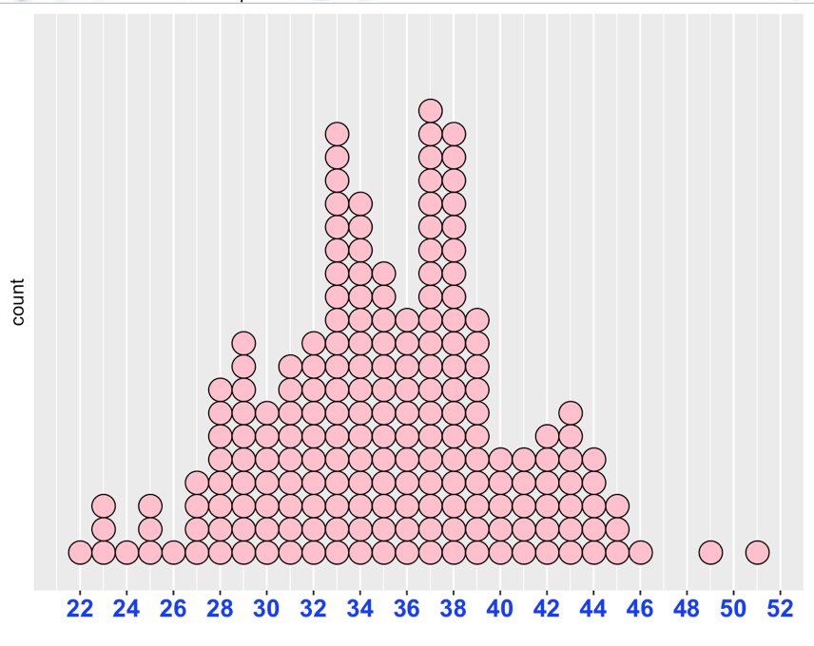

1. Hunchlab and Predpol are used for predictive _______________________

Northpointe is an algorithm for predictive _________________________

1. Describe a primary **advantage** of the algorithms noted in question 4, and a primary **disadvantage**.