# Class diagram

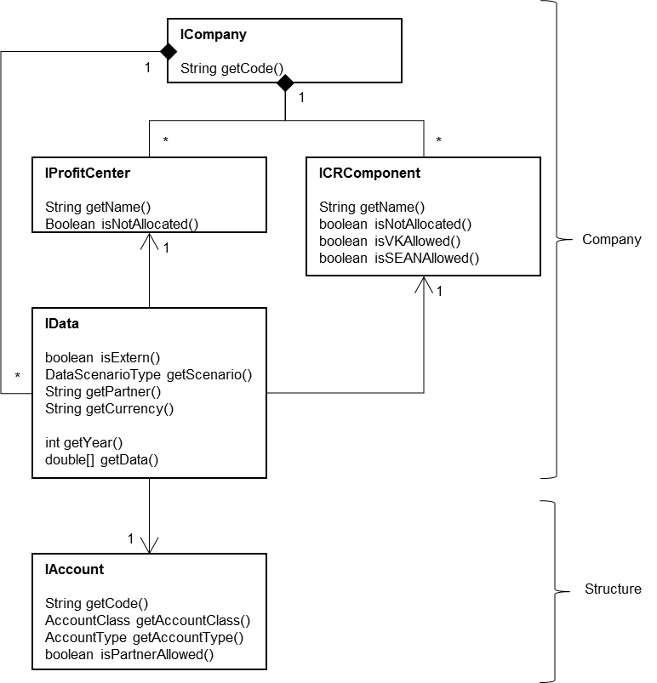

# Example

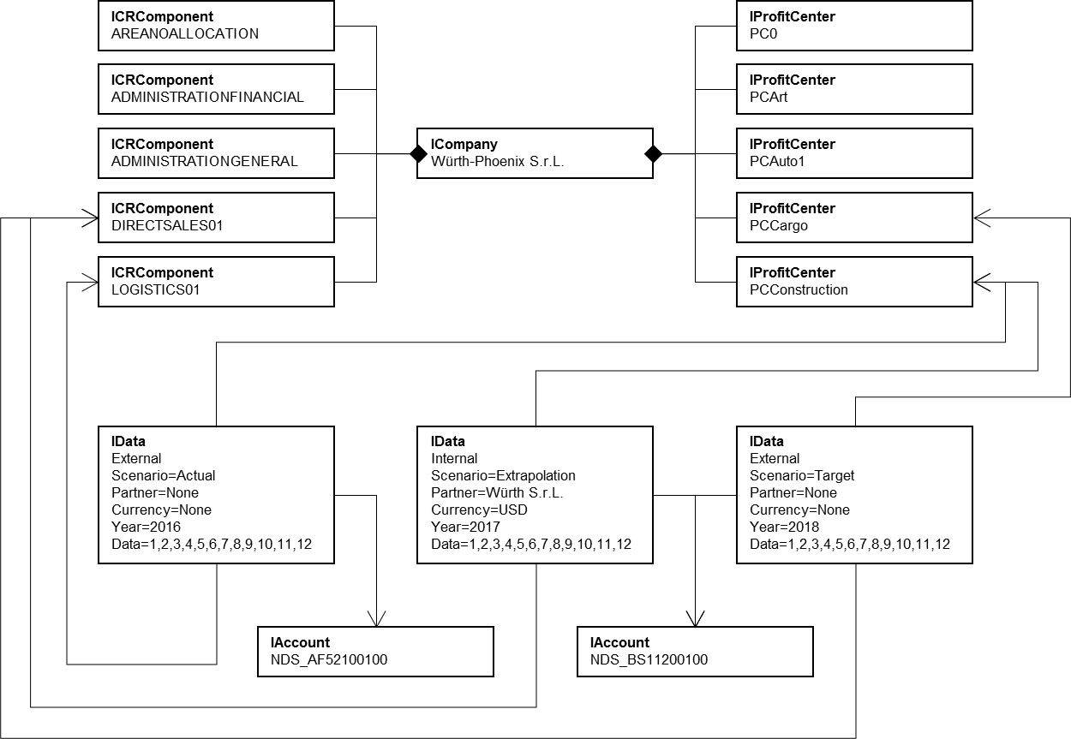

## ICompany

One legal entity of the Group

A company (ICompany) aggregates profit centers (IProfitCenter), c/r components (ICRComponent) and data (IData)

Attributes:

* Code: the code of the company, alphanumeric

## IProfitCenter

A business unit category of a company. Business units without category are set as ‘Not Allocated’

Attributes:

* Name: the name of the profit center, alphanumeric
* Not Allocated: true if not allocated, boolean

## ICRComponent

A cost/revenue category of a company. C/R components without category are set as ‘Not Allocated’

Attributes:

* Name: the name of the c/r component, alphanumeric
* Not allocated: true if ‘Not Allocated’, boolean
* VK allowed: accepts data associated to Account Type ‘VK’, boolean
* SEAN allowed: accepts data associated to Account Type ‘SEAN’, boolean

## IAccount

A reporting account like sales, number of orders, etc.

Attributes:

* Code: the code of the account, alphanumeric
* Account class: the class of the account, AccountClass
* Account type: the type of the account or nothing, AccountType
* Partner allowed: accepts data with Partner

## IData

The yearly data

A data (IData) is aggregated to a company (ICompany) and associated to a profit center (aggregated to the same company), to a c/r component (aggregated to the same company) and to an account (IAccount)

Attributes:

* Extern: External or Internal data, Boolean
* Scenario: the scenario of the data, DataScenarioType
* Partner: the code of the partner company or nothing, alphanumeric
* Currency: the code of the currency or nothing, alphanumeric
* Year: the year, int
* Data: the monthly data, double[12]

# Data types

## Account classes (AccountClass)

* Sales Reporting
* P/L Statement
* Allocation Formula
* Balance Sheet
* Logistics

## Account types (AccountType)

* Account class ‘Sales Reporting’
  + Branch Office
  + Special Analyses
  + Special Analyses – Number of Invoicing Days
  + Special Analyses – Service Degree
  + VK
  + SEAN
  + Employees
  + SML
  + SML – Gross Profit
  + SML – Potential
  + Customers
* Account class ‘P/L Statement’
  + Prognosis – Sales
  + Prognosis – Operating Result
  + Prognosis – Number of ADM - Month + 1
  + Prognosis – Number of ADM - Month + 2
  + Prognosis – Number of ADM – December
* Account class ‘Balance Sheet’
  + Asset Partner

## Scenario types (ScenarioType)

* Actual
* Deferral
* Extrapolation
* Target
* Plan

# Rules IData

## Account class ‘Allocation Formula’

### Scenario

Scenario type ‘Deferral’, ‘Extrapolation’ not valid

### Partner

No Partner

### Currency

No Currency

## Account class ‘Logistics’

### Profit Center

Only Profit Center ‘Not Allocated’

### C/R Component

Only C/R Component ‘Not Allocated’

### Internal/External

Only External

### Scenario

Only Scenario type ‘Actual’

### Partner

No Partner

### Currency

No Currency

## Account class ‘Sales Reporting’

### Profit Center

Account type ‘Branch Office’, ‘Special Analyses’, ‘VK’: only Profit Center ‘Not Allocated’

### C/R Component

Account type ‘VK’: C/R Component ‘Not Allocated’ or ‘VK Allowed’

Account type ‘SEAN’: C/R Component ‘Not Allocated’ or ‘SEAN Allowed’

Account type ‘Branch Office’, ‘Special Analyses’, ‘Employees’: only C/R Component ‘Not Allocated’

Account type ‘SML’, ‘Customer’: C/R Component ‘Not Allocated’ not valid

### Internal/External

Account type ‘Branch Office’, ‘Special Analyses’, ‘VK’: only External

### Scenario

Scenario type ‘Deferral’ valid only for Account type ‘Branch Office’

Scenario type ‘Extrapolation’, ‘Target’, ‘Plan’ valid for Account type ‘SEAN’, ‘Special Analyses’, ‘SML – Gross Profit’, ‘SML – Potential’

### Partner

No Partner

### Currency

No Currency

## Account class ‘P/L Statement’

### Profit Center

Account type ‘Prognosis*’ or Partner set: only Profit Center ‘Not Allocated’

### C/R Component

Account type ‘Prognosis*’ or Partner set: only C/R Component ‘Not Allocated’

### Internal/External

Account type ‘Prognosis*’ (Account type ‘Prognosis - Sales’ excluded): only External

Partner: only External

### Scenario

Account type ‘Prognosis*’ or Partner set: only Scenario type ‘Actual’

### Partner

Account type ‘Prognosis*’: no Partner

### Currency

Account type ‘Prognosis*’ or no Partner: no Currency

Partner: Currency mandatory

## Account class ‘Balance Sheet’

### Profit Center

Account type different from ‘Asset Partner’ and Partner set: only Profit Center ‘Not Allocated’

### C/R Component

Only C/R Component ‘Not Allocated’

### Internal/External

Only External

### Scenario

Account type different from ‘Asset Partner’ and Partner set: Scenario type ‘Deferral’ not valid

### Currency

Account type different from ‘Asset Partner’ and Partner set: Currency mandatory

No Currency in the other case