# Bioinformatics-
First repository

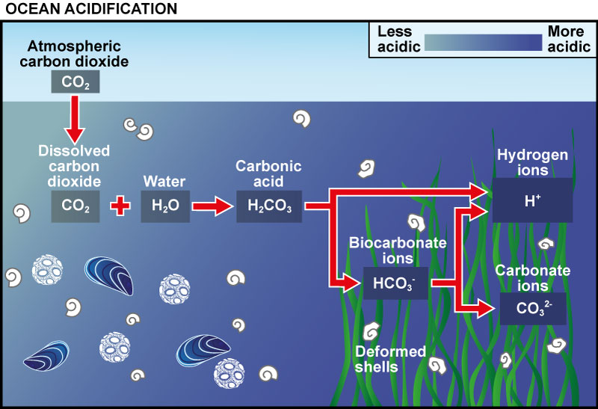
This was the first attempt for the project. In the image below we can observe a description of what is going on now in the oceans. The uptake of the atmospheric CO2 is increasing and all the chemical reactions are affecting the H+ ions content in the water. Thus, it is getting more acid.

