*App Name* Design Document

(image of logo)

Designed by:

Lucian Irsigler

Banzile Nhlebela

Laaiqah Bayat

Prashan Rajaratnam

Version:1.0

Date Created: x

Contents

1. Introduction 3

1.1 App Purpose and Usages 3

2. User Interface Design 4

2.1 Login Screen 4

2.2 Customer Screens 5

2.2.1. Profile 5

2.2.2. View Item List 6

2.2.3 View Product 8

2.2.4 Review Product 8

2.3 Seller Screens 9

2. 3.1 Adding Product 9

2.3.2 View Reviews 10

2.4 HELP Screen 13

2.4.1.FAQ WINDOW 13

3. Business Rules 15

4. Entity Relational Diagrams (ERD) 16

4.1 ERD 16

4.2 Implementation of ERD 17

4.3 Normalisation 17

# 1. Introduction

## 1.1 App Purpose and Usages

“AppName” is a user-friendly mobile marketplace designed for buyers and sellers to interact in a seamless manner. Our app will act as an intermediary between the two users by use of a multitude of different features.

As a buyer, you have access to the following features:

1. Create an account
2. Search for items
3. View items details in a sorted list
4. Review an item that you have purchased

As a seller, you have access to the following features:

1. Create an account
2. Post items and all their essential details
3. View how your customer’s have reviewed your products.

“AppName” offers a reliable and efficient mobile marketplace experience, promoting ease of access, security and seamless transactions between buyers and sellers.

# 2. User Interface Design

This section is will show exactly how the user interface will look and work as well as what is interactable on each screen.

## 2.1 Login Screen

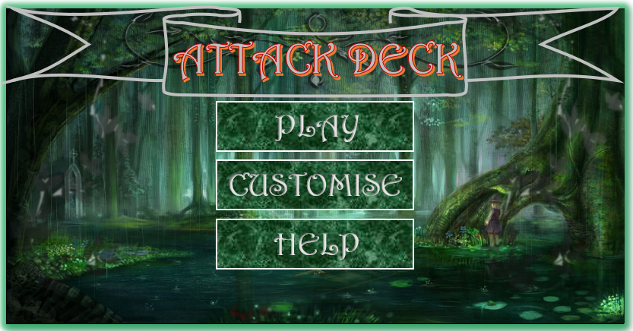

|  |  |  |  |
| --- | --- | --- | --- |
|  |  | Clickable? | Function and Description |
| 1 | TITLE | No | Displays the tile of the game in a legible font |
| 2 | PLAY BUTTON | Yes | A button with the text “PLAY” in a legible font. When clicked by user, opens the *Play Screen,* begins a new conflict and closes current screen. |
| 3 | CUSTOMISE BUTTON | Yes | A button with the text “CUSTOMISE” in a legible font. When clicked by user, opens the *Customise Screen* and closes current screen. |
| 4 | HELP BUTTON | Yes | A button with the text “HELP” in a legible font. When clicked by user, opens the *Help Screen* and closes current screen. |

## 2.2 Customer Screens

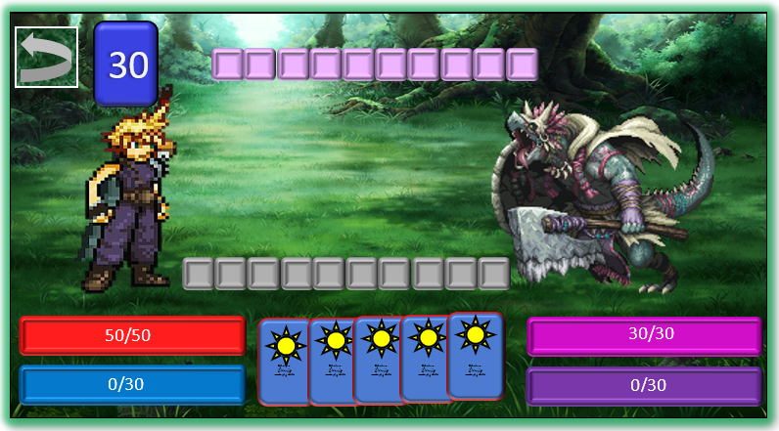

### 2.2.1. Profile

**VICTORY**

### 2.2.2. View Item List

**DEFEAT**

|  |  |  |  |
| --- | --- | --- | --- |
|  |  | Clickable? | Function and Description |
| 1 | Player Character sprite | No | An image that represent the player, standing confidently. There will be 3 Sprites, a neutral stance while the player decides what to do, an offensive stance for when the player attacks and an injured stance for when the player takes damage. |
| 2 | Enemy Character sprite | No | An image that represent the enemy, there will be multiple enemy types. There will be 3 Sprites, a neutral stance while the player decides what to do, an offensive stance for when the enemy attacks and an injured stance for when the enemy takes damage. |
| 3 | Player Health Bar | No | A red bar denoting the players current HP (Health Points) out of a total of 50. By default, the player starts at full health. The health will decrease when the player is struck on a loss equal to the amount of damage dealt by the enemy. Ideally the length of the bar would increase and decrease proportional to the numbers added or subtracted to the total where 0 is the minimum length and 50 is the maximum length. |

|  |  |  |  |
| --- | --- | --- | --- |
| 4 | Enemy Health Bar | No | A light purple bar denoting the enemies current HP (Health Points) out of a total (can be 20 0r 30). By default, the enemy starts at full health. The health will decrease when the enemy is struck on a loss equal to the amount of damage dealt by the player. Ideally the length of the bar would increase and decrease proportional to the numbers added or subtracted to the total where 0 is the minimum length and 20/30 is the maximum length. |
| 5 | Player AP Bar | No | A light blue bar that denotes the amount of AP (Action Points) the player currently has as a number out of 30. It will start by default as 0 and will increase by 5 per round won or 10 if the player achieves a critical win (view point 8 for more information) to a maximum of 30. Ideally the length of the bar would increase and decrease proportional to the numbers added or subtracted to the total where 0 is the minimum length and 30 is the maximum length. |
| 6 | Enemy AP Bar | No | A dark purple bar that denotes the amount of AP (Action Points) the enemy currently has as a number out of 30. It will start by default as 0 and will increase by 5 per round won or 10 if the enemy achieves a critical win (view point 9 for more information) to a maximum of 30. Ideally the length of the bar would increase and decrease proportional to the numbers added or subtracted to the total where 0 is the minimum length and 30 is the maximum length. |
| 7 | Dealer Deck | Yes | The back of a stack of cards with a number on it. The Dealer Deck contains 30 cards of which five cards have the value of 1, five cards have the value of 2, five cards have the value of 3, five cards have the value of 4, five cards have the value of 5, five cards have the value of 6. The number on the back of the button denotes how many cards are currently in the deck. When the player clicks the Dealer Deck, a randomly selected card will be drawn from the deck and its value(1-6) will be added to the Player Attack Gauge and 1 is subtracted from the number displayed on the back of the Deck, this action is called *Hitting*. When the number on the back of the Deck reaches 0, all 30 cards will be added again, and the number will reset to 0. There is also a Dealer Deck for the enemy, but its values are invisible to the player. |
| 8 | Player Attack Gauge | No | A grey bar divided into 10 blocks. When the player *Hits* and draws a card from their Dealer Deck, the cards value is added to the Attack Gauge; displayed by turning the corresponding amount of grey blocks orange from left to right.  e.g. If the player Hits and gets a 3, then 3 of the grey blocks will turn orange from left to right.  If the amount of orange blocks exceeds the enemy’s amount of red blocks, the player wins and deals damage equal to the difference in Attack Gauges. If the player *Hits* and manages to turn exactly 10 of the blocks orange (no more, no less) then they achieve a critical win, dealing 20 damage to the opponent and earning 10 AP. |

|  |  |  |  |
| --- | --- | --- | --- |
| 9 | Enemy Attack Gauge | No | A pinkish grey bar divided into 10 blocks. When the enemy *Hits* and draws a card from their Dealer Deck, the cards value is added to the Attack Gauge; displayed by turning the corresponding amount of pinkish grey blocks orange from right to left.  e.g. If the enemy Hits and gets a 3, then 3 of the pinkish grey blocks will turn red from right to left.  If the amount of red blocks exceeds the players amount of orange blocks, the enemy wins and deals damage equal to the difference in Attack Gauges. |
| 10 | Action Hand | Yes | 5 unique Action Cards (whose properties are expanded upon in the Customise Screen) that are only available to the player. When the Player hovers their mouse over each card, they will expand in size so that the player can read their effects. Upon clicking on one of the cards, the player will expend 5 AP and the effect of the chosen Action Card will be applied to the battle. |
| 11 | Return Button | Yes | An arrow in a block that when clicked by the player abandons the current conflict and returns to the Start Screen. |
| 12 | Victory Box | No | A Box with legible font that appears when the player reduces the enemy’s health to 0. |
| 13 | Defeat Box | No | A Box with legible font that appears when the enemy reduces the player’s health to 0. |

### 2.2.3 View Product

### 2.2.4 Review Product

## 2.3 Seller Screens

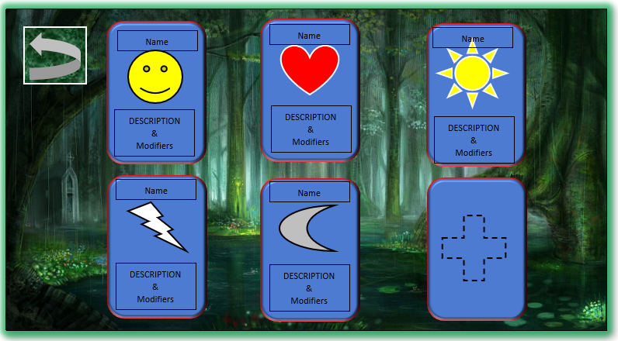

### 2. 3.1 Adding Product

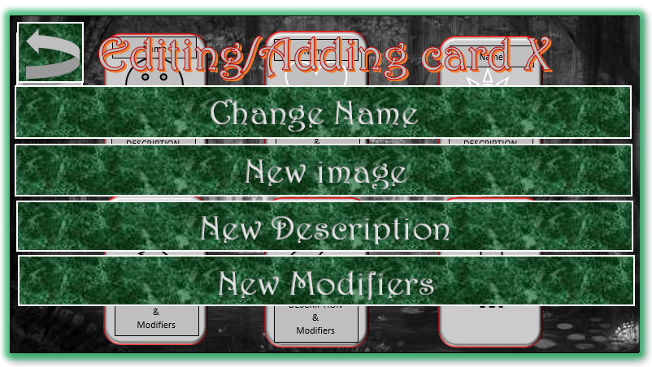

**DELETE CARD / Add Preset**

### 2.3.2 View Reviews

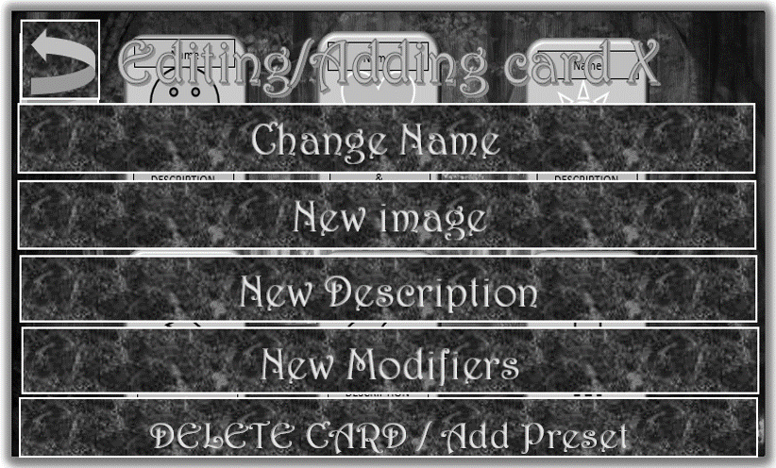

**WEAPON**

**EQUIPMENT**

**CONSUMABLE**

**If the card is a *Consumable*, its modifiers will read: Add/Subtract [number] from player’s/enemy’s Health Bar/AP Bar/attack Gauge**

**If the card is *Equipment*, its modifiers will read: Cause the Enemy to become unbalanced/stunned/weak**

**If the card is a *Weapon*, its modifiers will read: Deal [number] damage immediately and cause Enemy to start bleeding bleed/become poisoned/Nothing**

|  |  |  |  |
| --- | --- | --- | --- |
|  |  | Clickable? | Function and Description |
| 1 | Return Button | Yes | An arrow in a block that when clicked by the player abandons the current screen and returns to the Start Screen. |
| 2 | Action Card | Yes | A unique card with special characteristics that the player can use in combat. There are three types of Action cards: *Consumables, Equipment and Weapons* (More in point 5). 5 complete cards can be displayed at a time. When a player hovers their mouse over a card, they will expand in size so the player can read about it. If the player clicks on an Action Card, they will be taken to the editing screen. |
| 3 | Name of Card | No | Text displaying the name of the card |
| 4 | Picture of Card | No | An impressive picture that relates to the use of the card. |
| 5 | Description and Modifiers of Card | No | Text that firstly explains what the card **is** in the games fantasy lore. Secondly, the text explains what the card does.  If the card is a *Consumable*, its modifiers will read: Add/Subtract [number] from player’s/enemy’s Health Bar/AP Bar/attack Gauge  If the card is *Equipment*, its modifiers will read: Cause the Enemy to become unbalanced/stunned/weak  If the card is a *Weapon*, its modifiers will read: Deal [number] damage immediately and cause Enemy to start bleeding bleed/become poisoned/Nothing |
| 6 | Add new Card Button | Yes | A button in the shape of an Action Card but with a dotted plus + on its face. When clicked, the player will be taken to the Adding Screen |
| 7 | Editing / Adding heading | No | A heading that displays whether the player is on the Editing screen to edit an existing Action Card or the Adding screen to create a new Action card. |
| 8 | Change Name Button | Yes | A button that when clicked by the user, allows them to type a name to an Action card while Editing or Adding  If the player enters a name that already applies to another Action Card, an error message will be displayed and will ask them to enter a different name |
| 9 | New Image Button | Yes | A button that when clicked by the user, allows them to import an image for an Action card while Editing or Adding from their hardrive. |
| 10 | New Description Button | Yes | A button that when clicked by the user, allows them to type a description to an Action card while Editing or Adding |
| 11 | New Modifiers Button | Yes | A button that when clicked by the user, opens a Modifier Type Window that allows them to select a type of Action Card and then create new modifiers to an Action card while Editing or Adding according to a few presets (EXPANDED IN: 13-15) |
| 12 | DELETE/Add Preset | Yes | When Editing an existing card, a delete button is displayed that when clicked removes the card from the users Action hand  When Adding, a Add Preset button is displayed that when clicked allows the user to select a pre-existing Action Card from the games database.  If the player tries to add a new card when there are already 5 current cards, an error message will be displayed asking them to delete a card first. |
| 13 | Consumable Button | Yes | When clicked, opens the preset modifier text for Consumable Action cards |
| 14 | Equipment Button | Yes | When clicked, opens the preset modifier text for Equipment Action cards |
| 15 | Weapon Button | Yes | When clicked, opens the preset modifier text for Weapon Action cards |
| 16 | [Consumable/Equipment/Weapon] Modifier preset text | Clickable drop down boxes | Preset text relative to the type of Action card selected from the modifier type window with drop boxes that the user can use to select pieces of the sentence to create their modifier. |

## 2.4 HELP Screen

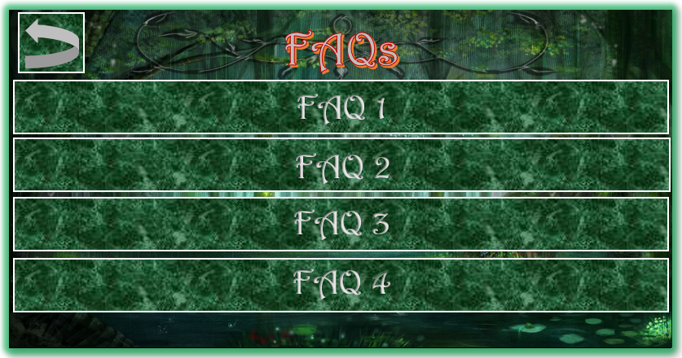

### 2.4.1.FAQ WINDOW

**Q: A frequently asked question about the game Attack Deck?**

**A: An Answer to the frequently asked question**

|  |  |  |  |
| --- | --- | --- | --- |
|  |  | Clickable? | Function and Description |
| 1 | Return Button | Yes | An arrow in a block that when clicked by the player abandons the current screen and returns to the Start Screen. |
| 2 | FAQ Heading | No | A heading that says “FAQs” in a legible font |
| 3 | FAQ 1 Button | Yes | A clickable button that leads to a corresponding FAQ window. Displays a frequently asked question. |
| 4 | FAQ 2 Button | Yes | A clickable button that leads to a corresponding FAQ window. Displays a frequently asked question. |
| 5 | FAQ 3 Button | Yes | A clickable button that leads to a corresponding FAQ window. Displays a frequently asked question. |
| 6 | FAQ 4 Button | Yes | A clickable button that leads to a corresponding FAQ window. Displays a frequently asked question. |
| 7 | FAQ Window | No | A window that pops up for a few seconds that displays the FAQ clicked by the user and it’s answer. |

# Business Rules

Our app will run based on the following business rules

User Account:

* Each user must have a unique account tied to a valid email address and username.
* Users must provide accurate and complete information when registering.
* On the administration end, we will assign the user an ID.
* Each user must have the following required attributes: user ID username, password, Salt, first name, last name, email, phone and address.

Products List:

* Sellers can list products that they have the rights to sell.
* Each product must have the following required attributes: a product ID (primary key), a user ID, name, description, price, category (foreign key to Categories table) and a dated added.

Reviews:

* Each review belongs to one product.
* A product may have a review with the option of multiple reviews from different buyers.
* Each review must have the following required attributes: a review ID (primary key), user ID (primary key as well as foreign key to Users table), product ID, the rating and a date.

Categories:

* Each product belongs to a category.
* Each category may have many products.
* The categories table has 1 required attribute which will act as the primary key and that is the category name.

# Entity Relational Diagrams (ERD)

## ERD

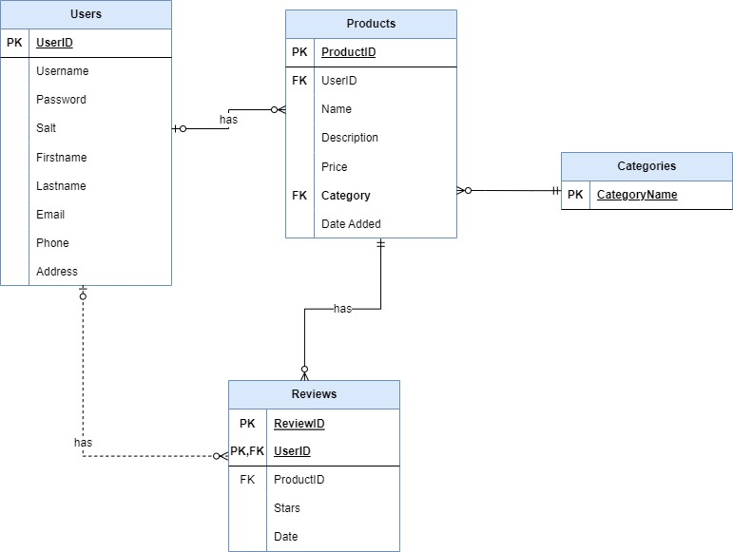

## Implementation of ERD

(remember to put data validation aspects into implementation)

Php for each table and corresponding inserIINTOproducts

Security stuff

## 4.3 Normalization