Individual Contribution Summary

Student: Nguyen Huyen Minh Nhat
Student ID: 105550225
Unit: COS40005 - Computing Technology Project A
Sprint 0: Weeks 1-6
Preparation & Submission: 21 October 2026
Team: Hanoi Group 5

Contents
1. Contribution Evidence and Impact 2
1.1. Research foundation and experimental approach 2
1.2. SCRUM-45 - Statistical methodology 2
1.3. SCRUM-49 - SQLite telemetry schema 2
1.4. Tests and quality assurance 2
1.5. Time records and contribution status 3
2. Teamwork, Communication and Professional Practice 4
3. Reflection, Learning and Continuous Improvement 6
4. Evidence and GitHub Traceability 6
Acknowledgment of Country 7

1. Contribution Evidence and Impact
My Data Science role in the preparation phase was to define how the project would measure investigation quality and capture the data needed for that comparison. I worked mainly on SCRUM-45 (statistical methodology) and SCRUM-49 (SQLite telemetry schema), while developing a research foundation for the three planned investigation modes.
Work item | My work | Evidence / outcome
Research foundation (W1-4) | Study context, end users, AI reliability, KOST, reproducible evaluation and ethical constraints. | Individual Research Report draft; research preparation.
SCRUM-45 | Specify IOC scoring, A/C comparison, B baseline and NIST AI RMF MEASURE mapping. | Assigned Jira issue marked Done; mentor meeting notes identify contribution.
SCRUM-49 | Design 10-table SQLite telemetry model and constraints for sessions and analyst actions. | Assigned Jira issue marked Done; client meeting notes identify 10 tables.
Local tests | Check scorer edge cases and relational constraints using Python unittest. | 7/7 passed on 21 October; local tests only.

1.1. Research foundation and experimental approach
Situation and task: We needed to compare human-only (A), AI-only (B) and human-with-AI (C) investigation without confusing speed with correctness. I was responsible for the Data Science perspective: what to measure, how to interpret the scores and what the study could realistically support.
Action: I worked through SOC user requirements, AI hallucination and automation-bias risks, research ethics, ground-truth requirements and reproducibility. My individual research draft also considered participant experience, order effects and the need to preserve a clear link between case evidence and reported findings.
Result and impact: The research helped shape a measurable evaluation plan and clarified what data the prototype would need to retain. It is preparation for a controlled study, not evidence that the planned participant experiments have already taken place.

1.2. SCRUM-45 - Statistical methodology
Situation and task: The team needed a defensible measurement scheme for investigation accuracy and efficiency before collecting results. Jira assigned me the task to define F1/Recall and align the measurement strategy with the NIST AI Risk Management Framework.
Action: I defined true positives, false positives and false negatives for scenario-approved indicators of compromise (IOCs), including how precision, recall and F1 should handle missing predictions. I considered investigation duration, root-cause correctness and unsupported AI claims as separate outcomes. For human comparisons I distinguished A versus C within-participant differences from the autonomous AI-only condition B, which cannot be treated as an additional human repeated-measures condition. I also described tracking incorrect AI suggestions that are actually displayed and remain in the final report, rather than using Accept clicks alone.
Result and impact: The method gives the team consistent scoring rules and makes later comparisons easier to reproduce and critique. The issue is Done in Jira, but final scenario ground truth, participant allocation and methodology sign-off still require group review.

1.3. SCRUM-49 - SQLite telemetry schema
Situation and task: Scoring and behavioural analysis require reliable logs of investigation sessions, decisions and final answers. My assigned task was to define the SQLite schema for clicks, timers and analyst actions.
Action: I prepared a 10-table design covering participants, scenarios, sessions, telemetry events, AI interactions, AI suggestions, exposures, decisions, final reports and report IOCs. The design applies keys, relational constraints, uniqueness and checks to reduce inconsistent data. For example, records should not attach AI interactions to a human-only session, and decisions should correspond to suggestions that were actually shown.
Result and impact: The proposed schema links measurement requirements to the React/FastAPI data contract and creates a baseline for later integration. The local database checks passed, but this is not yet a deployed or integrated data store. The team lead still needs to review the schema and event naming before backend integration.

1.4. Tests and quality assurance
On 21 October I reran the supplied evidence-package unittest command from the project root: python -m unittest discover -s tests -v. All seven tests passed in 0.029 seconds. The checks covered IOC scoring, empty predictions, foreign keys, Condition A restrictions, cross-session suggestion decisions, report IOC uniqueness and Condition B participant rules. This is evidence for the local test suite, not for a running end-to-end SOC Workbench.
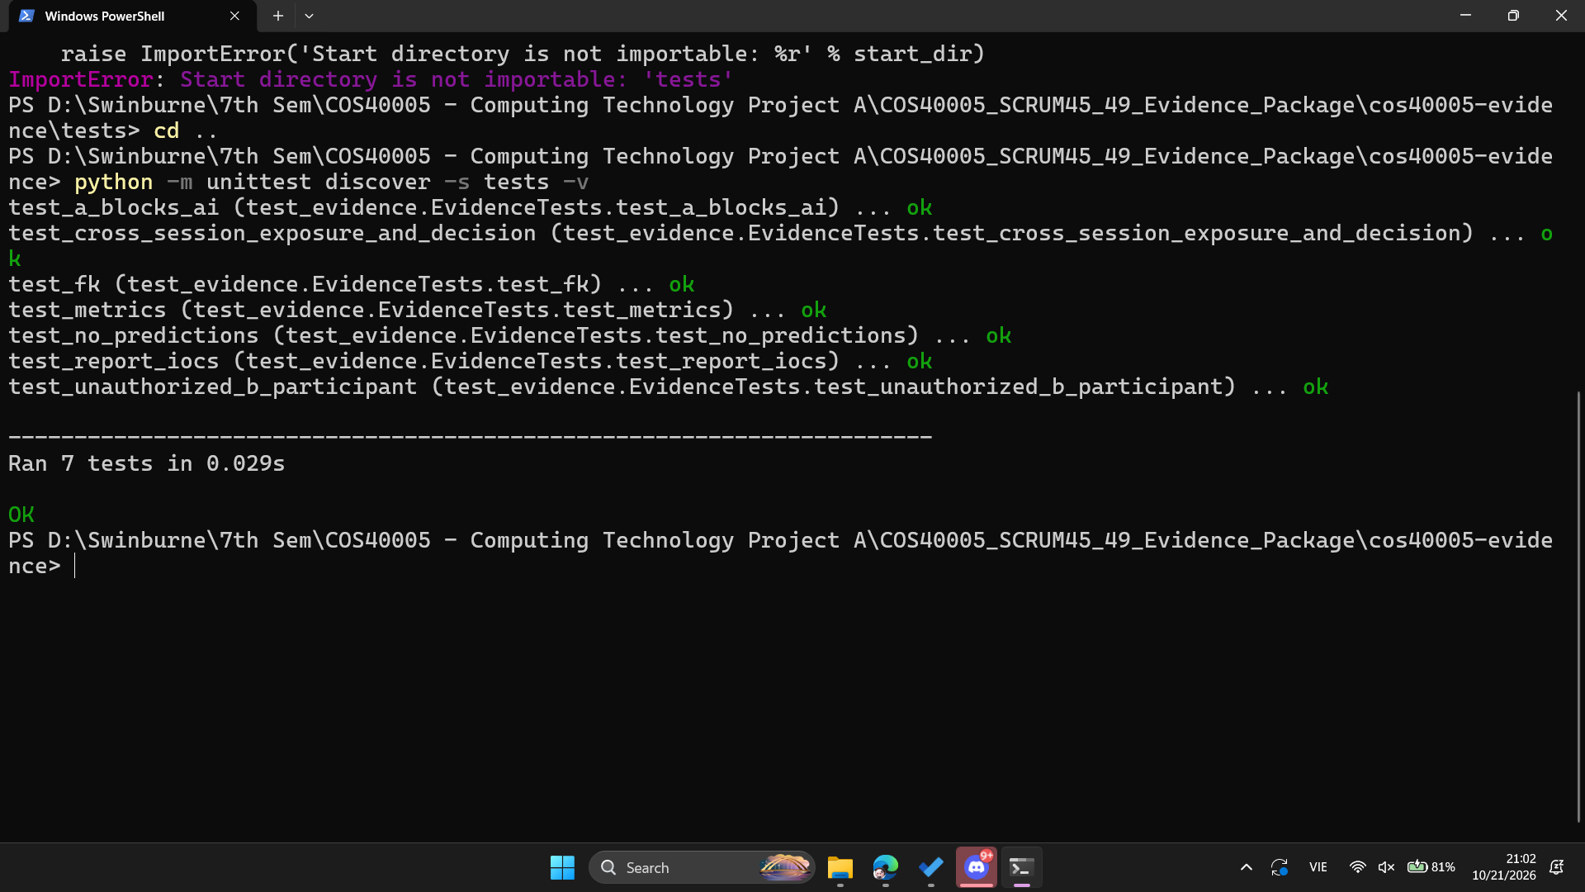
Fig. 1. Seven local Python unittest cases completed successfully on 21 October 2026.
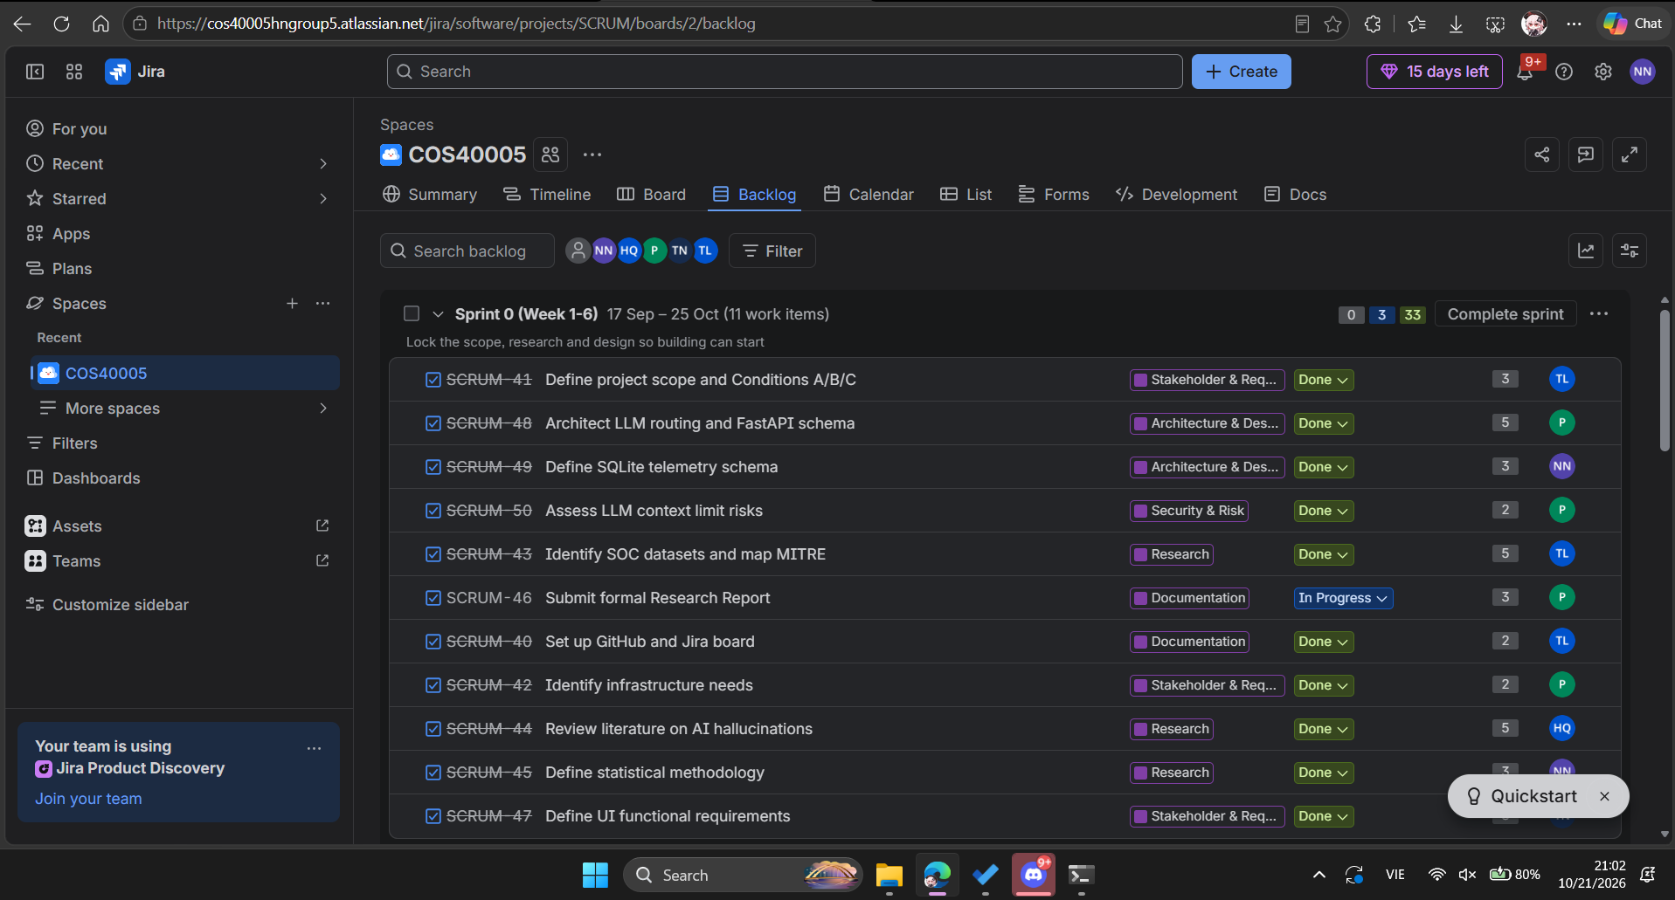
Fig. 2. Sprint 0 Jira backlog showing SCRUM-45 and SCRUM-49 marked Done.

1.5. Time records and contribution status
Jira issue | Recorded work start | Time spent | Task status
SCRUM-49 | 10 Oct 2026, 09:00 | 2h 32m | Done
SCRUM-45 | 12 Oct 2026, 20:00 | 1h 30m | Done
Total documented on Jira | Two entries | 4h 02m | Both Done
The Jira worklogs were entered on 21 October and retrospectively reference earlier work-start times. They document 4h 02m against these two tasks; they do not cover all possible research, meeting and preparation hours. I have kept the other activities separate rather than inventing an additional total.

2. Teamwork, Communication and Professional Practice
My work depended on other members: the cybersecurity role defines scenarios and ground-truth IOCs, while the UI and API roles need agreed telemetry event names and a consistent timing policy. This shaped how I proposed metrics and relational fields. Clear ownership of those dependencies will be important when the group starts integration.
In the 20 October client meeting, Robert Leyba reviewed the team's preparation. The notes identify my work under “Huyen”: SCRUM-45 (precision, recall, F1, investigation time and NIST alignment), SCRUM-49 (10-table telemetry schema) and seven passing local tests. The notes also state that both deliverables await team-lead review before backend integration. This is direct evidence that my work was included in the team review.
The group feedback was 86/100 - GREEN, with ratings of “Preparation 5, Progress 4, Evidence 4, Technical 5, Critical Thinking 4 and Communication 4”. This is a team-level assessment, not an individual score. Robert highlighted strong preparation and a sound research direction, while asking the group to combine the research, connect the front end and back end, and show one working scenario. I take that as useful feedback on what my design work must support next.
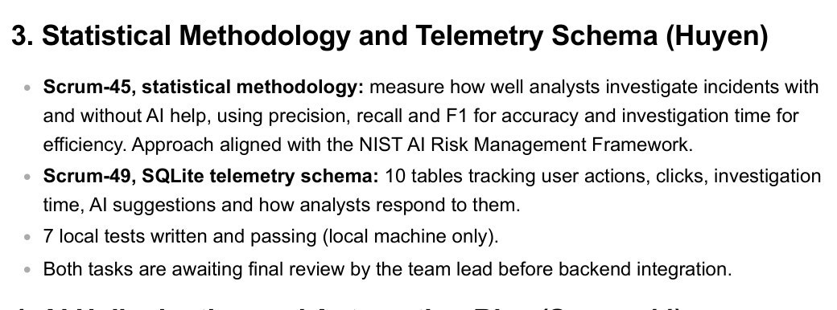
Fig. 3. 20 October meeting notes identifying the Data Science contribution as “Huyen”.
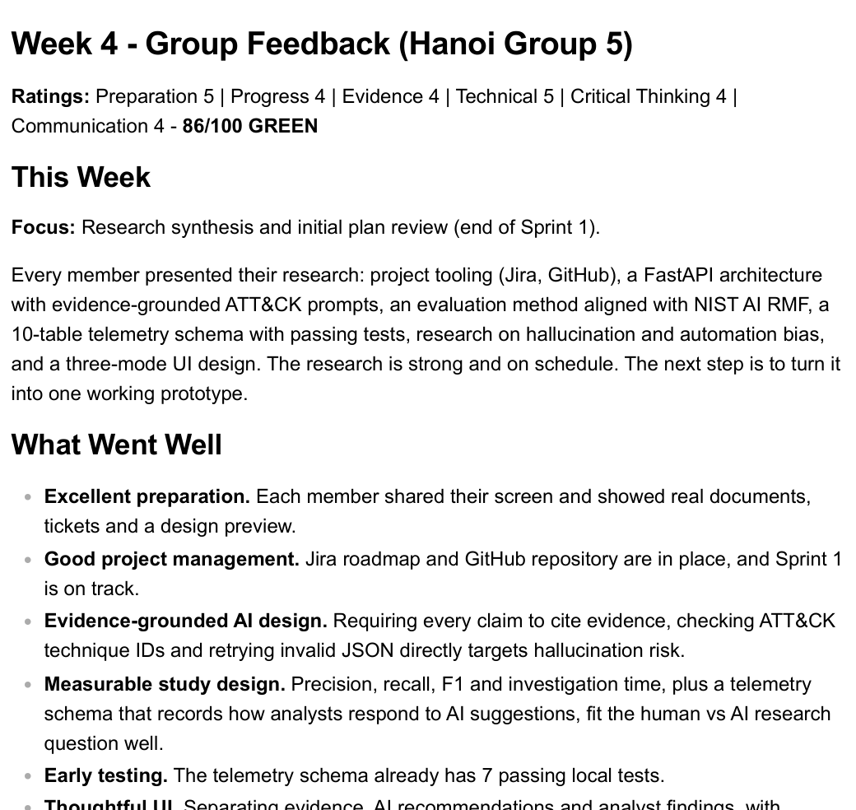
Fig. 4. Group feedback: measured study design and passing tests, alongside pending review and integration.

3. Reflection, Learning and Continuous Improvement
My main learning has been that data collection and metric definitions have to be designed together. A score such as F1 can be misleading if IOCs are not normalised consistently or if the ground truth changes between conditions. Likewise, a recorded Accept click is not enough to conclude that an analyst retained a false AI finding in the final report. The measurement rules need to be decided before seeing participant results.
A key limitation is the gap between local validation and integration. Seven passing tests are a useful checkpoint, but the prototype has not yet shown real telemetry flowing through the UI, API and database. For the next phase I need to review the shared event contract with the API/UI owners, test a complete synthetic investigation session and agree ground-truth conventions with the cybersecurity owner. I should also keep short task notes and commit technical work closer to the point it is completed, so my individual contribution is easier to trace.

4. Evidence and GitHub Traceability
Evidence | Where it comes from | What it demonstrates
E1 - Task ownership | SCRUM-45 and SCRUM-49 (Jira) | Assigned to me; both marked Done and worklogs recorded.
E2 - Test output | Python unittest screenshot, 21 Oct | 7 local tests passed; not integration tests.
E3 - Client meeting | Robert Leyba meeting notes, 20 Oct, p. 2 | My Data Science tasks and pending team-lead review.
E4 - Client feedback | Week 4 Group Feedback, 20 Oct, pp. 1-2 | Team-level 86/100 assessment and improvement priorities.
E5 - Methodology/design | Validated Evidence v1.0, Google Drive | Definitions, schema proposal and local validation summary.
The shared GitHub repository was still primarily a scaffold during Sprint 0. Uploading these report and evidence files on 21 October documents earlier research and local validation; the eventual upload commit date must not be represented as the original date of every contribution. The Git commit can substantiate the archival handover and file history, while Jira, dated evidence and meeting feedback substantiate the earlier work.

Jira: https://cos40005hngroup5.atlassian.net/browse/SCRUM-45 and /browse/SCRUM-49
Technical reference: https://docs.google.com/document/d/1wJrCf0XTEcXOwZwF4yXrc-fD07BKqIQ0Bc1d6kJImlY/edit
GitHub: https://github.com/lucianle1024/COS40005

Acknowledgment of Country
I acknowledge the Traditional Owners of the lands on which Swinburne University of Technology operates and pay respect to Elders past and present.
Review before submission: Confirm personal descriptions, any unlogged hours and compliance with the unit AI declaration requirements. Planned experiments, approval and integration are not claimed as completed.

