Setup information for Route 53 as a DNS secondary.

Goal:
To set up Route 53 standard DNS to act as a secondary DNS provider for Dynect's advanced DNS services platform in the case where policy requires a secondary DNS. Since Route 53 does not support things such as Active Failover, Global Sever Load Balancing, CDN Manager, DNSSEC, these advanced services will be mirrored down to Route 53 as a pool of standard records (for example if you have 6 IP addresses split between US East and US West in your Global Server Load Balancing (GSLB) Route 53 will get a pool of 6 A records only since this is all they support) which means you will lose the benefit of these services when a Route 53 serves a request, as such we would not recommend using Route 53 as a secondary server in these cases.

Pre-requisits:
    - Dynect account (or if you don't have one yet and want to give it a try, email demo@dyn.com and we'll hook you up!)

    - An Amazon Route 53 account.

    - An Ubuntu machine (though this will probably work on other linux flavors without a problem this example was tested on Ubuntu, actually on an Ubuntu EC2 image to be exact)
    - The following python libraries installed (most will be done in the normal python install, some of the ones I had to add I included the shell command I added them with):
      - socket
      - ConfigParser
      - dnspython (dns) - $ sudo apt-get install python-dnspython
      - httplib2 - $ sudo apt-get install python-httplib2
      - json
      - uuid
      - hashlib
      - hmac

Information to have before starting:
    - Dynect User name, Customer name and Password

    - Amazon Access Id and Secret Access Key (both available by logging into your Amazon account and viewing your credentials)

    - Any fqdns from Dynect that you want to be synced down to Route 53

    - The IP address of the server you will be running the scripts on

Setup:
    - Unzip all of the files from the github repo into a single directory (I created /home/myuser/route53)

    - Edit the install_dir in settings.py and the BASEPATH in install.sh to be the directory you wish to have the scripts run from

    - Edit the file dynect.cfg and fill in:
      - Dynect User name
      - Dynect Customer name
      - Dynect Password
      - Route 53 Access Id
      - Route 53 Secret Access Key
      - Lock Path (this is simply a writable folder when the application can create files used to make sure it doesn't try to sync the same fqdn concurrently)
      - Any fqdn's you wish to sync as a section header with the only parameter underneath the section being “sync : yes” to tell it to sync. It would look like this:
[mycoolsite.net]
sync : yes
[awesome.mycoolsite.net]
sync : yes
- Update any logging settings in the file you wish

    - Edit the file handle_notify.cfg and fill in:
    - update the notify_ip to add the ips to allow to send notifications (this is a comma separated list with no spaces). You can find these ip addresses in Dynect under your zone's “Zone Options”

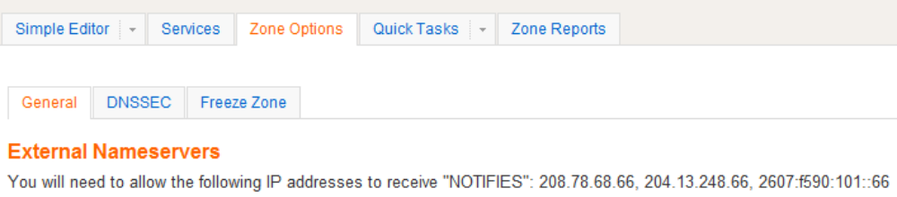

- update any logging settings you wish

    - Tell Dynect which server to send it's notify messages to. In Dynect go to your zone and under “Zone Options” enter the ip address of your server under Host 1 and check the “Notify This Host” check box (in the screen shot below 1.2.3.4 was used as the server ip of the Ubuntu machine where the scripts are running)

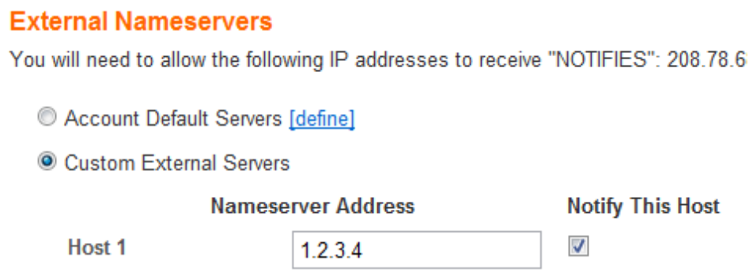

    - Install the scripts – At this point you have two options, run the install.sh which will perform the necessary steps and ask for your input when needed or manually perform each step (which many people want to do simply to know everything that is happening under the hood)

- If you do NOT run the install.sh script, do the following to install the files
- Create the directory /usr/local/route53
$ sudo mkdir /usr/local/route53

- Copy over each of the script and config files:
$ sudo cp handle_notify.py /usr/local/route53/handle_notify.py
$ sudo cp dynect.py /usr/local/route53/dynect.py)
$ sudo cp route53helper.py /usr/local/route53/route53helper.py
$ sudo cp sync_route53.py /usr/local/route53/sync_route53.py
$ sudo cp handle_notify.cfg /usr/local/route53/handle_notify.cfg
$ sudo cp dynect.cfg /usr/local/route53/dynect.cfg)

                - Now create an installed file so if the install.sh script is run it will know that all this has already been done:
$ sudo sh -c 'echo "installed" > /usr/local/route53/install.txt'

                - If you wish to have the sync occur on a timed basis, add the cron job for it (replace minutes/hours/days with the time to loop or an asterisk, for example if you want to check every hour and a half you would replace minutes with 30 and hours with 1 making the line “sudo echo "*/30 */1 * * * /usr/local/route53/sync_route53.py" >> tempcronfile”):
$ crontab -l > tempcronfile
$ sudo echo "*/minutes */hours */days * * /usr/local/route53/sync_route53.py" >> tempcronfile
$ crontab tempcronfile
$ rm tempcronfile

                - If you want to reply to the Dynect notify requests, run the following:
$ sudo python /usr/local/route53/handle_notify.py

That is it! You now have a Secondary DNS server through Route 53 for your Dynect DNS master!

