# Sample inspection application – User documentation

Table of Contents

Sample inspection application – User documentation 1

History of modifications 1

Initial assumptions 1

Connecting to the application 1

Basic interface 2

Noticeable differences 3

## History of modifications

|  |  |  |
| --- | --- | --- |
| Date | Name | Comment |
| 04/28/2016 | Luciano Jardim | Created |

## Initial assumptions

This document assumes that the operator knows how to operate a web application, knows how to use a web browser, knows how to click on buttons, enter data in text boxes, and choose an option in a dropdown list.

## Connecting to the application

* The application can executed using a web browser. IE 11 or better, and the latest version of Chrome are supported
* To connect to the test site use the following URI, <http://qa-sampleinspection.hearthnhome.com/>, or, to connect to production use <http://sampleinspection.hearthnhome.com/>.
* The site was created with Windows authentication enabled. Enter your network userid and password as in the example below (the window will vary depending on the browser):
  + 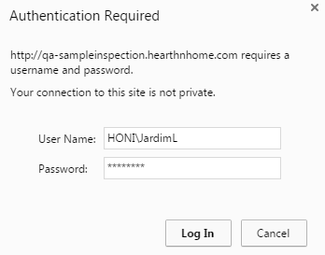
  + Tip: allow the browser to save the password, depending on the browser, either click on the check box that says “Remember my credentials” or accept the browser’s offer to save it for you.
* The user interface is better experienced when using a larger monitor (24”).

## Basic interface

* The navigation bar (navbar) allows access to all options available to users.
  + 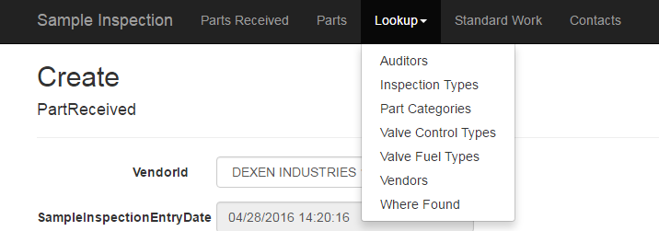
* Each component that has data of its own: Parts Received, Parts, Auditors, Inspection Types, Valve Fuel Types, Vendors, and Where found have a similar interface that allows users to update the data. Basic operations for each component are: Index, Create, Edit, Details, and Delete.
  + Index
    - Lists data and allow access to other functions:
    - 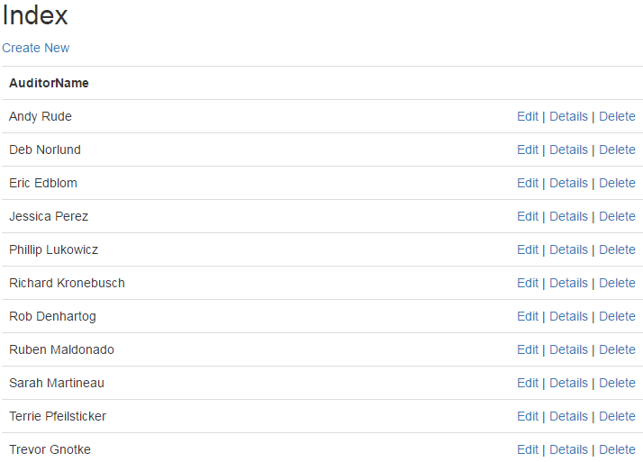
  + Create
    - Allows new data to be entered in the database
    - 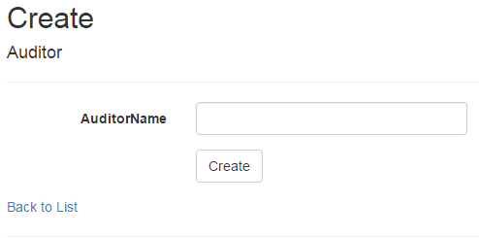
    - Enter the data in the fields of the screen and click on the Create button to have the data added to the database.
  + Details
    - Displays one line of data
    - 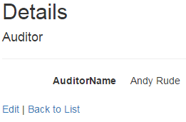
  + Delete
    - Allow data to be deleted from the database
    - 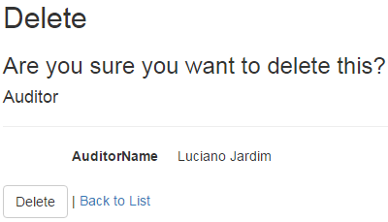
      * You have to click on the Delete button to confirm the operation, and delete the data.
    - If the data cannot be used for any reason, the system will display a message like to one below:
    - 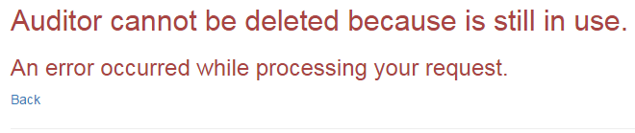

## Noticeable differences

* Sample Inspection
  + It is the default screen of the application, displayed when the application is first executed. It displays the Create screen for PartReceived.
  + It allows the user to create a new PartReceiveds, a part that will have its tests recorded.
  + Depending on the part number and vendor combination selected, the user will be taken to record the results of a specific part category if the button “Edit Part Received Specific Data” is clicked, e.g., if part number 2155-501 sold by Dexen is selected, the user will enter test results for valves because 2155-501 sold by Dexen is a valve. See the screen below:
  + 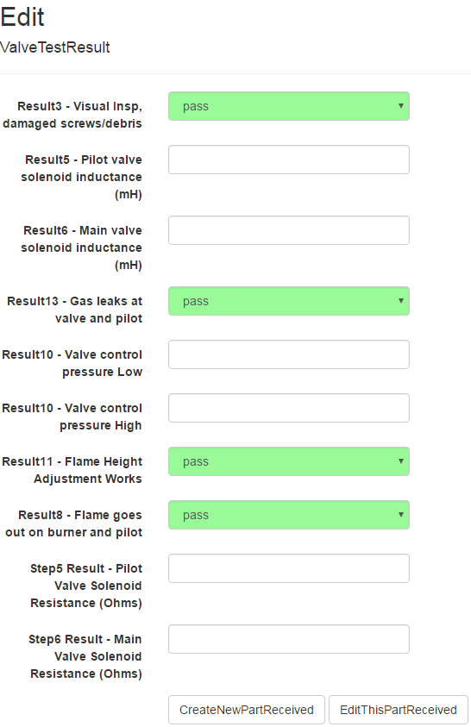
  + Notice that this scree has two buttons. The first “CreateNewPartReceived” will take you to enter a new Part Received. The second “EditThisPartReceived” will allow you to continue editing the same Part Received that is being displayed.
* Parts
  + Part is connected to the specific part category determined by the part number and part category that was entered.
  + For instance, let suppose that a valve with part number 750-501 needs to be modified, and the operator asks to Edit that part number. The screen below is displayed:
  + 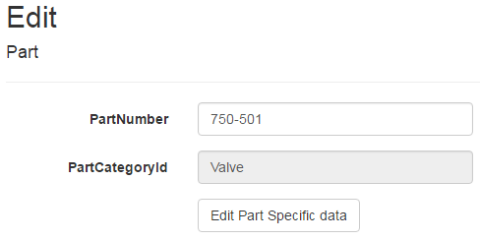
  + Notice that there is a button called “Edit Part Specific data”, if the operator clicks on this button, the data specific to this valve is display, as such:
  + 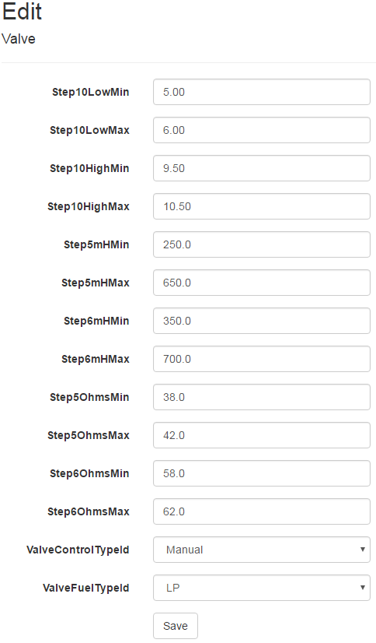
* Standard Work
  + Option in the navbar that allows you to have access to instructions on how to test parts.
* Contacts
  + Option in the navbar with people that could be contacted if support is necessary.