CMPT 743 – Assignment 1
Spring 2020
Luciano Oliveira
Student # 301393900

Image Segmentation

• Report your resulting segmentations of the test images.
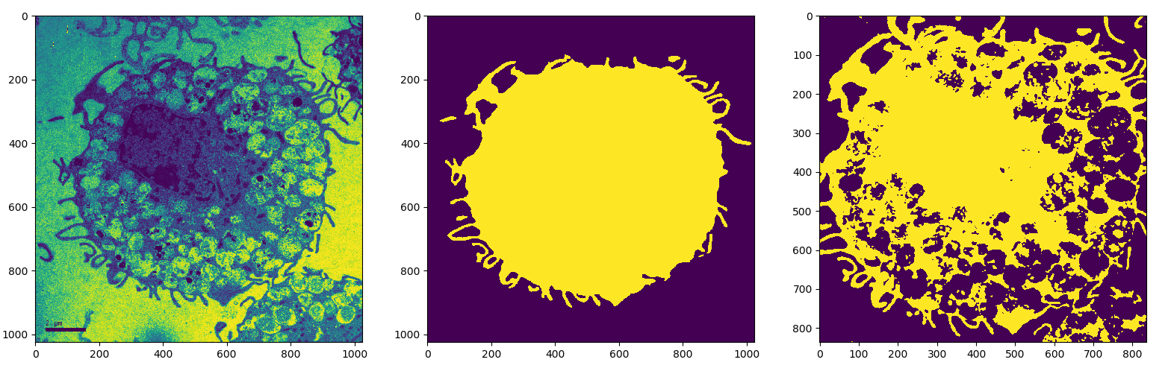
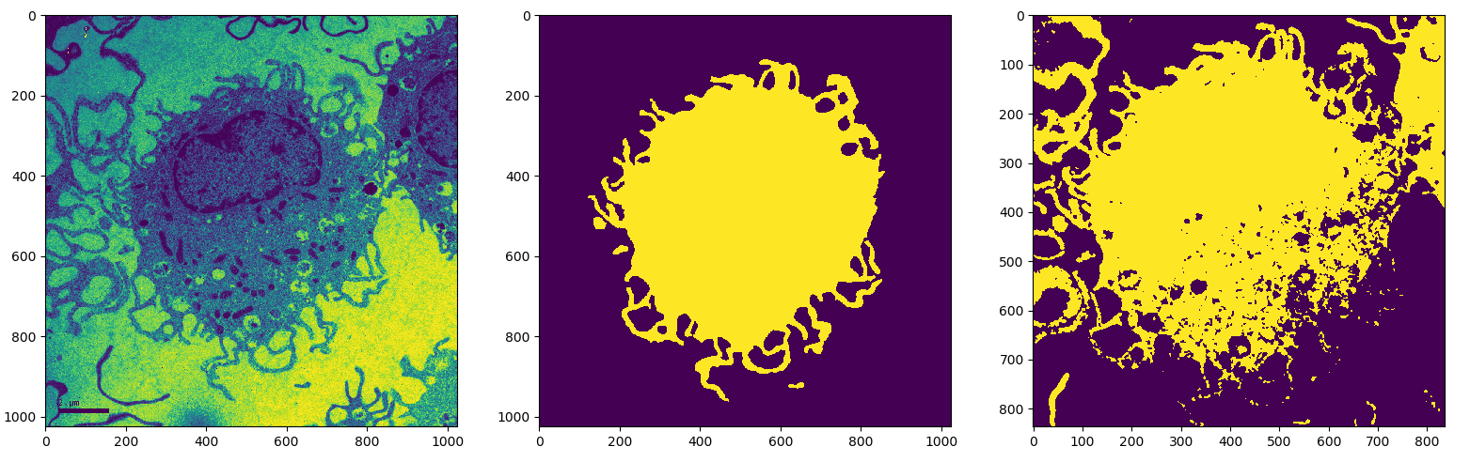
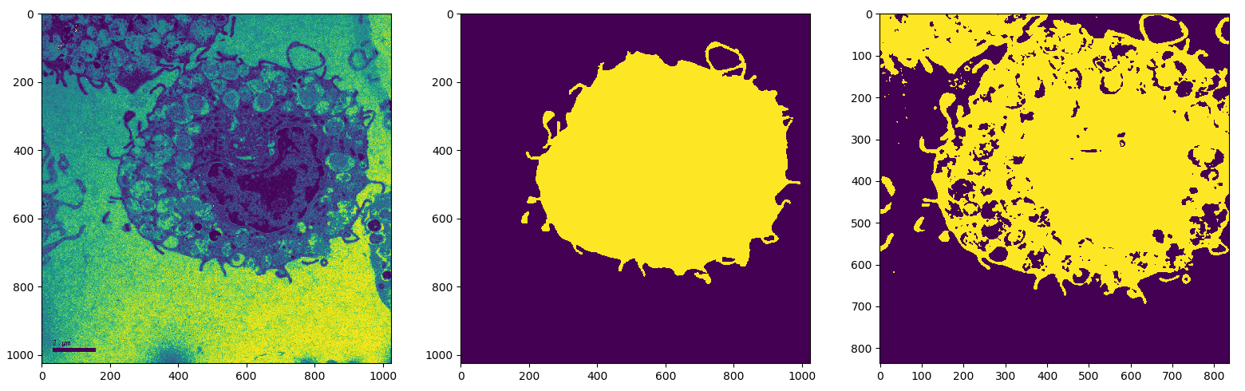
• How big was the size of the images you trained the network on?
In the dataloader.py, I resized them to 512x512 for training (which is exactly half the size of the original image). But for testing, I kept the full sized image.

• Did you train your network on GPU or CPU?
I trained on both, but my final output was on GPU.

• Which data augmentation strategies did you use?
I used histogram equalization to normalize all images (in order to achieve better results since some images are much brighter than others).
For augmentation, I used horizontal flipping, rotation, and gamma correction.

• Did you deviate from the original network structure?
Yes, I added batch_normalization because I was only getting blank results before that.
And I also added sigmoid for the last output of the model. I realized it made my results more consistent.

• How many epochs did you train?
I trained for only 3 epochs because the model converged fast.

• How long did your training take?
13 minutes.

UNet: Implementation on Atlas 200 DK


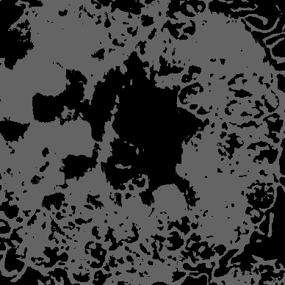
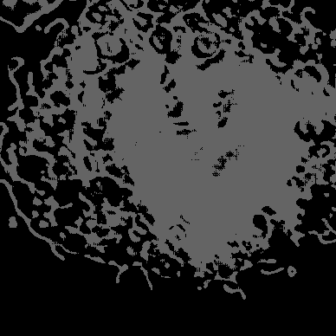

aipp_op {
aipp_mode: static
input_format : YUV420SP_U8
csc_switch : true
rbuv_swap_switch : true
matrix_r0c0 : 256
matrix_r0c1 : 0
matrix_r0c2 : 0
matrix_r1c0 : 0
matrix_r1c1 : 0
matrix_r1c2 : 0
matrix_r2c0 : 0
matrix_r2c1 : 0
matrix_r2c2 : 0
input_bias_0 : 0
input_bias_1 : 0
input_bias_2 : 0
src_image_size_w :640
src_image_size_h :576

crop :true
load_start_pos_w : 34
load_start_pos_h : 2
crop_size_w :572
crop_size_h :572

var_reci_chn_0: 0.0039
var_reci_chn_1: 0.0039
var_reci_chn_2: 0.0039
}

Bonus: Image Inpainting

  0001_train_gt |   0001_train_in |   0001_train_out |   0001_test_gt |   0001_test_in |   0001_test_out
  0005_train_gt |   0005_train_in |   0005_train_out | 0005_test_gt |   0005_test_in |   0005_test_out
  0010_train_gt |   0010_train_in |   0010_train_out | 0010_test_gt |   0010_test_in |   0010_test_out
  0050_train_gt |   0050_train_in |   0050_train_out | 0050_test_gt |   0050_test_in |   0050_test_out

  0100_train_gt |   0100_train_in |   0100_train_out | 0100_test_gt |   0100_test_in |   0100_test_out

