**Sales Engineer – Exercise Answers**

Following the questions on <https://github.com/DataDog/hiring-engineers/>

*I did my own way over here...*

* Host: Centos 7 as a VM on Virtual Box
* DD-agent installed using the single command for Centos
* Apache HTTPD installed and hosting a simple App in JS Node. (Datadog integration enabled)
* Tomcat also has been installed hosting a single HTML PAGE listening on port 8080 (Datadog is monitoring as well)
* Docker service has been installed and being monitored by Datadog integration as well.

Below the screenshots for each monitored service mentioned above:

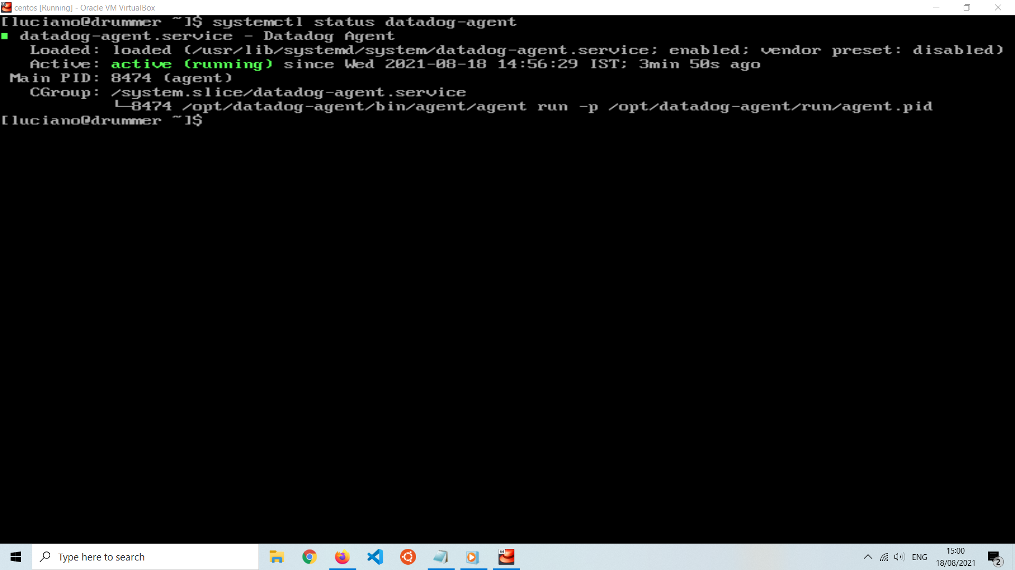

Datadog agent installed and running

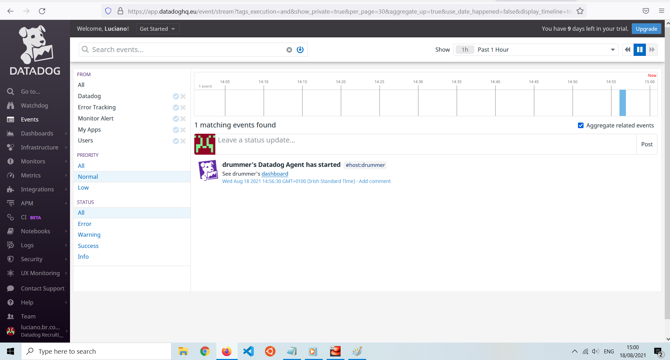

Confirmed installation on Datadog GUI (Web Console)

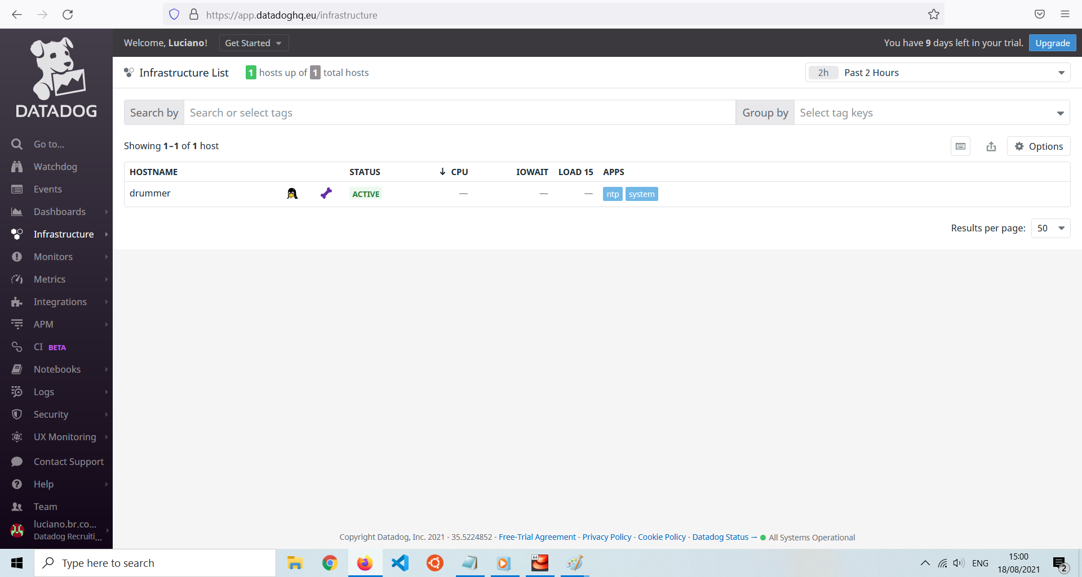

TAG

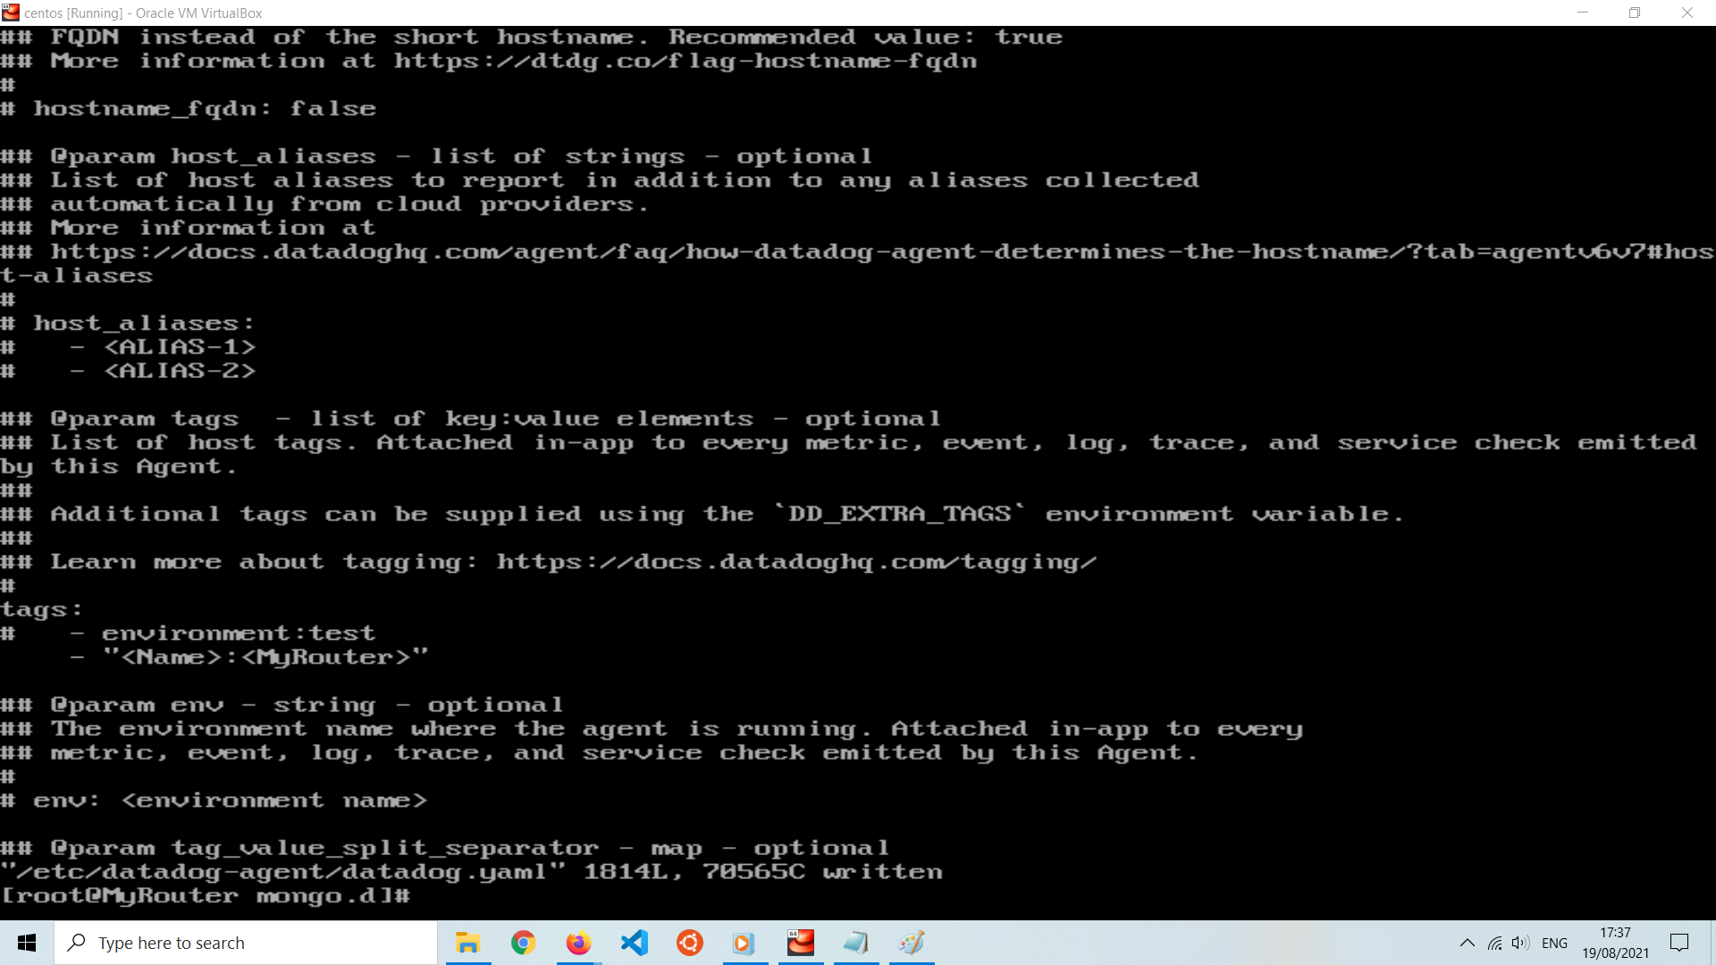

**APACHE HTTP has installed and hosting a web App on /var/www/html directory**

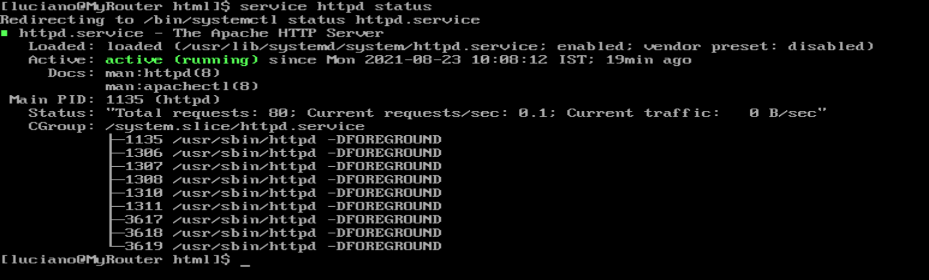

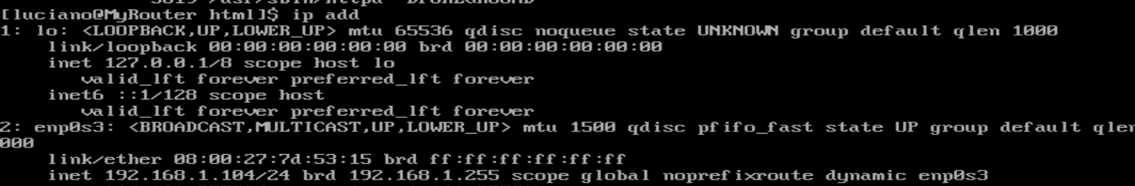

Datadog Apache metrics Enabled

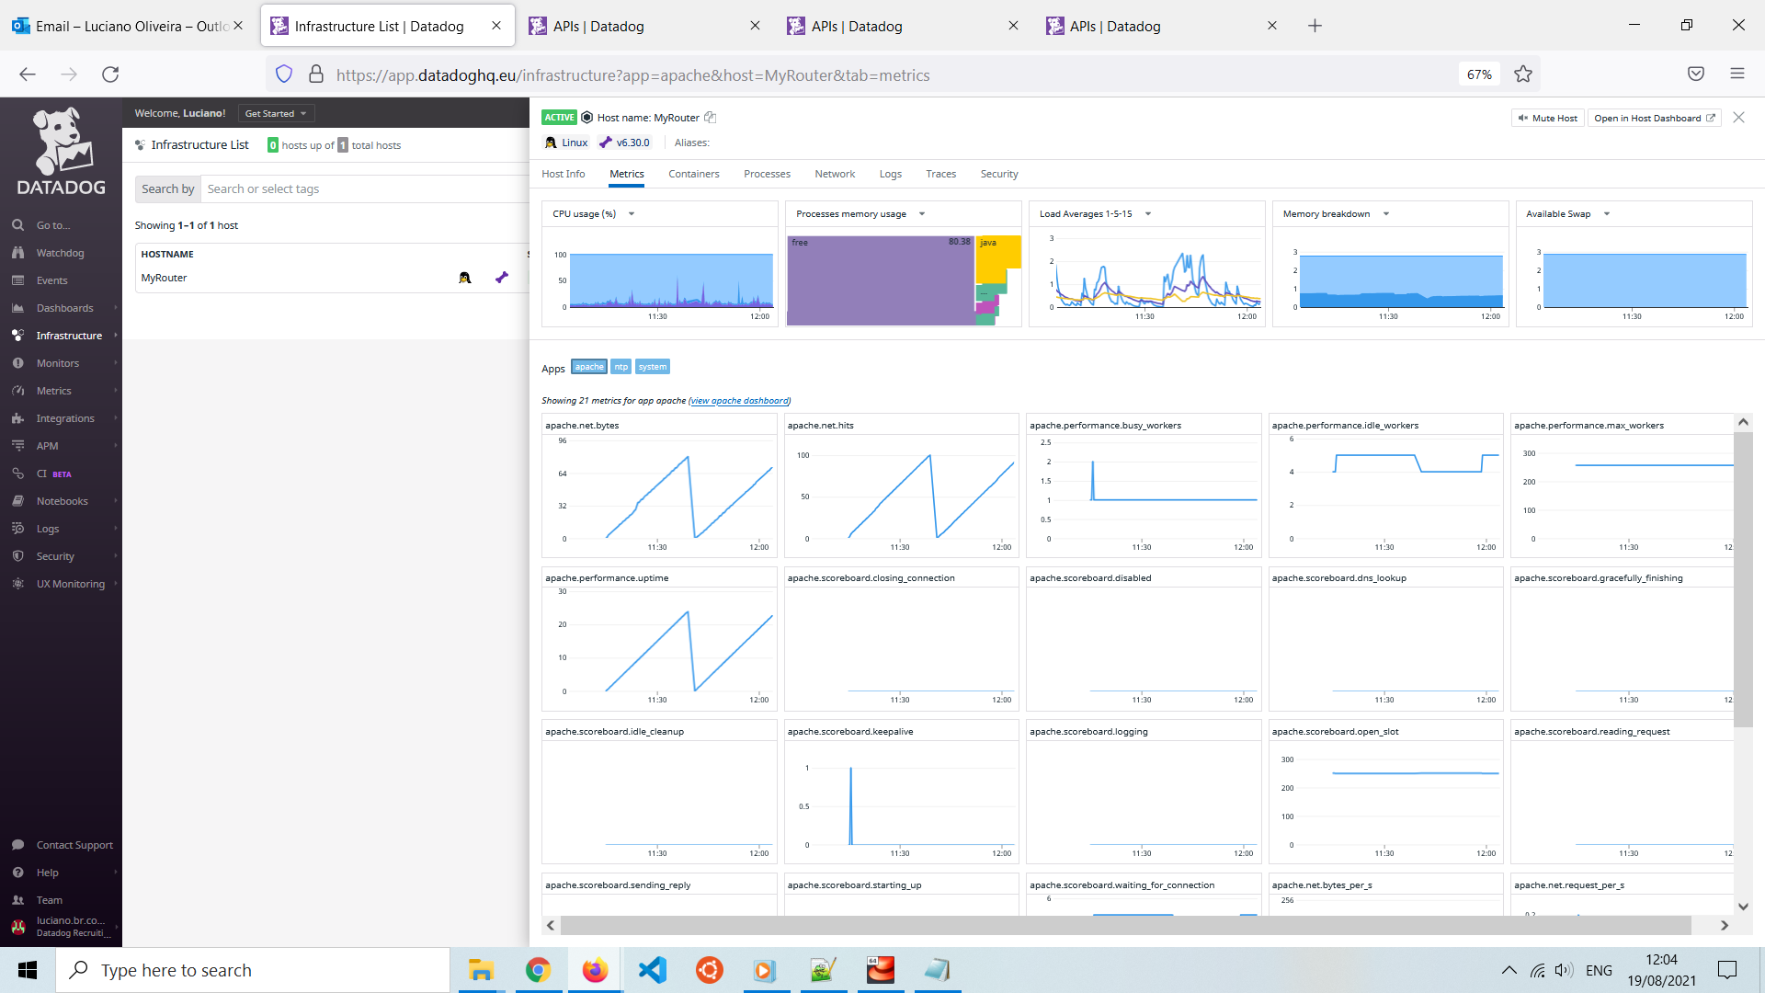

**Tomcat metrics integration enabled**

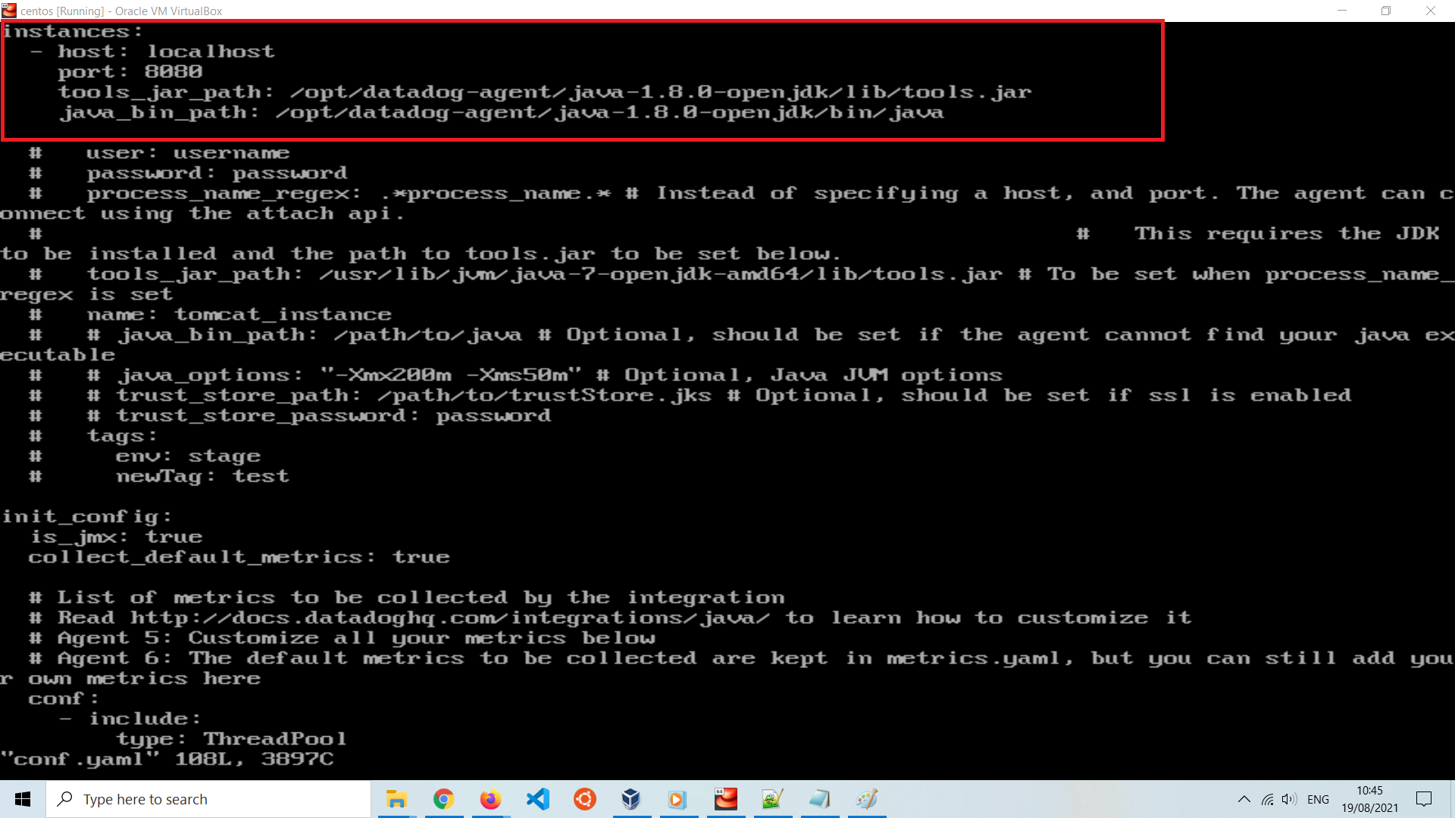

Tomcat.d/conf.yaml JVM enabled listening on port 8080

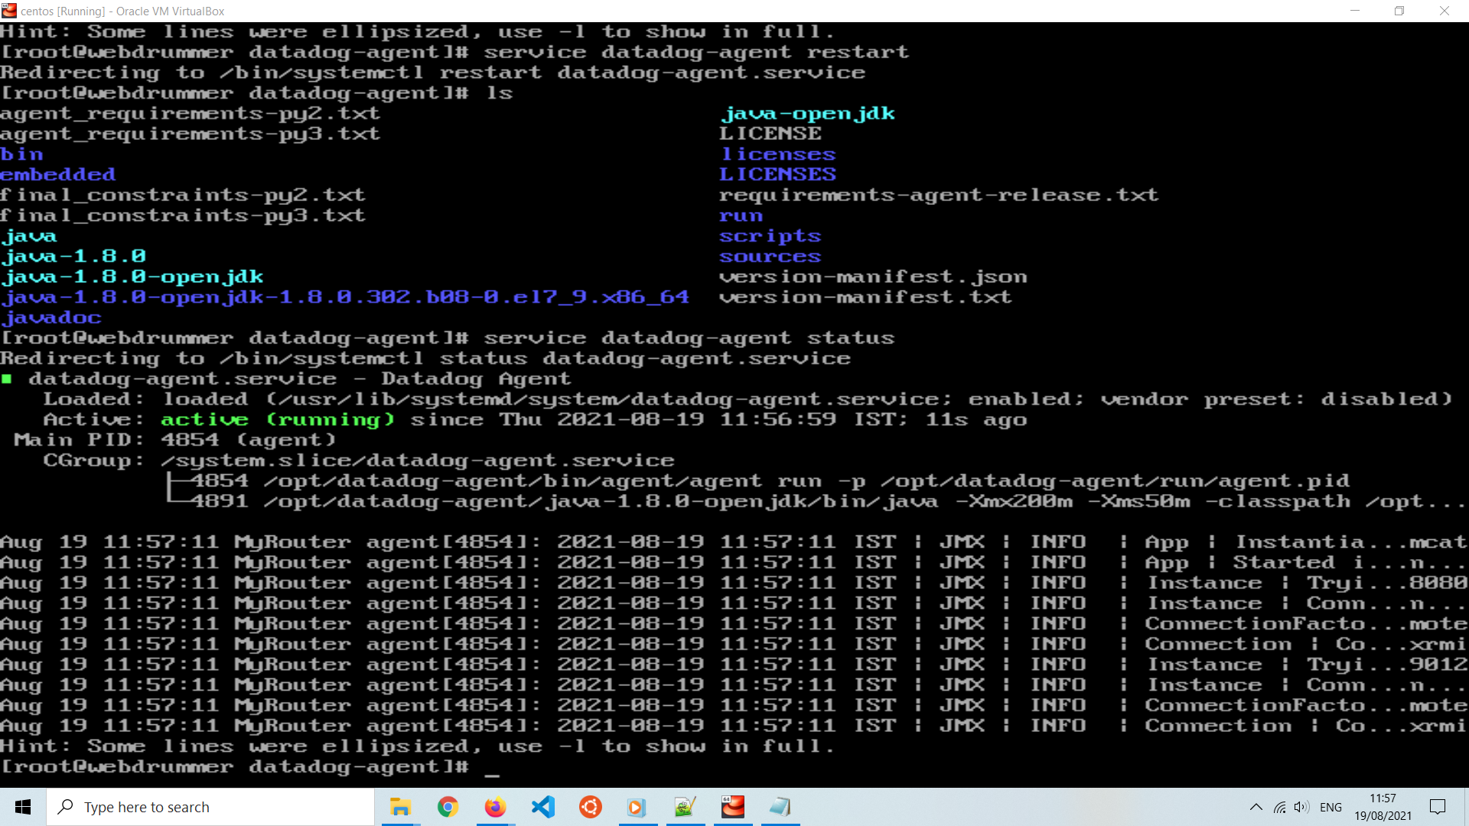

Output of agent restart after tomcat integration enabled

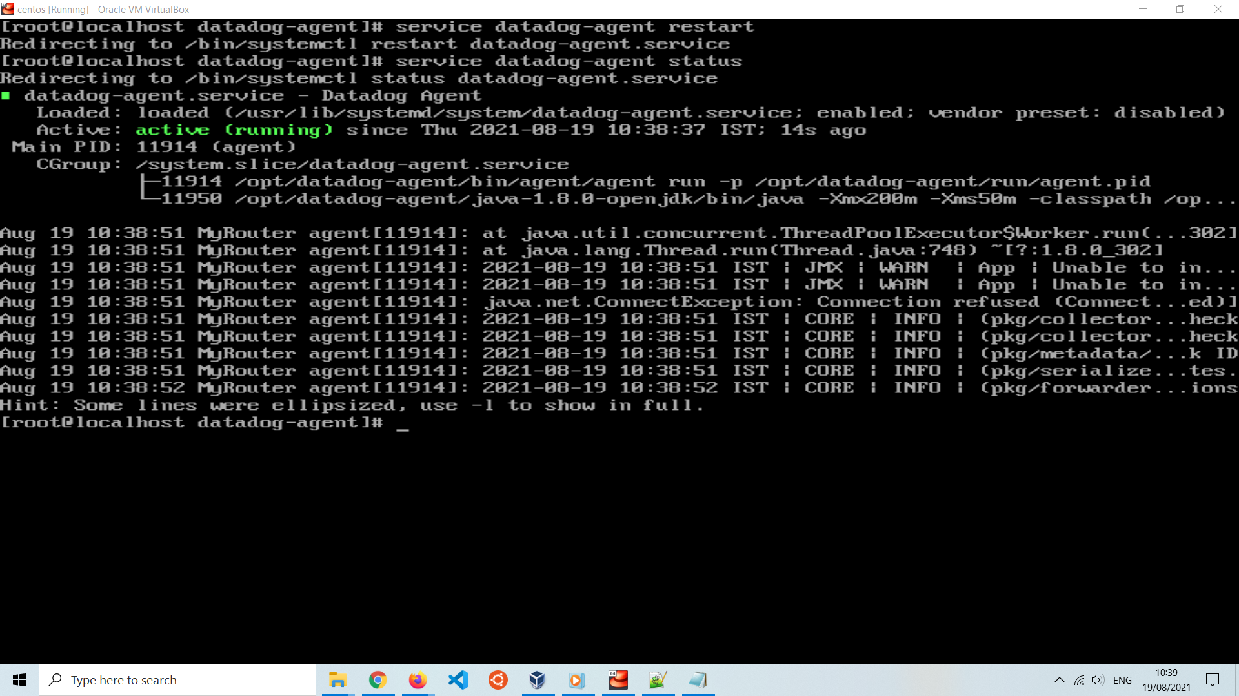

Datadog web GUI console showing tomcat metrics results

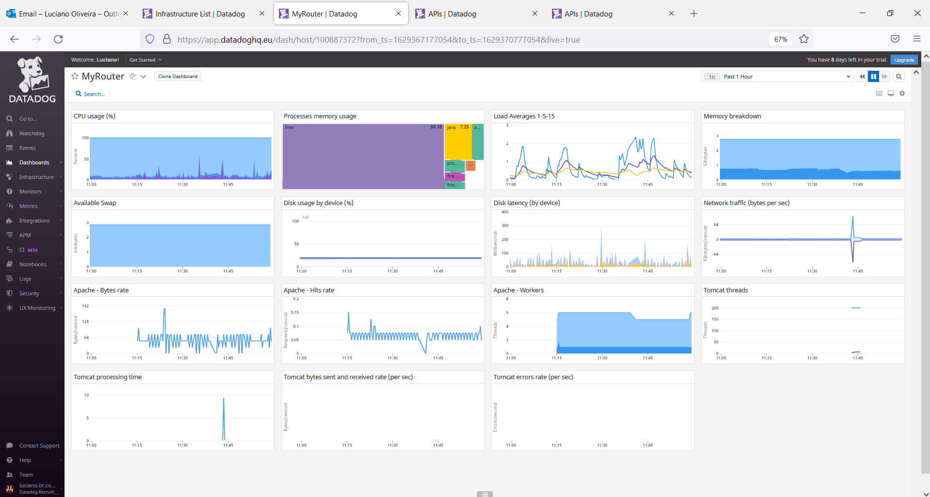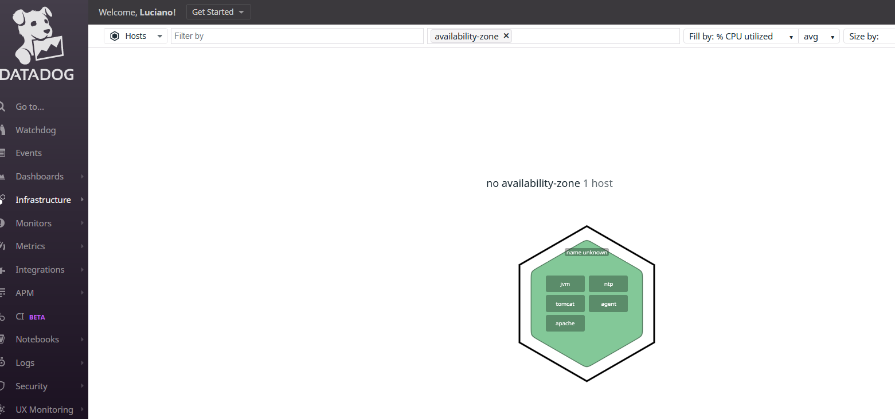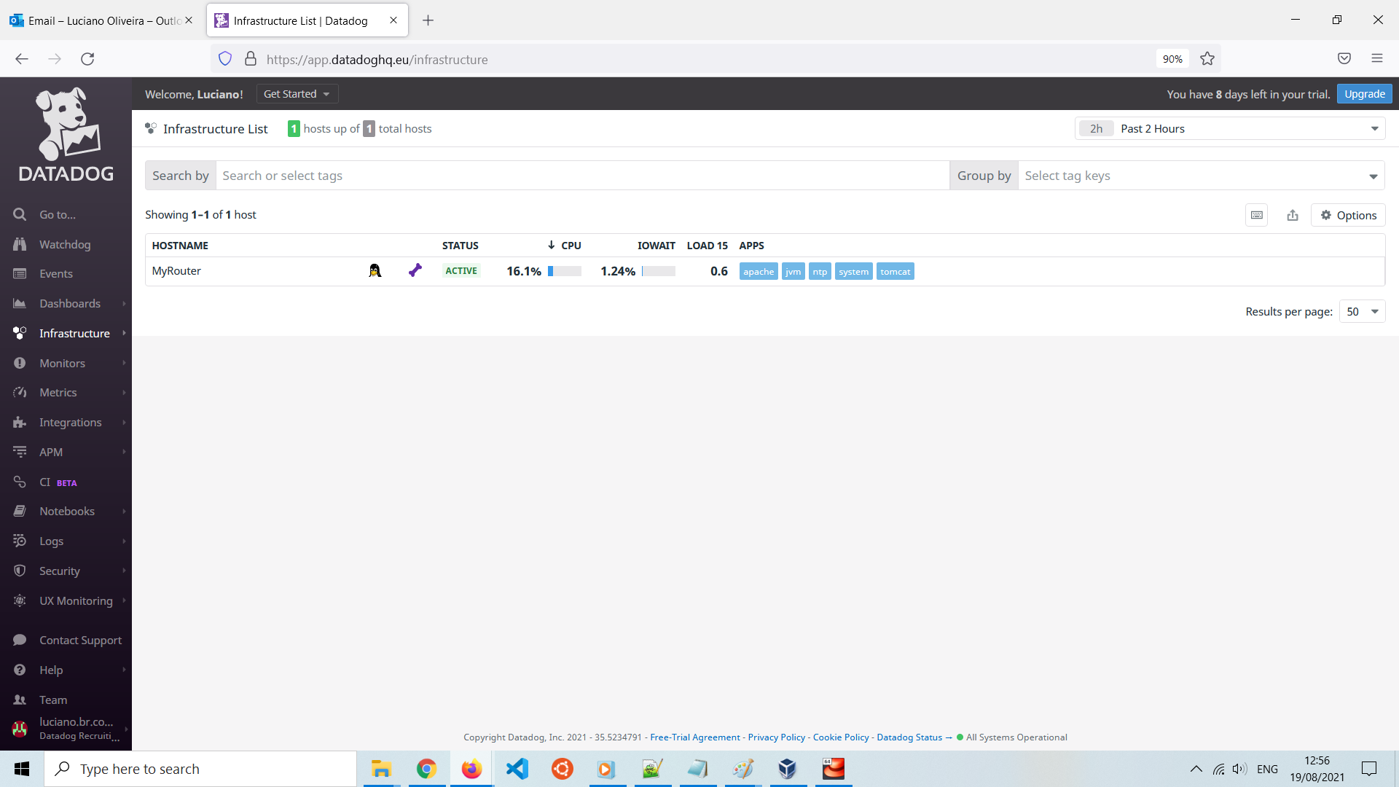

Docker service running on host and Datadog integration enabled

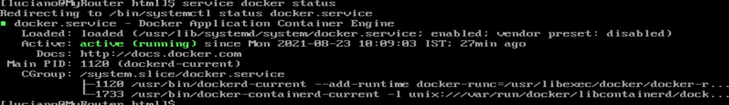

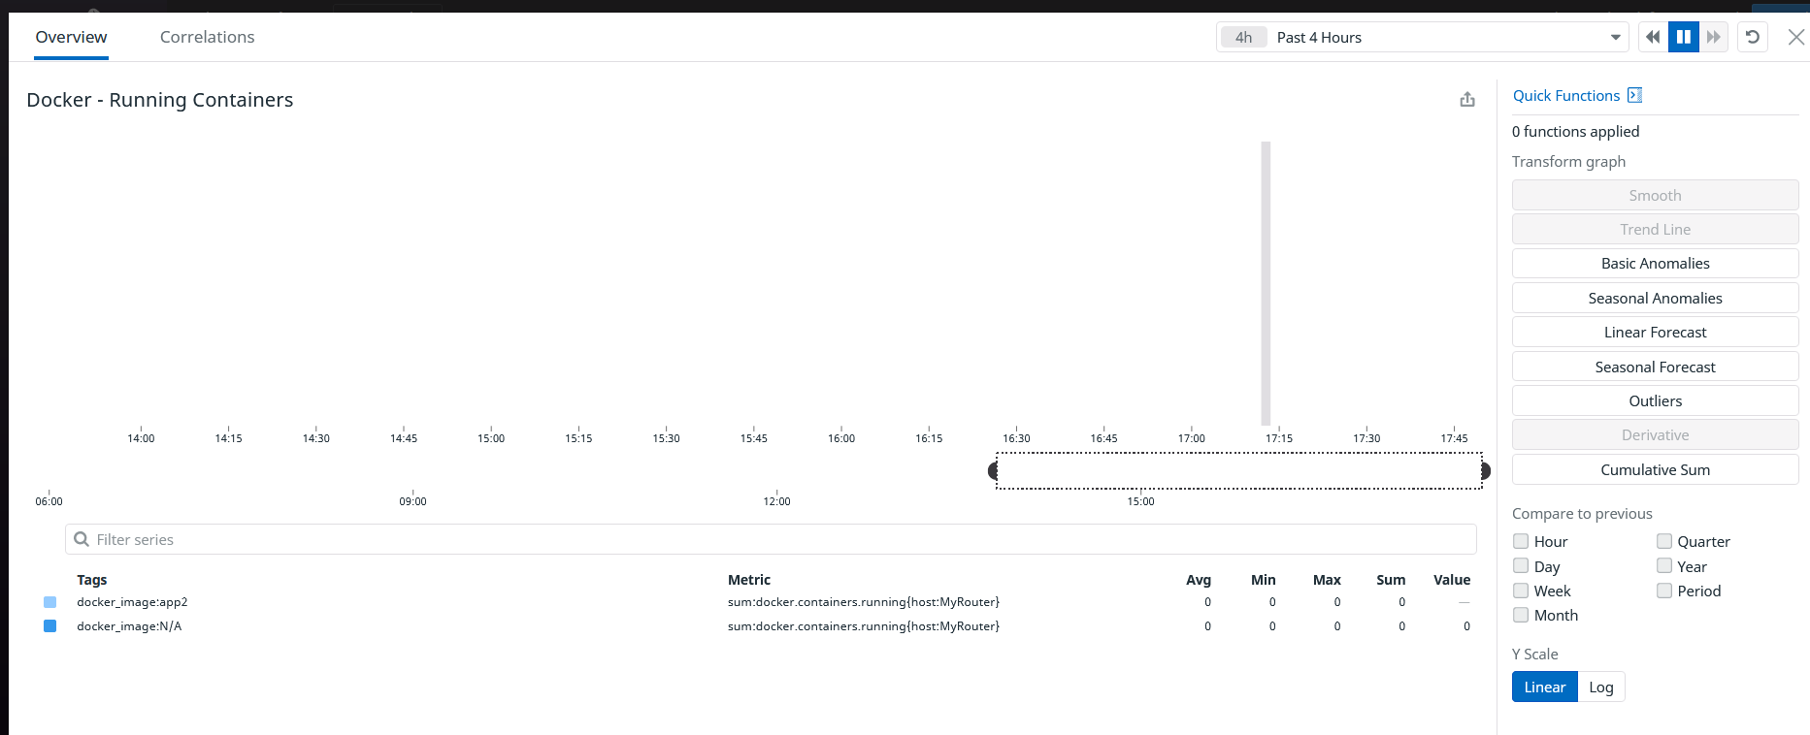

No containers have been created so far.

**A monitor has been created to monitor the if datadog agent is running properly on the host**

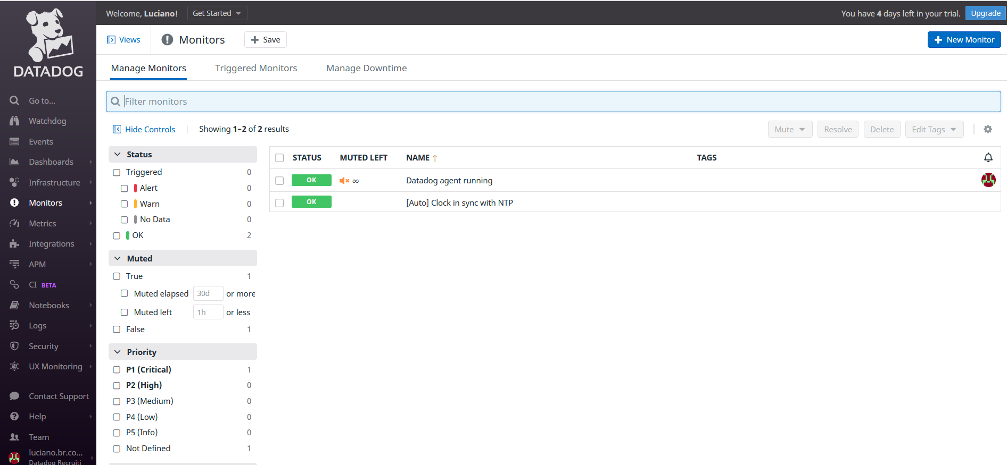

**Downtime has been set as well**

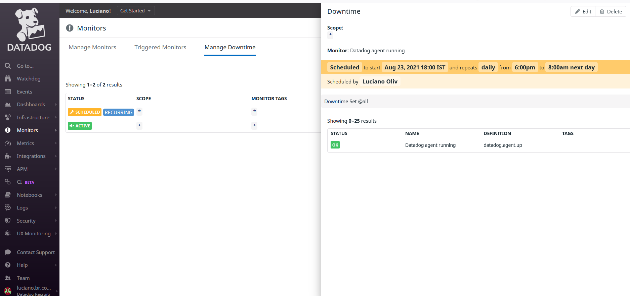

**From here are my BLOCKERS**

When I tried to install APM I have been blocked by an error

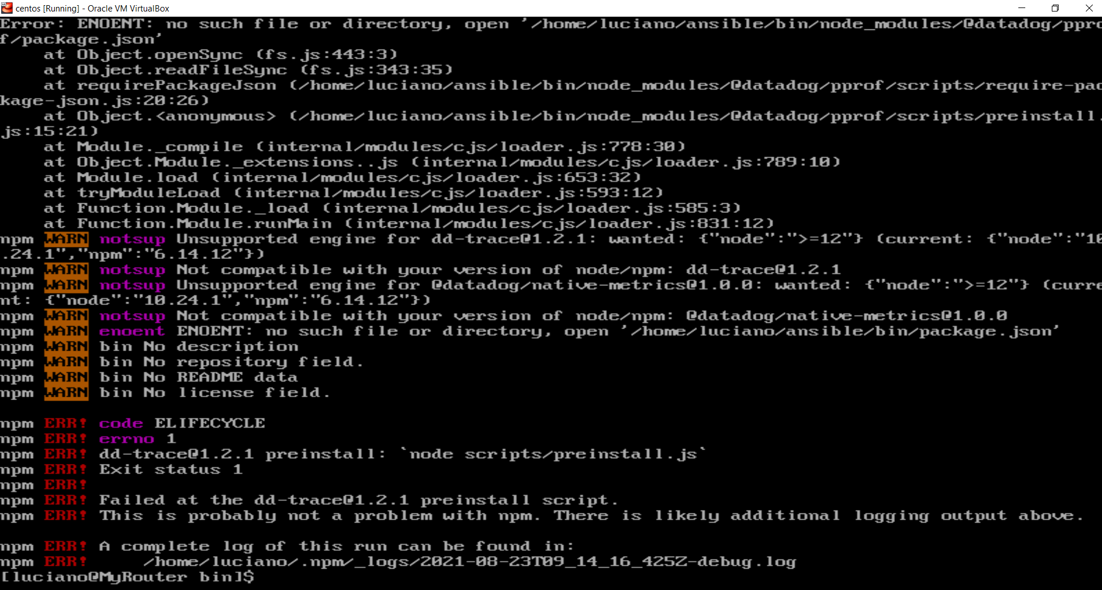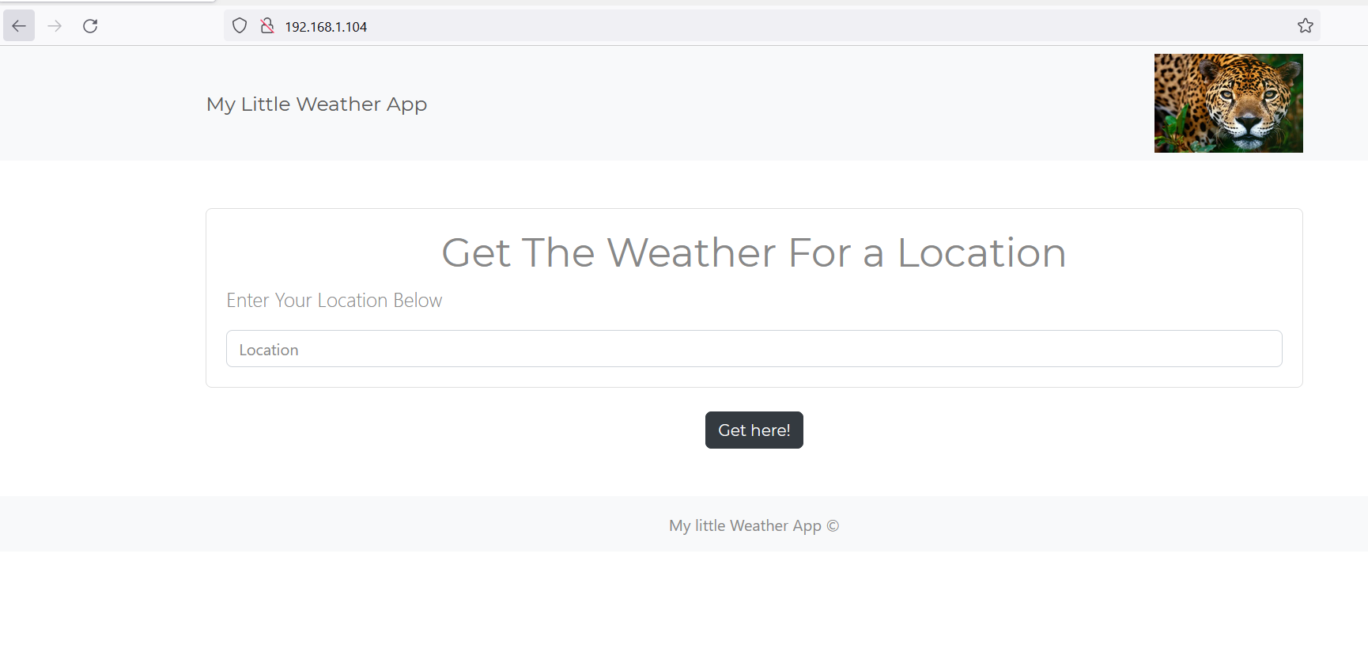

The App is running OK, however, APM integration couldn’t be enabled so far... I am still working on it.

Public Dashboard also have been created  
<https://p.datadoghq.eu/sb/4b2083cc-fb92-11eb-8b64-da7ad0900005-f796e4562d9676c4cd91b75f4f07e957>

MongoDB also have been installed, however, couldn’t enable mondoDB integration, after creation of the DB for Datado tests and user, the service could not be restarted again, still working on it.

PS.

* I have attached all my conf files and the app.
* Services have been installed using the official documentation for Centos 7 using YUM repository

Glossary:

<https://www.digitalocean.com/community/tutorials/how-to-install-the-apache-web-server-on-centos-7>

<https://www.digitalocean.com/community/tutorials/how-to-install-apache-tomcat-8-on-centos-7>

<https://docs.docker.com/engine/install/centos/>

<https://docs.mongodb.com/manual/tutorial/install-mongodb-on-red-hat/>