Capstone Project - The Battle of the Neighborhoods
Applied Data Science Capstone by IBM/Coursera
Luciano Pinheiro
jun 2021

Business problem
Belém is an poor Amazon city and capital of Pará State, in Brazil. It has about 1.5 million residents. On the last decades, the city had a exponencial growth. But this growth was not organized. So, while some places had a good development, with lots of new big and small businness, others were simply forgotten or occupied in a illegal way.

The idea here is to explore the city trying to find the distribution of a particular business over the city, trying to find some gaps, wich may help enterpreneurs to find places to start new businness.

We will demonstrate the solution with pharmacies. But you may notice that with just small changes, it will work with any sort of business.

Data
Based on definition of our problem, factors that will influence our decission are:

- number of existing pharmacies in the neighborhood
- the size of district/neighborhood

We will get the names of districts on an Wikipedia page. Then, the geolocation will be returned by geocoder python library.

Another source of data is the list of pharmacies from Foursquare API.

On that API, there is no district information, so we must apply a function to link the venue/place to some neighborhood.

Following data sources will be needed to extract/generate the required information:

- Wikipedia
- Foursquare API
- geocode python library

Methodology
Having the main data, we can see the distribution, the density and the gaps on the map. We may now intersect the amount of pharmacies on each district and their population to find the best places where an entepreneur may use the data. With luck, we may find a good way to represent that.

Analysis
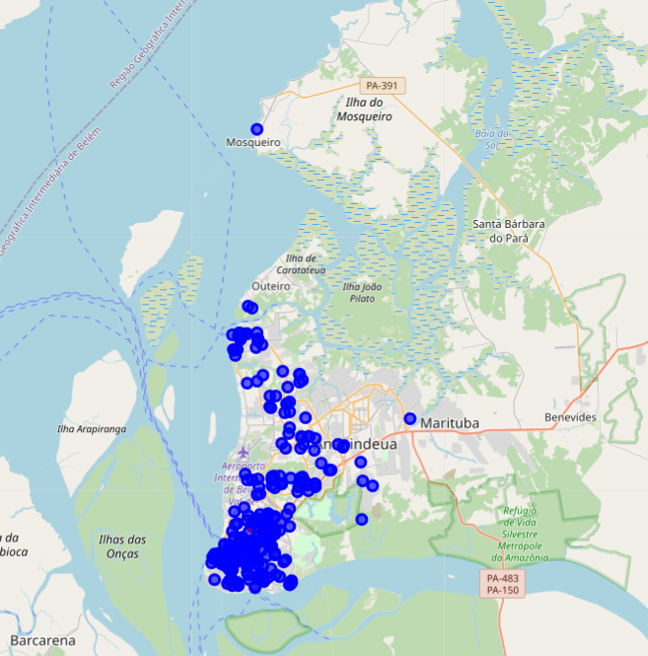Image 1: Distribution of pharmacies in Belém

We may now intersect the amount of pharmacies on each district and their population, to find the best places where an entepreneur may use the data. Best places here are places with high density of people and low density of pharmacies.

The next table show the neighbourhoods, the number of pharmacies and the number of pharmacies per 1000 inhabitants.

district | inhabitants | pharmacies | pharmacies per 1000
Sucurijuquara | 1074 | 0.0 | 0.000000
Souza | 13190 | 0.0 | 0.000000
Murubira | 1519 | 0.0 | 0.000000
Mangueirão | 36224 | 0.0 | 0.000000
Natal do Murubira | 1098 | 0.0 | 0.000000
Águas Negras | 6555 | 0.0 | 0.000000
Água Boa | 8553 | 0.0 | 0.000000
Itaiteua[8][9] | 1939 | 0.0 | 0.000000
Maracajá | 3345 | 0.0 | 0.000000
São João do Outeiro | 12134 | 0.0 | 0.000000
Ariramba | 1942 | 0.0 | 0.000000
Pratinha | 22589 | 0.0 | 0.000000
São Clemente | 7714 | 0.0 | 0.000000
Aeroporto | 1170 | 0.0 | 0.000000
Maracacueira | 9819 | 0.0 | 0.000000
Miramar | 515 | 0.0 | 0.000000
Bonfim | 776 | 0.0 | 0.000000
Caruará | 794 | 0.0 | 0.000000
Cabanagem | 27781 | 1.0 | 0.035996
Campina de Icoaraci | 26722 | 1.0 | 0.037422
Barreiro | 26003 | 1.0 | 0.038457
Telégrafo | 42953 | 2.0 | 0.046563
Sacramenta | 44413 | 3.0 | 0.067548
Benguí[nota 1] | 29379 | 2.0 | 0.068076
Cidade Velha | 12128 | 1.0 | 0.082454
Coqueiro | 51776 | 5.0 | 0.096570
Paracuri | 9934 | 1.0 | 0.100664
Parque Verde | 39126 | 4.0 | 0.102234
Montese | 61439 | 7.0 | 0.113934
Condor | 42758 | 5.0 | 0.116937
Tapanã | 66669 | 8.0 | 0.119996
Jurunas | 64478 | 8.0 | 0.124073
Guamá | 94610 | 12.0 | 0.126836
Tenoné | 30429 | 4.0 | 0.131454
Maracangalha | 30534 | 5.0 | 0.163752
Águas Lindas | 17520 | 3.0 | 0.171233
Cremação | 31264 | 6.0 | 0.191914
Pedreira | 69608 | 14.0 | 0.201126
Marambaia | 66708 | 15.0 | 0.224861
Curió-Utinga | 16642 | 4.0 | 0.240356
Agulha | 19712 | 5.0 | 0.253653
Marco | 65844 | 17.0 | 0.258186
Ponta Grossa | 13245 | 4.0 | 0.302001
Castanheira | 24424 | 8.0 | 0.327547
Brasília | 6019 | 2.0 | 0.332281
Mangueiras | 2851 | 1.0 | 0.350754
Aurá | 1827 | 1.0 | 0.547345
Umarizal | 30090 | 18.0 | 0.598205
Nazaré | 20504 | 13.0 | 0.634023
Fátima | 12385 | 8.0 | 0.645943
Cruzeiro | 11369 | 8.0 | 0.703668
Una | 6724 | 5.0 | 0.743605
São Brás | 19936 | 15.0 | 0.752408
Batista Campos | 19136 | 17.0 | 0.888378
Val-de-Cans | 7032 | 7.0 | 0.995449
Reduto | 6336 | 9.0 | 1.420455
Guanabara | 1919 | 3.0 | 1.563314
Campina | 6156 | 12.0 | 1.949318
Universitário | 2557 | 7.0 | 2.737583
On the following map, we combined the size of neighborhood (green) with the number of pharmacies per 1000 inhabitants (blue). The red circles are districts with no pharmacies.

We may see that some big districts have a small number of pharmacies, and that may be some a good opportunitty. In general, the bigger the green aura, the better the opportunity.

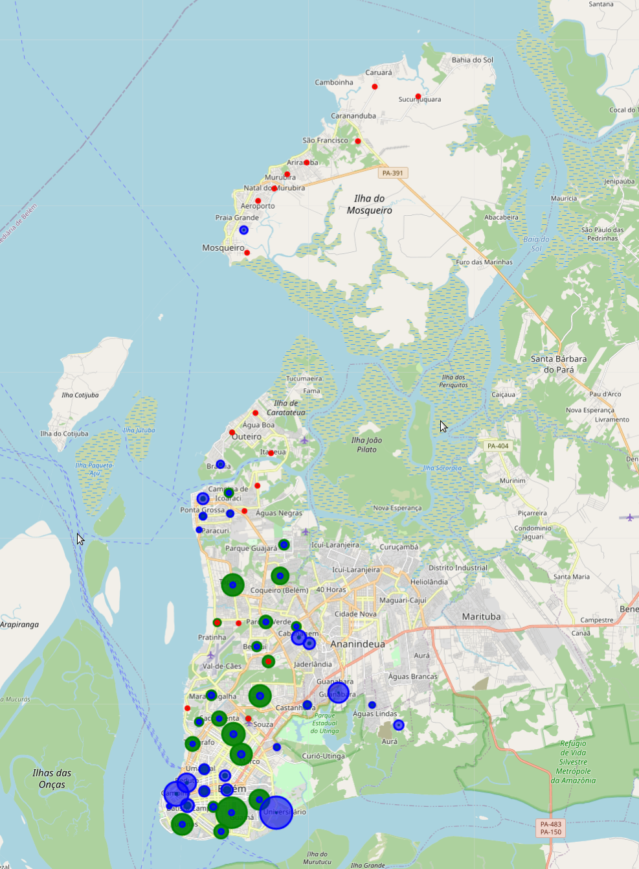Image 1: Neighborhoods and pharmacies

We can see visually in the map that some big neighborhoods have a small number of pharmacies. So, we can create an Opportinity Index based on that observation. The index may use the size of neighborhood and the number of pharmacies per capita.

The formula is as follow:

OI = inhabitants/4000 – (3+ Pharmacies_per_1000 ]*8)

The 10 best disctricts are:

district | inhabitants | pharmacies | Pharmacies per 1000 | Opportunity index
Guamá | 94610 | 12.0 | 0.126836 | 19.637808
Pedreira | 69608 | 14.0 | 0.201126 | 12.792990
Tapanã | 66669 | 8.0 | 0.119996 | 12.707284
Jurunas | 64478 | 8.0 | 0.124073 | 12.126913
Marambaia | 66708 | 15.0 | 0.224861 | 11.878115
Montese | 61439 | 7.0 | 0.113934 | 11.448277
Marco | 65844 | 17.0 | 0.258186 | 11.395512
Coqueiro | 51776 | 5.0 | 0.096570 | 9.171441
Sacramenta | 44413 | 3.0 | 0.067548 | 7.562868
Telégrafo | 42953 | 2.0 | 0.046563 | 7.365750

Results and discussion
The data shows that Belém is short of pharmacies. Some districs have 0 activities. Based only at location, we could say that any of that districts may be eligible for a new business. Visually, we have 4 highlights: the Island of Mosqueiro, the Island of Caratateua, Mangueirão district and around Pratinha neighborhood.

Other interesting view is the last map, wich show the relationship between the size of the district and the number of pharmacies. We even made a formula to show numerically this relationship. In this way, Guamá, Pedreira e Tapanã are very dense disctricts with relative low amount of pharmacies.

We must at last say that this analysis worked only in two dimensions: the number of pre-existent business and the population of districts. We know for experience that this is a violent city and maybe the low density areas are too risky to open a business. Some neighborhoods may have no basic services, like paved streets or bus line nearby.

For further work, we could make the use of spatial security data, like police stations location overall real state price. It is also interesting to play with Opportunity Index formula. For example, in another combination of parameters, Mangueirão was the second best due to lack of pharmacies in a 32K inhabitants in a small area.

Conclusion
The main goal of this work is to find oportunities to a pharmacy business in the city of Belém. Due to low density of competitors, it's not so hard to find a good place, although, as said before, the location and population are not the only dimensions to evaluate.

