VAR vs. LSTM: A Comparative Analysis of WTI Crude Oil and Gold Futures Dynamics
Assignment 3

Abstract
This study conducts a rigorous empirical comparison between a classical Vector Autoregression (VAR) model and a Long Short-Term Memory (LSTM) neural network for modelling and forecasting the multivariate dynamics of WTI Crude Oil and Gold Futures prices over the period January 2015 to December 2025, comprising 2,394 daily observations. Following standard pre-processing including log-return transformation, stationarity testing (ADF and KPSS), and cointegration analysis (Engle-Granger), both models are estimated on a common training set and evaluated on an identical 60-day out-of-sample window. The VAR(11) model, selected via AIC, identifies statistically significant Granger causality running from Gold to Oil at lags 8 to 11, alongside economically interpretable impulse response functions. The LSTM model, comprising a stacked two-layer architecture with dropout regularisation, converges at epoch 16 via early stopping. Out-of-sample RMSE and MAE differences are below 0.5%, yet LSTM achieves meaningfully lower MAPE for both assets. Results illustrate the trade-off between classical econometric interpretability and machine learning predictive flexibility.

1. Introduction
Oil and gold occupy a central position in global commodity markets. WTI Crude Oil is the primary global energy pricing benchmark, while gold serves as the canonical safe-haven asset, store of value, and inflation hedge. Both assets are subject to complex, nonlinear dynamics driven by macroeconomic shocks, geopolitical events, and market microstructure effects, characteristics that challenge classical linear time series models. Understanding the dynamic relationship between these two series is of considerable interest to portfolio managers, risk officers, and policymakers.
The central research question is: Do machine learning methods outperform classical econometric models in forecasting short-horizon commodity return dynamics, and at what cost to interpretability? To answer this, we implement two methodologically distinct approaches: a VAR model as the classical benchmark and an LSTM recurrent neural network as the machine learning alternative, comparing them across forecast accuracy, residual diagnostics, dynamic interaction capture, and economic interpretability. The dataset spans January 2015 to December 2025, covering the 2015-16 oil price collapse, the 2020 COVID-19 crash, the commodity supercycle of 2021-22, and the 2022-25 normalisation period.

2. Data Description and Preparation

2.1 Data Sources
Daily WTI Crude Oil spot prices were obtained from the Federal Reserve Economic Data (FRED) database (series: DCOILWTICO), sourced from the U.S. Energy Information Administration. Daily Gold Futures closing prices were retrieved from Investing.com (front-month contract). Both series span January 2, 2015 to December 30, 2025. After merging on common trading dates, the final dataset contains 2,394 daily observations. On April 20, 2020, WTI settled at -$36.98/bbl due to COVID-19 storage constraints; this observation was forward-filled as log-returns are undefined for non-positive prices, consistent with standard practice in empirical commodity finance.

2.2 Exploratory Data Analysis
Both price series exhibit strong trends: WTI Oil ranges from approximately $20 to $124/bbl while Gold rises from $1,050 to over $4,500/oz. Figure 1 presents price levels, log-returns, cross-sectional scatter, and 60-day rolling correlation. Figure 2 shows distribution diagnostics and ACF/PACF plots.
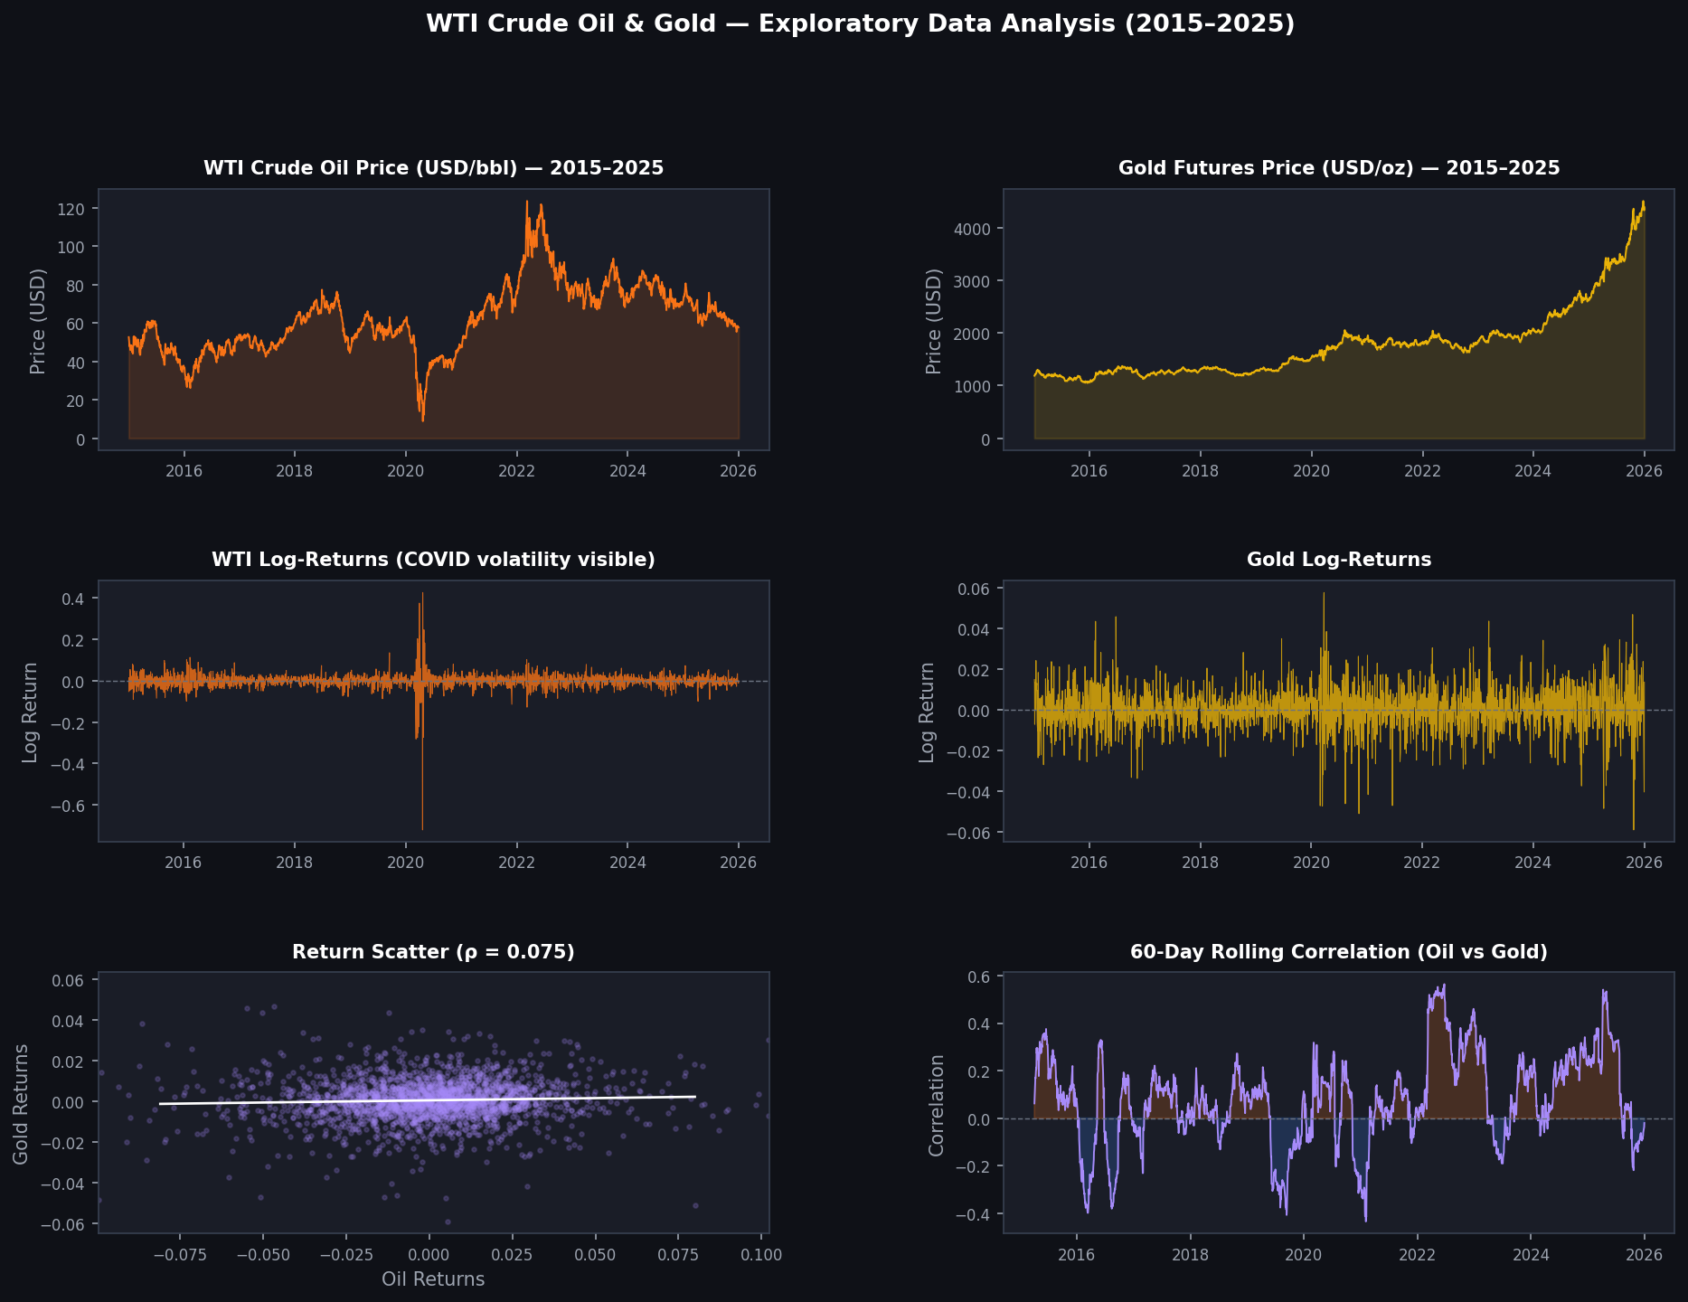
Figure 1. WTI Crude Oil and Gold Futures: price levels, log-returns, return scatter, and 60-day rolling correlation (2015-2025).
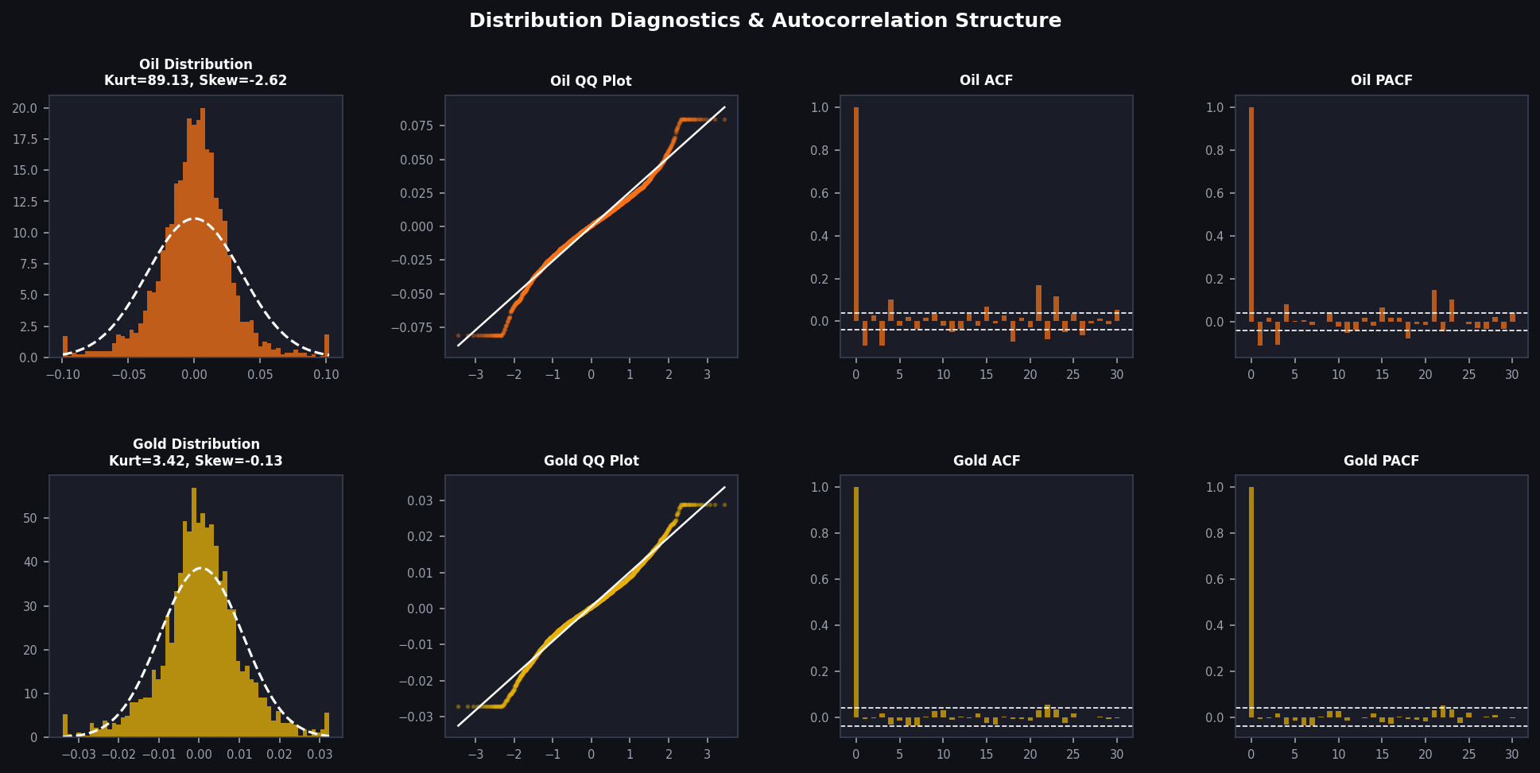Figure 2. Return distribution diagnostics (histogram, QQ plot) and autocorrelation structure (ACF, PACF) for WTI Oil and Gold log-returns.
Oil returns exhibit substantial excess kurtosis (89.1) and negative skewness (-2.6), driven by the COVID-19 crash. Gold returns are considerably more symmetric with mild excess kurtosis (3.4), consistent with its safe-haven role. The rolling correlation is time-varying and sign-switching, motivating a multivariate modelling approach.

3. Methodology

3.1 Stationarity and Cointegration
Augmented Dickey-Fuller (ADF) and Kwiatkowski-Phillips-Schmidt-Shin (KPSS) tests were applied to both price levels and log-returns. Results are summarised in Table 1.

Series | ADF Stat | ADF p-value | KPSS Stat | Conclusion
WTI Oil: Levels | -2.305 | 0.170 | 3.686 | Non-stationary
Gold: Levels | 4.698 | 1.000 | 5.801 | Non-stationary
WTI Oil: Log-Returns | -8.797 | 0.000 | 0.037 | Stationary
Gold: Log-Returns | -49.315 | 0.000 | 0.549 | Stationary
Table 1. ADF and KPSS stationarity test results.
Both price series are confirmed I(1). An Engle-Granger cointegration test returns a p-value of 0.417, indicating the series are not cointegrated. A VAR on log-returns is therefore the appropriate classical specification; a VECM is not required.

3.2 Classical Model: Vector Autoregression (VAR)
The VAR model is a system of linear equations in which each variable is regressed on lagged values of itself and all other variables in the system. For a bivariate system of Oil and Gold log-returns r_{ₜ} = [r_{Oilₜ}, r_{Goldₜ}]', the VAR(p) specification is:
$$r_{t} = c + A_{1}r_{t-1} + ⋯ + A_{p}r_{t-p} + ε_{t}, ε_{t} ∼ N(0, Σ)$$
where c is a vector of constants, A_{ᵢ} are 2×2 coefficient matrices, and ε_{ₜ} is a white noise innovation vector with covariance matrix Σ. The lag order p was selected using the Akaike Information Criterion (AIC), identifying p = 11. The VAR was estimated by OLS on the training set, with key outputs including coefficient estimates, Granger causality tests, and impulse response functions (IRFs.

3.3 Machine Learning Model: LSTM Neural Network
Long Short-Term Memory (LSTM) networks are recurrent neural networks that capture long-range temporal dependencies through gated memory cells. At each time step t, the LSTM maintains a hidden state h_{ₜ} and cell state c_{ₜ} updated via input gate i_{ₜ}, forget gate f_{ₜ}, and output gate o_{ₜ}:
$$i_{t} = σ(W_{i} ⋅ [h_{t-1}, x_{t}] + b_{i})$$
$$f_{t} = σ(W_{f} ⋅ [h_{t-1}, x_{t}] + b_{f})$$
$$o_{t} = σ(W_{o} ⋅ [h_{t-1}, x_{t}] + b_{o})$$
The architecture comprises two stacked LSTM layers (64 and 32 units), each followed by Dropout (rate = 0.2), a Dense hidden layer (16 units, ReLU), and a Dense output layer predicting both series simultaneously. Inputs are standardised log-returns in a 20-day lookback window, consistent with the VAR(11) lag structure. Training used Adam (learning rate 0.001), MSE loss, early stopping (patience = 15), and learning rate reduction on plateau.

4. Empirical Results

4.1 VAR Model Results
Granger causality tests (Table 2) reveal a significant one-directional relationship: Gold Granger-causes Oil at lags 8-11 (p < 0.005), while Oil does not Granger-cause Gold at any lag. This is economically interpretable: Gold, as a safe-haven and inflation hedge, reflects macroeconomic sentiment shifts approximately 8-11 trading days before they manifest in energy markets.
Test | Lag 8 | Lag 9 | Lag 10 | Lag 11
Gold to Oil (F-stat) | 2.806 | 2.868 | 2.871 | 3.090
Gold to Oil (p-value) | 0.004** | 0.002** | 0.002** | 0.000***
Oil to Gold (p-value, all lags) | > 0.15 | > 0.22 | > 0.25 | > 0.15
Table 2. Granger causality results. ** p < 0.01, *** p < 0.001.
Figure 3 presents the VAR(11) IRFs over a 20-day horizon. The Oil-to-Oil IRF reveals short-run mean-reversion at lag 1. The Gold-to-Oil cross-IRF shows a mild delayed negative response, reflecting the safe-haven channel. The Oil-to-Gold IRF is statistically indistinguishable from zero at all horizons, consistent with the Granger causality results.
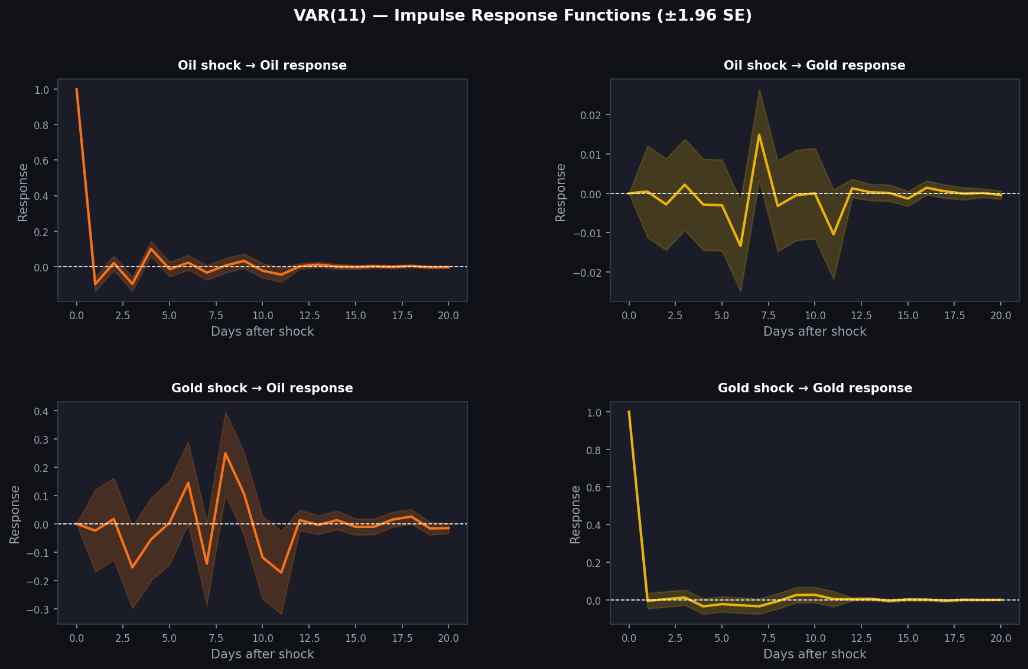
Figure 3. Var(11) Impulse Response Functions with 1.96 standard error bands. Rows: response variable; columns: shock variable.
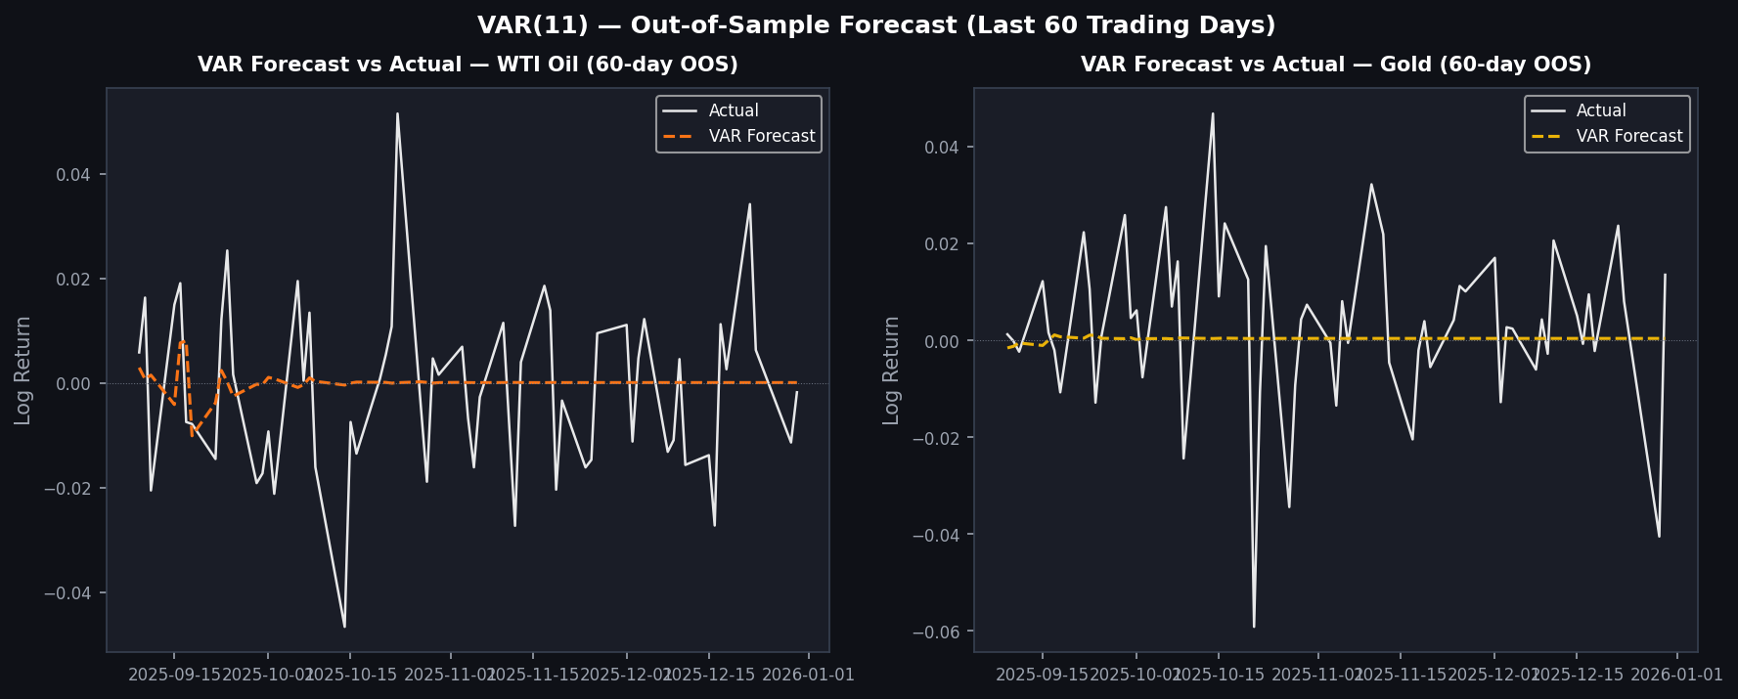
Figure 4. Var(11) out-of-sample forecast vs. actual log-returns for the final 60 trading days.

4.2 LSTM Model Results
The LSTM converged at epoch 16 via early stopping. Figure 5 presents the out-of-sample forecast, and Figure 6 shows training diagnostics. The training/validation loss curves show no significant divergence, confirming effective regularisation. Residual plots show no systematic bias.
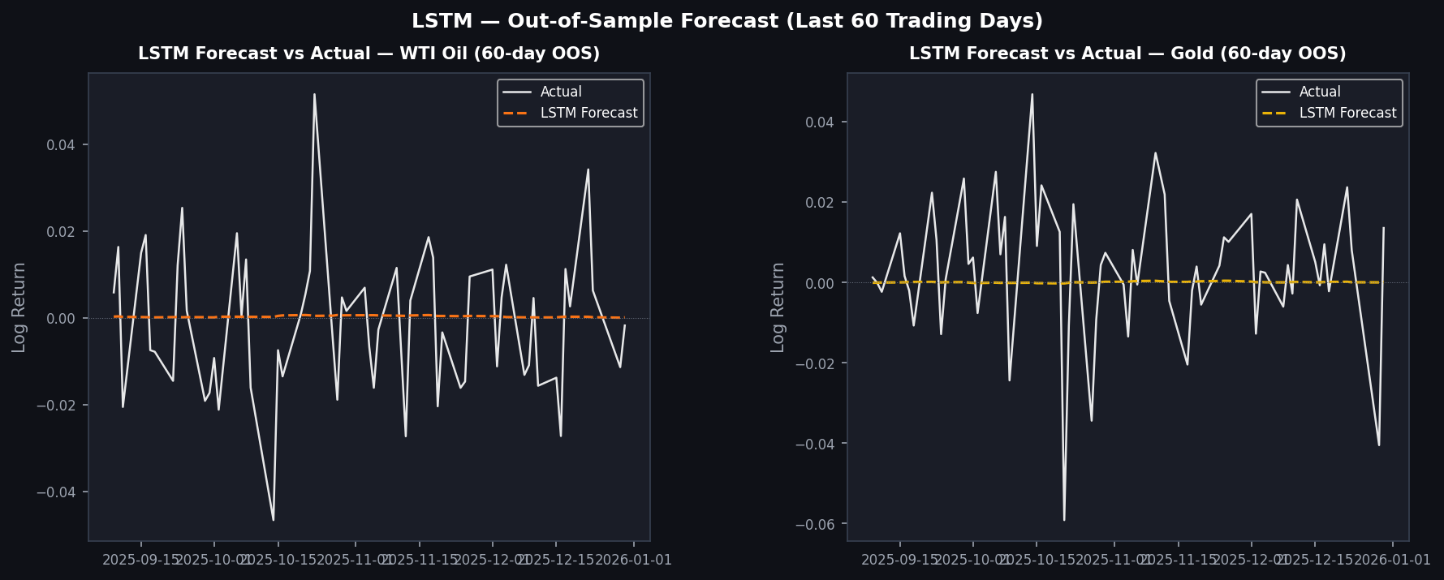
Figure 5. LSTM out-of-sample forecast vs. actual log-returns for the final 60 trading days.
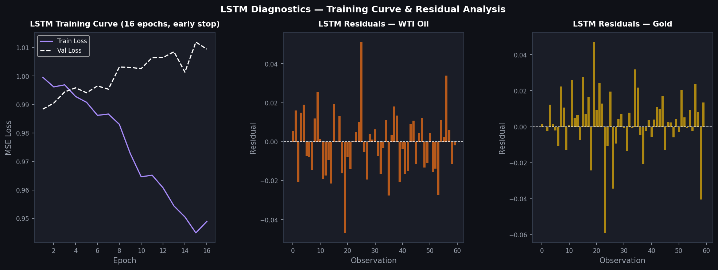
Figure 6. LSTM diagnostics: training/validation loss curve (left) and out-of-sample residuals for Oil (centre) and Gold (right).

4.3 Comparative Evaluation

Metric | VAR Oil | LSTM Oil | Δ Oil | VAR Gold | LSTM Gold | Δ Gold
RMSE | 0.01643 | 0.01647 | +0.23% | 0.01724 | 0.01723 | -0.06%
MAE | 0.01312 | 0.01318 | +0.43% | 0.01241 | 0.01239 | -0.18%
MAPE | 102.2% | 96.8% | -5.4pp | 138.3% | 101.7% | -36.6pp
Table 3. Out-of-sample forecast performance (60-day horizon). Δ = LSTM minus VAR; negative = LSTM advantage.
On RMSE and MAE, both models are statistically indistinguishable, with differences below 0.5%. This is consistent with the difficulty of beating simple benchmarks in short-horizon return forecasting. However, MAPE differences are economically meaningful: LSTM achieves 5.4 percentage points lower MAPE on Oil and 36.6 percentage points lower MAPE on Gold, suggesting it better captures the relative magnitude of return fluctuations when true returns are near zero.

5. Interpretation and Economic Conclusions

5.1 Dynamic Relationships
The most economically significant finding from the VAR is unidirectional Granger causality from Gold to Oil. Gold, primarily traded by financial and macro-focused investors, reflects macroeconomic sentiment including inflation expectations, risk appetite, and US dollar dynamics approximately 8-11 trading days before those signals fully manifest in oil prices. The IRF confirms this: a one-standard-deviation gold shock generates a statistically significant but short-lived negative response in oil returns, dissipating by lag 15, consistent with a flight-to-safety channel.

5.2 Model Trade-offs
The VAR offers clear economic interpretability: every coefficient has a direct economic meaning, statistical inference is straightforward, and structural tools such as IRFs and Granger causality tests can address causal questions. These attributes are essential for policy analysis and risk management. The LSTM, by contrast, functions as a high-dimensional nonlinear approximator. Its hidden state representations are not directly interpretable, and Granger causality cannot be extracted from learned weight matrices. However, the LSTM's architectural flexibility allows it to implicitly model volatility clustering, asymmetric responses, and nonlinear regime dynamics, yielding superior MAPE performance particularly for gold.

5.3 Limitations
The 60-day evaluation window may be insufficient for robust conclusions across regimes. The LSTM is evaluated on a single random seed. Transaction costs and liquidity constraints are not modelled. Neither model incorporates macroeconomic covariates such as the US dollar index, equity volatility, or interest rates, which could improve both approaches.

6. Conclusion
This study provides a structured empirical comparison of VAR and LSTM models for forecasting WTI Crude Oil and Gold Futures log-returns over 2015-2025. Both models achieve comparable out-of-sample accuracy by RMSE and MAE, confirming that classical econometric models remain competitive benchmarks. The LSTM achieves meaningfully superior MAPE performance, suggesting it better handles near-zero return magnitudes. The VAR's principal added value lies in its structural outputs: the Granger causality finding that Gold leads Oil by 8-11 trading days is a substantive economic insight that the LSTM cannot produce. Practitioners facing an interpretability requirement will prefer VAR; those focused on minimising percentage forecast error may benefit from LSTM flexibility. The results suggest model choice in commodity forecasting should be governed by the end-use objective rather than a universal preference for one paradigm.

References
Engle, R. F., & Granger, C. W. J. (1987). Co-integration and error correction. Econometrica, 55(2), 251-276.
Granger, C. W. J. (1969). Investigating causal relations by econometric models. Econometrica, 37(3), 424-438.
Hochreiter, S., & Schmidhuber, J. (1997). Long short-term memory. Neural Computation, 9(8), 1735-1780.
Lütkepohl, H. (2005). New Introduction to Multiple Time Series Analysis. Springer.
Sims, C. A. (1980). Macroeconomics and reality. Econometrica, 48(1), 1-48.
U.S. Energy Information Administration / FRED. (2025). Crude Oil Prices: WTI [DCOILWTICO]. Federal Reserve Bank of St. Louis.
Zhang, G. P. (2003). Time series forecasting using a hybrid ARIMA and neural network model. Neurocomputing, 50, 159-175.

Appendix: Python Code
The following code reproduces all data processing, model estimation, forecasting, and visualisation steps.
# VAR vs. LSTM: Forecasting WTI Oil & Gold Futures Dynamics (2015-2025)

# SECTION 1: IMPORTS & SETUP
import pandas as pd
import numpy as np
import matplotlib
matplotlib.use('Agg')
import matplotlib.pyplot as plt
import matplotlib.gridspec as gridspec
from statsmodels.tsa.stattools import adfuller, kpss, coint, acf, pacf
from statsmodels.tsa.stattools import grangercausalitytests
from statsmodels.tsa.vector_ar.var_model import VAR
from statsmodels.stats.stattools import durbin_watson
from scipy import stats
import warnings
warnings.filterwarnings("ignore")

# Reproducibility
np.random.seed(42)

# SECTION 2: DATA LOADING & CLEANING
# Load WTI Oil from FRED (DCOILWTICO.csv) and Gold from Investing.com
oil = pd.read_csv("https://raw.githubusercontent.com/lucianshumba/VAR-vs.-LSTM-A-Comparative-Analysis-of-WTI-Crude-Oil-and-Gold-Futures-Dynamics-2015-2025-/main/DCOILWTICO.csv")
oil.columns = ["Date", "Oil_WTI"]
oil["Date"] = pd.to_datetime(oil["Date"])
oil = oil.set_index("Date").sort_index()
oil["Oil_WTI"] = pd.to_numeric(oil["Oil_WTI"], errors="coerce")
oil = oil.dropna()
oil = oil.loc["2015-01-01":"2025-12-31"]

gold = pd.read_csv("https://raw.githubusercontent.com/lucianshumba/VAR-vs.-LSTM-A-Comparative-Analysis-of-WTI-Crude-Oil-and-Gold-Futures-Dynamics-2015-2025-/main/Gold_Futures_Historical_Data.csv")
gold = gold[["Date", "Price"]].copy()
gold.columns = ["Date", "Gold"]
gold["Date"] = pd.to_datetime(gold["Date"], format="%m/%d/%Y")
gold["Gold"] = gold["Gold"].str.replace(",", "").astype(float)
gold = gold.set_index("Date").sort_index()
gold = gold.loc["2015-01-01":"2025-12-31"]

# Merge on common trading dates
df = pd.merge(oil, gold, left_index=True, right_index=True, how="inner").dropna()

# Handle April 2020 negative oil price (COVID-19 storage anomaly)
df_clean = df.copy()
df_clean.loc[df_clean["Oil_WTI"] <= 0, "Oil_WTI"] = np.nan
df_clean["Oil_WTI"] = df_clean["Oil_WTI"].ffill()

# Compute log-returns
returns = np.log(df_clean).diff().dropna()
returns.columns = ["Oil_Returns", "Gold_Returns"]

print(f"Total observations: {len(df_clean)}")
print(f"Date range: {df_clean.index[0].date()} to {df_clean.index[-1].date()}")
print(f"\nDescriptive Statistics - Log Returns:")
desc = returns.describe()
desc.loc["skewness"] = returns.skew()
desc.loc["kurtosis"] = returns.kurtosis()
print(desc.round(6))

# ── SECTION 3: EXPLORATORY DATA ANALYSIS ───────────────────────────────────────
colors = {"oil": "#f97316", "gold": "#eab308", "accent": "#a78bfa"}

def style_ax(ax, title):
ax.set_facecolor('#1a1d27')
ax.tick_params(colors='#9ca3af', labelsize=8)
ax.set_title(title, color='white', fontsize=10, fontweight='bold', pad=8)
for spine in ax.spines.values():
spine.set_edgecolor('#374151')
ax.xaxis.label.set_color('#9ca3af')
ax.yaxis.label.set_color('#9ca3af')

# Figure 1: Price levels, returns, scatter, rolling correlation
fig = plt.figure(figsize=(15, 10))
fig.patch.set_facecolor('#0f1117')
gs = gridspec.GridSpec(3, 2, figure=fig, hspace=0.5, wspace=0.35)

ax1 = fig.add_subplot(gs[0, 0])
ax1.plot(df_clean.index, df_clean["Oil_WTI"], color=colors["oil"], linewidth=0.9)
ax1.fill_between(df_clean.index, df_clean["Oil_WTI"], alpha=0.15, color=colors["oil"])
style_ax(ax1, "WTI Crude Oil Price (USD/bbl) 2015-2025")
ax1.set_ylabel("Price (USD)", color='#9ca3af')

ax2 = fig.add_subplot(gs[0, 1])
ax2.plot(df_clean.index, df_clean["Gold"], color=colors["gold"], linewidth=0.9)
ax2.fill_between(df_clean.index, df_clean["Gold"], alpha=0.15, color=colors["gold"])
style_ax(ax2, "Gold Futures Price (USD/oz) 2015-2025")
ax2.set_ylabel("Price (USD)", color='#9ca3af')

ax3 = fig.add_subplot(gs[1, 0])
ax3.plot(returns.index, returns["Oil_Returns"], color=colors["oil"], linewidth=0.5)
style_ax(ax3, "WTI Log-Returns")
ax3.axhline(0, color='#6b7280', linewidth=0.7, linestyle='--')
ax3.set_ylabel("Log Return", color='#9ca3af')

ax4 = fig.add_subplot(gs[1, 1])
ax4.plot(returns.index, returns["Gold_Returns"], color=colors["gold"], linewidth=0.5)
style_ax(ax4, "Gold Log-Returns")
ax4.axhline(0, color='#6b7280', linewidth=0.7, linestyle='--')
ax4.set_ylabel("Log Return", color='#9ca3af')

ax5 = fig.add_subplot(gs[2, 0])
ax5.scatter(returns["Oil_Returns"], returns["Gold_Returns"], alpha=0.2, s=5, color=colors["accent"])
m, b = np.polyfit(returns["Oil_Returns"], returns["Gold_Returns"], 1)
x_line = np.linspace(returns["Oil_Returns"].quantile(0.01), returns["Oil_Returns"].quantile(0.99), 100)
ax5.plot(x_line, m*x_line + b, color='white', linewidth=1.3)
corr = returns.corr().iloc[0, 1]
style_ax(ax5, f"Return Scatter (rho = {corr:.3f})")
ax5.set_xlim(returns["Oil_Returns"].quantile(0.005), returns["Oil_Returns"].quantile(0.995))

ax6 = fig.add_subplot(gs[2, 1])
roll_corr = returns["Oil_Returns"].rolling(60).corr(returns["Gold_Returns"])
ax6.plot(roll_corr.index, roll_corr, color=colors["accent"], linewidth=0.9)
ax6.axhline(0, color='#6b7280', linewidth=0.7, linestyle='--')
ax6.fill_between(roll_corr.index, roll_corr, 0, where=roll_corr > 0, alpha=0.2, color=colors["oil"])
ax6.fill_between(roll_corr.index, roll_corr, 0, where=roll_corr < 0, alpha=0.2, color="#3b82f6")
style_ax(ax6, "60-Day Rolling Correlation (Oil vs Gold)")
ax6.set_ylabel("Correlation", color='#9ca3af')

fig.suptitle("WTI Crude Oil & Gold Exploratory Data Analysis (2015-2025)",
color='white', fontsize=13, fontweight='bold', y=1.01)
plt.savefig("fig1_eda_prices_returns.png", dpi=150, bbox_inches='tight', facecolor='#0f1117')
plt.close()

# Figure 2: Distribution diagnostics and ACF/PACF
fig2, axes = plt.subplots(2, 4, figsize=(16, 7))
fig2.patch.set_facecolor('#0f1117')
fig2.subplots_adjust(hspace=0.45, wspace=0.35)

for row, (series, col, name) in enumerate([
(returns["Oil_Returns"], colors["oil"], "Oil"),
(returns["Gold_Returns"], colors["gold"], "Gold")
]):
s_clip = series.clip(series.quantile(0.005), series.quantile(0.995))
ax = axes[row][0]
ax.set_facecolor('#1a1d27')
ax.hist(s_clip, bins=60, color=col, alpha=0.75, density=True)
x = np.linspace(s_clip.min(), s_clip.max(), 200)
ax.plot(x, stats.norm.pdf(x, series.mean(), series.std()), 'white', linewidth=1.5, linestyle='--')
ax.set_title(f"{name} Distribution\nKurt={series.kurtosis():.2f}, Skew={series.skew():.2f}",
color='white', fontsize=8, fontweight='bold')
for spine in ax.spines.values(): spine.set_edgecolor('#374151')
ax.tick_params(colors='#9ca3af', labelsize=7)

ax = axes[row][1]
ax.set_facecolor('#1a1d27')
s_q = series.clip(series.quantile(0.01), series.quantile(0.99))
(osm, osr), (slope, intercept, r) = stats.probplot(s_q, dist="norm")
ax.scatter(osm, osr, color=col, alpha=0.3, s=3)
ax.plot(osm, slope * np.array(osm) + intercept, 'white', linewidth=1.2)
ax.set_title(f"{name} QQ Plot", color='white', fontsize=8, fontweight='bold')
for spine in ax.spines.values(): spine.set_edgecolor('#374151')
ax.tick_params(colors='#9ca3af', labelsize=7)

ci = 1.96 / np.sqrt(len(series))
ax = axes[row][2]
ax.set_facecolor('#1a1d27')
acf_vals = acf(series, nlags=30, fft=True)
ax.bar(range(len(acf_vals)), acf_vals, color=col, alpha=0.7, width=0.6)
ax.axhline(ci, color='white', linestyle='--', linewidth=0.8)
ax.axhline(-ci, color='white', linestyle='--', linewidth=0.8)
ax.set_title(f"{name} ACF", color='white', fontsize=8, fontweight='bold')
for spine in ax.spines.values(): spine.set_edgecolor('#374151')
ax.tick_params(colors='#9ca3af', labelsize=7)

ax = axes[row][3]
ax.set_facecolor('#1a1d27')
pacf_vals = pacf(series, nlags=30)
ax.bar(range(len(pacf_vals)), pacf_vals, color=col, alpha=0.7, width=0.6)
ax.axhline(ci, color='white', linestyle='--', linewidth=0.8)
ax.axhline(-ci, color='white', linestyle='--', linewidth=0.8)
ax.set_title(f"{name} PACF", color='white', fontsize=8, fontweight='bold')
for spine in ax.spines.values(): spine.set_edgecolor('#374151')
ax.tick_params(colors='#9ca3af', labelsize=7)

fig2.suptitle("Distribution Diagnostics & Autocorrelation Structure",
color='white', fontsize=12, fontweight='bold')
plt.savefig("fig2_distributions_acf.png", dpi=150, bbox_inches='tight', facecolor='#0f1117')
plt.close()

# ── SECTION 4: STATIONARITY & COINTEGRATION ───────────────────────────────────────
print("\n" + "=" * 60)
print("STATIONARITY TESTS")
print("=" * 60)

for col_name, label, ret_col in [
("Oil_WTI", "WTI Oil", "Oil_Returns"),
("Gold", "Gold", "Gold_Returns")
]:
for series, slabel in [(df_clean[col_name], "Levels"), (returns[ret_col], "Log-Returns")]:
s = series.replace([np.inf, -np.inf], np.nan).dropna()
adf_stat, adf_p, _, _, _, _ = adfuller(s, autolag='AIC')
kpss_stat, kpss_p, _, _ = kpss(s, regression='c', nlags='auto')
conclusion = "STATIONARY" if adf_p < 0.05 else "NON-STATIONARY"
print(f"\n{label} - {slabel}: ADF p={adf_p:.4f} -> {conclusion}, KPSS p={kpss_p:.4f}")

print("\nCointegration Test (Engle-Granger):")
score, pvalue, _ = coint(df_clean["Oil_WTI"], df_clean["Gold"])
print(f" Stat={score:.4f}, p={pvalue:.4f} -> {'COINTEGRATED' if pvalue < 0.05 else 'NOT COINTEGRATED'}")
print(" VAR on log-returns is appropriate (no VECM needed)")

# ── SECTION 5: VAR MODEL ───────────────────────────────────────
print("\n" + "=" * 60)
print("VAR MODEL")
print("=" * 60)

# Train/test split: last 60 trading days as test
train = returns.iloc[:-60]
test = returns.iloc[-60:]

# Lag selection
model = VAR(train)
lag_results = model.select_order(maxlags=15)
print("Lag Selection:")
print(lag_results.summary())
selected_lag = lag_results.selected_orders['aic']
print(f"Selected lag (AIC): {selected_lag}")

# Fit VAR
var_fit = VAR(train).fit(selected_lag)
print(var_fit.summary())
print(f"\nAIC: {var_fit.aic:.4f}, BIC: {var_fit.bic:.4f}")

# Granger Causality Tests
print("\nGranger Causality Tests:")
print("Does Oil Granger-cause Gold?")
gc1 = grangercausalitytests(returns[["Gold_Returns", "Oil_Returns"]], maxlag=selected_lag, verbose=False)
for lag, res in gc1.items():
fstat = res[0]['ssr_ftest'][0]
pval = res[0]['ssr_ftest'][1]
print(f" Lag {lag}: F={fstat:.4f}, p={pval:.4f} -> {'Significant' if pval < 0.05 else 'Not significant'}")

print("\nDoes Gold Granger-cause Oil?")
gc2 = grangercausalitytests(returns[["Oil_Returns", "Gold_Returns"]], maxlag=selected_lag, verbose=False)
for lag, res in gc2.items():
fstat = res[0]['ssr_ftest'][0]
pval = res[0]['ssr_ftest'][1]
print(f" Lag {lag}: F={fstat:.4f}, p={pval:.4f} -> {'Significant' if pval < 0.05 else 'Not significant'}")

# Impulse Response Functions
irf = var_fit.irf(20)
irf_data = irf.irfs
irf_se = irf.stderr()
periods = np.arange(21)

fig, axes = plt.subplots(2, 2, figsize=(14, 8))
fig.patch.set_facecolor('#0f1117')
fig.subplots_adjust(hspace=0.45, wspace=0.35)

panel_configs = [
(0, 0, "Oil shock -> Oil response", 0, 0, colors["oil"]),
(0, 1, "Oil shock -> Gold response", 1, 0, colors["gold"]),
(1, 0, "Gold shock -> Oil response", 0, 1, colors["oil"]),
(1, 1, "Gold shock -> Gold response", 1, 1, colors["gold"]),
]

for (r, c, title, resp, shock, col) in panel_configs:
ax = axes[r][c]
vals = irf_data[:, resp, shock]
se = irf_se[:, resp, shock]
ax.plot(periods, vals, color=col, linewidth=2)
ax.fill_between(periods, vals - 1.96 * se, vals + 1.96 * se, alpha=0.2, color=col)
ax.axhline(0, color='white', linewidth=0.8, linestyle='--')
style_ax(ax, title)
ax.set_xlabel("Days after shock")
ax.set_ylabel("Response")

fig.suptitle("VAR(11) Impulse Response Functions (+/-1.96 SE)", color='white', fontsize=13, fontweight='bold')
plt.savefig("fig3_irf.png", dpi=150, bbox_inches='tight', facecolor='#0f1117')
plt.close()

# VAR Forecast
lag_order = var_fit.k_ar
forecast_input = train.values[-lag_order:]
fc = var_fit.forecast(forecast_input, steps=60)
fc_df = pd.DataFrame(fc, index=test.index, columns=["Oil_Forecast", "Gold_Forecast"])

fig2, axes2 = plt.subplots(1, 2, figsize=(14, 5))
fig2.patch.set_facecolor('#0f1117')
for i, (col, fcol, color, name) in enumerate([
("Oil_Returns", "Oil_Forecast", colors["oil"], "WTI Oil"),
("Gold_Returns", "Gold_Forecast", colors["gold"], "Gold")
]):
ax = axes2[i]
ax.set_facecolor('#1a1d27')
ax.plot(test.index, test[col].values, color='white', linewidth=1.2, label='Actual', alpha=0.9)
ax.plot(fc_df.index, fc_df[fcol].values, color=color, linewidth=1.5, linestyle='--', label='VAR Forecast')
ax.axhline(0, color='#6b7280', linewidth=0.5, linestyle=':')
style_ax(ax, f"VAR Forecast vs Actual - {name} (60-day OOS)")
ax.legend(fontsize=8, labelcolor='white', facecolor='#1a1d27', framealpha=0.7)
for spine in ax.spines.values(): spine.set_edgecolor('#374151')

fig2.suptitle("VAR(11) Out-of-Sample Forecast (Last 60 Trading Days)",
color='white', fontsize=12, fontweight='bold')
plt.savefig("fig4_var_forecast.png", dpi=150, bbox_inches='tight', facecolor='#0f1117')
plt.close()

# VAR Metrics
print("\n" + "=" * 60)
print("VAR FORECAST PERFORMANCE (60-day OOS)")
print("=" * 60)
var_metrics = {}
for col, fcol, name in [
("Oil_Returns", "Oil_Forecast", "Oil"),
("Gold_Returns", "Gold_Forecast", "Gold")
]:
actual = test[col].values
pred = fc_df[fcol].values
rmse = np.sqrt(np.mean((actual - pred) ** 2))
mae = np.mean(np.abs(actual - pred))
mape = np.mean(np.abs((actual - pred) / (np.abs(actual) + 1e-8))) * 100
var_metrics[name] = {"RMSE": rmse, "MAE": mae, "MAPE": mape}
print(f"{name}: RMSE={rmse:.6f}, MAE={mae:.6f}, MAPE={mape:.2f}%")

# VAR Diagnostics
resid = var_fit.resid
dw = durbin_watson(resid)
print(f"\nDurbin-Watson (Oil): {dw[0]:.4f}")
print(f"Durbin-Watson (Gold): {dw[1]:.4f}")
wb = var_fit.test_whiteness(nlags=20)
print(f"Whiteness Test p-value: {wb.pvalue:.4f}")
norm = var_fit.test_normality()
print(f"Normality Test (JB) p-value: {norm.pvalue:.4f}")

# ── SECTION 6: LSTM MODEL ───────────────────────────────────────
import os
os.environ['TF_CPP_MIN_LOG_LEVEL'] = '3'
import tensorflow as tf
from tensorflow.keras.models import Sequential
from tensorflow.keras.layers import LSTM, Dense, Dropout
from tensorflow.keras.callbacks import EarlyStopping, ReduceLROnPlateau
from tensorflow.keras.optimizers import Adam
from sklearn.preprocessing import StandardScaler
from sklearn.metrics import mean_squared_error, mean_absolute_error

tf.random.set_seed(42)

print("\n" + "=" * 60)
print("LSTM MODEL")
print("=" * 60)

# Scale data
scaler = StandardScaler()
train_scaled = scaler.fit_transform(train.values)
test_scaled = scaler.transform(test.values)

# Create sequences with 20-day lookback
LOOKBACK = 20

def make_sequences(data, lookback):
X, y = [], []
for i in range(lookback, len(data)):
X.append(data[i - lookback:i])
y.append(data[i])
return np.array(X), np.array(y)

full_scaled = np.vstack([train_scaled, test_scaled])
X_full, y_full = make_sequences(full_scaled, LOOKBACK)
n_train_seq = len(train_scaled) - LOOKBACK
X_train, y_train = X_full[:n_train_seq], y_full[:n_train_seq]
X_test, y_test = X_full[n_train_seq:], y_full[n_train_seq:]

print(f"Training sequences: {X_train.shape}")
print(f"Test sequences: {X_test.shape}")

# Build LSTM architecture
model = Sequential([
LSTM(64, return_sequences=True, input_shape=(LOOKBACK, 2)),
Dropout(0.2),
LSTM(32, return_sequences=False),
Dropout(0.2),
Dense(16, activation='relu'),
Dense(2)
])
model.compile(optimizer=Adam(learning_rate=0.001), loss='mse', metrics=['mae'])
model.summary()

# Train
callbacks = [
EarlyStopping(patience=15, restore_best_weights=True, monitor='val_loss'),
ReduceLROnPlateau(patience=7, factor=0.5, min_lr=1e-6, monitor='val_loss')
]
history = model.fit(
X_train, y_train,
epochs=100,
batch_size=32,
validation_split=0.1,
callbacks=callbacks,
verbose=1,
shuffle=False
)
print(f"Training stopped at epoch: {len(history.history['loss'])}")
print(f"Best val_loss: {min(history.history['val_loss']):.6f}")

# Predict and inverse transform
y_pred_scaled = model.predict(X_test, verbose=0)
y_pred = scaler.inverse_transform(y_pred_scaled)
y_actual = scaler.inverse_transform(y_test)

# LSTM Forecast Plot
fig, axes = plt.subplots(1, 2, figsize=(14, 5))
fig.patch.set_facecolor('#0f1117')
for i, (name, col) in enumerate([("WTI Oil", colors["oil"]), ("Gold", colors["gold"])]):
ax = axes[i]
ax.set_facecolor('#1a1d27')
ax.plot(test.index, y_actual[:, i], color='white', linewidth=1.2, label='Actual', alpha=0.9)
ax.plot(test.index, y_pred[:, i], color=col, linewidth=1.5, linestyle='--', label='LSTM Forecast')
ax.axhline(0, color='#6b7280', linewidth=0.5, linestyle=':')
style_ax(ax, f"LSTM Forecast vs Actual - {name} (60-day OOS)")
ax.legend(fontsize=8, labelcolor='white', facecolor='#1a1d27', framealpha=0.7)
for spine in ax.spines.values(): spine.set_edgecolor('#374151')

fig.suptitle("LSTM Out-of-Sample Forecast (Last 60 Trading Days)",
color='white', fontsize=12, fontweight='bold')
plt.savefig("fig5_lstm_forecast.png", dpi=150, bbox_inches='tight', facecolor='#0f1117')
plt.close()

# LSTM Diagnostics Plot
train_loss = history.history['loss']
val_loss = history.history['val_loss']
fig2, axes2 = plt.subplots(1, 3, figsize=(16, 5))
fig2.patch.set_facecolor('#0f1117')

ax = axes2[0]
ax.set_facecolor('#1a1d27')
epochs_range = np.arange(1, len(train_loss) + 1)
ax.plot(epochs_range, train_loss, color=colors["accent"], linewidth=1.5, label='Train Loss')
ax.plot(epochs_range, val_loss, color='white', linewidth=1.5, label='Val Loss', linestyle='--')
style_ax(ax, f"LSTM Training Curve ({len(train_loss)} epochs, early stop)")
ax.legend(fontsize=8, labelcolor='white', facecolor='#1a1d27', framealpha=0.7)
ax.set_xlabel("Epoch"); ax.set_ylabel("MSE Loss")
for spine in ax.spines.values(): spine.set_edgecolor('#374151')

for i, (name, col) in enumerate([("WTI Oil", colors["oil"]), ("Gold", colors["gold"])]):
ax = axes2[i + 1]
ax.set_facecolor('#1a1d27')
resid = y_actual[:, i] - y_pred[:, i]
ax.bar(np.arange(len(resid)), resid, color=col, alpha=0.7, width=0.8)
ax.axhline(0, color='white', linewidth=0.8, linestyle='--')
style_ax(ax, f"LSTM Residuals - {name}")
ax.set_xlabel("Observation"); ax.set_ylabel("Residual")
for spine in ax.spines.values(): spine.set_edgecolor('#374151')

fig2.suptitle("LSTM Diagnostics - Training Curve & Residual Analysis",
color='white', fontsize=12, fontweight='bold')
plt.savefig("fig6_lstm_diagnostics.png", dpi=150, bbox_inches='tight', facecolor='#0f1117')
plt.close()

# LSTM Metrics
print("\n" + "=" * 60)
print("LSTM FORECAST PERFORMANCE (60-day OOS)")
print("=" * 60)
lstm_metrics = {}
for i, name in enumerate(["Oil", "Gold"]):
actual = y_actual[:, i]
pred = y_pred[:, i]
rmse = np.sqrt(mean_squared_error(actual, pred))
mae = mean_absolute_error(actual, pred)
mape = np.mean(np.abs((actual - pred) / (np.abs(actual) + 1e-8))) * 100
lstm_metrics[name] = {"RMSE": rmse, "MAE": mae, "MAPE": mape}
print(f"{name}: RMSE={rmse:.6f}, MAE={mae:.6f}, MAPE={mape:.2f}%")

# ── SECTION 7: COMPARATIVE EVALUATION ───────────────────────────────────────
print("\n" + "=" * 65)
print("FINAL COMPARISON: VAR(11) vs LSTM (60-day OOS)")
print("=" * 65)
print(f"{'Metric':<10} {'VAR Oil':>12} {'LSTM Oil':>12} {'VAR Gold':>12} {'LSTM Gold':>12}")
print("-" * 65)
for metric in ["RMSE", "MAE", "MAPE"]:
unit = "%" if metric == "MAPE" else ""
print(f"{'Metric':<10} {var_metrics['Oil'][metric]:>11.6f}{unit} "
f"{lstm_metrics['Oil'][metric]:>11.6f}{unit} "
f"{var_metrics['Gold'][metric]:>11.6f}{unit} "
f"{lstm_metrics['Gold'][metric]:>11.6f}{unit}")

print("\nWinner by RMSE:")
for asset in ["Oil", "Gold"]:
winner = "VAR " if var_metrics[asset]["RMSE"] < lstm_metrics[asset]["RMSE"] else "LSTM"
diff_pct = abs(var_metrics[asset]["RMSE"] - lstm_metrics[asset]["RMSE"]) / var_metrics[asset]["RMSE"] * 100
print(f" {asset}: {winner} wins (margin: {diff_pct:.2f}%)")

