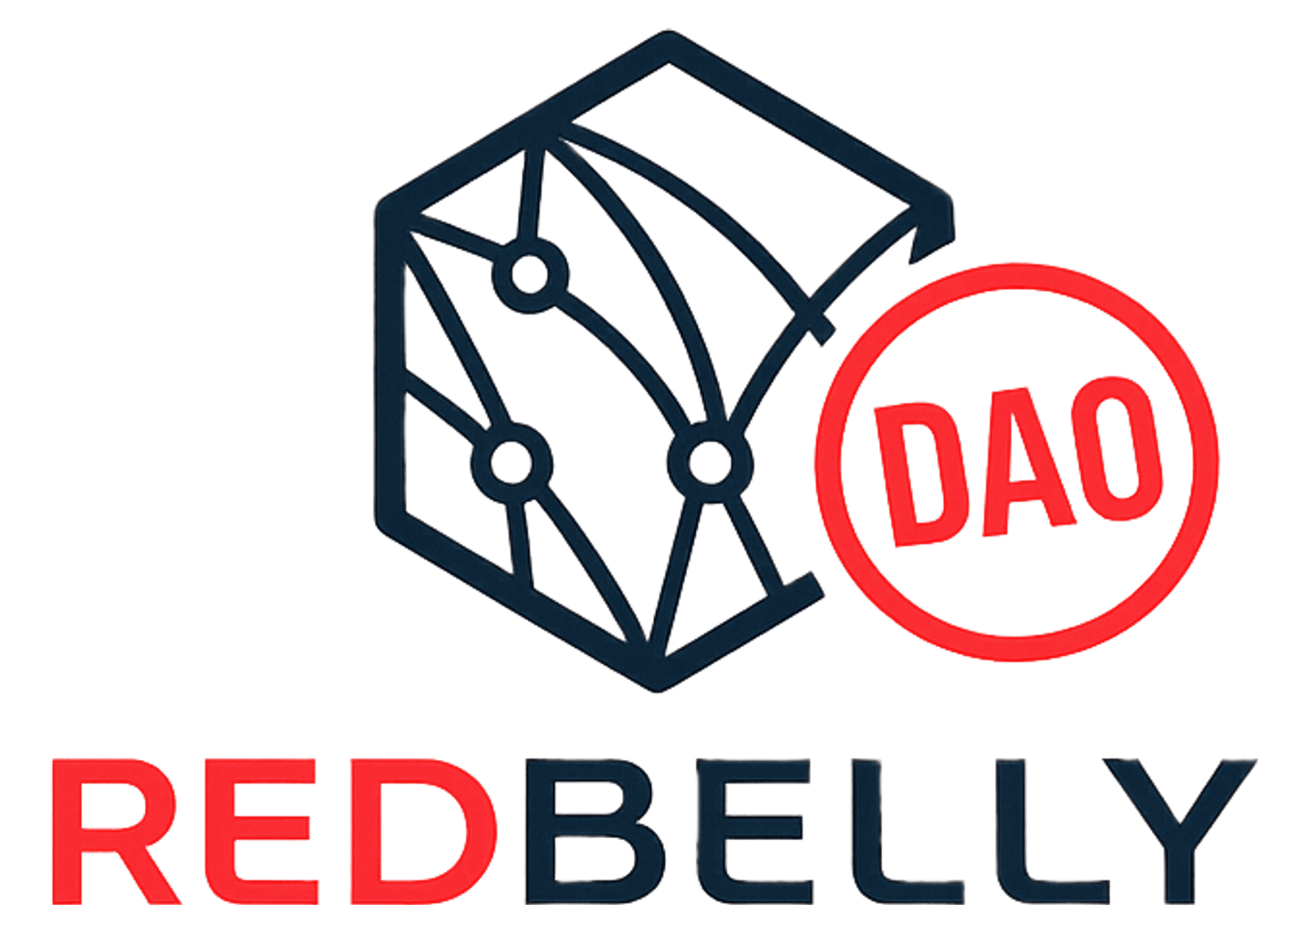
REDBELLY DAO MEMBER GUIDE

How DAO voting works now
DAO voting has moved off Snapshot. Members now vote on the Redbelly DAO governance platform, which was approved for continued use on 22 September 2026. This guide explains the rules as the platform applies them today: who can vote, when that is decided, and how many votes you get.
LAST VERIFIED 22 OCT 2026 7 SHORT PAGES

THE SHORT ANSWERS
Who can vote  Any wallet that is verified and enabled at Redbelly Access. Every proposal published on the platform today is open to verified wallets only. | When it is checked  At the snapshot, which is the moment a proposal is published. Your wallet must be enabled before that moment.
How many votes  One per verified wallet on proposals that count one verified address, one vote. Each wallet counts on its own. | What it costs  Nothing. A vote is a signed message, not a transaction. You pay no gas and nothing leaves your wallet.
STEP ZERO

Before you vote: verify a wallet
You do this once, at Redbelly Access, the official Redbelly Network portal. Skip ahead if your wallet already shows Account status: Enabled there.
- Connect your wallet. The portal names MetaMask and Coinbase Wallet. The address you connect becomes your public address on Redbelly Network.
- Verify your identity. Averer, the accredited issuer, checks your passport with a biometric check. The issuer covers the access fees.
- Enable the account. Once you are approved, press Enable account and sign in your wallet. When the portal shows Account status: Enabled, the wallet can vote on proposals published from then on.
The voting platform calls an enabled wallet one that holds a Receptor credential. In this guide, verified and enabled mean the same thing.
SECTION 1

How to vote, step by step
Once your wallet is enabled, voting takes about a minute. The steps use the button names on the platform.
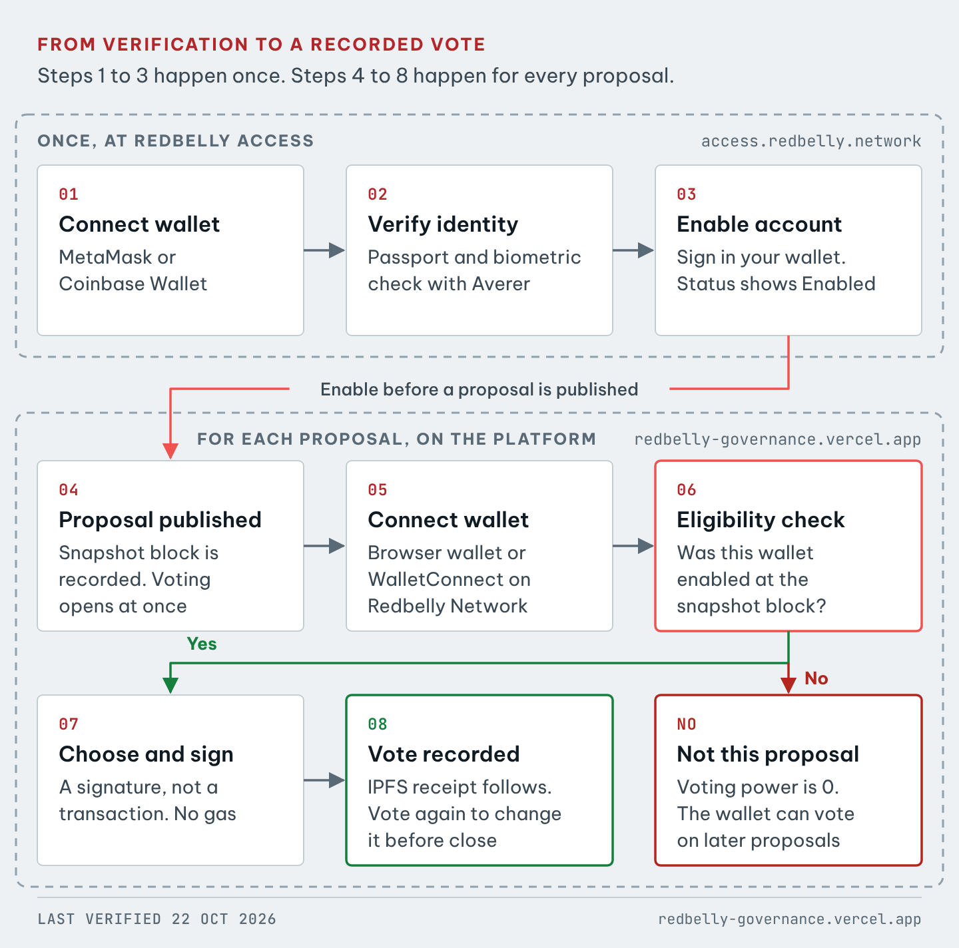
FIGURE 1 From verification to a recorded vote. Steps 1 to 3 happen once. Steps 4 to 8 happen for every proposal.
- Connect. Open redbelly-governance.vercel.app, press Connect wallet and choose Browser wallet or WalletConnect. On a phone, use WalletConnect or your wallet app's own browser.
- Switch network if asked. If you see Switch to Redbelly Network, press it. The platform only works on Redbelly Network, chain ID 151.
- Open a proposal. Under Proposals, pick an open one. The line under its title shows how votes are counted, for example One verified address, one vote.
- Check you are eligible. The Cast your vote panel should say Eligible to vote. Any other message is explained in Why can't I vote?
- Choose. Pick your option. Some proposals let you tick several options, split your power or rank them, and the panel shows how. You can add a reason. It is public.
- Review and sign. Press Review and sign, check your choice, then press Sign in wallet and approve in your wallet. This is a signed message, not a transaction: no gas, and nothing can move. The Wallet safety page shows exactly what you sign.
- Done. The panel shows Vote recorded. A View IPFS receipt link appears when the receipt is published. Your vote counts even before it appears.
Changing your vote
Until voting closes, press Change vote and sign again. Only the latest ballot from each wallet counts.

SECTION 2

When eligibility is checked
Once per proposal, at its snapshot. The snapshot is taken the moment the proposal is published.
- When a proposal is published, the platform records the latest Redbelly block. This is the snapshot block. Voting opens at the same time.
- When you connect, the platform checks whether your wallet was enabled at that block. On proposals weighted by RBNT, it also reads your RBNT balance at that block.
- The result is fixed until the proposal closes. Changes after the snapshot, such as enabling a wallet or buying RBNT, do not count for that proposal.
- Each proposal's Details tab shows its snapshot block. The Proposal Resubmission Policy (#f832b) uses block 3208192, produced at 06:47 UTC on 30 September 2026. Voting opened at 06:49 UTC.
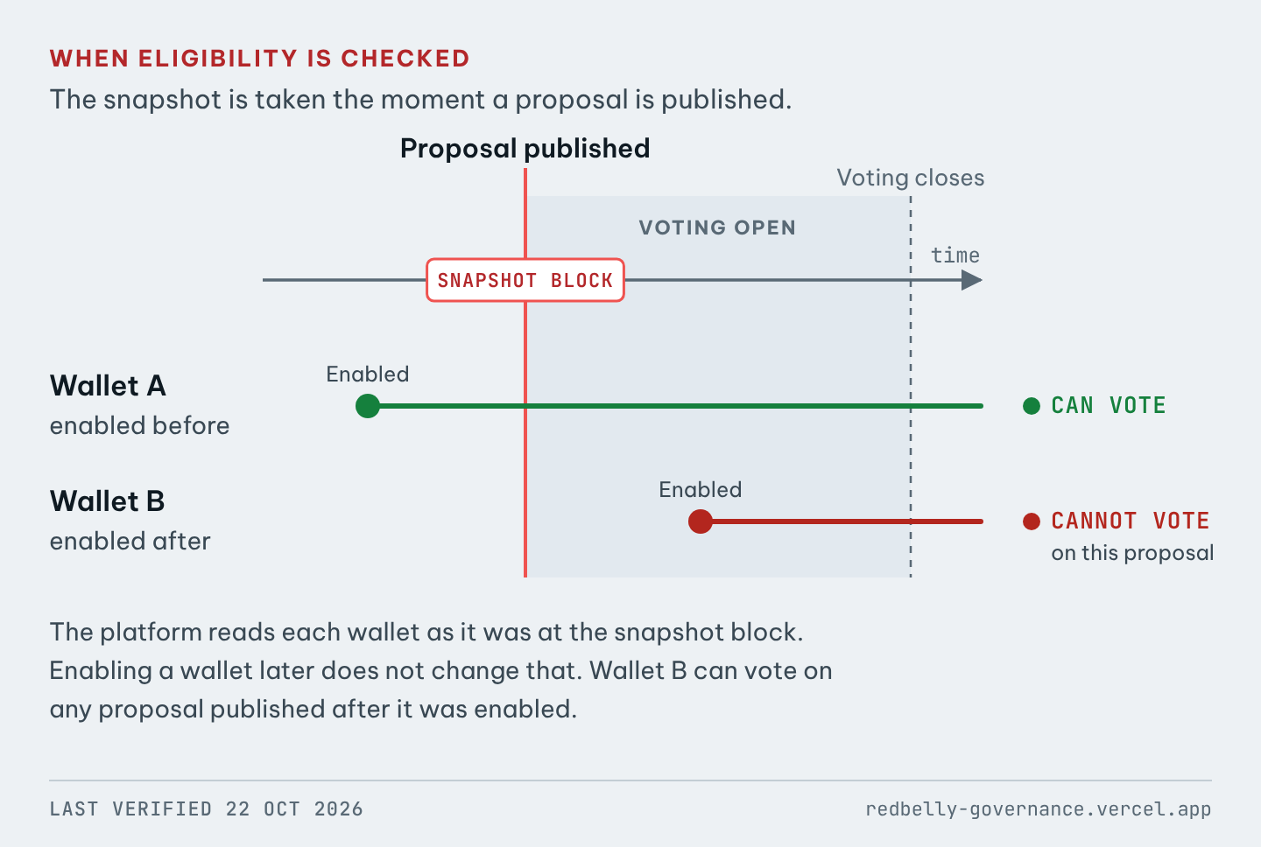
FIGURE 2 Eligibility is read at the snapshot block. Wallet A was enabled before it and can vote. Wallet B was enabled after it and cannot vote on this proposal.
SECTION 3

Why a wallet verified after a proposal opens cannot vote on it
Because the platform checks your wallet as it was at the snapshot block, and at that block the wallet was not enabled yet.
Enabling a wallet is a transaction on Redbelly Network, recorded in a block. A wallet enabled after the snapshot block has no access record at that block, so the platform gives it 0 voting power on that proposal. The list of wallets that can vote is fixed when voting starts.
The wallet is not locked out. It can vote on every proposal published after it was enabled.
TESTED ON 22 OCTOBER 2026
Four wallets enabled between 17 and 21 October 2026 show as verified on the platform today, yet each has 0 voting power on the Proposal Resubmission Policy, whose snapshot is from 30 September. The Redbelly access contract shows them as not enabled at block 3208192.

SECTION 4

How many votes you get
One vote per verified wallet, on proposals that count one verified address, one vote. The DAO's three most recent proposals, from 2 and 30 September 2026, were counted this way.
Each proposal sets its own voting power. It is shown under the title and in the Details tab, next to Strategy.
THE PROPOSAL SHOWS | YOUR VOTING POWER
One verified address, one vote, or Strategy verified-identity | 1 for each eligible wallet, whatever it holds
Strategy native-balance (RBNT balance) | The RBNT the wallet held at the snapshot block
Strategy erc20-balance (token balance) | The wallet's balance of the named token at the snapshot block

In every case the wallet must also have been enabled at the snapshot, because every proposal published today is open to verified wallets only.

One vote per verified account
Redbelly Access calls each wallet address an account. Each verified account gets one ballot per proposal. A second ballot from the same wallet replaces the first.

Several wallets under one verification
Redbelly Access lets one verified person link up to 10 wallets, with Add another account or Link another wallet. Each linked wallet is enabled separately.
The platform does not group wallets by person. Each wallet that was enabled before the snapshot is a separate verified account with one vote. A wallet enabled later, or never enabled, has no vote on that proposal. The platform states this itself: verified addresses are not necessarily unique people.
Some proposals ask members to vote from one wallet only. That request comes from the proposal's author, and the platform does not enforce it.
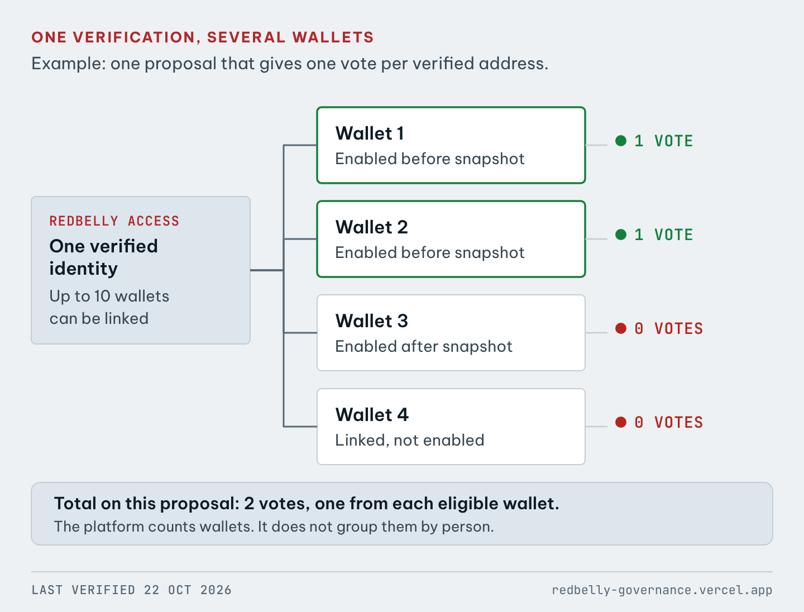
FIGURE 3 One verification, four linked wallets, one proposal. Only the wallets enabled before the snapshot can vote, and each counts once.
SECTION 5

Why can't I vote?
Find the message the platform shows you.
WHAT YOU SEE | WHAT IT MEANS | WHAT TO DO
Connect your wallet to check eligibility | No wallet is connected. | Press Connect wallet.
No wallet detected or No wallet in this browser | This browser has no wallet. | Install a browser wallet, open the site inside your wallet app, or use WalletConnect.
Switch to Redbelly Network | Your wallet is on another network. | Press it and approve the switch in your wallet.
Complete KYC to participate in DAO voting | This wallet is not verified and enabled. | Verify and enable it at Redbelly Access, then press Check again. It can vote on proposals published after that.
Connect an address that was verified at the proposal snapshot. | The wallet was not enabled at this proposal's snapshot. | Use a wallet that was enabled before the proposal was published, or wait for the next proposal.
This address held no voting power at the proposal snapshot. | The proposal is weighted by a balance, and the wallet held none at the snapshot block. | Use a wallet that held the asset at that time.
Eligibility unavailable | The check did not finish. | Press Check again. If it keeps failing, contact the proposal's organiser.
Voting closed | The deadline has passed. | Votes can no longer be cast or changed.

SECTION 6

Known limits of the current setup
What to expect from the platform as it works today.
- One vote per wallet, not per person. Up to 10 wallets can share one verification, and each enabled wallet votes on its own.
- Identity quorum counts wallets. When a proposal needs a minimum number of verified voters, the platform treats that number as a floor on wallets, not proof of that many separate people.
- No late entry. The snapshot is taken when the proposal is published. A wallet enabled even a minute later cannot vote on it.
- Proposals are fixed once open. A published proposal cannot be edited.
- Ballots are public. Each proposal lists every wallet that voted, its choice, its voting power and any reason.
- Ballots are kept by the platform, not on the blockchain. Each carries the voter's signature so anyone can check it. IPFS receipts can take a while to appear.
- Phones need a wallet app. Browser wallets only work inside a wallet app's own browser. WalletConnect works anywhere.
- Older proposals came from Snapshot. Proposals from before 28 August 2026 were imported from the DAO's old Snapshot space and are marked as imported.
SECTION 7

Words used in this guide
Wallet, address | An app such as MetaMask that holds your keys. Its address, starting 0x, is your public ID.
Redbelly Access | The official portal where you verify your identity and enable wallets.
Averer | The accredited issuer that checks your identity.
Enabled wallet | A verified wallet switched on at Redbelly Access. The platform says it holds a Receptor credential. Receptor is Redbelly's identity protocol.
Snapshot block | The latest Redbelly block when a proposal is published. Eligibility and balances are read there.
Voting power | How much a ballot counts. Set by the proposal's Strategy.
Signature | Approving a message in your wallet to prove the vote is yours. The format is called EIP-712.
Gas | A fee for sending a transaction. Voting sends none.
IPFS receipt | A public copy of your signed ballot on IPFS, a shared file network.
Quorum | The minimum turnout a proposal needs. Identity quorum counts distinct verified voters.
SECTION 8

How this guide was checked
Every rule here was checked against the live platform and Redbelly's public pages on 22 October 2026. Nothing comes from Snapshot or older guides.
- Governance platform: Overview, Wallet safety, New proposal and proposal pages with their Details tab.
- The platform's public data at /api/proposals, /api/power and /api/identity: strategy, snapshot block, voting power and verified status.
- Redbelly Access: its FAQ and account screens, including the 10 wallet limit.
- Redbelly Developer Portal, User access: how users claim an access credential and enable their account.
- Redbelly access contract on Routescan: the contract the platform checks, and the enable transactions used in the test above.
Every check, and how to repeat it, is in VERIFICATION.md.
This guide describes how voting works today. It does not propose changes to the voting rules.

