Build a Traffic Sign Recognition Project
The goals / steps of this project are the following:
- Load the data set (see below for links to the project data set)
- Explore, summarize and visualize the data set
- Design, train and test a model architecture
- Use the model to make predictions on new images
- Analyze the softmax probabilities of the new images
- Summarize the results with a written report

Rubric Points:
Here I will consider the rubric point individually and describe how I addressed each point in my implementation.
Writeup / README
1. Provide a Writeup / README that includes all the rubric points and how you addressed each one. You can submit your writeup as markdown or pdf. You can use this template as a guide for writing the report. The submission includes the project code.
Data Set Summary & Exploration
1. Provide a basic summary of the data set. In the code, the analysis should be done using python, numpy and/or pandas methods rather than hardcoding results manually.
The pandas library has been used to calculate properties of the traffic signs data sets:
- Number of training examples = 34799
- Number of validation examples = 4410
- Number of testing examples = 12630
- Image data shape = (32, 32, 3)
- Number of classes = 43

2. Include an exploratory visualization of the dataset.
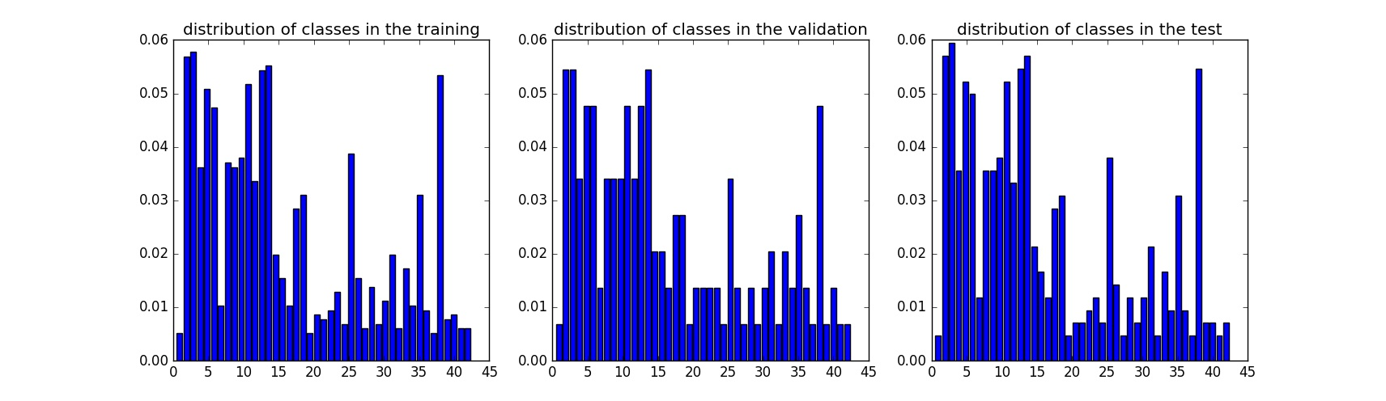
Design and Test a Model Architecture
- Describe how you preprocessed the image data. What techniques were chosen and why did you choose these techniques? Consider including images showing the output of each preprocessing technique. Pre-processing refers to techniques such as converting to grayscale, normalization, etc. (OPTIONAL: As described in the "Stand Out Suggestions" part of the rubric, if you generated additional data for training, describe why you decided to generate additional data, how you generated the data, and provide example images of the additional data. Then describe the characteristics of the augmented training set like number of images in the set, number of images for each class, etc.)
For the first proprocessing step, the raw images has been converted to grayscale because the RGB contains information which is not necessary import for the classifier.
The second preprocessing step is normalization which changes the grayscale images shape to (32,32,1)

2. Describe what your final model architecture looks like including model type, layers, layer sizes, connectivity, etc.) Consider including a diagram and/or table describing the final model.
My final model consisted of the following layers:

Layer | Description
Convolution 5*5 | Input:32*32*1,Output:28*28*6  Stride 1*1,valid padding
Relu
Pooling | Input:28*28*6 Output:14*14*6
Convolution 5*5 | Output:10*10*16  Stride 5*5,valid pudding
Relu
Pooling | Input:10*10*16 Output:5*5*16
Convolution | Output:1x1x400  Stride 5*5,valid pudding
Relu
Flatten | Input:1*1*400,Output:400
Flatten | Input:5*5*16, Output:400
Concat | Input:400,400 Ouput:800
Dropout
Fully connected | Input:800 Output:43

- Describe how you trained your model. The discussion can include the type of optimizer, the batch size, number of epochs and any hyperparameters such as learning rate.

AdamOptimizer is usually a more accuracy optimizer than others.
Based on some CNN research papers,80 is the value of epochs and 128 for batch size. Learning rate is set to be 0.0008.
After iterative trains, if the initial data is good, it takes 50 epochs to accuracy 0.93 but 80 epoch is an conservative choice.

- Describe the approach taken for finding a solution and getting the validation set accuracy to be at least 0.93. Include in the discussion the results on the training, validation and test sets and where in the code these were calculated. Your approach may have been an iterative process, in which case, outline the steps you took to get to the final solution and why you chose those steps. Perhaps your solution involved an already well known implementation or architecture. In this case, discuss why you think the architecture is suitable for the current problem.

Training result:
- validation set accuracy of 0.951
- test set accuracy of 0.924

If an iterative approach was chosen:
- What was the first architecture that was tried and why was it chosen?
LeNet-5 will be chosen with its high accuracy.
- What were some problems with the initial architecture?
The initial architecture shows a high accuracy for the training data but a low accuracy for the validation data. The best guess is that initial architecture over-fitting the training data especially after iterative trains.
- How was the architecture adjusted and why was it adjusted?
The dropout technique is used to solve the over-fitting problem
Two flatten layers are used based on ‘Traffic Sign Recognition with Multi-Scale Convolutional Networks’paper.

- Which parameters were tuned? How were they adjusted and why?
The epochs has been 100 at the very first and than decrease to 50 after several iterates.And 80 is chosen when considering a random initialization.
- What are some of the important design choices and why were they chosen?
The layout of the CNN with two Flatten layers.
The dropout technique to solve over-fitting problem.

If a well known architecture was chosen:
- What architecture was chosen?
LeNet
- Why did you believe it would be relevant to the traffic sign application?
Because LeNet has been widely used in image classification problems.
- How does the final model's accuracy on the training, validation and test set provide evidence that the model is working well?
The accuracy of the test data is 0.924 which is better than normal human being.
Test a Model on New Images
- Choose five German traffic signs found on the web and provide them in the report. For each image, discuss what quality or qualities might be difficult to classify.
Five Germany traffic signs:
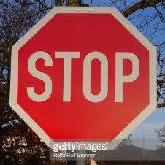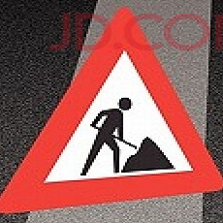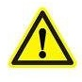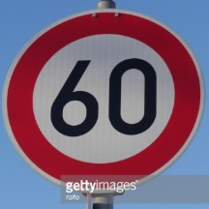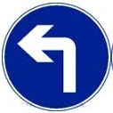
The first and second pictures maybe difficult because of the background.

- Discuss the model's predictions on these new traffic signs and compare the results to predicting on the test set. At a minimum, discuss what the predictions were, the accuracy on these new predictions, and compare the accuracy to the accuracy on the test set (OPTIONAL: Discuss the results in more detail as described in the "Stand Out Suggestions" part of the rubric).

Here are the results of the prediction:
Image | Prediction
Stop | Stop
Road work | Road work
General caution | General caution
Speed limit(60km/h) | Speed limit(60km/h)
Turn left ahead | Turn left ahead

Five of the five traffic signs have been classified corrected which gives a 100% accuracy and it is higher than test data accuracy.

- Describe how certain the model is when predicting on each of the five new images by looking at the softmax probabilities for each prediction. Provide the top 5 softmax probabilities for each image along with the sign type of each probability. (OPTIONAL: as described in the "Stand Out Suggestions" part of the rubric, visualizations can also be provided such

The top five soft max probabilities of the first image:
Probability | Prediction
1.00 | Stop
2.76e-09 | Speed limit(30km/h)
1.99e-09 | Keep right
1.38e-09 | Turn right ahead
3.73e-10 | Yield

The second image:
Probability | Prediction
O.99 | Road work
4.94e-04 | Dangerous curve to the right
3.52e-04 | Right-of-way at the next intersection
8.18e-15 | Pedestrians
2.42e-27 | Children crossing

The third image:
Probability | Prediction
1.00 | General caution
4.23e-25 | Traffic signals
1.22e-34 | Go straight or left
0 | Speed limit(20km/h)
0 | Speed limit(30km/h)

The fourth image:
Probability | Prediction
1 | Speed limit(60km/h)
3.39e-12 | Ahead only
6.22e-14 | Speed limit(30km/h)
8.30e-17 | Speed limit(50km/h)
5.94e-17 | Speed limit(80km/h)

The fifth image:
Probability | Prediction
1.00 | Turn left ahead
3.97e-13 | Ahead only
1.05e-26 | Right-of-way at the next intersection
2.62e-17 | Roundabout mandatory
4.65e-29 | Speed limit(30km/h)

