Luciana V. Frutos Ramos

Project 8 - Enhance an existing project

Testing the performance of our app against the competition:

Our App – Todos

Competitor – todolistme.net

The following tests compare and show the performance of our app and the competition. By mimicking the conditions of usage to run tests on the dev console from google chrome and determine any enhancement needed.

Performance test

Our app, Todos, has a faster page load time and less requests than the competition:

**Todos**

* Page load time: 122 ms
* Requests: 13
* DOM fully loaded: 13ms
* Responsive: yes

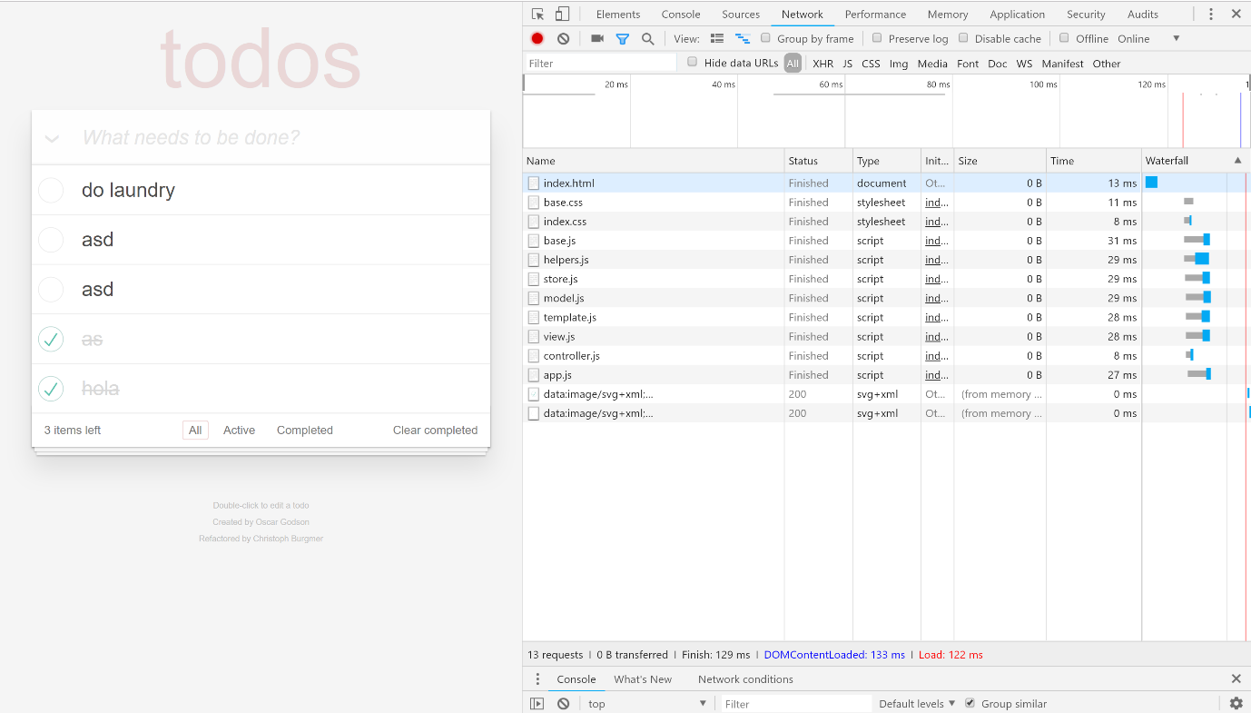

**todolistme.net**

* Page load time: 11.36 s
* Requests: 67
* DOM fully loaded: 1.15s
* Responsive: no

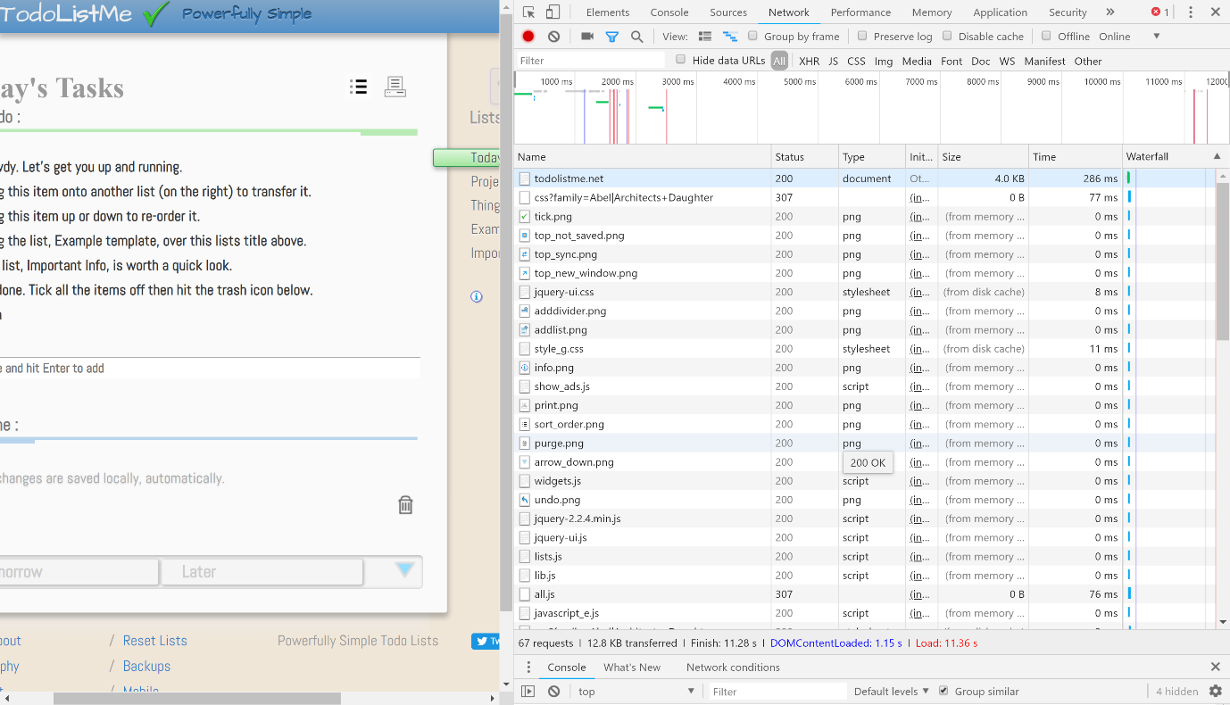

Testing the performance during usage

**Creating a new task**

The following metrics show a recording when adding new tasks.

For **Todos** takes:

* 33.4 ms of scripting, 34.8 ms to render the DOM and 10.3 ms of painting the new item.

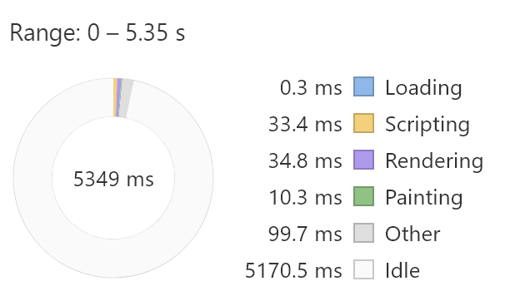

For **Todolistme.net** takes:

* 213.8 ms of scripting, 123.4 ms to render the DOM and 123.4 ms to paint the new item.

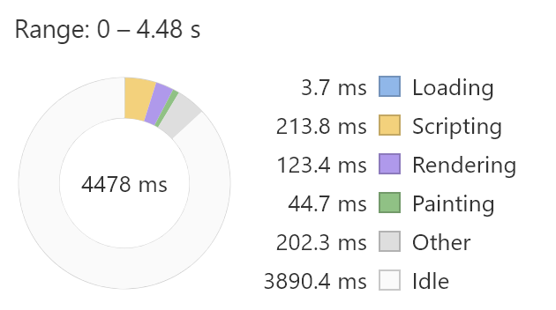

**Deleting a task**

The following metrics shows a recording when deleting tasks.

For **Todos** takes:

* 38.8 ms of scripting, 15.9 ms to render the DOM and 6.1 ms of painting the new item.

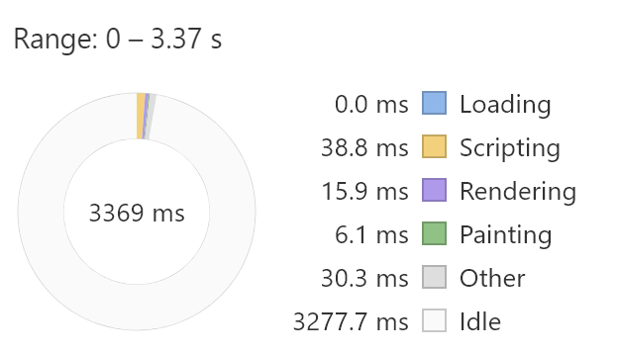

For **Todolistme.net** takes:

* 206.8 ms of scripting, 181.3 ms to render the DOM and 57.1 ms to paint the new item.

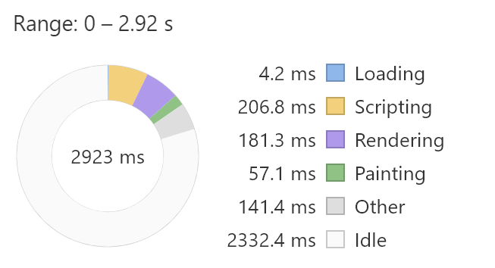

**Switching over filters**

The following metrics shows a recording while making any GIT requests in the app.

In the case of **Todos** app the filters are All, Complete and Active and it takes:

* 38.8 ms of scripting, 15.9 ms to render the DOM and 6.1 ms of painting the new item.

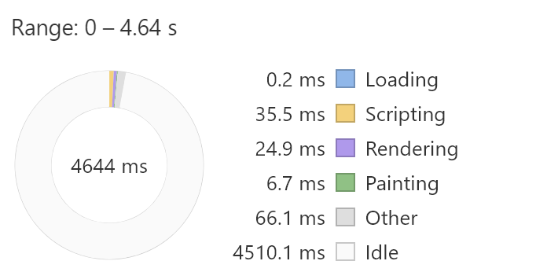

In the case of **Todolistme.net** app the filters Lists and it takes:

* 206.8 ms of scripting, 181.3 ms to render the DOM and 57.1 ms to paint the new item.

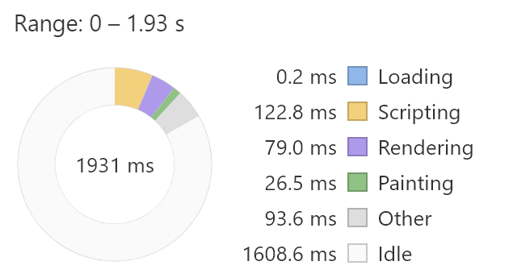

**Conclusion**

In conclusion, Todos app has a better performance compared to todolistme.net and is written in a cleaner and better JavaScript. However, there is some room for improvement such as using a tool that merges all scripts into one for fast loading and another for code optimization such as JSMin, which obfuscates the code, deletes spaces and comments.