Process flow
for
Tokenized KYC

Table of Contents
High level Process flow: 3
Process flow for a mid sized nbfc: 4
Process flow for mid sized nbfc: Addendum: 5

High level Process flow:
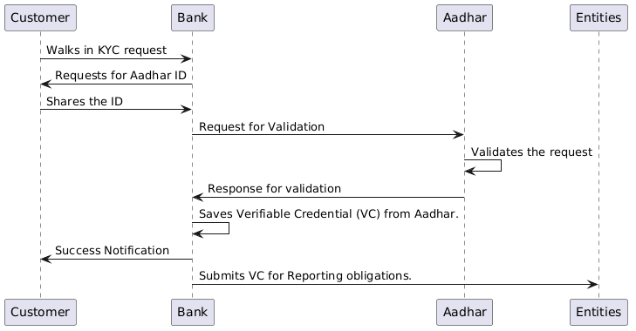

Process flow for a mid sized nbfc:
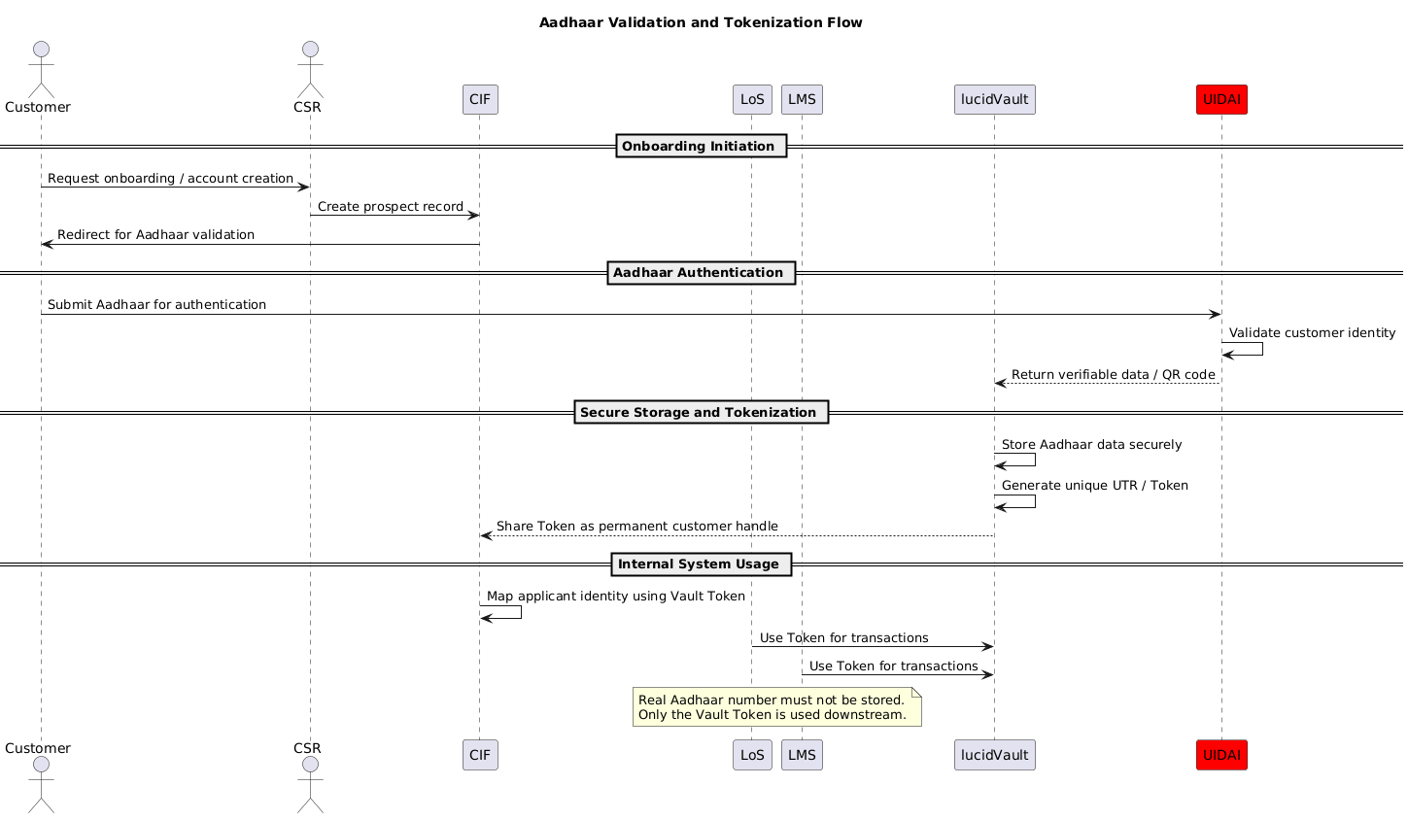

Process flow for mid sized nbfc: Addendum:
