- DQN for MsPacman-v5
- Training curve: // set smoothing in 0.99
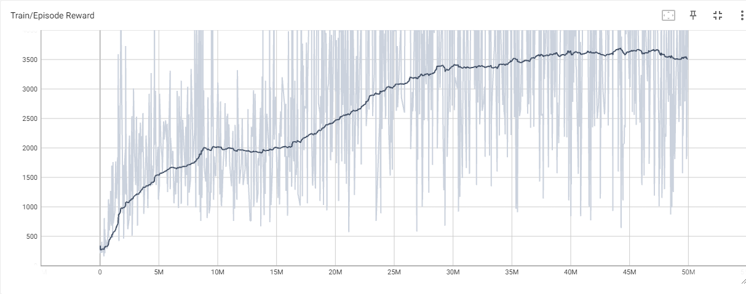
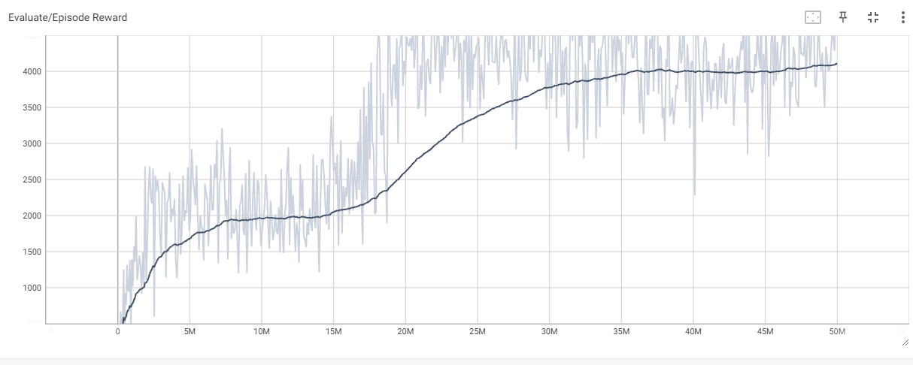

- Testing results (5 games):
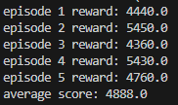
- DQN for Enduro-v5
- Training curve: // set smoothing in 0.99
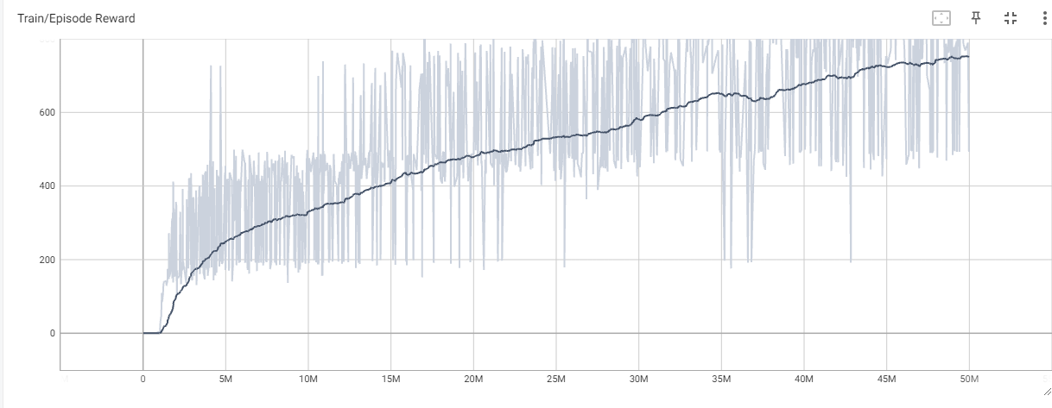
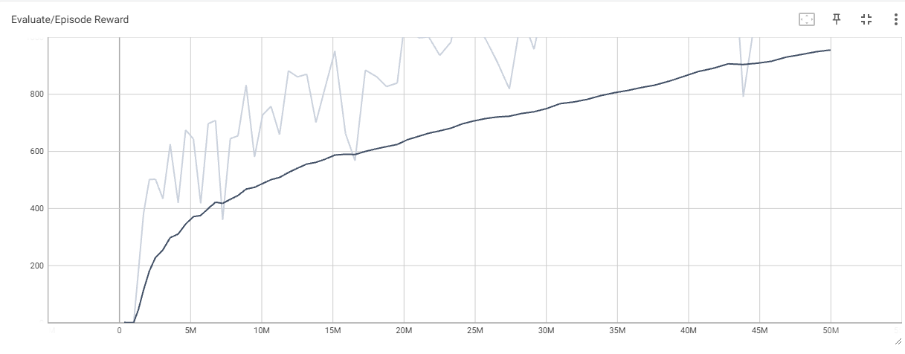
- Testing results (5 games):


