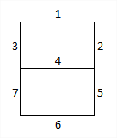

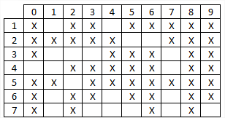

1

AB

CD

10

11

00 ²

01

|  |  |  |  |
| --- | --- | --- | --- |
| X |  |  | X $$\overline{A}C+ A\overline{B}\overline{C}+ \overline{B}\overline{C}\overline{D}+ \overline{A}B\overline{C}D$$ |
|  | X |  |  |
| X | X |  |  |
| X | X |  |  |

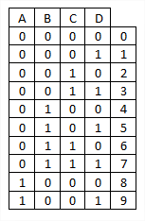

00

10

11

01

|  |  |  |  |
| --- | --- | --- | --- |
| X | X |  | X $$\overline{A}\overline{B}+ \overline{B}\overline{C}+ \overline{A}\overline{C}\overline{D}+ \overline{A}CD$$ |
| X |  |  | X |
| X | X |  |  |
| X |  |  |  |

3

AB

10

10

11

11

01

01

00

00

AB

CD

2

|  |  |  |  |
| --- | --- | --- | --- |
| X | X |  | X $$\overline{A}B\overline{C}+ A\overline{B}\overline{C}+ \overline{A}B\overline{D}+ \overline{A}\overline{C}\overline{D}$$ |
|  | X |  | X |
|  |  |  |  |
|  | X |  |  |

CD

10

10

11

11

01

01

00

00

|  |  |  |  |
| --- | --- | --- | --- |
|  | X |  | X $$\overline{A}B\overline{C}+ \overline{A}\overline{B}C+ \overline{A}C\overline{D}+ A\overline{B}\overline{C}$$ |
|  | X |  | X |
| X |  |  |  |
| X | X |  |  |

4

5

AB

10

11

01

00

AB

CD

10

10

11

11

01

00

01

00

|  |  |  |  |
| --- | --- | --- | --- |
| X | X |  | X $$\overline{A}\overline{C}+ \overline{A}D+ \overline{A}B+ \overline{B}\overline{C}$$ |
| X | X |  | X |
| X | X |  |  |
|  | X |  |  |

CD

10

11

01

00

6

7

CD

AB

AB

10

10

11

11

01

01

00

00

|  |  |  |  |
| --- | --- | --- | --- |
| X |  |  | X $$\overline{A}\overline{B}C+\overline{A}C\overline{D}+ \overline{B}\overline{C}\overline{D}+ \overline{A}B\overline{C}D+A\overline{B}\overline{C}$$ |
|  | X |  | X |
| X |  |  |  |
| X | X |  |  |

|  |  |  |  |
| --- | --- | --- | --- |
| X |  |  | X $$\overline{B}\overline{C}\overline{D}+ \overline{A}C\overline{D}$$ |
|  |  |  |  |
|  |  |  |  |
| X | X |  |  |

CD

00

00

11

11

01

01

10

10