Homework 3

Modification to the datapaths and state machines
As asked we changed our datapaths and our state diagrams to make the cache become a write-through and write-no-allocate cache. We dropped the write-back behaviour.

- State machines modifications

Cache Controller Read

Here we removed the states « wait bus grant writeback » and « wait bus grant complete », and changed the transitions to be adequate.

Cache Controller Write

Here, we only removed the « tagWrDirty » signal, because it does not more exist because we removed the write-back and replaced it with a write-through.

Bus Controller State machine :

TODO

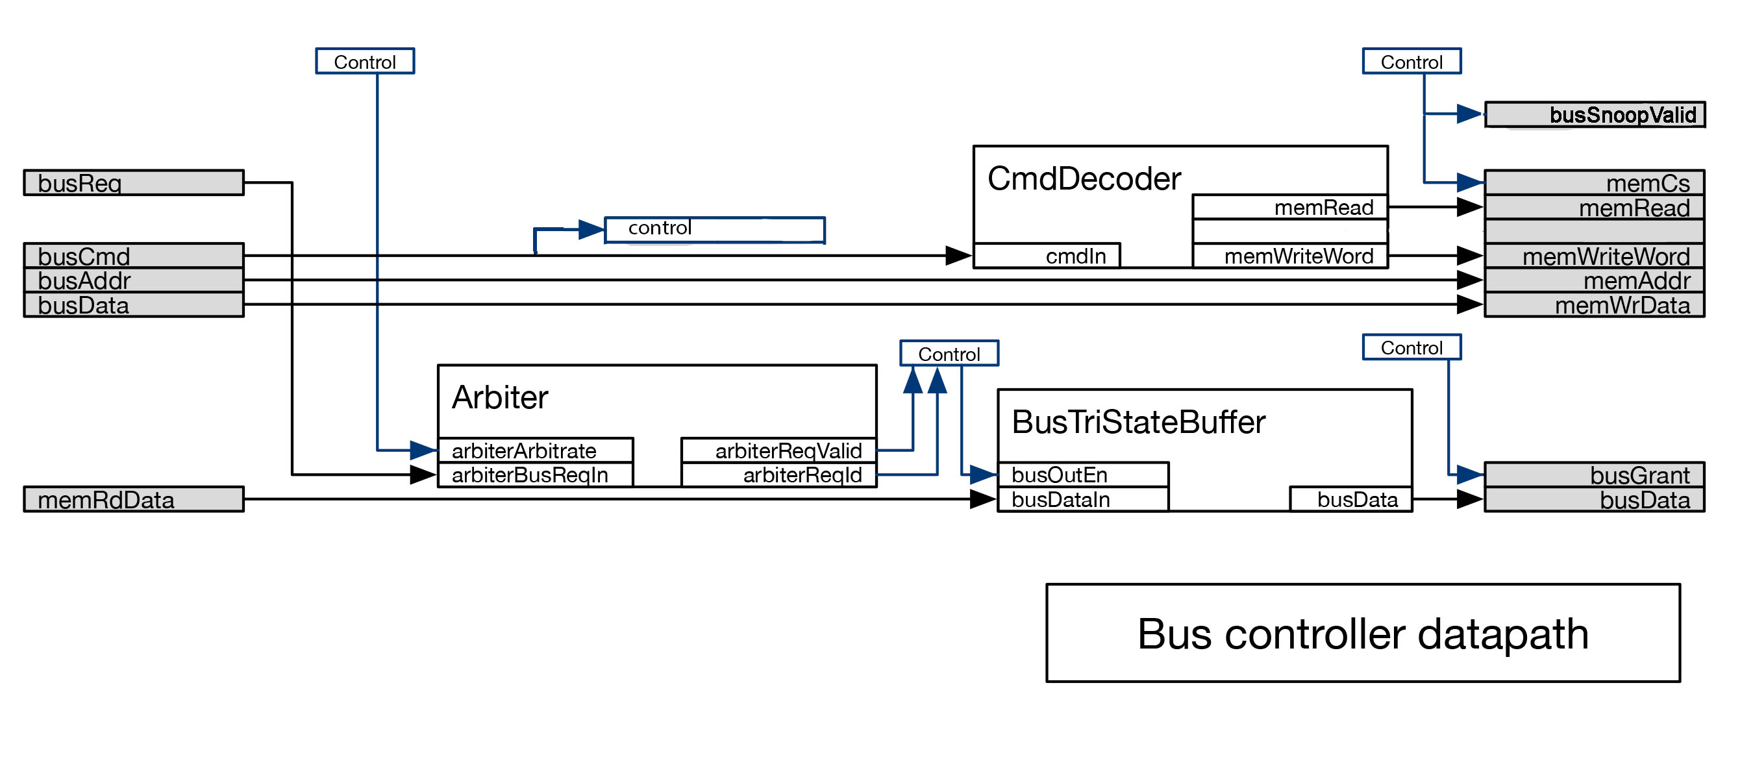
- Datapaths modifications

New state machine : Snoop Machine

New interface for the tag array

Regsiters that must remain and the ones that should be removed
Corners cases

