Databases Project – Spring 2017
Prof. Anastasia Ailamaki
Team No: 14
Names: Perrotta Lucie, Phan Hoang Kim Lan, Nguyen Tim
Contents
Deliverable 1 2
Deliverable 1 2
Assumptions 2
Entity Relationship Schema 2
Schema 2
Description 2
Relational Schema 3
ER schema to Relational schema 3
DDL 5
Deliverable 2 15
Assumptions 15
Parsing and cleaning of the data 16
Query Implementation 26
Deliverable 3 29
Assumptions 29
Query Implementation 29
Query Analysis 29
Selected Queries (and why) 29
Query 1 29
Query 2 29
Query 3 29
Interface 30
Design logic Description 30
Screenshots 30
General Comments 30

Deliverable 1

Assumptions
The assumptions we made were that we are supposed to delete and to create some tables from the data to optimize the efficiency and the size of our DB.
Here are our assumptions :
- If one person has written thousands of books, it would be a loss of space to copy their name in every issue whey worked in. Instead, we would create a table “artist” with this person inside, and just this person’s id to all the books they have written
- Having just the price as an attribute for “issue” is not possible because there exists different currencies for the prices of the issues. So we added a table “price” related to the “issue” table to take into account the currency and the amount in this currency.
- The table “genre” that we have created is not essential but we did this for some efficiency purpose. This is faster to get our genres in a table as as an attribute.

Entity Relationship Schema

Description
We translated the given dataset description into entities. We add some entities to better sort data :
- Artist : id, name which describe the different persons for a story
- Price : id, amount, currency which describe the different prices for an issue
- Genre : id, name which describe the different genres of stories
- Website : id, url which describe the different URLs of the indicia publishers, the publishers and the brand groups
- Character : id, name which describe the different characters in a story
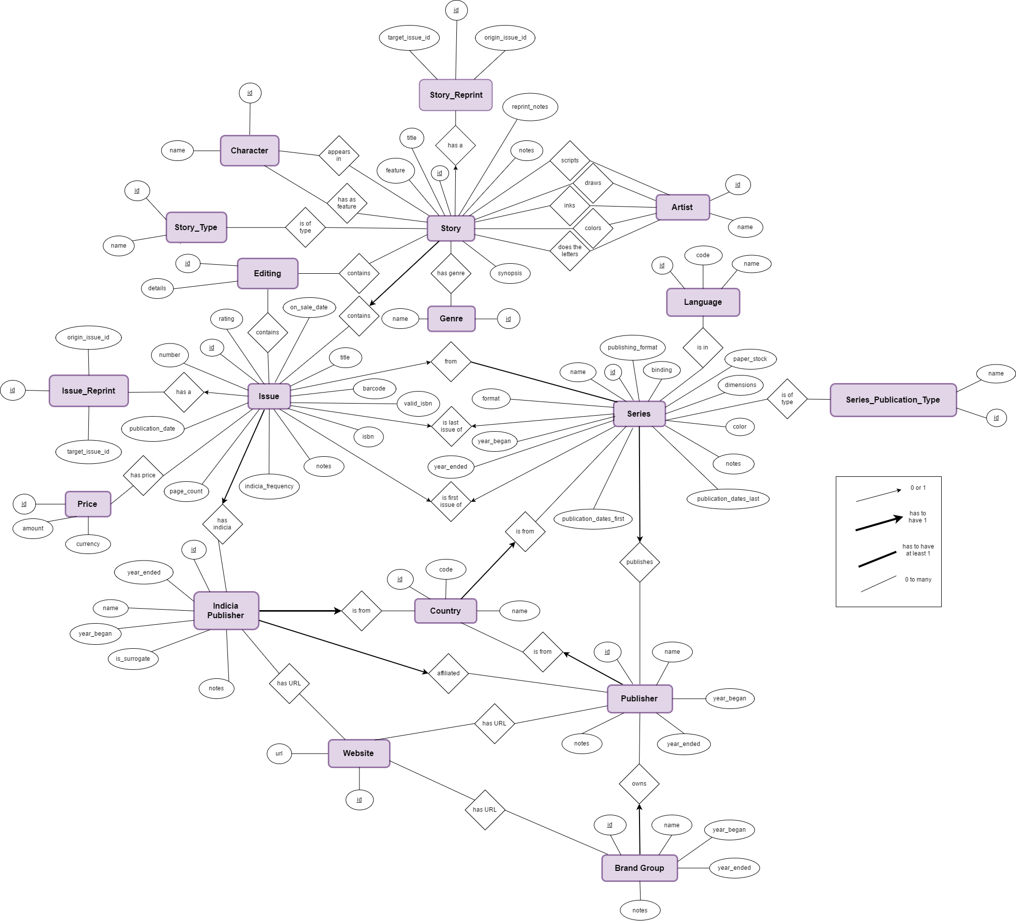
- Editing : id, details which describe the different editing details about a story or an issue

We then linked the “artist” table to the story table through multiples relations :
- scripts : describing the story author(s)
- draws : describing the artist(s) who did the drawing
- inks : describing the artist(s) who did the inking
- colors : describing the artist(s) who added color to non-colored artwork
- does the letters : describing the creator(s) or studio(s) that did the lettering/typesetting

Similarily, we linked the price entity to the issue entity through the “has_price” relationship, since a single issue can have many prices, expressed in many currencies.

We also created a table “character” and linked it to the story entity with the “has as feature” and “appears in” relations, since some famous characters are featured in many stories (superheroes typically).
Similarly, we created an entity Genre, since a story may have many genre, common with other series.
We created an entity Website as the brands/incidia/publisher share common websites.

Relational Schema

ER schema to Relational schema
The translation straightly follows a certain logic. For each entity in the ER model we create a table. The arrow types have been translated in relations tables and foreign keys.

- For each relation 1 to 1 between entity A and entity B, we directly replaced the B’s name in A’s attributes by an id B_id, and set it as a foreign key pointing on B’s id itself.

- For each relation from 1 to n, we created an intermediate table “has_...” containing relations. A relation is composed of both ids of the two entities connected through this relation, and the id of the relation. This relation table contains then 2 foreign keys, pointing on both entities related. We hence have 7 “has tables”, for connecting for instance artists with the story they’ve been working on, or also for connecting the many prices an issue could have.

We then deleted all the “artist fields, cost field, etc…”, i.e. “inks, pencils etc.” since entities are directly connected through the relation.

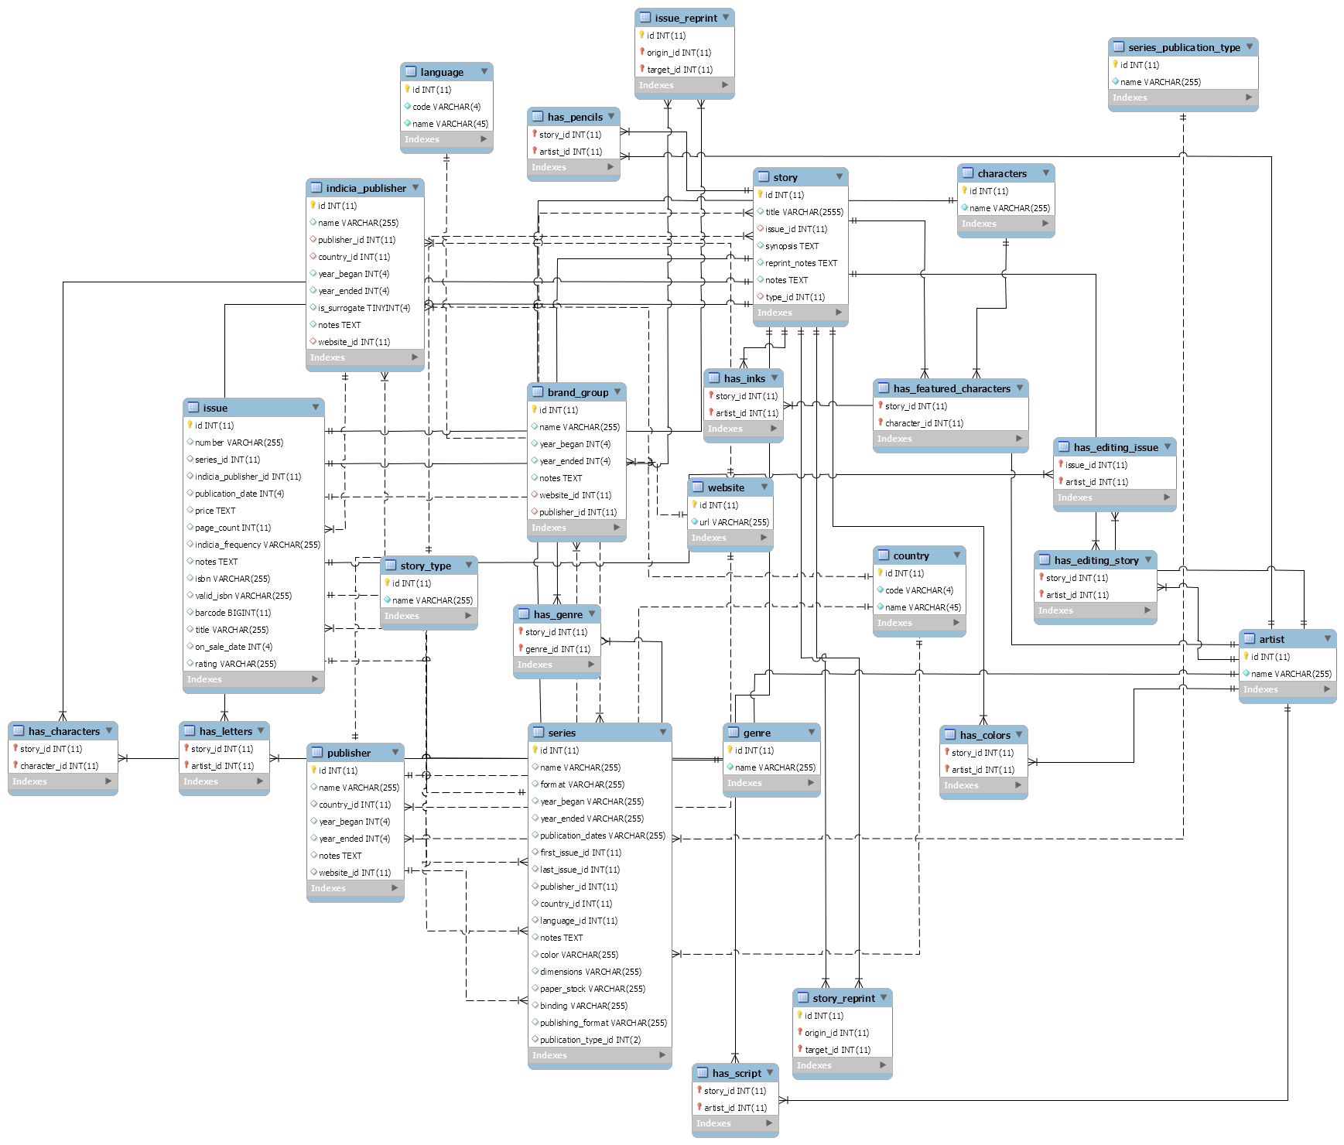

DDL
- -----------------------------------------------------
-- Table `mydb`.`artist`
-- -----------------------------------------------------
CREATE TABLE IF NOT EXISTS `mydb`.`artist` (
`id` INT(11) NOT NULL,
`name` VARCHAR(255) NOT NULL,
PRIMARY KEY (`id`))
ENGINE = InnoDB
DEFAULT CHARACTER SET = utf8;

-- -----------------------------------------------------
-- Table `mydb`.`country`
-- -----------------------------------------------------
CREATE TABLE IF NOT EXISTS `mydb`.`country` (
`id` INT(11) NOT NULL,
`code` VARCHAR(4) NOT NULL,
`name` VARCHAR(45) NOT NULL,
PRIMARY KEY (`id`))
ENGINE = InnoDB
DEFAULT CHARACTER SET = utf8;

-- -----------------------------------------------------
-- Table `mydb`.`website`
-- -----------------------------------------------------
CREATE TABLE IF NOT EXISTS `mydb`.`website` (
`id` INT(11) NOT NULL,
`url` VARCHAR(255) NOT NULL,
PRIMARY KEY (`id`))
ENGINE = InnoDB
DEFAULT CHARACTER SET = utf8;

-- -----------------------------------------------------
-- Table `mydb`.`publisher`
-- -----------------------------------------------------
CREATE TABLE IF NOT EXISTS `mydb`.`publisher` (
`id` INT(11) NOT NULL,
`name` VARCHAR(255) NULL DEFAULT NULL,
`country_id` INT(11) NULL DEFAULT NULL,
`year_began` INT(4) NULL DEFAULT NULL,
`year_ended` INT(4) NULL DEFAULT NULL,
`notes` TEXT NULL DEFAULT NULL,
`website_id` INT(11) NULL DEFAULT NULL,
PRIMARY KEY (`id`),
INDEX `country_id_idx` (`country_id` ASC),
INDEX `website_id` (`website_id` ASC),
CONSTRAINT `country_id_publisher`
FOREIGN KEY (`country_id`)
REFERENCES `mydb`.`country` (`id`)
ON DELETE SET NULL
ON UPDATE NO ACTION,
CONSTRAINT `website_id_publisher`
FOREIGN KEY (`website_id`)
REFERENCES `mydb`.`website` (`id`)
ON DELETE SET NULL
ON UPDATE NO ACTION)
ENGINE = InnoDB
DEFAULT CHARACTER SET = utf8;

-- -----------------------------------------------------
-- Table `mydb`.`brand_group`
-- -----------------------------------------------------
CREATE TABLE IF NOT EXISTS `mydb`.`brand_group` (
`id` INT(11) NOT NULL,
`name` VARCHAR(255) NULL DEFAULT NULL,
`year_began` INT(4) NULL DEFAULT NULL,
`year_ended` INT(4) NULL DEFAULT NULL,
`notes` TEXT NULL DEFAULT NULL,
`website_id` INT(11) NULL DEFAULT NULL,
`publisher_id` INT(11) NULL DEFAULT NULL,
PRIMARY KEY (`id`),
INDEX `publisher_id_idx` (`publisher_id` ASC),
INDEX `website_id` (`website_id` ASC),
CONSTRAINT `publisher_id_brand`
FOREIGN KEY (`publisher_id`)
REFERENCES `mydb`.`publisher` (`id`)
ON DELETE SET NULL
ON UPDATE NO ACTION,
CONSTRAINT `website_id_brand`
FOREIGN KEY (`website_id`)
REFERENCES `mydb`.`website` (`id`)
ON DELETE NO ACTION)
ENGINE = InnoDB
DEFAULT CHARACTER SET = utf8;

-- -----------------------------------------------------
-- Table `mydb`.`characters`
-- -----------------------------------------------------
CREATE TABLE IF NOT EXISTS `mydb`.`characters` (
`id` INT(11) NOT NULL,
`name` VARCHAR(255) NOT NULL,
PRIMARY KEY (`id`))
ENGINE = InnoDB
DEFAULT CHARACTER SET = utf8;

-- -----------------------------------------------------
-- Table `mydb`.`genre`
-- -----------------------------------------------------
CREATE TABLE IF NOT EXISTS `mydb`.`genre` (
`id` INT(11) NOT NULL,
`name` VARCHAR(255) NOT NULL,
PRIMARY KEY (`id`))
ENGINE = InnoDB
DEFAULT CHARACTER SET = utf8;

-- -----------------------------------------------------
-- Table `mydb`.`indicia_publisher`
-- -----------------------------------------------------
CREATE TABLE IF NOT EXISTS `mydb`.`indicia_publisher` (
`id` INT(11) NOT NULL,
`name` VARCHAR(255) NULL DEFAULT NULL,
`publisher_id` INT(11) NULL DEFAULT NULL,
`country_id` INT(11) NULL DEFAULT NULL,
`year_began` INT(4) NULL DEFAULT NULL,
`year_ended` INT(4) NULL DEFAULT NULL,
`is_surrogate` TINYINT(4) NULL DEFAULT NULL,
`notes` TEXT NULL DEFAULT NULL,
`website_id` INT(11) NULL DEFAULT NULL,
PRIMARY KEY (`id`),
INDEX `publisher_id_idx` (`publisher_id` ASC),
INDEX `country_id_idx` (`country_id` ASC),
INDEX `website_id` (`website_id` ASC),
CONSTRAINT `country_id_indicia`
FOREIGN KEY (`country_id`)
REFERENCES `mydb`.`country` (`id`)
ON DELETE SET NULL
ON UPDATE NO ACTION,
CONSTRAINT `publisher_id_indicia`
FOREIGN KEY (`publisher_id`)
REFERENCES `mydb`.`publisher` (`id`)
ON DELETE SET NULL
ON UPDATE NO ACTION,
CONSTRAINT `website_id_indicia`
FOREIGN KEY (`website_id`)
REFERENCES `mydb`.`website` (`id`)
ON DELETE SET NULL
ON UPDATE NO ACTION)
ENGINE = InnoDB
DEFAULT CHARACTER SET = utf8;

-- -----------------------------------------------------
-- Table `mydb`.`language`
-- -----------------------------------------------------
CREATE TABLE IF NOT EXISTS `mydb`.`language` (
`id` INT(11) NOT NULL,
`code` VARCHAR(4) NOT NULL,
`name` VARCHAR(45) NOT NULL,
PRIMARY KEY (`id`))
ENGINE = InnoDB
DEFAULT CHARACTER SET = utf8;

-- -----------------------------------------------------
-- Table `mydb`.`series_publication_type`
-- -----------------------------------------------------
CREATE TABLE IF NOT EXISTS `mydb`.`series_publication_type` (
`id` INT(11) NOT NULL,
`name` VARCHAR(255) NOT NULL,
PRIMARY KEY (`id`))
ENGINE = InnoDB
DEFAULT CHARACTER SET = utf8;

-- -----------------------------------------------------
-- Table `mydb`.`series`
-- -----------------------------------------------------
CREATE TABLE IF NOT EXISTS `mydb`.`series` (
`id` INT(11) NOT NULL,
`name` VARCHAR(255) NULL DEFAULT NULL,
`format` VARCHAR(255) NULL DEFAULT NULL,
`year_began` VARCHAR(255) NULL DEFAULT NULL,
`year_ended` VARCHAR(255) NULL DEFAULT NULL,
`publication_dates` VARCHAR(255) NULL DEFAULT NULL,
`first_issue_id` INT(11) NULL DEFAULT NULL,
`last_issue_id` INT(11) NULL DEFAULT NULL,
`publisher_id` INT(11) NULL DEFAULT NULL,
`country_id` INT(11) NULL DEFAULT NULL,
`language_id` INT(11) NULL DEFAULT NULL,
`notes` TEXT NULL DEFAULT NULL,
`color` VARCHAR(255) NULL DEFAULT NULL,
`dimensions` VARCHAR(255) NULL DEFAULT NULL,
`paper_stock` VARCHAR(255) NULL DEFAULT NULL,
`binding` VARCHAR(255) NULL DEFAULT NULL,
`publishing_format` VARCHAR(255) NULL DEFAULT NULL,
`publication_type_id` INT(2) NULL DEFAULT NULL,
PRIMARY KEY (`id`),
INDEX `first_issue_id_idx` (`first_issue_id` ASC),
INDEX `last_issue_id_idx` (`last_issue_id` ASC),
INDEX `publisher_id_idx` (`publisher_id` ASC),
INDEX `country_id_idx` (`country_id` ASC),
INDEX `language_id_idx` (`language_id` ASC),
INDEX `publication_type_id` (`publication_type_id` ASC),
CONSTRAINT `country_id_series`
FOREIGN KEY (`country_id`)
REFERENCES `mydb`.`country` (`id`)
ON DELETE SET NULL
ON UPDATE NO ACTION,
CONSTRAINT `first_issue_id_series`
FOREIGN KEY (`first_issue_id`)
REFERENCES `mydb`.`issue` (`id`)
ON DELETE SET NULL
ON UPDATE NO ACTION,
CONSTRAINT `language_id_series`
FOREIGN KEY (`language_id`)
REFERENCES `mydb`.`language` (`id`)
ON DELETE SET NULL
ON UPDATE NO ACTION,
CONSTRAINT `last_issue_id_series`
FOREIGN KEY (`last_issue_id`)
REFERENCES `mydb`.`issue` (`id`)
ON DELETE SET NULL
ON UPDATE NO ACTION,
CONSTRAINT `publication_type_id_series`
FOREIGN KEY (`publication_type_id`)
REFERENCES `mydb`.`series_publication_type` (`id`)
ON DELETE NO ACTION
ON UPDATE NO ACTION,
CONSTRAINT `publisher_id_series`
FOREIGN KEY (`publisher_id`)
REFERENCES `mydb`.`publisher` (`id`)
ON DELETE SET NULL
ON UPDATE NO ACTION)
ENGINE = InnoDB
DEFAULT CHARACTER SET = utf8;

-- -----------------------------------------------------
-- Table `mydb`.`issue`
-- -----------------------------------------------------
CREATE TABLE IF NOT EXISTS `mydb`.`issue` (
`id` INT(11) NOT NULL,
`number` VARCHAR(255) NULL DEFAULT NULL,
`series_id` INT(11) NULL DEFAULT NULL,
`indicia_publisher_id` INT(11) NULL DEFAULT NULL,
`publication_date` INT(4) NULL DEFAULT NULL,
`price` TEXT NULL DEFAULT NULL,
`page_count` INT(11) NULL DEFAULT NULL,
`indicia_frequency` VARCHAR(255) NULL DEFAULT NULL,
`notes` TEXT NULL DEFAULT NULL,
`isbn` VARCHAR(255) NULL DEFAULT NULL,
`valid_isbn` VARCHAR(255) NULL DEFAULT NULL,
`barcode` BIGINT(11) NULL DEFAULT NULL,
`title` VARCHAR(255) NULL DEFAULT NULL,
`on_sale_date` INT(4) NULL DEFAULT NULL,
`rating` VARCHAR(255) NULL DEFAULT NULL,
PRIMARY KEY (`id`),
INDEX `indicia_publisher_id` (`indicia_publisher_id` ASC),
INDEX `series_id` (`series_id` ASC),
CONSTRAINT `indicia_publishier_id_issue`
FOREIGN KEY (`indicia_publisher_id`)
REFERENCES `mydb`.`indicia_publisher` (`id`)
ON DELETE CASCADE
ON UPDATE CASCADE,
CONSTRAINT `series_id_issue`
FOREIGN KEY (`series_id`)
REFERENCES `mydb`.`series` (`id`)
ON DELETE CASCADE
ON UPDATE CASCADE)
ENGINE = InnoDB
DEFAULT CHARACTER SET = utf8;

-- -----------------------------------------------------
-- Table `mydb`.`story_type`
-- -----------------------------------------------------
CREATE TABLE IF NOT EXISTS `mydb`.`story_type` (
`id` INT(11) NOT NULL,
`name` VARCHAR(255) NOT NULL,
PRIMARY KEY (`id`))
ENGINE = InnoDB
DEFAULT CHARACTER SET = utf8;

-- -----------------------------------------------------
-- Table `mydb`.`story`
-- -----------------------------------------------------
CREATE TABLE IF NOT EXISTS `mydb`.`story` (
`id` INT(11) NOT NULL,
`title` VARCHAR(2555) NULL DEFAULT NULL,
`issue_id` INT(11) NULL DEFAULT NULL,
`synopsis` TEXT NULL DEFAULT NULL,
`reprint_notes` TEXT NULL DEFAULT NULL,
`notes` TEXT NULL DEFAULT NULL,
`type_id` INT(11) NULL DEFAULT NULL,
PRIMARY KEY (`id`),
INDEX `issue_id_idx` (`issue_id` ASC),
INDEX `type_id_idx` (`type_id` ASC),
CONSTRAINT `issue_id_story`
FOREIGN KEY (`issue_id`)
REFERENCES `mydb`.`issue` (`id`)
ON DELETE CASCADE
ON UPDATE CASCADE,
CONSTRAINT `type_id_story`
FOREIGN KEY (`type_id`)
REFERENCES `mydb`.`story_type` (`id`)
ON DELETE SET NULL
ON UPDATE CASCADE)
ENGINE = InnoDB
DEFAULT CHARACTER SET = utf8;

-- -----------------------------------------------------
-- Table `mydb`.`has_characters`
-- -----------------------------------------------------
CREATE TABLE IF NOT EXISTS `mydb`.`has_characters` (
`story_id` INT(11) NOT NULL,
`character_id` INT(11) NOT NULL,
PRIMARY KEY USING BTREE (`story_id`, `character_id`),
INDEX `character_id_idx` (`character_id` ASC),
INDEX `story_id_idx` (`story_id` ASC),
CONSTRAINT `character_id_characters`
FOREIGN KEY (`character_id`)
REFERENCES `mydb`.`characters` (`id`)
ON DELETE CASCADE
ON UPDATE NO ACTION,
CONSTRAINT `story_id_characters`
FOREIGN KEY (`story_id`)
REFERENCES `mydb`.`story` (`id`)
ON DELETE CASCADE
ON UPDATE NO ACTION)
ENGINE = InnoDB
DEFAULT CHARACTER SET = utf8;

-- -----------------------------------------------------
-- Table `mydb`.`has_colors`
-- -----------------------------------------------------
CREATE TABLE IF NOT EXISTS `mydb`.`has_colors` (
`story_id` INT(11) NOT NULL,
`artist_id` INT(11) NOT NULL,
PRIMARY KEY (`story_id`, `artist_id`),
INDEX `story_id_idx` (`story_id` ASC),
INDEX `artist_id_idx` (`artist_id` ASC),
CONSTRAINT `artist_id_colors`
FOREIGN KEY (`artist_id`)
REFERENCES `mydb`.`artist` (`id`)
ON DELETE CASCADE
ON UPDATE NO ACTION,
CONSTRAINT `story_id_colors`
FOREIGN KEY (`story_id`)
REFERENCES `mydb`.`story` (`id`)
ON DELETE CASCADE
ON UPDATE NO ACTION)
ENGINE = InnoDB
DEFAULT CHARACTER SET = utf8;

-- -----------------------------------------------------
-- Table `mydb`.`has_editing_issue`
-- -----------------------------------------------------
CREATE TABLE IF NOT EXISTS `mydb`.`has_editing_issue` (
`issue_id` INT(11) NOT NULL,
`artist_id` INT(11) NOT NULL,
PRIMARY KEY (`issue_id`, `artist_id`),
INDEX `artist_id_editing_issue` (`artist_id` ASC),
CONSTRAINT `artist_id_editing_issue`
FOREIGN KEY (`artist_id`)
REFERENCES `mydb`.`artist` (`id`)
ON DELETE CASCADE
ON UPDATE NO ACTION,
CONSTRAINT `issue_id_editing_issue`
FOREIGN KEY (`issue_id`)
REFERENCES `mydb`.`issue` (`id`)
ON DELETE CASCADE
ON UPDATE NO ACTION)
ENGINE = InnoDB
DEFAULT CHARACTER SET = latin1;

-- -----------------------------------------------------
-- Table `mydb`.`has_editing_story`
-- -----------------------------------------------------
CREATE TABLE IF NOT EXISTS `mydb`.`has_editing_story` (
`story_id` INT(11) NOT NULL,
`artist_id` INT(11) NOT NULL,
PRIMARY KEY (`story_id`, `artist_id`),
INDEX `artist_id_editing` (`artist_id` ASC),
CONSTRAINT `artist_id_editing`
FOREIGN KEY (`artist_id`)
REFERENCES `mydb`.`artist` (`id`)
ON DELETE CASCADE,
CONSTRAINT `story_id_editing`
FOREIGN KEY (`story_id`)
REFERENCES `mydb`.`story` (`id`)
ON DELETE CASCADE)
ENGINE = InnoDB
DEFAULT CHARACTER SET = latin1;

-- -----------------------------------------------------
-- Table `mydb`.`has_featured_characters`
-- -----------------------------------------------------
CREATE TABLE IF NOT EXISTS `mydb`.`has_featured_characters` (
`story_id` INT(11) NOT NULL,
`character_id` INT(11) NOT NULL,
PRIMARY KEY USING BTREE (`story_id`, `character_id`),
INDEX `character_id_feat` (`character_id` ASC),
CONSTRAINT `character_id_feat`
FOREIGN KEY (`character_id`)
REFERENCES `mydb`.`characters` (`id`)
ON DELETE CASCADE,
CONSTRAINT `story_id_feat`
FOREIGN KEY (`story_id`)
REFERENCES `mydb`.`story` (`id`)
ON DELETE CASCADE)
ENGINE = InnoDB
DEFAULT CHARACTER SET = latin1;

-- -----------------------------------------------------
-- Table `mydb`.`has_genre`
-- -----------------------------------------------------
CREATE TABLE IF NOT EXISTS `mydb`.`has_genre` (
`story_id` INT(11) NOT NULL,
`genre_id` INT(11) NOT NULL,
PRIMARY KEY (`genre_id`, `story_id`),
INDEX `genre_id_idx` (`genre_id` ASC),
INDEX `story_id_idx` (`story_id` ASC),
CONSTRAINT `genre_id_genre`
FOREIGN KEY (`genre_id`)
REFERENCES `mydb`.`genre` (`id`)
ON DELETE CASCADE
ON UPDATE NO ACTION,
CONSTRAINT `story_id_genre`
FOREIGN KEY (`story_id`)
REFERENCES `mydb`.`story` (`id`)
ON DELETE CASCADE
ON UPDATE NO ACTION)
ENGINE = InnoDB
DEFAULT CHARACTER SET = utf8;

-- -----------------------------------------------------
-- Table `mydb`.`has_inks`
-- -----------------------------------------------------
CREATE TABLE IF NOT EXISTS `mydb`.`has_inks` (
`story_id` INT(11) NOT NULL,
`artist_id` INT(11) NOT NULL,
PRIMARY KEY (`story_id`, `artist_id`),
INDEX `stpry_Id_idx` (`story_id` ASC),
INDEX `artist_id_idx` (`artist_id` ASC),
CONSTRAINT `artist_id_inks`
FOREIGN KEY (`artist_id`)
REFERENCES `mydb`.`artist` (`id`)
ON DELETE CASCADE
ON UPDATE NO ACTION,
CONSTRAINT `story_id_inks`
FOREIGN KEY (`story_id`)
REFERENCES `mydb`.`story` (`id`)
ON DELETE CASCADE
ON UPDATE NO ACTION)
ENGINE = InnoDB
DEFAULT CHARACTER SET = utf8;

-- -----------------------------------------------------
-- Table `mydb`.`has_letters`
-- -----------------------------------------------------
CREATE TABLE IF NOT EXISTS `mydb`.`has_letters` (
`story_id` INT(11) NOT NULL,
`artist_id` INT(11) NOT NULL,
PRIMARY KEY (`story_id`, `artist_id`),
INDEX `artist_id_letters` (`artist_id` ASC),
CONSTRAINT `artist_id_letters`
FOREIGN KEY (`artist_id`)
REFERENCES `mydb`.`artist` (`id`)
ON DELETE CASCADE,
CONSTRAINT `story_id_letters`
FOREIGN KEY (`story_id`)
REFERENCES `mydb`.`story` (`id`)
ON DELETE CASCADE)
ENGINE = InnoDB
DEFAULT CHARACTER SET = utf8
COLLATE = utf8_bin;

-- -----------------------------------------------------
-- Table `mydb`.`has_pencils`
-- -----------------------------------------------------
CREATE TABLE IF NOT EXISTS `mydb`.`has_pencils` (
`story_id` INT(11) NOT NULL,
`artist_id` INT(11) NOT NULL,
PRIMARY KEY (`story_id`, `artist_id`),
INDEX `id_artist_idx` (`artist_id` ASC),
INDEX `story_id_idx` (`story_id` ASC),
CONSTRAINT `artist_id_pencils`
FOREIGN KEY (`artist_id`)
REFERENCES `mydb`.`artist` (`id`)
ON DELETE CASCADE
ON UPDATE NO ACTION,
CONSTRAINT `story_id_pencils`
FOREIGN KEY (`story_id`)
REFERENCES `mydb`.`story` (`id`)
ON DELETE CASCADE
ON UPDATE NO ACTION)
ENGINE = InnoDB
DEFAULT CHARACTER SET = utf8;

-- -----------------------------------------------------
-- Table `mydb`.`has_script`
-- -----------------------------------------------------
CREATE TABLE IF NOT EXISTS `mydb`.`has_script` (
`story_id` INT(11) NOT NULL,
`artist_id` INT(11) NOT NULL,
PRIMARY KEY (`story_id`, `artist_id`),
INDEX `story_id_idx` (`story_id` ASC),
INDEX `artist_id_idx` (`artist_id` ASC),
CONSTRAINT `artist_id_script`
FOREIGN KEY (`artist_id`)
REFERENCES `mydb`.`artist` (`id`)
ON DELETE CASCADE
ON UPDATE NO ACTION,
CONSTRAINT `story_id_script`
FOREIGN KEY (`story_id`)
REFERENCES `mydb`.`story` (`id`)
ON DELETE CASCADE
ON UPDATE NO ACTION)
ENGINE = InnoDB
DEFAULT CHARACTER SET = utf8;

-- -----------------------------------------------------
-- Table `mydb`.`issue_reprint`
-- -----------------------------------------------------
CREATE TABLE IF NOT EXISTS `mydb`.`issue_reprint` (
`id` INT(11) NOT NULL,
`origin_id` INT(11) NOT NULL,
`target_id` INT(11) NOT NULL,
PRIMARY KEY (`id`, `origin_id`, `target_id`),
INDEX `origin_issue_id_idx` (`origin_id` ASC),
INDEX `target_issue_id_idx` (`target_id` ASC),
CONSTRAINT `origin_issue_id_issue_reprint`
FOREIGN KEY (`origin_id`)
REFERENCES `mydb`.`issue` (`id`)
ON DELETE CASCADE
ON UPDATE NO ACTION,
CONSTRAINT `target_issue_id_issue_reprint`
FOREIGN KEY (`target_id`)
REFERENCES `mydb`.`issue` (`id`)
ON DELETE CASCADE
ON UPDATE NO ACTION)
ENGINE = InnoDB
DEFAULT CHARACTER SET = utf8;

-- -----------------------------------------------------
-- Table `mydb`.`story_reprint`
-- -----------------------------------------------------
CREATE TABLE IF NOT EXISTS `mydb`.`story_reprint` (
`id` INT(11) NOT NULL,
`origin_id` INT(11) NOT NULL,
`target_id` INT(11) NOT NULL,
PRIMARY KEY (`id`, `origin_id`, `target_id`),
INDEX `origin_id_idx` (`origin_id` ASC),
INDEX `target_id_idx` (`target_id` ASC),
CONSTRAINT `origin_id_reprint`
FOREIGN KEY (`origin_id`)
REFERENCES `mydb`.`story` (`id`)
ON DELETE CASCADE
ON UPDATE NO ACTION,
CONSTRAINT `target_id_reprint`
FOREIGN KEY (`target_id`)
REFERENCES `mydb`.`story` (`id`)
ON DELETE CASCADE
ON UPDATE NO ACTION)
ENGINE = InnoDB
DEFAULT CHARACTER SET = utf8;

Deliverable 2
Design evolved a bit from milestone 1. Tables we added are has_featured_character(story_id, character_id) as well as has_editing(story_id, artist_id).

Assumptions
Parsing leads to lots of assumptions. Here the ones we had to assume :
- Names are full of information between parenthesis or brackets (such as (signed), (translator)…). We delete them to be able to rely them (instead of having twice the same author). Also to make them match even more, we construct a comparative string, which is the name of author without spaces, dot and hyphen. These can permit us to avoid duplicata or obtain full names of artists (our actual version uniquely keep first found entry but should be modify so that we keep the longer and most detailed ones).
- Dates are difficult to retrieve from given csv file, because of its non-uniform format. We assume:
  - “1870’s” become “1870”
  - “July 10 1870” become “1870”
  - “1870-07-10” become “1870”
- Stories with null titles are deleted.

Parsing and cleaning of the data
We choose to use a local database, using wamp server (windows local server) and phpmyadmin. Thus we are parsing the csv file using php.

We had to parse multiple times the csv’s given to us.
For the beginning, we created scripts which create sql commands from csv data. During the process, we get rid of null values such as “Null”, “none”, “[nn]”, “?”, etc. We also had to change some column types such as:
- isbn , rating, number of issue becoming varchar
- synospsis of story becoming text
- dates becoming integer

TODO KL changer les commentaires sur les fichers php et beaucoup parler du cleaning

We used the following php commands to do the parsing. This is the “functions.php” file, used in every php parsing files.

[functions.php]
<?php

function parseNullValue($s) {

if(empty($s) && $s!='0') return true;

$nullValues = ['NULL', '[nn]', 'nn', 'none', '[none]','?', '(unknown)','None'];
foreach($nullValues as $n) {
if ($s === $n) {
return true;
}
}
return false;
}

function parseDoubleQuote($s) {

if(parseNullValue($s)) return "NULL";

$res = str_replace('"', '\"', $s);
$res = str_replace('\\\\"', '\"', $res);
return '"'.$res.'"';
}

function getDateFromYear($year) {

if(parseNullValue($year)) return "NULL";

$res = preg_replace("/[^\d\s-]/" , "", $year);
$res1 = preg_split("/[\s-]/" , $res);

for ($i = 0; $i < sizeof($res1); $i++) {
if(strlen($res1[$i])==4) {
return $res1[$i];
}
}

$month=1; $day=1;
$hour=0; $minute=0; $second=0;

// no date with 4 digits
return "0";
}

function getInt($i) {

if(parseNullValue($i)) return "NULL";

// suppress [ ] char
$i = preg_replace("/\[*\]*/" ,"", $i);

return $i;
}

// return last index used in csv - useful for assigning id
function getLastIndex($file) {
$index;
while((!feof($file)) && ($val = fgetcsv($file))){
$index = $val[0];
}
return (empty($index)) ? 0 : $index+1;
}

// return words separated by delimiter
function parseNames($s, $delimiter=";"){
// get rid of first and last double quotes
$string = substr($s, 1, -1);
$array = explode($delimiter, $string);
for($i = 0; $i< sizeof($array); $i++){
$array[$i] = ltrim($array[$i]);
}
return array_filter($array, function($value) { return $value !== ''; });
}

// return true if $s in contained in $csv file (opened) (at position $pos), false otherwise
function isInCsv($file, $s, $pos){

rewind($file);

if(empty($s)) {
return false;
}

while(! feof($file)){
$val = fgetcsv($file);
if($val[$pos]==$s) {
return $val[0];
}
}
return false;
}

// return true if $s in contained in $csv file (opened) (at position $pos), false otherwise
function isInCsvName($file, $s, $pos){

rewind($file);

if(empty($s)) {
return false;
}

$string = parseToCompare($s);

while(! feof($file)){
$content = fgetcsv($file);
$val = parseToCompare($content[$pos]);
if($val==$string) {
return $content[0];
}
}
return false;
}

// modify string so that it can match even with the following differences : whitespaces, dot, dash (essentially for names)
// in csv -> will keep first occurence
function parseToCompare($s){
$res = preg_replace("/\s/", "", $s);
$res = preg_replace("/\-/", "", $res);
$res = preg_replace("/\./", "", $res);
$res = strtolower($res);
return $res;
}

// delete from $s all content between () or [] or ?
function parseComments($s) {
$res = preg_replace("/\[.*\]/", "", $s);
$res = preg_replace("/\(.*\)/", "", $res);
$res = preg_replace("/\?/", "", $res);

if(empty(preg_replace("/\s/","",$res))){
return "NULL";
}

$res = trim($res);
return $res;
}

Website :
Websites come from publisher, indicia_publisher and brand_group csv file. We get the url values, parse null values, and add it in a new website table. We never add twice the same website. Once done, we process publisher, indicia_publisher and brand_group csv files and write into a new csv file their values plus their url values changed into website ids (which become a foreign key referencing the website table). These csv files are then process into sql commands to import them into our database.

[website_tocsv.php]
<?php
include("db.php");
include("functions.php");

$files = array("comics/brand_group.csv" => 5 , "comics/indicia_publisher.csv" => 8, "comics/publisher.csv" => 6);
$csv = fopen("comics/website.csv", "a+"); // write into this sql to import

echo "<h1>Websites</h1>";

$index = getLastIndex($csv);

$min = 0;
$max = 10000000;

// get websites from all given files
foreach ($files as $f => $pos) {
$i = 0;
echo "begin with " . $f;
$file = fopen($f,"r");
$val = fgetcsv($file); // avoid url column name

while(! feof($file)){
$i++;
$val = fgetcsv($file);

if($i > $min){

$url = $val[$pos];

// if the websie
if(!parseNullValue($url)){
if(isInCsv($csv, $url,1)===false) {
$add = $index . ",".$url."\n";
fwrite($csv, $add);
$index++;
}
}
}

if($i==$max){
return;
}
}
fclose($file);

}

fclose($csv);
?>

[website_to_id.php]
<?php
include("db.php");
include("functions.php");

$files = array("comics/brand_group.csv" => 5 , "comics/indicia_publisher.csv" => 8, "comics/publisher.csv" => 6);
$filesnames = array("comics/brand_group.csv" => "comics/brand_group_id.csv" , "comics/indicia_publisher.csv" => "comics/indicia_publisher_id.csv", "comics/publisher.csv" => "comics/publisher_id.csv");
$csv = fopen("comics/website.csv", "r"); // write into this sql to import

echo "<h1>Websites to id</h1>";
echo "<h2>Don't forget to run websites script first !!</h2>";

$index = getLastIndex($csv);

$min = 0;
$max = 1000000000;

// get websites from all given files
foreach ($files as $f => $pos) {
$i = 0;
$file = fopen($f,"r");
$out = implode(",",fgetcsv($file))."\n";

while(! feof($file) && ($i<$max)){
$i++;
$val = fgetcsv($file);

if($i > $min){

$url = $val[$pos];

if(!parseNullValue($url)){
$index = isInCsvName($csv, $url,1);
$val[$pos] = $index;
}

//var_dump($val);
$out .= implode(",",$val)."\n";

if($i>$max) break;
}

}
fclose($file);
file_put_contents($filesnames[$f], $out);
}

fclose($csv);
?>

[website.php]
<?php
include("db.php");
include("functions.php");

$file = fopen("comics/website.csv","r");
$mysql = fopen("website.sql", "w"); // write into this sql to import

/*
website id ->> mettre dans table website -> remettre foreign key
year -> date
*/

$min = 0;
$max = 100000;
$i = 0;

/*
0 => string 'id' (length=2)
1 => string 'code' (length=4)
2 => string 'name' (length=4)
*/

while(! feof($file)){
$i++;
$val = fgetcsv($file);

if($i > $min){

$id = getInt($val[0]);
$url = parseDoubleQuote($val[1]);

$query = 'INSERT INTO website(id,url) VALUES(
'.$id.', '.$url.'
);';

//print_r($query);
fwrite($mysql,$query);

$s1 = $con->query($query);
/*var_dump($s1);*/

if($i==$max){
break;
}
}

}
fclose($file);
?>

Artist, Characters, Genre :
Artists come from story csv file. We get names, parse null values, and add it in a new artist table.
If a story has an artist (for script, letters, inks…) we add in an artist csv file the found artist (id, artist name) and we also add in a has_ csv file the pairs (story_id, artist_id). These csv files are then process into sql commands to import them into our database.

This same idea is also applied to characters (features and characters from story) and genres.

[genre_tocsv.php]
<?php
include("db.php");
include("functions.php");

$file = fopen("comics/story.csv","r");
$csv = fopen("comics/genre.csv", "a+");
$has_csv = fopen("comics/has_genre.csv", "w+");

echo "<h1>Genre</h1>";

$index = getLastIndex($csv);

$min = 0;
$max = 10000;
$i = 0;

var_dump(fgetcsv($file));

while(! feof($file)){
$i++;
$val = fgetcsv($file);

if($i > $min){

$id = getInt($val[0]);
$genre = parseDoubleQuote($val[10]);

if($genre!="NULL"){
$genre_array = parseNames($genre);
foreach ($genre_array as $p){
$p = parseComments($p);
$exist = isInCsvName($csv, $p,1);
if(!is_numeric($exist)) {
$add = $index . ",".$p."\n";
fwrite($csv, $add);

// has_
$query = $id.",".$index ."\n";
fwrite($csv, $add);

$index++;
}
else {

$query = $id.",".$exist ."\n";
fwrite($has_csv, $query);
}
}
}

if($i==$max){
break;
}
}
}

fclose($file);
fclose($csv);

?>

Screenshots of the database, as seen from the phpMyAdmin interface
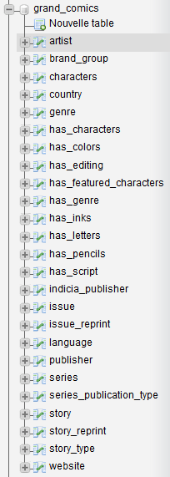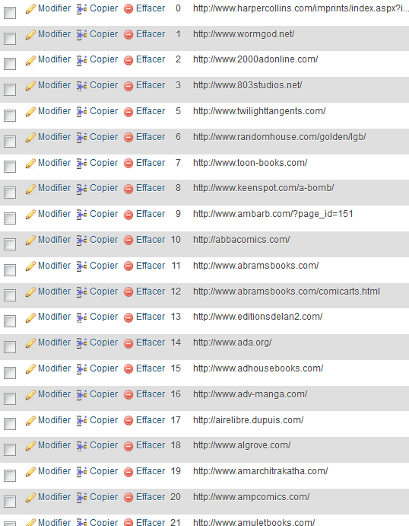
All tables Website table

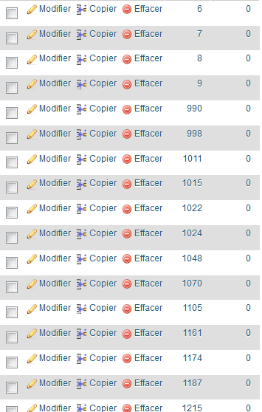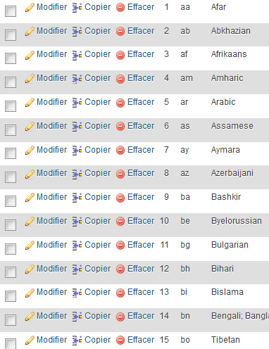
Has_genre table Language table

Query Implementation

Here are the 8 queries we were asked to implement in MySQL.

For this first query we first select all the brand name possessing at least one indicia publisher from Belgium. We choose to get the name of the brand_group and the number of Belgian indicia it possesses. Then we simply sort the resulting table by number of indicia and get the name only. Note that we don’t need to go through the Publisher table, which makes us gain some time.
-- a)
SELECT T.name
FROM (
SELECT B.name,
COUNT(*) AS bid
FROM brand_group B,
indicia_publisher I,
country C
WHERE C.name = 'Belgium' AND
C.id = I.country_id AND
I.publisher_id = B.publisher_id
GROUP BY B.name
) AS T
ORDER BY T.bid

For the query b), we simply use the chain AND rule to get all publishers from Denmark, in a straightforward fashion.
-- b)
SELECT P.id, P.name
FROM publisher P,
country C,
series S
WHERE C.name = 'Denmark' AND
S.country_id = C.id AND
S.publisher_id = P.id AND
S.publication_type_id = 1

For querry c), the fashion is similar to b), we simply apply the chain rule, to get series from Switzerland and published in a magazine.
-- c)
SELECT S.name
FROM series S,
country C,
series_publication_type T
WHERE T.name = 'magazine' AND
T.id = S.publication_type_id AND
S.country_id = C.id AND
C.name = "Switzerland"

Here in d) we simply want to get all issues from 1990, sorted by year. Note that for simplicity purposes, all the dates have been converted to years stored as integers, since most of the dates simple consists as a year, often followed by text such as “circa”. It is hence easier to work with int(4) formatted years.
-- d)
SELECT COUNT(*)
FROM issue I
WHERE I.publication_date >= 1990
GROUP BY I.publication_date

For the query e), we simply do a left join between the indicias and the series (to avoid going through the publisher table). Then we just ask for names resembling Dc comics.
-- e)
SELECT I.name AS name,
COUNT(I.id) AS nb
FROM indicia_publisher I
LEFT JOIN series S
ON S.publisher_id = I.publisher_id
WHERE I.name LIKE '%DC_comics%'
GROUP BY I.name

For query f), we first select all stories that have been reprinted at least once, and then regroup them by original story. Finally, we count how many times each original story has been reprinted and sort them according to that. We only print the names of the stories for aesthetical purposes.
-- f)
SELECT S.title
FROM story S,
story_reprint R
WHERE S.id = R.origin_id
GROUP BY R.origin_id
ORDER BY COUNT(R.origin_id)

This query (g) was interesting since it uses the chain rule in a particular fashion. What we are seeking are artists who contributed to every part of the making of some story. That is, we want all artist who did color, write, draw and ink a story. We simply want an artist who did all 4 on a same story and a story who had all 4 done by a single artist.
-- g)
SELECT distinct A.name
FROM artist A,
has_script SC,
has_pencils P,
has_colors C,
has_inks I,
story S
WHERE A.id = SC.artist_id AND
A.id = P.artist_id AND
A.id = C.artist_id AND
A.id = I.artist_id AND
S.id = SC.story_id AND
S.id = P.story_id AND
S.id = C.story_id AND
S.id = I.story_id

For the last query h), we wanted Batman to be a non-featured character of a non-reprinted story. For that purpose, we seek all stories which were not reprinted, that is, which are not featured in the reprint table. We hence look for the story in the reprint table and expect the number of its occurrences to be 0.
Then, we simply say we want Batman to be in the non-featured characters. Note the utilization of the command LIKE in order to seek for all strings containing “Batman”.
-- h)
SELECT S.title
FROM story S,
characters C,
has_characters HS
WHERE 0 = ( SELECT COUNT(distinct R.origin_id)
FROM story_reprint R
WHERE S.id = R.origin_id
) AND
HS.character_id = C.id AND
HS.story_id = S.id AND
C.name LIKE '%Batman%' AND
S.features NOT LIKE '%Batman%'

Deliverable 3

Assumptions
<In this section write down the assumptions you made about the data. Write a sentence for each assumption you made>

Query Implementation
TODO LUCIE

Query Analysis

Selected Queries (and why)

Query 1
<Initial Running time:
Optimized Running time:
Explain the improvement:
Initial plan
Improved plan>

Query 2
<Initial Running time:
Optimized Running time:
Explain the improvement:
Initial plan
Improved plan>

Query 3
<Initial Running time:
Optimized Running time:
Explain the improvement:
Initial plan
Improved plan>

Interface

Design logic Description
<Describe the general logic of your design as well as the technology you decided to use>
TODO KL

Screenshots
<Provide some initial screen shots of your interface>

General Comments
<In this section write general comments about your deliverable (comments and work allocation between team members>

