**Configuration and verification of remote user authentication on a Cisco router and switch using local username-password authentication using SSH.**

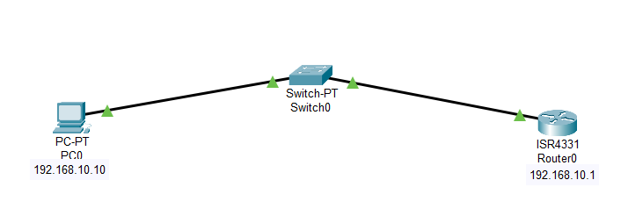

IPv4 Address:- 192.168.10.10 IPv4 Address:- 192.168.10.1

Gateway:- 192.168.10.1

CNSRouter#

CNSRouter#config t

CNSRouter(config)#hostname CNSRouter

CNSRouter(config)#enable password cisco

CNSRouter(config)#ip domain-name cisco.com

CNSRouter(config)#username Admin password cisco

CNSRouter(config)#cry?

CNSRouter(config)#crypto key generate RSA

How many bits in the modulus [512]: 1024

CNSRouter(config)#line vty 0 15

CNSRouter(config-line)#login local

CNSRouter(config-line)#transport input SSH

CNSRouter(config-line)#exit

CNSRouter(config)#ip ssh version 2

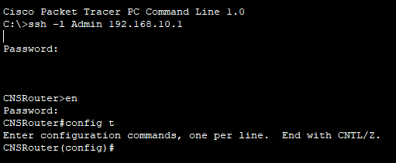

**Configuration and verification of remote user authentication on a Cisco router and switch using local username-password authentication.**



IPv4 Address:- 192.168.10.10 IPv4 Address:- 192.168.10.1

Gateway:- 192.168.10.1

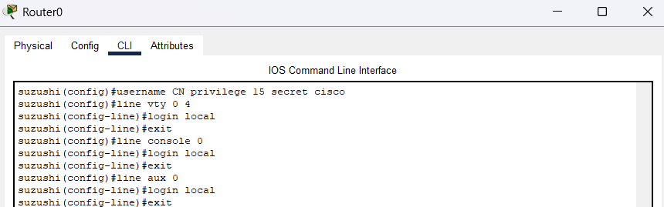

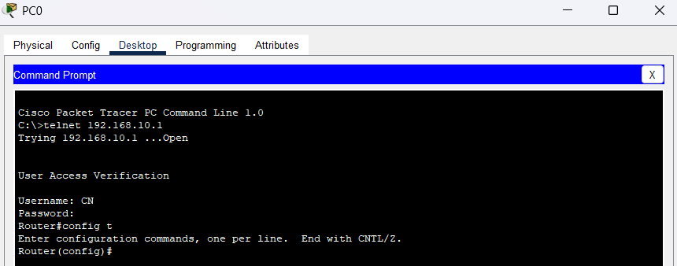

**Configuration and verification of remote user authentication on a Cisco router using AAA server based username-password authentication.**

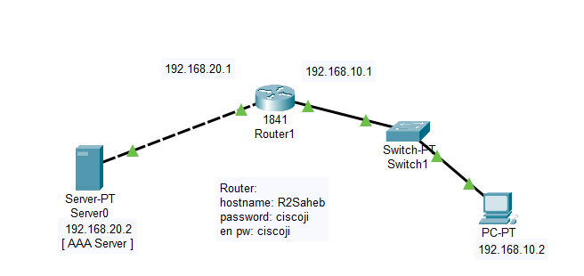

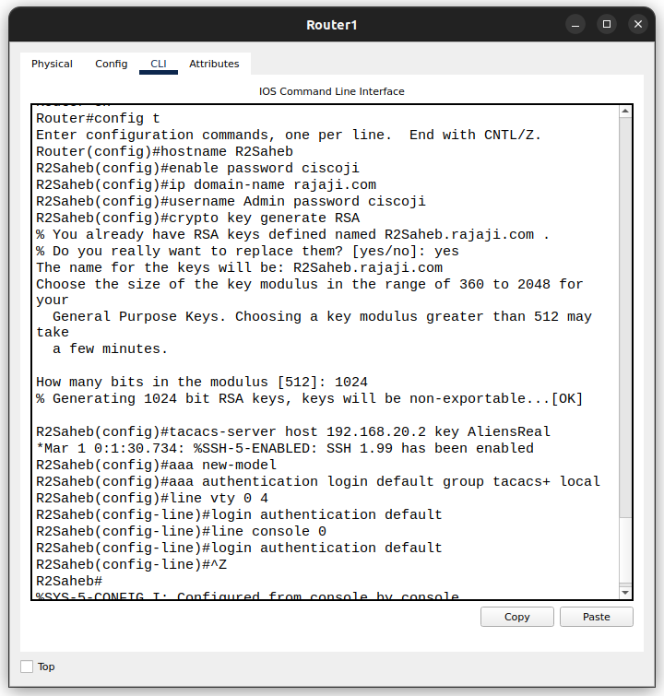

GO to Service of server   
AAA

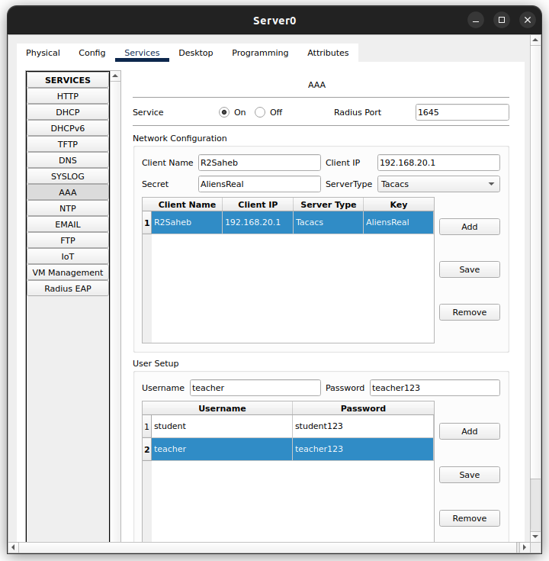

Router



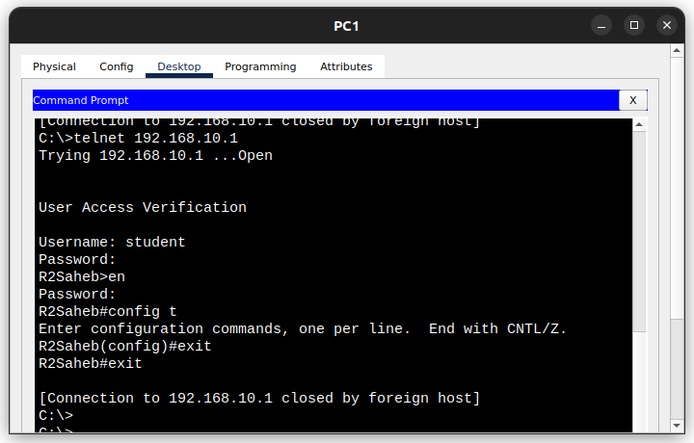

**Configuration and verification of remote user authentication on a Cisco router using AAA server based username-password authentication with SSH.**

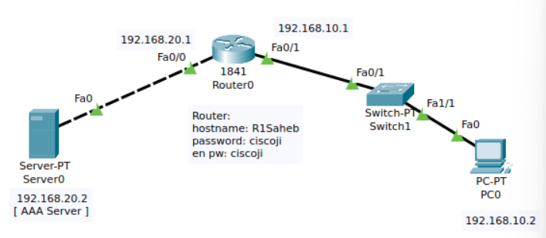

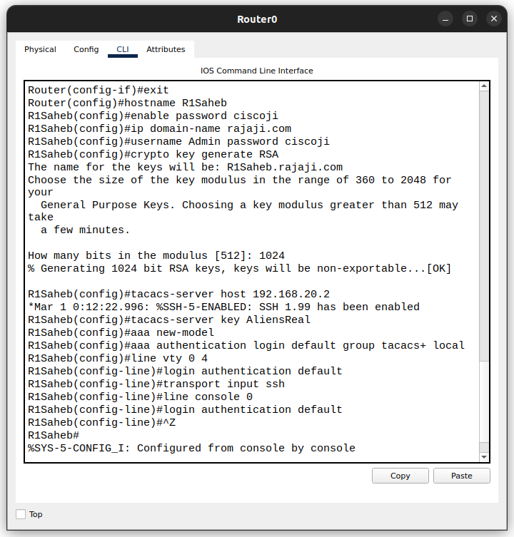

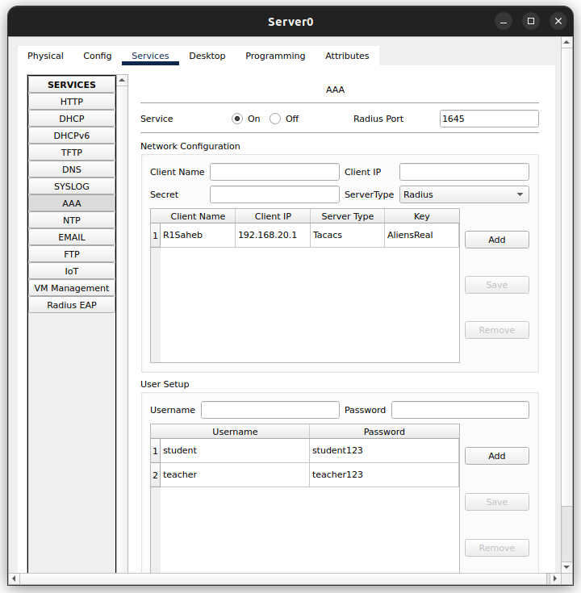



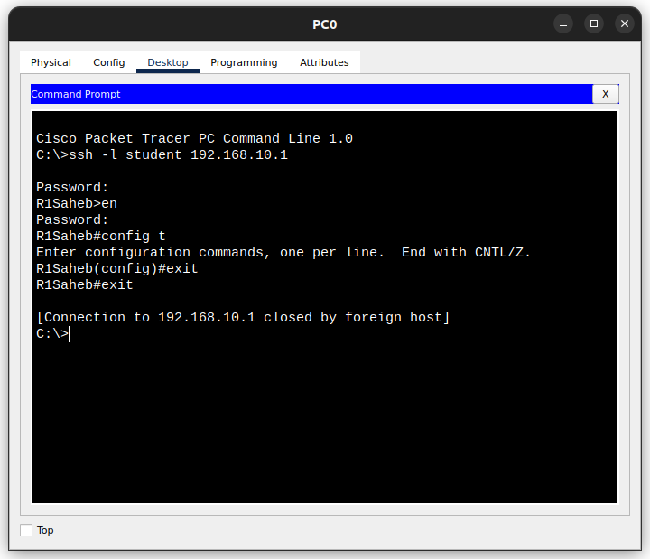

**Configuration and verification of a standard access list for permit and deny to a remote server.**

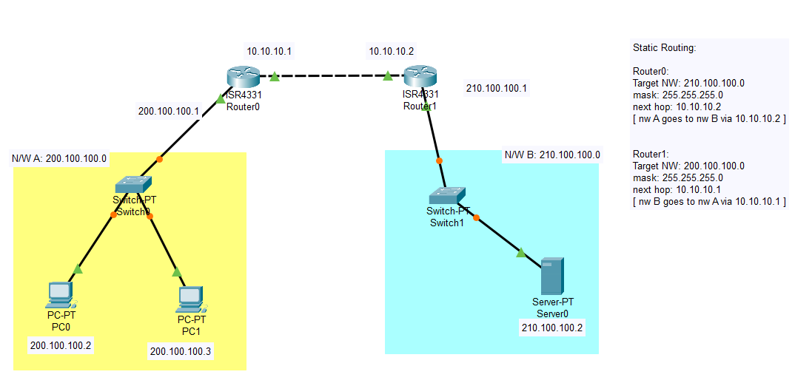

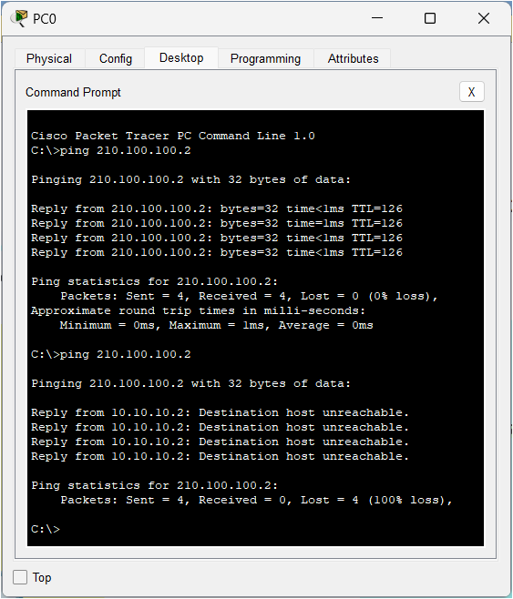

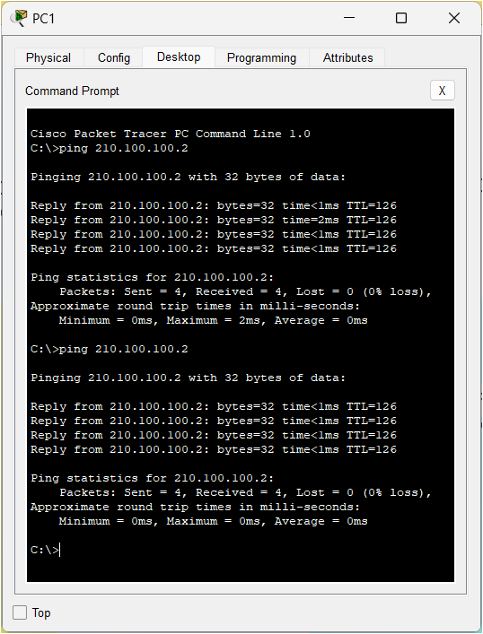

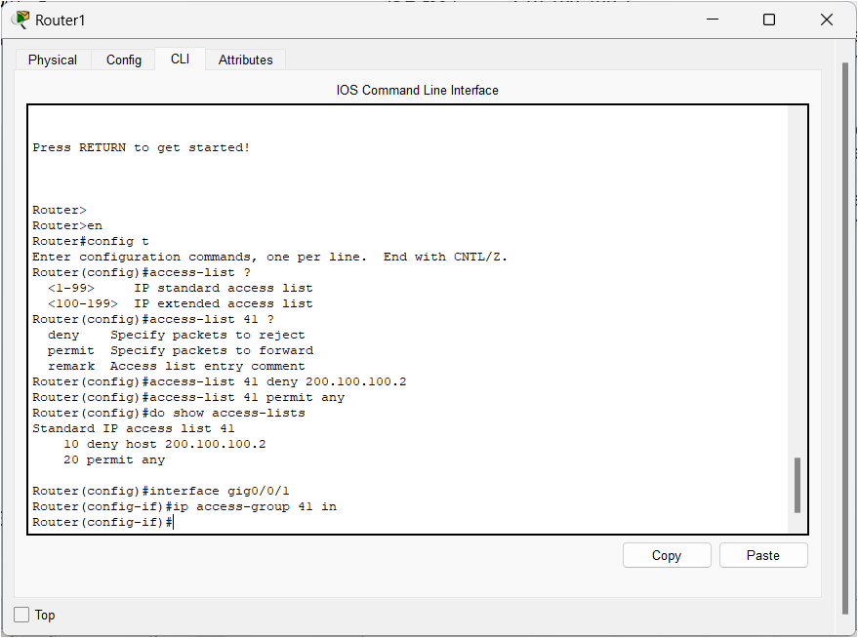

**Configuration and verification of an extended access list for permit and deny to a remote server (HTTP/FTP).**

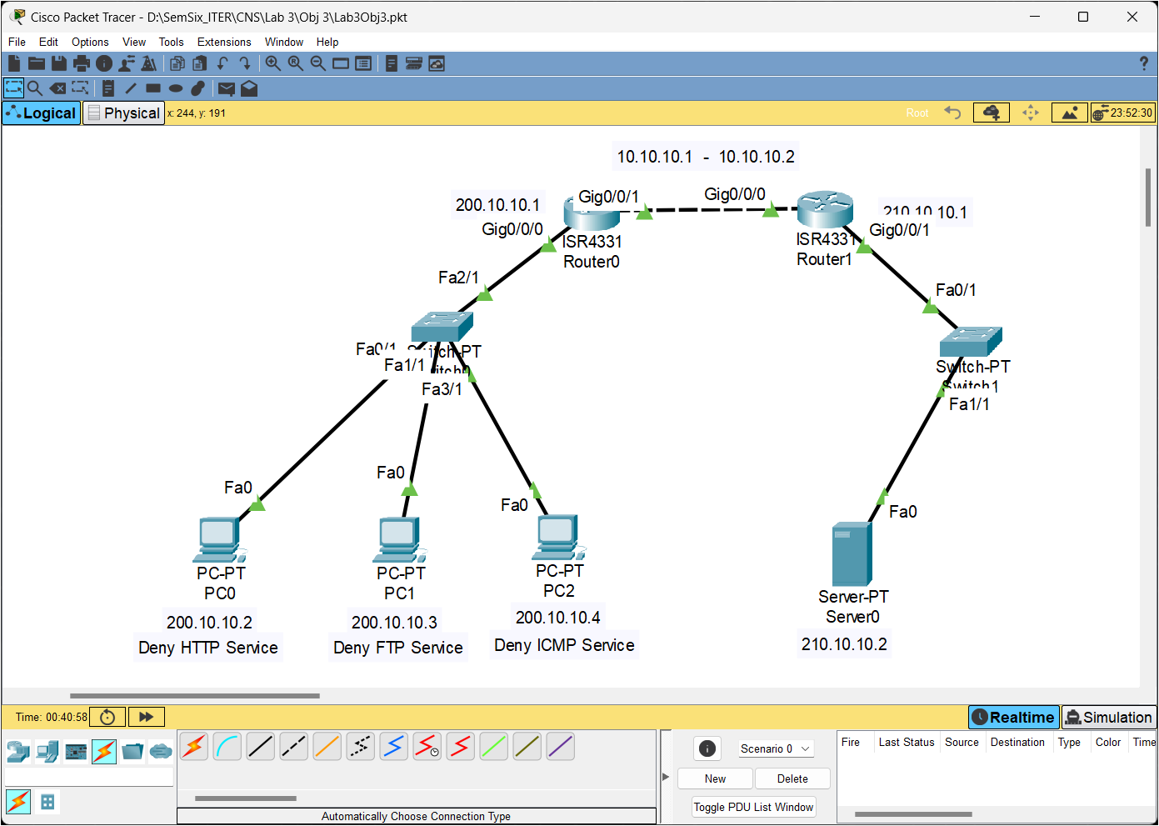

CLI FOR REMOTE SERVER

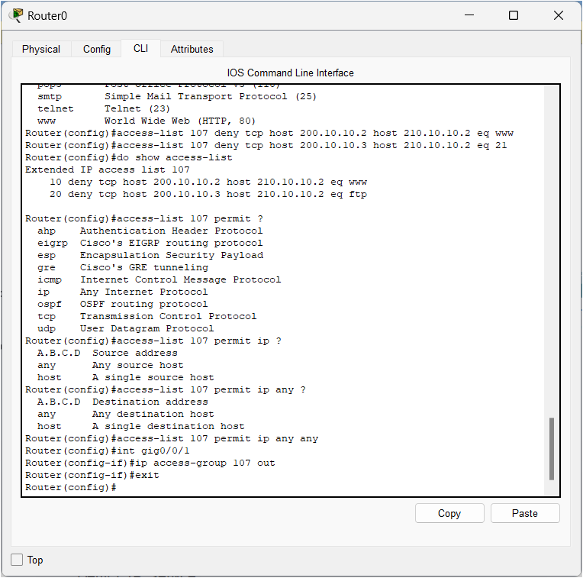

CLI FOR ICMP

