ENHANCED DECISION BRIEF | 27 JULY 2026

FormFill: MVP Solution Architecture and Decision Brief

Prepared for discussion with Nigel
AUT AI Hackathon | 7–8 August 2026 | FormFill Team: Rahul Bhaskaran and Arya Vijayan

Executive architecture position
MVP product form | A desktop-first, browser-based accessible web application. It runs as a single local session, works with the user’s existing screen reader, and does not require an account or cloud storage.
Highest-priority MVP | Prove that a blind or low-vision user can independently complete one representative PDF or image form using keyboard and screen reader from upload through final answer review.
P0 core journey | Upload → extract field structure → mandatory user correction → form overview → one-question-at-a-time completion → deterministic validation and error recovery → final review.
Not P0 | Speech-to-text, universal form compatibility, PDF write-back, digital signatures, CAPTCHA, external submission, user accounts and cloud storage.

Meeting objective
Seek architecture guidance on the smallest credible product that can be demonstrated reliably in 48 hours, with accessibility and end-to-end completion taking precedence over feature breadth.

One-minute project summary
FormFill is an accessibility-focused form-completion assistant for blind and low-vision users. It complements JAWS, NVDA and VoiceOver rather than replacing them. The MVP converts one difficult PDF or image form into a structured, keyboard-first guided workflow, lets the user correct AI-detected fields, provides clear validation, and finishes with a complete answer review.

What user research changed
User feedback shifted the problem away from “better screen reading” and towards “making inaccessible forms independently completable”. The strongest needs are predictable navigation, labelled controls, clear required status, specific error recovery, and user control over extraction mistakes. Voice is useful but secondary because names, accents and identifiers may be misheard.

Critical review: gaps resolved in this version
The earlier brief had a sound architecture direction, but it did not yet make the product decision, MVP priority or user journey sufficiently explicit for a short hackathon build.
Gap in previous brief | Why it creates risk | Resolution in v0.2
MVP described as a capability list rather than a single outcome. | Everything can appear equally important, so optional features compete with the core accessibility journey. | Define one P0 acceptance scenario and explicitly rank P0, P1, P2 and out-of-scope items.
Product form factor not stated clearly. | Frontend and architecture discussion becomes abstract because there is no firm delivery boundary. | Define a desktop-first browser application, single-session and local-first, as the MVP product form.
No step-by-step visual of the user experience. | Stakeholders cannot quickly see what the user actually does or where human control is required. | Add an MVP use case diagram, visual user stories and a textual end-to-end journey.
Optional voice and AI functions sit beside core workflow capabilities. | The team may spend scarce build time on attractive features that do not prove independent completion. | Keep TTS and plain-language help at P1; move speech-to-text to P2.
Architecture is more componentised than the hackathon requires. | Separate managers and services can create unnecessary implementation overhead. | Collapse non-essential internal services for the prototype and preserve separation only where it protects accessibility, validation or AI boundaries.
Success criteria are implied, not testable. | A demo can look impressive without proving independent accessible completion. | Define a pass scenario based on keyboard-only, screen-reader-compatible completion, correction, validation recovery and final review.

MVP priority hierarchy
Priority | Capabilities | Rule
P0 MUST | Upload representative PDF/PNG/JPG; native fields/text first with vision fallback; mandatory field review/edit; form summary; keyboard and screen-reader guided completion; deterministic validation and error recovery; final answer review. | The demo is not complete until this path works end to end.
P1 SHOULD | Plain-English field help; browser text-to-speech; confidence/source metadata that helps the user understand extraction. | Add only after P0 is reliable.
P2 COULD | Speech-to-text; JSON export; source highlighting/bounding boxes; broader form types; richer UI polish. | Useful only if time remains.
OUT | Digital signatures; CAPTCHA solving; external website submission; user accounts; cloud storage; universal form compatibility; production hardening. | Do not spend hackathon time here.
MVP acceptance statement
The MVP passes when a blind or low-vision tester can use JAWS or NVDA with the keyboard to upload the selected form, correct extracted fields, complete required questions, recover from one validation error and review final answers without sighted help.

MVP use case: what the product must prove
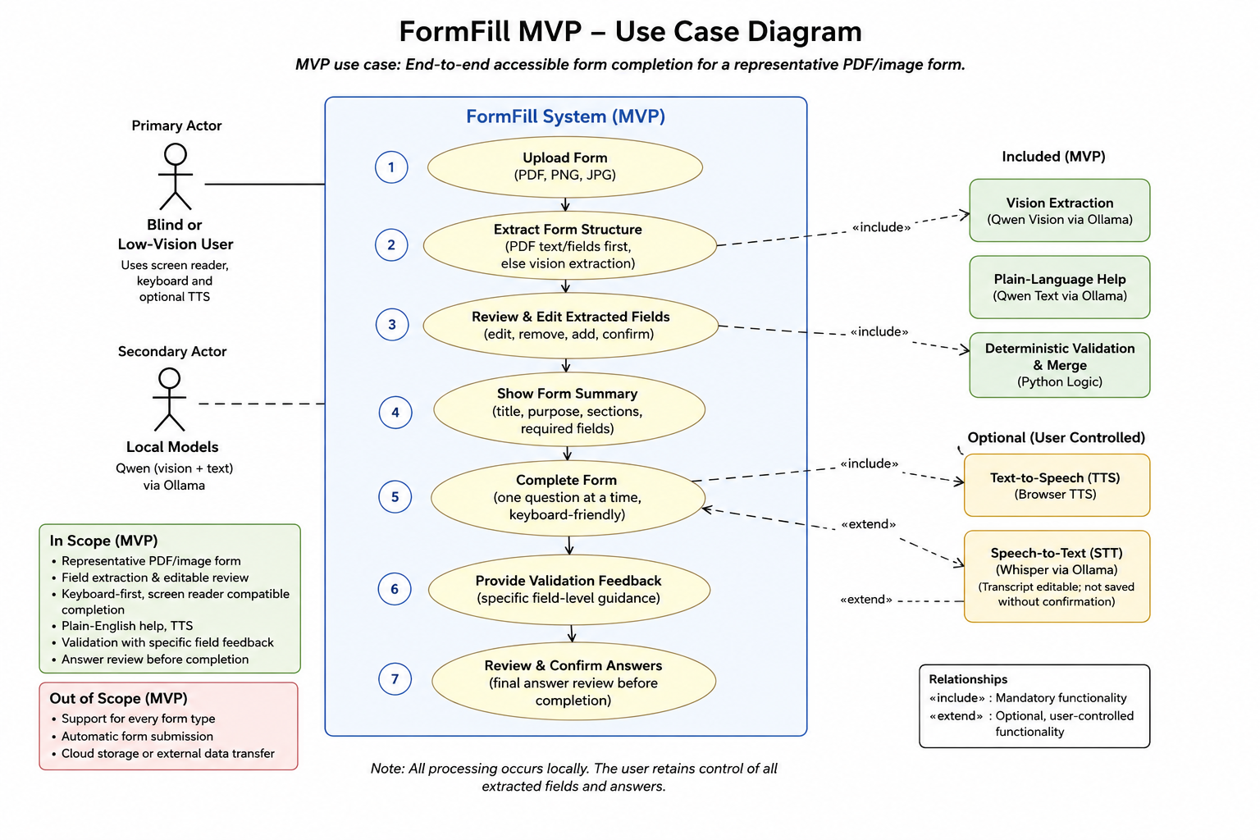
Figure 1. FormFill MVP use case. The central P0 journey is the seven-step user path inside the FormFill system boundary.

Visual user stories: the end-to-end MVP experience
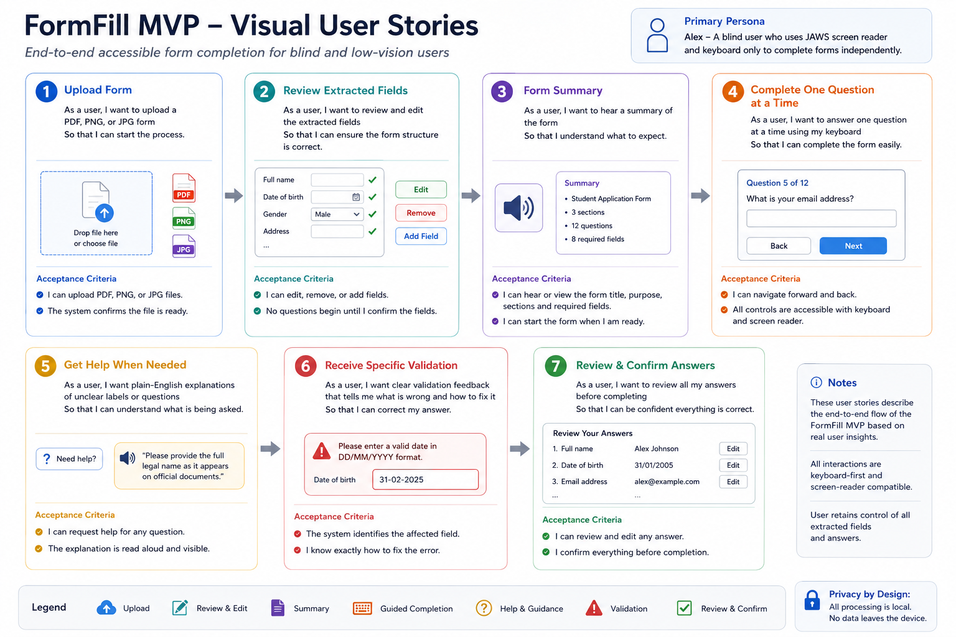
Figure 2. Visual user stories. The persona shown is illustrative; the MVP must remain compatible with the user’s chosen supported screen reader.
The textual journey on the next page provides the accessible equivalent of this visual.

How the user uses the MVP
Step | User action | FormFill response | P0 acceptance evidence
1 | Open FormFill in a browser. | Starts a local, single-session workflow. No account is required. | Page loads with a meaningful title, heading and initial focus.
2 | Upload one supported PDF, PNG or JPG. | Checks native PDF fields and text first; uses image/vision extraction only where needed. | Upload can be completed by keyboard and the file status is announced.
3 | Review the detected form structure. | Shows proposed fields, types, required status and source context. | User can edit, add or remove fields before continuing.
4 | Confirm the form overview. | Announces title, purpose, sections, required fields and likely information needed. | User knows what the form contains before answering.
5 | Answer one question at a time. | Presents a labelled, keyboard-operable control with Back and Next navigation. | Focus order is predictable and works with JAWS/NVDA.
6 | Request help where wording is unclear. | Provides a short plain-English explanation and optional browser TTS. | Help does not change the user’s answer and remains optional.
7 | Correct validation errors. | Identifies the affected field, explains the problem and moves focus back without losing context. | User can recover independently from at least one deliberate error.
8 | Review and confirm all answers. | Shows every captured answer for final correction, then ends the local session. | No automatic external submission occurs; the user retains control.

Product form factor
- Browser-based web application, desktop-first for the hackathon demo. It is not a PDF-reader plug-in, browser extension, mobile app or autonomous form-submission agent.
- The user continues to use JAWS, NVDA or VoiceOver. FormFill’s job is to present semantically accessible HTML, logical focus order, labelled controls and a predictable guided sequence.
- Local-first execution on the demo machine. Extracted fields and answers remain in session memory and are not persisted by default.
- Frontend decision gate: keep Streamlit only if a real keyboard and JAWS/NVDA test proves acceptable semantics, focus management and error announcement. If it fails that gate, use a minimal semantic HTML/JavaScript frontend rather than adding more features.
Single highest-impact implementation task
Before adding speech-to-text, PDF write-back or broader AI capability, complete and fix a real screen-reader run of the entire P0 journey on the representative form. The MVP should optimise for successful independent completion, not the number of technologies demonstrated.

Application context
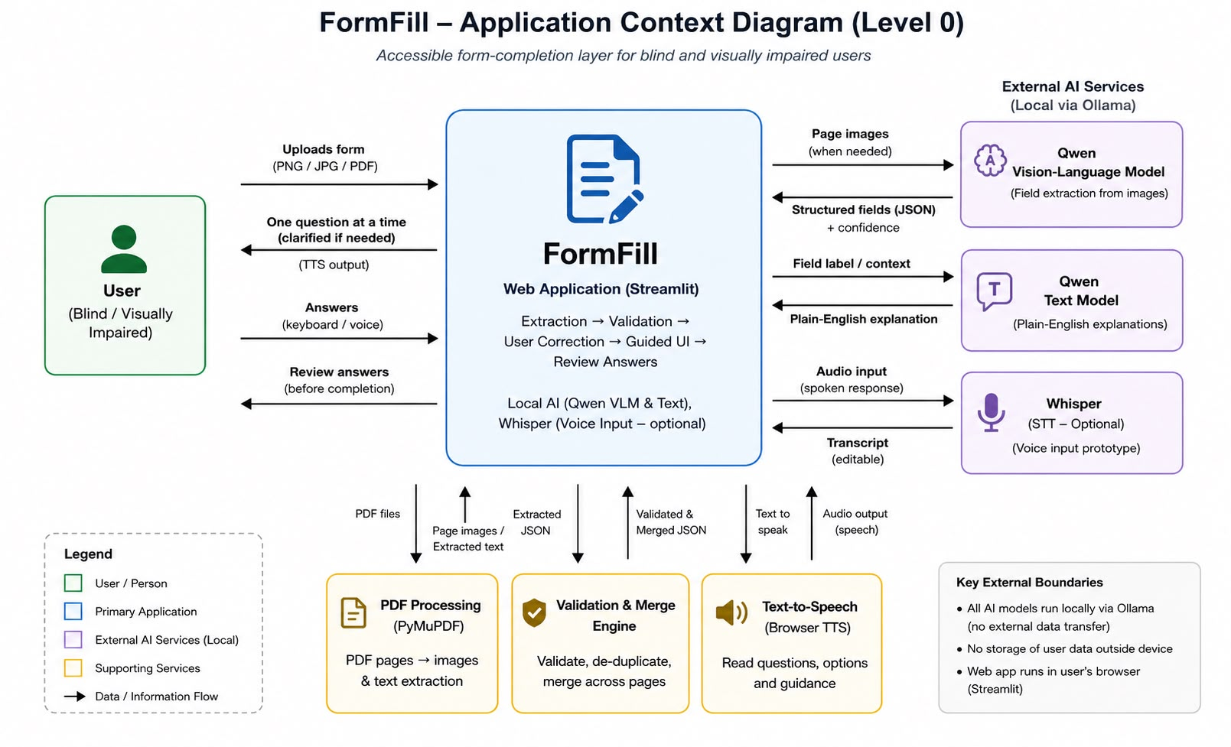
Figure 3. Current application context. Streamlit is the present prototype frontend, subject to the accessibility decision gate.

Context interpretation for the MVP
- Primary actor: blind or low-vision user completing the form independently.
- Primary system: browser-based FormFill interface and deterministic workflow.
- Supporting local services: PDF/image processing, Qwen vision extraction, Qwen text explanation and browser TTS.
- Optional service: Whisper speech-to-text. It is not required to prove the P0 user outcome.
- Trust boundary: no external submission and no default persistence of user answers during the hackathon demo.

Solution architecture and technical decision gates
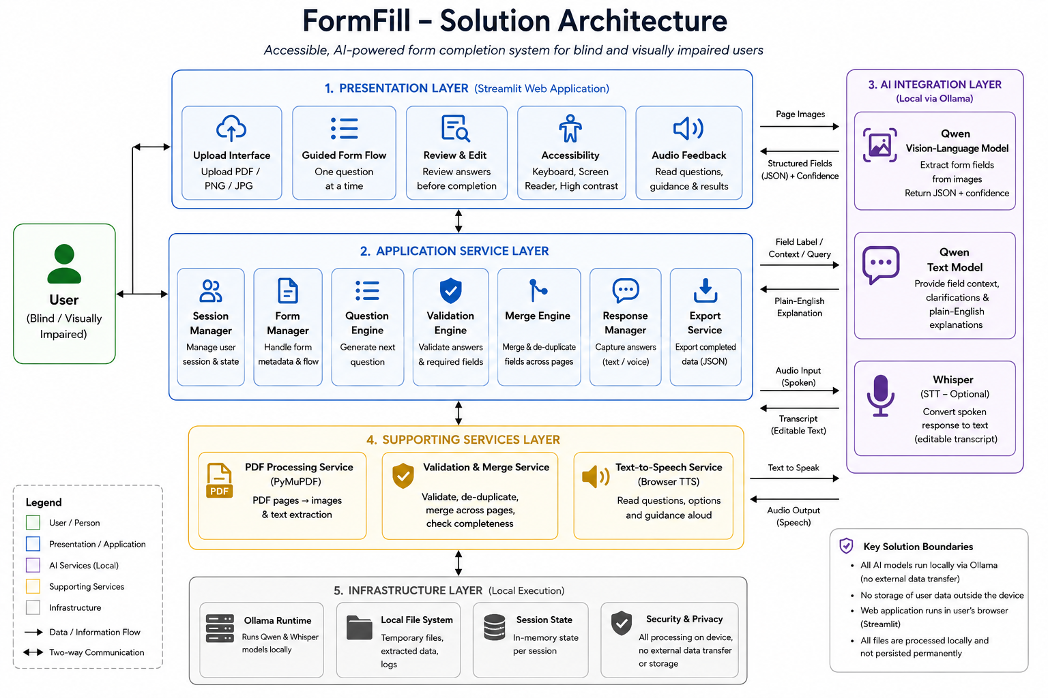
Figure 4. Current solution architecture. The diagram is useful as a target structure, but the MVP implementation should collapse non-essential services where that reduces build risk.
Area | Current direction | MVP recommendation | Priority / gate
Frontend | Streamlit guided prototype. | Use a desktop browser UI. Retain Streamlit only if keyboard, semantic labelling, focus recovery and JAWS/NVDA behaviour pass the accessibility checkpoint. | P0 gate
Document processing | PyMuPDF; native PDF fields/text before image extraction. | Keep this extraction hierarchy. It reduces unnecessary vision processing and gives more deterministic input where available. | P0
AI extraction | Local Qwen vision via Ollama. | Use AI to propose structure for scanned/image-only pages. Never proceed without mandatory user review. | P0 support
AI explanation | Local Qwen text model. | Use only for optional plain-language clarification. Do not let the model change answers or validation state. | P1
Validation | Deterministic Python rules. | Keep required checks, formats, navigation, field focus, error messages and answer state deterministic. | P0
Voice | Browser TTS; Whisper tested separately. | TTS is P1. Keep speech-to-text at P2 unless P0 is already reliable. | P1 / P2
State and storage | Session state and local files. | Use in-memory session state for the demo. Avoid accounts, databases and cloud persistence. | P0 simplicity

Recommended MVP architecture boundaries
AI may | AI must not
- Propose fields from scanned/image pages.  - Provide extraction confidence and source context.  - Generate optional plain-English explanations. | - Silently accept or finalise extracted fields.  - Control required status, navigation or validation rules.  - Change answers, submit forms externally or decide completion.

Simplify for the hackathon
- Do not build separate Session Manager, Form Manager, Question Engine, Response Manager and Export Service components unless the code already exists cleanly. For the MVP these can be modules inside one application service.
- Keep separation where failure has consequences: extraction versus user correction, AI versus deterministic validation, UI versus data/state, and optional speech versus typed input.
- Treat the layered architecture as the direction for evolution, not a requirement to instantiate every box during the 48-hour build.

Evaluation: what makes the demo credible
Measure | What to observe | Evidence of a credible MVP
Independent completion | Can the user finish the selected form without sighted assistance? | End-to-end completion succeeds using keyboard and supported screen reader.
Extraction quality | How many fields are correctly detected before correction? | Record accuracy and correction count; all errors can be corrected before questions begin.
Accessibility | Headings, labels, focus order, control operation and announcements. | All P0 interactions are keyboard reachable and understandable in JAWS/NVDA.
Validation recovery | Can the user understand and fix a deliberate invalid answer? | Specific field-level error is announced and focus returns without losing context.
Efficiency | Completion time and unnecessary navigation. | The guided flow is practical and does not introduce avoidable steps.
Privacy/control | What is stored or transferred? | No default cloud storage or external submission; the user confirms extracted fields and final answers.

Explicitly deferred
- Universal support for arbitrary documents and layouts.
- Digital signatures, CAPTCHA handling and automatic submission to external websites.
- User accounts, cloud storage and production-grade security hardening.
- Compulsory voice input or full PDF write-back.
- Broader multi-form compatibility until the representative end-to-end journey is proven.

Priority discussion questions for Nigel
- Does the P0 acceptance scenario represent the right minimum credible hackathon outcome, or should any step be removed?
- Should Streamlit be retained only behind an explicit JAWS/NVDA accessibility checkpoint, with a minimal semantic HTML/JavaScript frontend as the fallback?
- Is the extraction hierarchy correct for the MVP: interactive PDF fields → embedded text → OCR/vision only for scanned or image-only content?
- Is the proposed AI boundary right: AI for extraction and optional explanation; deterministic logic for validation, navigation, answer state and completion?
- What is the minimum field schema required now? Are label, type, required status, options, page number, source text and confidence sufficient without bounding boxes?
- What is the smallest evaluation session that would credibly demonstrate independent completion and accessibility before the hackathon presentation?

Desired meeting outcomes
- Confirm the P0 MVP acceptance statement and representative form.
- Confirm the browser-based desktop form factor and the frontend accessibility decision gate.
- Agree the extraction fallback sequence and minimum field schema.
- Confirm the AI versus deterministic-logic boundary.
- Agree which P1 and P2 features are explicitly deferred until P0 works.
- Prioritise the next implementation action: complete and remediate an end-to-end JAWS/NVDA P0 run.
Recommended decision
For the hackathon, judge every design or feature choice against one question: does it materially improve the probability that a blind or low-vision user can independently complete the selected form from upload to final review? If not, defer it.

Current materials
GitHub repository: github.com/lucifer0096/FormFill

