FORMFILL

MVP User Manual
A simple guide to completing difficult PDF and image forms accessibly
What FormFill is
FormFill is a browser-based accessible form-completion assistant. It helps blind and low-vision users turn a difficult PDF, scanned form or image into a simpler, keyboard-first, one-question-at-a-time experience. It works alongside screen readers such as JAWS, NVDA and VoiceOver.

Audience | Blind and low-vision users, testers, mentors and hackathon demonstrators
Product form | Desktop-first browser application
MVP goal | Complete one representative form independently from upload to final answer review
Version | MVP user guide v0.1 | 27 July 2026

1. Quick start
The whole FormFill journey can be understood as six simple stages:
1 | Upload | Choose the PDF, PNG or JPG form you want to complete.
2 | Check fields | Review what FormFill detected. Correct, add or remove fields before continuing.
3 | Understand | Read or listen to a short overview of the form and what information you may need.
4 | Answer | Complete one clearly labelled question at a time using the keyboard and your screen reader.
5 | Fix errors | If an answer is invalid, FormFill explains what is wrong and returns focus to that field.
6 | Review | Check every answer and edit anything that needs changing before finishing the session.

Before you start
- Use a desktop or laptop browser for the MVP demonstration.
- Have the form you want to complete available as a PDF, PNG or JPG.
- Use your normal supported screen reader and keyboard settings.
- For the MVP, assume your answers are kept only for the current session unless the team explicitly enables local saving.
Important
FormFill does not automatically submit your form to another organisation or website. You remain in control of the extracted fields and the answers.

1 | Upload the form  Start a new FormFill session and choose the source document.

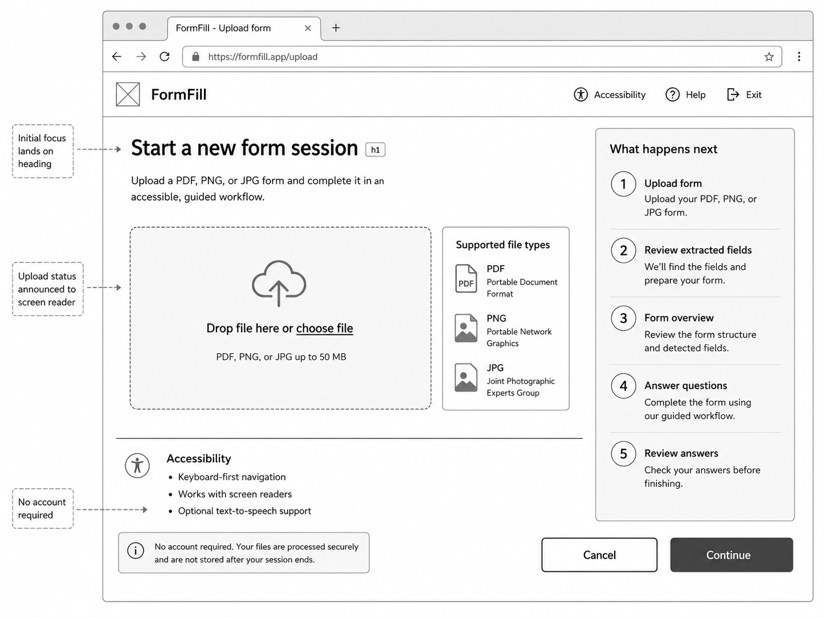

What you do
- Open FormFill in your browser.
- Move to the file upload control using the keyboard.
- Choose your PDF, PNG or JPG file and confirm the upload.

What FormFill does
- Checks whether the document already contains readable PDF fields or text.
- Uses image or vision extraction only when the form is scanned or image-based.
- Prepares a draft list of questions and fields for you to check.
Accessibility behaviour
The page should open on a meaningful heading, the upload control must be keyboard operable, and the upload status should be announced to the screen reader.

2 | Review the detected fields  Check the structure before FormFill starts asking questions.

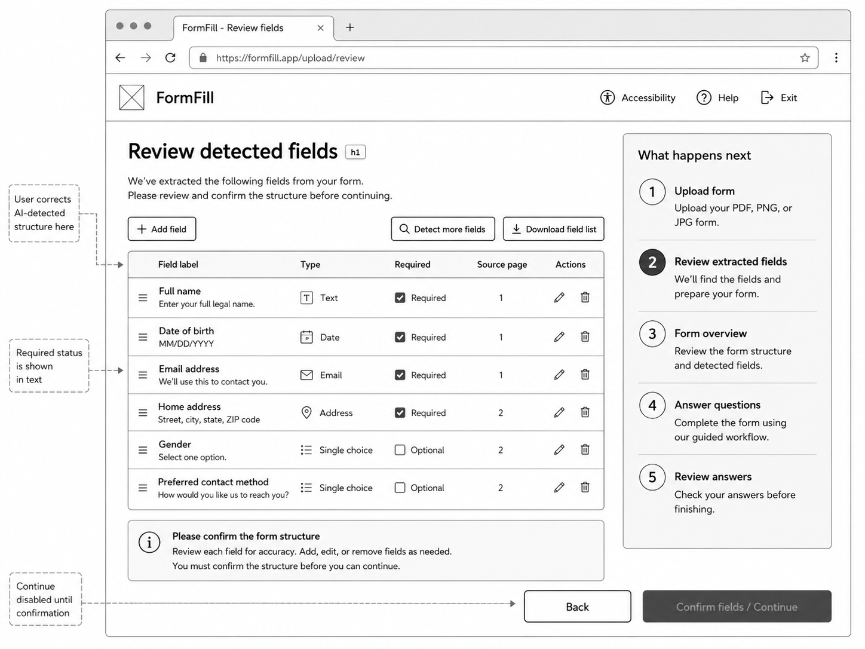

What you do
- Review each detected field.
- Edit any label or field type that is wrong.
- Remove fields that should not be there.
- Add anything FormFill missed.
- Confirm the structure only when it looks correct.
Why this step matters
AI extraction can make mistakes. FormFill deliberately puts you in control before any answers are collected. The AI proposes the structure; you confirm it.

3 | Read the form overview  Understand the form before you begin answering it.

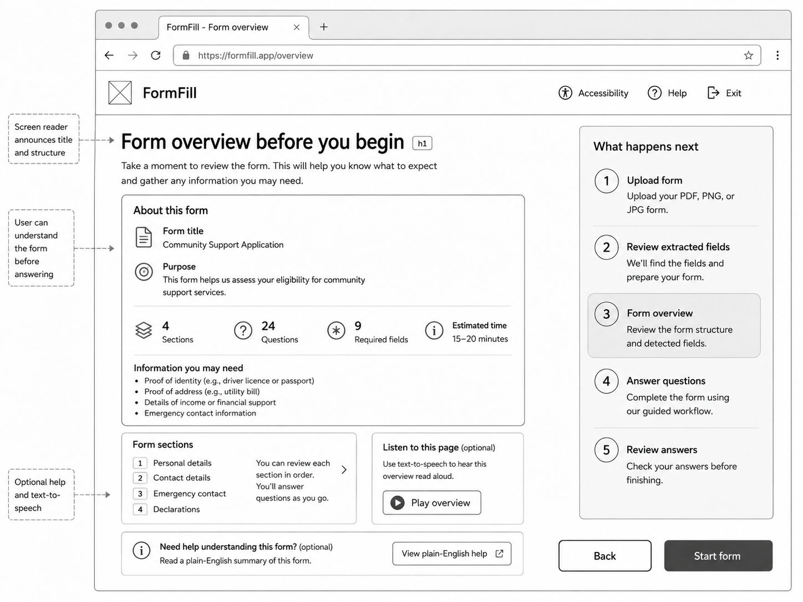

FormFill tells you
- The title and purpose of the form.
- How many sections and questions were found.
- Which fields are required.
- What information or documents you may need to have ready.
- The main sections you will move through.

Optional help
You may use plain-English help or text-to-speech where available. These features explain the form but do not answer questions for you.

4 | Answer one question at a time  Complete the form through a predictable, keyboard-first guided flow.

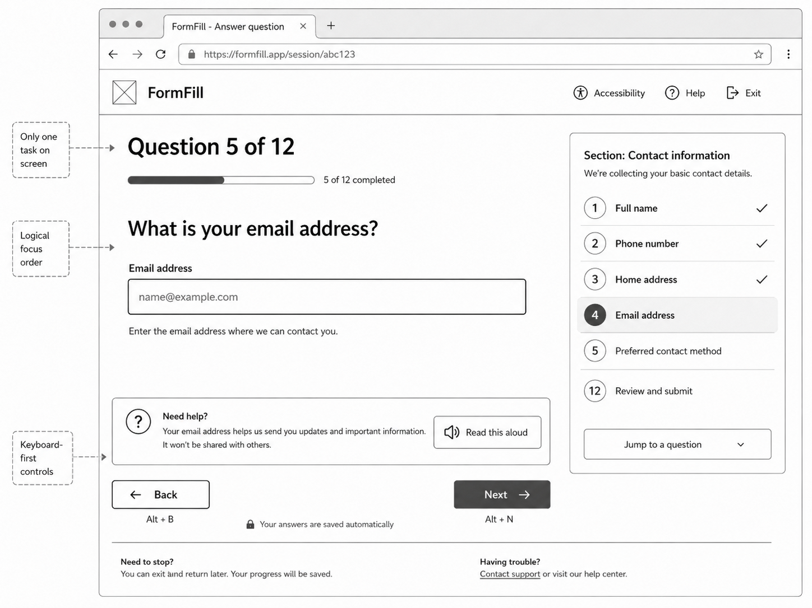

How it feels to use
Instead of navigating the original PDF, FormFill presents one clearly labelled task at a time. You answer the question, move to Next, and continue through the form in a predictable order.

Typical controls
- Tab to move between controls.
- Enter or Space to activate buttons and choices.
- Back to return to the previous question.
- Next to validate the current answer and continue.
- Optional Read aloud or Help controls where provided.
MVP session note
The wireframe shows an “answers saved automatically” message. For the hackathon MVP, this should be interpreted as session-only state unless secure persistence has been deliberately implemented.

5 | Correct an invalid answer  Receive specific guidance without losing your place.

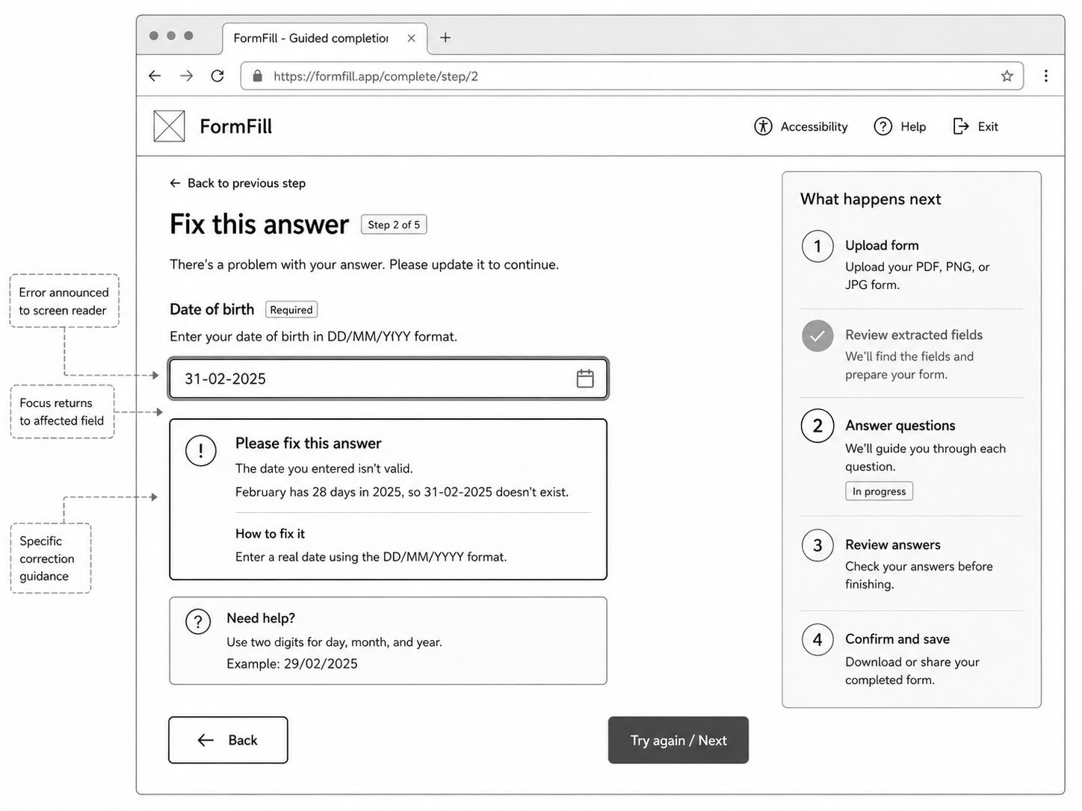

What happens when something is wrong
- FormFill identifies the exact field with the problem.
- The error is announced to the screen reader.
- The message explains what is wrong in plain language.
- FormFill explains how to correct it.
- Keyboard focus returns to the affected field so you do not have to search for it.
Example
If you enter 31/02/2025, FormFill can explain that February 2025 has only 28 days and ask you to enter a real date using DD/MM/YYYY.

6 | Review your answers  Check everything before you finish the FormFill session.

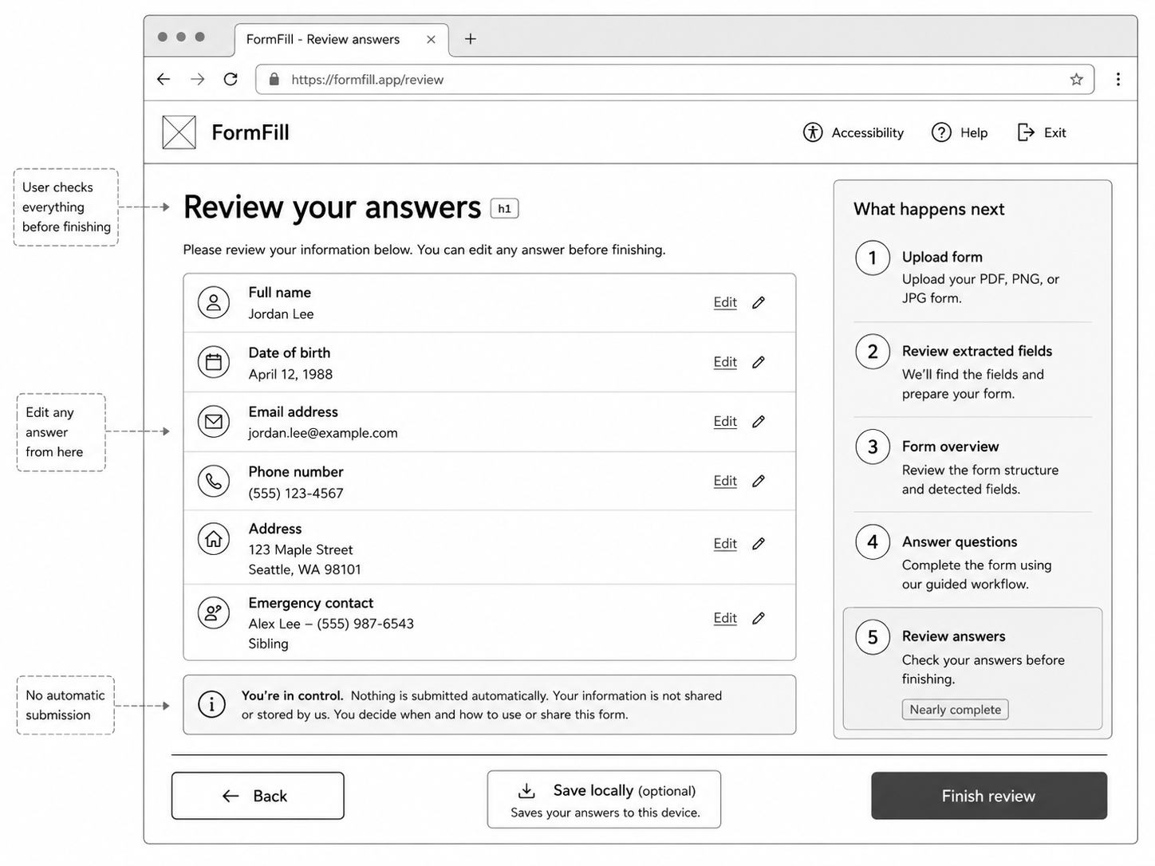

What you do
- Read through all captured answers.
- Use Edit beside any answer that needs changing.
- Return to the review until you are satisfied everything is correct.
- Finish the review when you are done.
You stay in control
Nothing should be submitted automatically as part of the MVP. Finishing the review means you have completed the FormFill guided session, not that FormFill has sent the original form to an external organisation.

2. Accessibility and user control

FormFill is designed to
- Work alongside JAWS, NVDA and VoiceOver rather than replace them.
- Provide logical headings and labelled controls.
- Support keyboard-only navigation.
- Show Required or Optional in text rather than relying on colour.
- Use specific field-level validation messages.
- Keep AI-generated extraction subject to mandatory user review.

AI is allowed to help with
- Detecting fields from scanned or image-based forms.
- Suggesting field labels and field types.
- Providing optional plain-English explanations.

AI should not
- Silently decide that the extracted form structure is correct.
- Change your answers.
- Control required-field rules or validation logic.
- Submit your form automatically.

3. What the MVP does not do
- Guarantee support for every possible PDF or form layout.
- Complete digital signatures.
- Solve CAPTCHA challenges.
- Automatically submit forms to third-party websites.
- Require user accounts or cloud storage.
- Guarantee that speech-to-text will be available or accurate.
- Provide production-grade security or long-term storage.

4. Quick troubleshooting
Problem | What to try
The upload is not recognised | Check that the file is PDF, PNG or JPG. Try a smaller or clearer copy of the form.
FormFill detected a field incorrectly | Use the review screen to edit, remove or add fields before continuing.
A question is hard to understand | Use plain-English help or read-aloud support if available.
I cannot move to the next question | Check for a required field or a validation message on the current question.
My screen reader does not announce the page correctly | Return to the main heading, check browser and screen-reader focus, then retry. Record the issue for the hackathon accessibility test.
I want to come back later | Do not assume the MVP will save the session permanently. Complete the session in one sitting unless local persistence has been explicitly enabled.

5. The product in one sentence
FormFill MVP
A browser-based accessible form-completion assistant that converts one difficult PDF or image form into a structured, keyboard-first, one-question-at-a-time experience that a blind or low-vision user can complete independently.

Remember these three things
1. FormFill simplifies  It turns the source form into a clearer guided experience. It does not replace your screen reader. | 2. You verify the AI  Always check the detected fields before answering. You can edit, add or remove fields. | 3. You control completion  Nothing is automatically submitted to an external organisation as part of the MVP.

MVP completion check
- I uploaded the selected form.
- I checked and confirmed the detected fields.
- I understood the form overview.
- I completed the questions using keyboard and screen reader.
- I recovered from any validation errors.
- I reviewed every answer before finishing.
This guide describes the intended hackathon MVP behaviour. Some wireframe labels are illustrative and may change during implementation and accessibility testing.

