Міністерство освіти і науки України

Національний університет «Львівська політехніка»



Звіт

до лабораторної роботи № 6

# з дисципліни: «Вебпрограмування»

# «Робота з об’єктами в JavaScript»

Виконав:

ст.гр. КІ-41

Чапля Ю.О.

Перевірив:

Добуш А.Р.

Львів 2023

**Мета:** отримати навички створення об'єктів, доступу до полів та методів, ознайомитись із прототипним успадкуванням.

**Хід роботи:**

*Lab6_1.html:*

*<script>*

*const router = {*

*type : "wireless",*

*interfaceType : "ethernet",*

*mobileSupport : true,*

*sdSupport : false,*

*info: function(){*

*alert(`Type: ${this.type}\nInterface: ${this.interfaceType}\nMobile communication support: ${this.mobileSupport}\n SD card support: ${this.sdSupport}`)*

*}*

*};*

*router.info();*

*</script>*

*Результат виконання :*

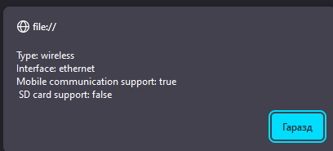

*Рис.1 виконання lab6_1.html*

*Lab6_2.html:*

*<script>*

*function Router (type, interfaceType, mobileSupport, sdSupport) {*

*this.type = type;*

*this.interfaceType = interfaceType;*

*this.mobileSupport = mobileSupport;*

*this.sdSupport = sdSupport;*

*Object.defineProperty(this, 'mobileSupport', {*

*get: function() {*

*if(this._mobileSupport)*

*return "supports";*

*else*

*return "doesn\'t support";*

*},*

*set: function(value) {*

*if(typeof value == 'boolean')*

*this._mobileSupport = value;*

*else*

*alert("Wrong data type (mobile suppurt is not boolean)!!!");*

*}*

*});*

*Object.defineProperty(this, 'sdSupport', {*

*get: function() {*

*if(this._sdSupport)*

*return "supports";*

*else*

*return "doesn\'t support";*

*},*

*set: function(value) {*

*if(typeof value == 'boolean')*

*this._sdSupport = value;*

*else*

*alert("Wrong data type (SD suppurt is not boolean)!!!");*

*}*

*});*

*}*

*Router.prototype.releaseDate = "11.15.2012"*

*Router.prototype.info = function () {*

*document.write (`Type: ${this.type}<br>Interface: ${this.interfaceType}<br>Mobile communication: ${this.mobileSupport}<br>SD card: ${this.sdSupport}<br>Release date: ${Router.prototype.releaseDate}`);*

*};*

*let myRouter = new Router("wireless", "ethernet");*

*myRouter.mobileSupport = true;*

*myRouter.sdSupport = false;*

*//myRouter.mobileSupport = "asd";*

*myRouter.info();*

*</script>*

*Результат виконання :*

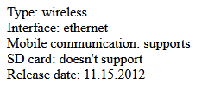

*Рис.2 виконання lab6_2.html*

*Lab6_3-5.html:*

*<script>*

*document.write("/////////////////////////////6_3////////////////////////<br>");*

*class Router {*

*constructor(type, interfaceType, mobileSupport, sdSupport) {*

*this.type = type;*

*this.interfaceType = interfaceType;*

*this.mobileSupport = mobileSupport;*

*this.sdSupport = sdSupport;*

*}*

*setType(type) {*

*if(type == "wireless" || type == "wired")*

*this.type = type;*

*else*

*this.type = "unknown";*

*}*

*getMobileSupport() {*

*return this.mobileSupport ? "supports" : "doesn\'t support";*

*}*

*getSdSupport() {*

*return this.sdSupport ? "supports" : "doesn\'t support"*

*}*

*info() {*

*document.write (`Type: ${this.type}<br>Interface: ${this.interfaceType}<br>Mobile communication: ${this.getMobileSupport()}<br>SD card: ${this.getSdSupport()}<br>`);*

*};*

*}*

*const myRouter = new Router("wired", "ethernet", true, false);*

*myRouter.setType("wireless");*

*myRouter.info();*

*document.write("/////////////////////////////6_4///////////////////////////<br>");*

*class ExtendedRouter extends Router {*

*constructor(type, interfaceType, mobileSupport, sdSupport, releaseDate, price) {*

*super(type, interfaceType, mobileSupport, sdSupport);*

*this.releaseDate = releaseDate;*

*this.price = price;*

*}*

*info() {*

*super.info();*

*document.write (`Release date: ${this.releaseDate}<br>Price: ${this.price}<br>`);*

*}*

*}*

*const myExtRouter = new ExtendedRouter("wired", "ethernet", true, false, '15.11.2012', 600);*

*myExtRouter.setType("wireless");*

*myExtRouter.info();*

*document.write("/////////////////////////////6_5///////////////////////////<br>");*

*const routers = [*

*new ExtendedRouter("wired", "ethernet", false, false, '15.11.2012', 400),*

*new ExtendedRouter("wireless", "WiFi", true, false, '20.05.2015', 500),*

*new ExtendedRouter("wired", "ethernet", false, true, '11.09.2010', 800),*

*new ExtendedRouter("wired", "ethernet", true, true, '21.12.2019', 1000),*

*new ExtendedRouter("wireless", "WiFi", true, true, '08.07.2018', 1200)*

*];*

*const maxPriceRouter = routers.reduce((max, current) => current.price > max.price ? current : max);*

*const minPriceRouter = routers.reduce((min, current) => current.price < min.price ? current : min);*

*const totalCost = routers.reduce((sum, current) => sum + current.price, 0);*

*const averageCost = totalCost / routers.length;*

*const aboveAverageCount = routers.filter(router => router.price > averageCost).length;*

*document.write(`Maximal price router:<br>`);*

*maxPriceRouter.info();*

*document.write(`Minimal price router:<br>`);*

*minPriceRouter.info();*

*document.write(`Total cost: ${totalCost}<br>`);*

*document.write(`Average cost: ${averageCost}<br>`);*

*document.write(`Routers with price above average cost: ${aboveAverageCount}<br>`);*

*</script>*

*Результат виконання :*

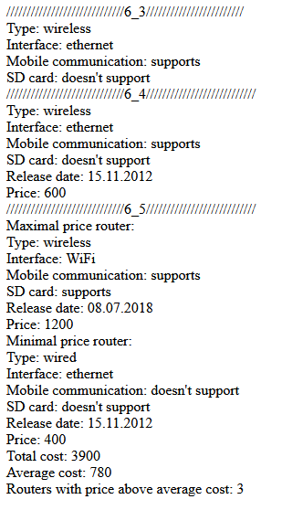

*Рис.3 виконання lab6_3-5.html*

**Висновок:** Навчився створювати об'єкти, отримувати доступ до полів та методів, ознайомився із прототипним успадкуванням..