Implementation of Identity Management using
Cloud Computing concept

1. Write a Java Program to perform following operations on googleDrive as IAM: a. Create Folder
b. Upload file under newly created folder
c. Give owner access rights to another user for newly created folder
d. Change access rights from owner to reader
e. Revoke access rights

Code:
package im1;
import com.google.api.client.auth.oauth2.Credential;
import com.google.api.client.extensions.java6.auth.oauth2.AuthorizationCodeInstalledApp;
import com.google.api.client.extensions.jetty.auth.oauth2.LocalServerReceiver;
import com.google.api.client.googleapis.auth.oauth2.GoogleAuthorizationCodeFlow;
import com.google.api.client.googleapis.auth.oauth2.GoogleClientSecrets;
import com.google.api.client.googleapis.javanet.GoogleNetHttpTransport;
import com.google.api.client.http.AbstractInputStreamContent;
import com.google.api.client.http.InputStreamContent;
import com.google.api.client.http.javanet.NetHttpTransport;
import com.google.api.client.json.JsonFactory;
import com.google.api.client.json.jackson2.JacksonFactory;
import com.google.api.client.util.store.FileDataStoreFactory;
import com.google.api.services.drive.Drive;
import com.google.api.services.drive.Drive.Permissions;
import com.google.api.services.drive.DriveScopes;
import com.google.api.services.drive.model.File;
import com.google.api.services.drive.model.FileList;
import com.google.api.services.drive.model.Permission;
import com.google.api.services.drive.model.PermissionList;
import com.google.common.util.concurrent.CycleDetectingLockFactory.WithExplicitOrdering;
import java.io.*;
import java.security.GeneralSecurityException;
import java.util.Collections;
import java.util.List;
import java.util.Scanner;
public class GDriveIAM {
private static final JsonFactory JSON_FACTORY = JacksonFactory.getDefaultInstance();
private static final java.io.File CREDENTIALS_FOLDER = new java.io.File("/Users/priteshbhuravane/MCA/Sem3 ");
private static final List<String> SCOPES = Collections.singletonList(DriveScopes.DRIVE);
// --------------------- AUTHENTICATION ---------------------
private static Credential getCredentials(final NetHttpTransport HTTP_TRANSPORT) throws IOException {
java.io.File clientSecretFilePath = new java.io.File("/Users/priteshbhuravane/MCA/Sem3/client_secret.json");
if (!clientSecretFilePath.exists()) {
throw new FileNotFoundException("Credentials File not found!");
}
try (InputStream in = new FileInputStream(clientSecretFilePath)) {
GoogleClientSecrets clientSecrets = GoogleClientSecrets.load(JSON_FACTORY, new InputStreamReader(in));
GoogleAuthorizationCodeFlow flow = new GoogleAuthorizationCodeFlow.Builder(
HTTP_TRANSPORT, JSON_FACTORY, clientSecrets, SCOPES)
.setDataStoreFactory(new FileDataStoreFactory(CREDENTIALS_FOLDER))
.setAccessType("offline")
.build();
return new AuthorizationCodeInstalledApp(flow, new LocalServerReceiver()).authorize("user");
}
}
public static void main(String[] args) throws IOException, GeneralSecurityException {
final NetHttpTransport HTTP_TRANSPORT = GoogleNetHttpTransport.newTrustedTransport();
Credential credential = getCredentials(HTTP_TRANSPORT);
Drive service = new Drive.Builder(HTTP_TRANSPORT, JSON_FACTORY, credential)
.setApplicationName("GDrive Access")
.build();
//1. create a folder for testing
File folderMetadata = new File();
folderMetadata.setName("IAM Test Folder");
folderMetadata.setMimeType("application/vnd.google-apps.folder");

File folder = service.files().create(folderMetadata)
.setFields("id,name").execute();
String folderID = folder.getId();

System.out.println("Create Folder: " +folder.getName() + " (ID:" +folderID+")");

//2. Upload word document filde undere newly crwerated folder
String localFilePath = "/Users/priteshbhuravane/MCA/Sem3/DSCC/IAM_GoggleDrive.docx";
java.io.File localFile = new java.io.File(localFilePath);

if (!localFile.exists()) {
System.out.println("Local doc file not found a : " +localFilePath);
return;
}
com.google.api.services.drive.model.File fileMetadata =new com.google.api.services.drive.model.File();
fileMetadata.setName("IAM_GoggleDrive.docx");
fileMetadata.setParents(Collections.singletonList(folderID));

com.google.api.client.http.FileContent mediaContent = new com.google.api.client.http.FileContent("application/vnd.openxmlformats-officedocument.wordprocessingml.document", localFile);

File uplodedFile = service.files().create(fileMetadata,mediaContent)
.setFields("id , name, parents")
.execute();
System.out.println("Uploded file : "+uplodedFile.getName()+"(ID:"+uplodedFile.getId()+")inside folder: " +folder.getName());

//3.share folder with user (Identity Management
Permission userPermission = new Permission()
.setType("user")
.setRole("writer")
.setEmailAddress("bhuravanepritesh@gmail.com");
service.permissions().create(folderID, userPermission)
.setSendNotificationEmail(true)
.execute();

System.out.println("Shared folder WithExplicitOrdering bhuravanepritesh@gmail.com as writer");

//4. List permisiion for the folder
PermissionList permissions = service.permissions().list(folderID).execute();
for(Permission perm : permissions.getPermissions())
{
System.out.println("Permision ID:" +perm.getId()+",Type:"+perm.getType()+",Role:"+perm.getRole());
}

// 5. Update permision (eg chnage user from writer ->reader)
if(!permissions.getPermissions().isEmpty())
{
String permissionId = permissions.getPermissions().get(0).getId();
Permission newPermission = new Permission().setRole("reader");
service.permissions().update(folderID, permissionId, newPermission).execute();
System.out.println("Update user role to Reader");
}
//6. Remove user permission
if (!permissions.getPermissions().isEmpty()) {
String permissionId = permissions.getPermissions().get(0).getId();
service.permissions().delete(folderID, permissionId).execute();
System.out.println("Removed user access from folder");
}
}
}

Output:

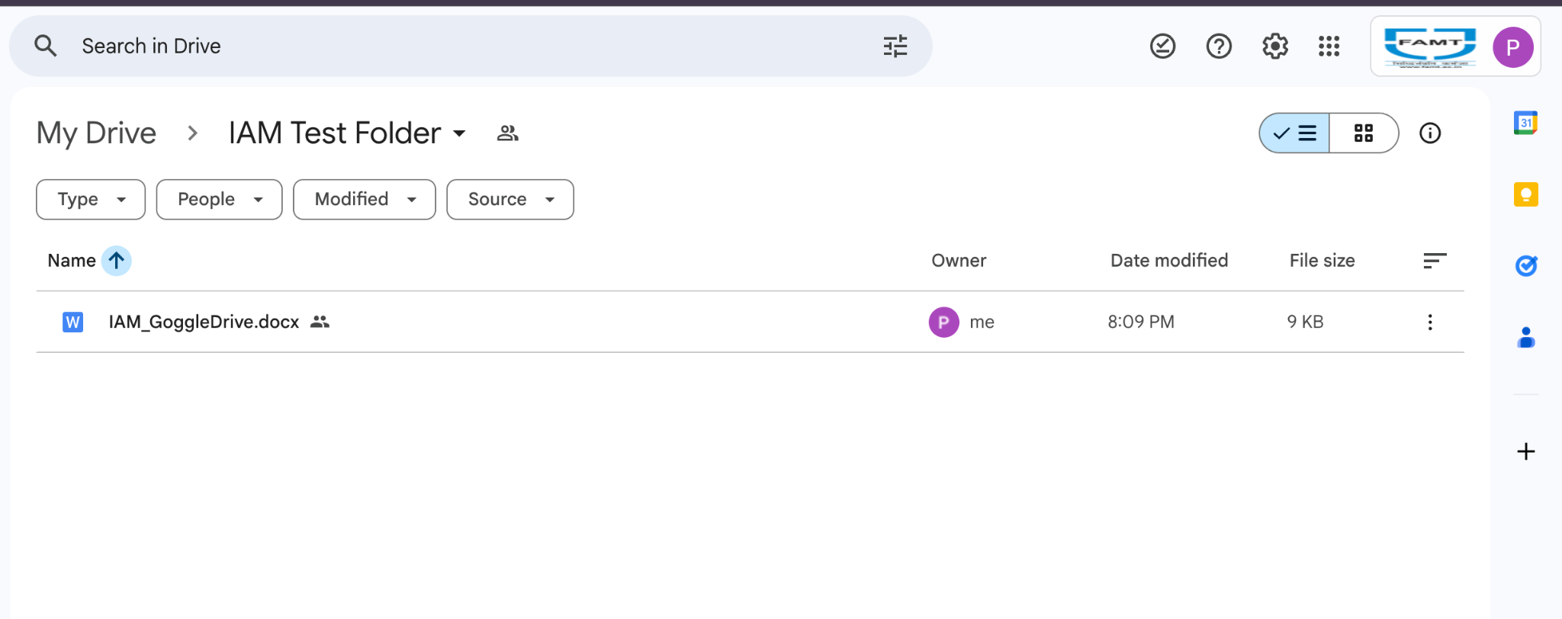

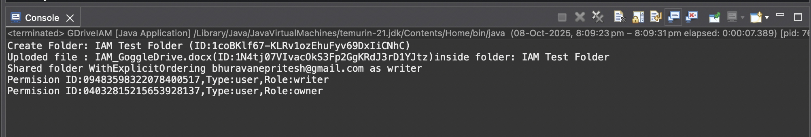

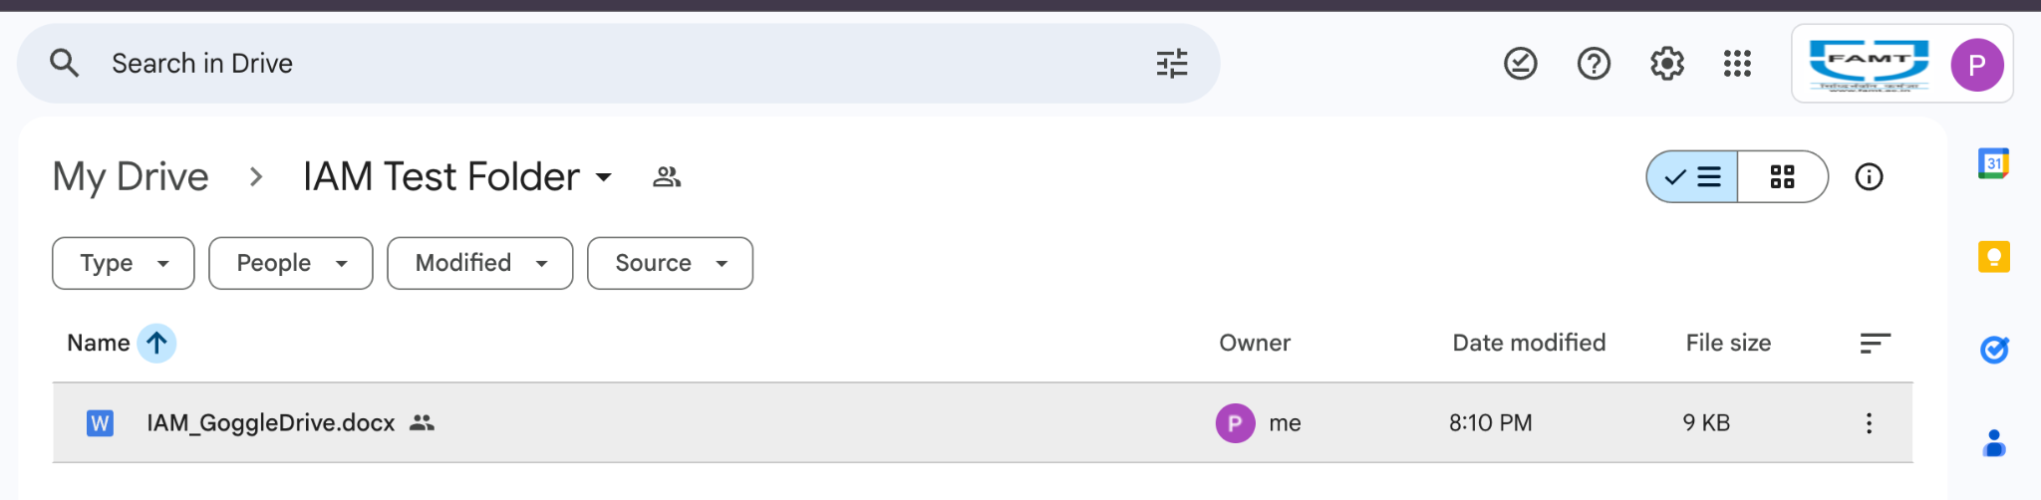

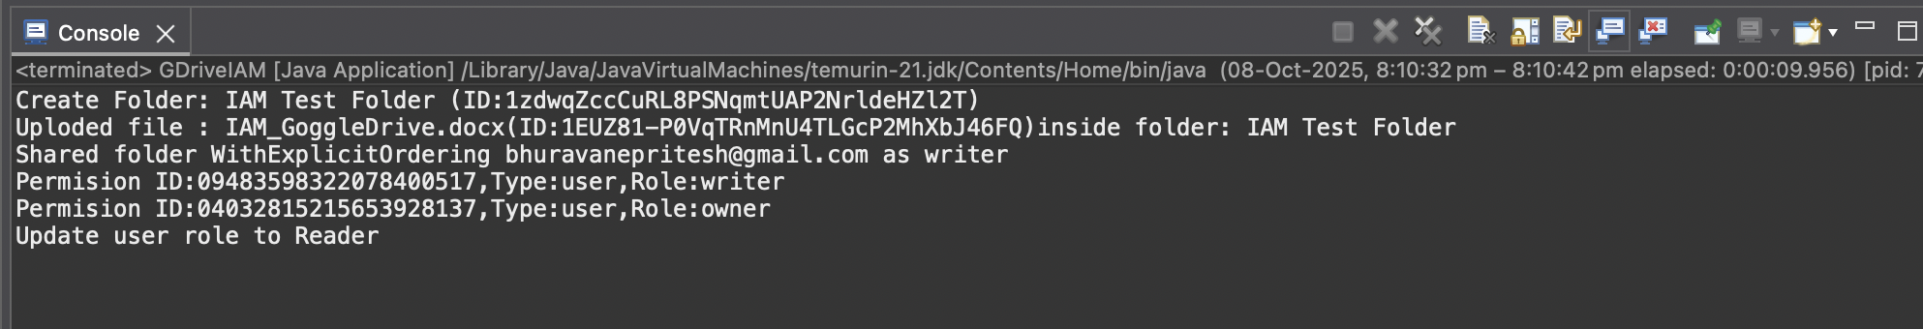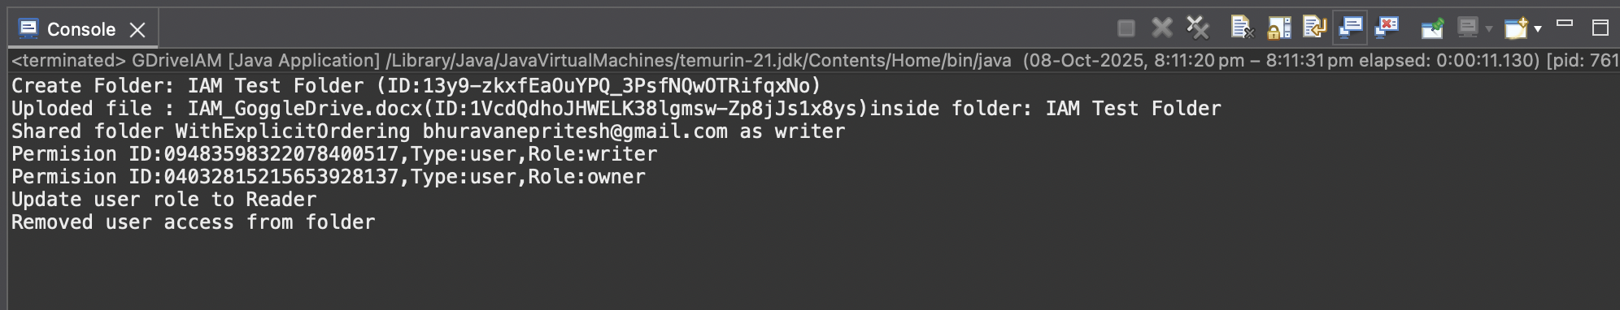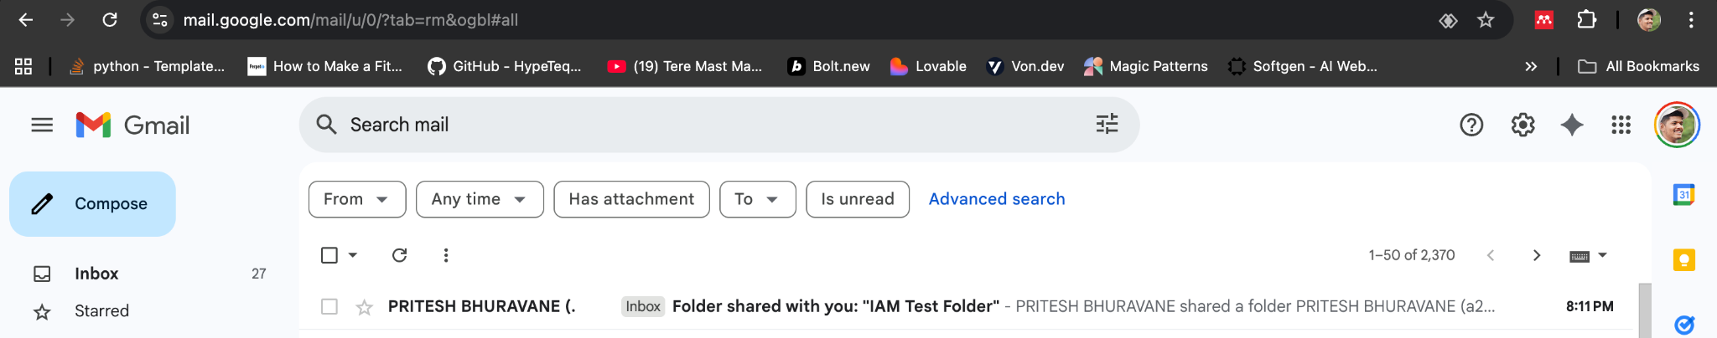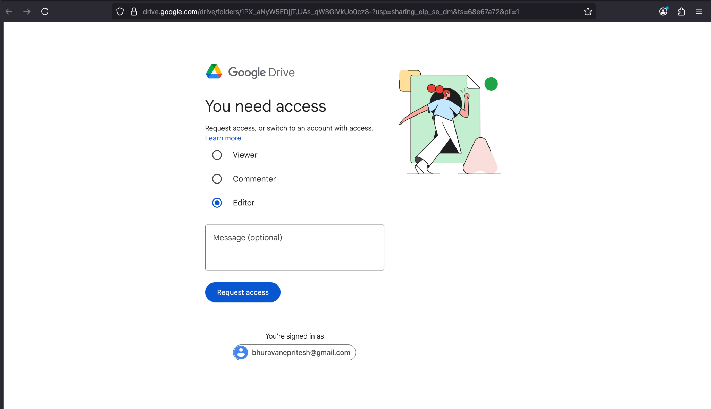

Conclusion:
This experiment successfully demonstrates Identity and Access Management (IAM) in a cloud environment using the Google Drive API and OAuth 2.0. It shows how authentication, authorization, and permission control can be securely managed for cloud resources, ensuring safe data sharing and access control.

