# 创建虚拟环境

C:\Users\lucifer\Desktop\learnpython\python_advan\stage06\作业\fproject>**virtualenv fprojectenv**

Using base prefix 'c:\\users\\lucifer\\appdata\\local\\programs\\python\\python36'

New python executable in C:\Users\lucifer\Desktop\learnpython\python_advan\stage06\作业\fproject\fprojectenv\Scripts\python.exe

Installing setuptools, pip, wheel...done.

C:\Users\lucifer\Desktop\learnpython\python_advan\stage06\作业\fproject>

* pycharm 选择虚拟环境

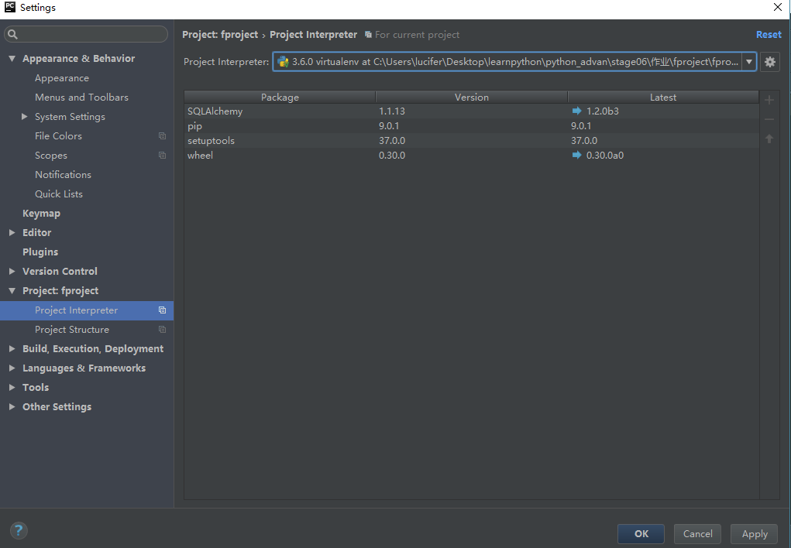

* windows下切换虚拟环境

C:\Users\lucifer\Desktop\learnpython\python_advan\stage06\作业\fproject>**cd fprojectenv\Scripts**

C:\Users\lucifer\Desktop\learnpython\python_advan\stage06\作业\fproject\fprojectenv\Scripts>**activate**

(fprojectenv) C:\Users\lucifer\Desktop\learnpython\python_advan\stage06\作业\fproject\fprojectenv\Scripts>

**可以看到进入了新的环境**

(fprojectenv) C:\Users\lucifer\Desktop\learnpython\python_advan\stage06\作业\fproject\fprojectenv\Scripts>**pip list**

DEPRECATION: The default format will switch to columns in the future. You can use --format=(legacy|columns) (or define a format=(legacy|columns) in your pip.conf under the [list] section) to disable this warning.

pip (9.0.1)

setuptools (37.0.0)

SQLAlchemy (1.1.13)

wheel (0.30.0)

(fprojectenv) C:\Users\lucifer\Desktop\learnpython\python_advan\stage06\作业\fproject\fprojectenv\Scripts>

**生成requirement.txt文件命令**

(fprojectenv) C:\Users\lucifer\Desktop\learnpython\python_advan\stage06\作业\fproject\fprojectenv\Scripts>**pip.exe freeze > ../../requirement.txt**

**由于很多flask很多第三方库只支持python2 虚拟环境改为python2**

**python2 在建立虚拟目录时不能有中文**

C:\Python27\Scripts>**virtualenv.exe C:\Users\lucifer\Desktop\learnpython\python_advan\stage06\fproject\env27**

New python executable in C:\Users\lucifer\Desktop\learnpython\python_advan\stage06\fproject\env27\Scripts\python27.exe

Also creating executable in C:\Users\lucifer\Desktop\learnpython\python_advan\stage06\fproject\env27\Scripts\python.exe

Installing setuptools, pip, wheel...done.

**数据库迁移**

(fprojectenv) C:\Users\lucifer\Desktop\learnpython\python_advan\stage06\作业\fpr

oject\fprojectenv\Scripts>**python ..\..\manager.py db init**

Creating directory C:\Users\lucifer\Desktop\learnpython\python_advan\stage06\作

业\fproject\fprojectenv\Scripts\migrations ... done

Creating directory C:\Users\lucifer\Desktop\learnpython\python_advan\stage06\作

业\fproject\fprojectenv\Scripts\migrations\versions ... done

Generating C:\Users\lucifer\Desktop\learnpython\python_advan\stage06\作业\fproje

ct\fprojectenv\Scripts\migrations\alembic.ini ... done

Generating C:\Users\lucifer\Desktop\learnpython\python_advan\stage06\作业\fproje

ct\fprojectenv\Scripts\migrations\env.py ... done

Generating C:\Users\lucifer\Desktop\learnpython\python_advan\stage06\作业\fproje

ct\fprojectenv\Scripts\migrations\README ... done

Generating C:\Users\lucifer\Desktop\learnpython\python_advan\stage06\作业\fproje

ct\fprojectenv\Scripts\migrations\script.py.mako ... done

Please edit configuration/connection/logging settings in 'C:\\Users\\lucifer\\De

sktop\\learnpython\\python_advan\\stage06\\作业\\fproject\\fprojectenv\\Scripts\

\migrations\\alembic.ini' before proceeding.

由于python3 已经不支持mysqldb 在迁移时会报错

ModuleNotFoundError: No module named 'MySQLdb'

解决方法是使用pymysql 在代码中引入以下部分

*import* pymysql  
pymysql.install_as_MySQLdb() #引入mysql安装文件

(fprojectenv) C:\Users\lucifer\Desktop\learnpython\python_advan\stage06\作业\fproject\fprojectenv\Scripts>**python ..\..\manager.py db migrate -m 'initial'**

C:\Users\lucifer\Desktop\learnpython\python_advan\stage06\作业\fproject\fprojectenv\lib\site-packages\pymysql\cursors.py:166: Warning: (1366, "Incorrect string

value: '\\xD6\\xD0\\xB9\\xFA\\xB1\\xEA...' for column 'VARIABLE_VALUE' at row 480")

result = self._query(query)

INFO [alembic.runtime.migration] Context impl MySQLImpl.

INFO [alembic.runtime.migration] Will assume non-transactional DDL.

INFO [alembic.autogenerate.compare] Detected added table 'ih_area_info'

INFO [alembic.autogenerate.compare] Detected added table 'ih_facility_info'

INFO [alembic.autogenerate.compare] Detected added table 'ih_user_profile'

INFO [alembic.autogenerate.compare] Detected added table 'ih_house_info'

INFO [alembic.autogenerate.compare] Detected added table 'ih_house_facility'

INFO [alembic.autogenerate.compare] Detected added table 'ih_house_image'

INFO [alembic.autogenerate.compare] Detected added table 'ih_order_info'

INFO [alembic.autogenerate.compare] Detected added index 'ix_ih_order_info_status' on '['status']'

Generating C:\Users\lucifer\Desktop\learnpython\python_advan\stage06\作业\fproject\fprojectenv\Scripts\migrations\versions\f813c6a4e43e_initial.py ... done

(fprojectenv) C:\Users\lucifer\Desktop\learnpython\python_advan\stage06\作业\fproject\fprojectenv\Scripts>**python ..\..\manager.py db upgrade**

C:\Users\lucifer\Desktop\learnpython\python_advan\stage06\作业\fproject\fprojectenv\lib\site-packages\pymysql\cursors.py:166: Warning: (1366, "Incorrect string value: '\

\xD6\\xD0\\xB9\\xFA\\xB1\\xEA...' for column 'VARIABLE_VALUE' at row 480")

result = self._query(query)

INFO [alembic.runtime.migration] Context impl MySQLImpl.

INFO [alembic.runtime.migration] Will assume non-transactional DDL.

INFO [alembic.runtime.migration] Running upgrade -> f813c6a4e43e, 'initial'

此时看到数据库的表已经创建

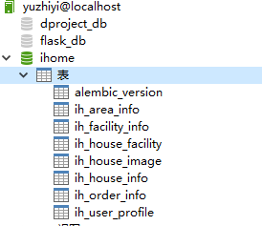

修改启动选项

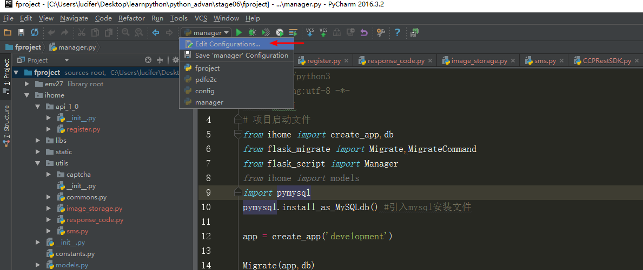

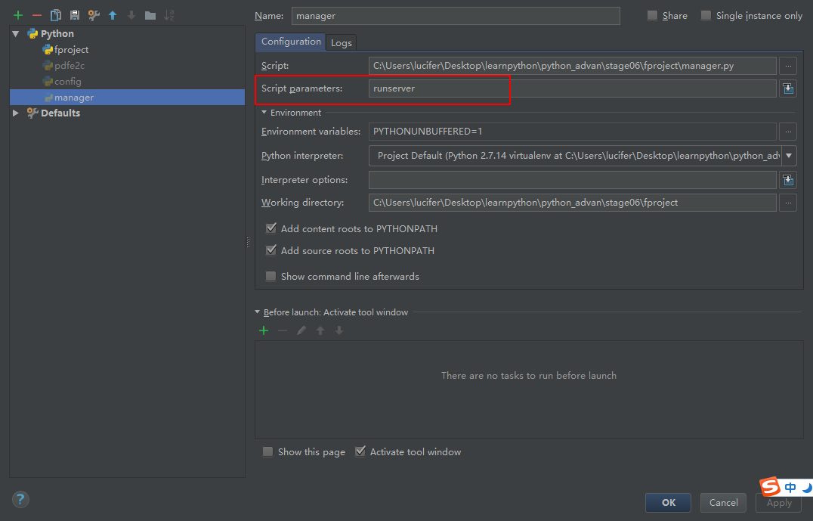

访问网址

