CASE STUDY

Radiology Study Triage and Worklist Prioritisation
AI Diagnostic and Radiology Screening Triage Assistant
A complete case study of the chest X-ray journey from clinical request to result clarification, centred on AI-assisted triage that helps radiologists decide which available study to review first.
Primary use case: triage and prioritisation of studies for radiologist review. Ordering, identity verification, PACS storage, image viewing, reporting, result access, follow-up comparison, and clarification form the end-to-end workflow that enables and completes the triage decision.
Audience | Radiology, clinical operations, AI governance, and technology leadership
Current maturity | Controlled demonstration and internal pilot candidate
Review date | 30 September 2026

Executive Summary
The primary purpose of the solution is to help radiologists decide which available chest X-ray study to review first. Each eligible uploaded study is screened by two AI components. A deterministic decision service combines those signals into High Priority, Review Flag, or Routine. The worklist then places unread studies ahead of viewed studies and orders each group by triage category and screening probability.
This is workflow prioritisation, not diagnosis. The category is an attention-management signal; every study still requires radiologist interpretation. A High Priority label recommends prompt review but does not confirm a critical result or trigger autonomous emergency escalation.

The Use Case in One Sentence
When multiple chest X-ray studies are waiting, the assistant identifies which studies may deserve earlier radiologist attention and makes the reason visible in the same review workspace.
Primary objective | Mechanism | Expected operational effect
Prioritise studies for review | Combine classification and localisation signals into a fixed category and sort the worklist. | Potentially reduce waiting time for suspicious studies while preserving radiologist control.
Explain the priority | Show screening probability, candidate regions, category, and deterministic reason. | Help the reader understand why a study moved up the queue.
Measure the effect | Compare time to first read and category agreement against a baseline. | Determine whether prioritisation improves service performance without unacceptable workload.

Complete Request to Clarification Journey
The use case begins before AI inference and ends after the treating doctor has consumed the reviewed result. Triage is the centre of the journey because it determines how available studies are ordered for radiologist attention. Every other stage either supplies trusted context to that decision, turns it into a clinical result, or closes the communication loop.
Stage | Primary action | Relationship to triage
1 Request | Doctor orders PA, AP, or paired PA plus AP and records indication and urgency. | Creates the patient-linked examination and supplies clinical context.
2 Queue | Radiology receives the order with accession, patient, view, priority, and status. | Defines which requested examination is awaiting acquisition.
3 Verify and upload | Radiologist confirms patient, accession, modality, view, and DICOM identifiers. | Prevents a priority from being assigned to the wrong patient or examination.
4 Store and analyse | Orthanc stores the study and the eligible image passes through both AI models. | Produces the two screening signals used for prioritisation.
5 Prioritise | The decision service assigns High Priority, Review Flag, or Routine and sorts the worklist. | This is the primary use case and operational decision point.
6 Review and report | Radiologist reviews full images, AI context, and clinical information and records the interpretation. | Converts a triage signal into a clinician-owned result.
7 Result access | Treating doctor sees the reviewed result in the patient context. | Ensures the prioritised study leads to an actionable reviewed result.
8 Compare and clarify | The care team compares linked studies and manages report questions. | Completes continuity and closes unresolved communication.

The AI category never replaces the doctor’s requested urgency, radiologist judgement, or hospital escalation policy. It is an additional study-level attention signal inside the radiology worklist.

Stage 1 Clinical Request
The treating doctor starts the examination from the patient record. The request captures the selected patient, examination type, required view, clinical indication, routine or urgent priority, and whether the study represents a new clinical problem or a follow-up.
Request element | Business rule | Why it matters
Patient | The request is created against a named patient. | Anchors every downstream image and result to one clinical record.
Examination | Chest X-ray PA, AP, or one paired PA plus AP order. | Defines the required acquisition and review scope.
Clinical indication | The doctor records the reason for imaging. | Gives the radiologist context when interpreting the prioritised study.
Requested urgency | Routine or urgent is retained from the ordering clinician. | Remains distinct from the AI category and local operational policy.
Follow-up context | A prior same-patient study may be linked. | Supports later longitudinal comparison without automated disease judgement.
Client request identity | Identical retries return the existing request; conflicting reuse is rejected. | Reduces duplicate requests during transient failures.

A paired PA plus AP request creates one examination and accession with two required study slots. The examination is not considered ready merely because one view has arrived.
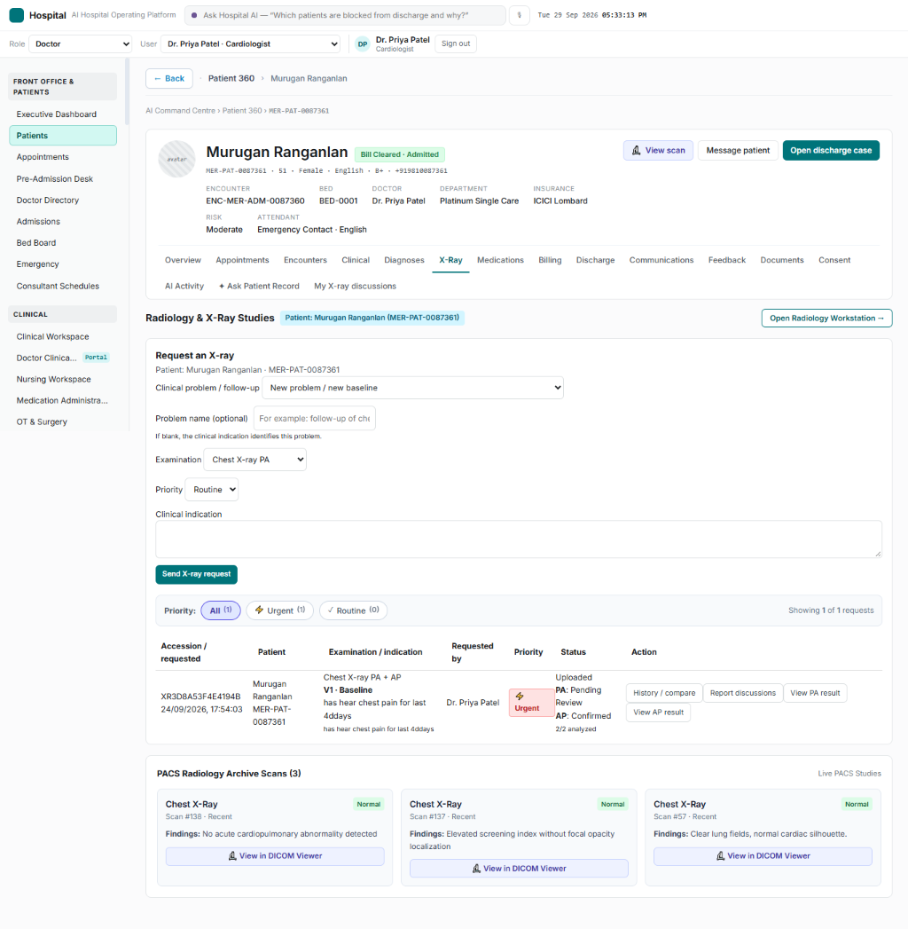
Figure 3 Patient 360 chest X-ray request and examination status

Stages 2 and 3 Radiology Queue Verification and Upload
The radiology queue presents the requested examination before any AI category exists. The radiologist selects the order and verifies the acquired DICOM against the intended patient and requested view. This safety boundary is essential because triage has value only when the analysed image is correctly linked.
Verification | System behaviour | Exception path
File and modality | Accept a readable CR or DX DICOM with pixel data and required UIDs. | Reject unreadable, unsupported, or incomplete files.
Accession | Accept blank accession or an accession matching the order; write the order accession to the stored copy. | Reject a conflicting accession.
Patient identity | Match the numeric ID, patient code, or an existing unambiguous verified mapping. | Require explicit radiologist confirmation for an unfamiliar identifier; reject a known mismatch.
Requested view | Match PA or AP to the order slot; require DICOM view position for a paired request. | Reject wrong or missing view information.
Duplicate protection | Check SOP instance and study UID use across accessions and orders. | Reject reuse linked to another examination.
PACS confirmation | Complete acquisition only after Orthanc confirms storage. | Reset the claim after failure so the same file can be retried.

Paired View Completeness
- PA and AP remain independently identifiable study slots under one accession.
- Each view can be uploaded, analysed, and reviewed independently.
- The paired examination is ready only after both required views have results.
- A failed view may be retried without re-analysing a completed sibling view.

Stage 4 Storage Eligibility and Analysis
Orthanc is the demonstration PACS. The watcher does not treat every archived image as a Meridian patient result. It first confirms that the PACS study is linked to an uploaded order-study record. Only then is the DICOM retrieved for analysis.
Processing step | Expected state | Failure handling
Order linkage | The PACS study maps to an eligible uploaded study slot. | Unlinked PACS content stays outside the patient result workflow.
DICOM preparation | Pixel data, rescale values, photometric interpretation, percentile clipping, and model inputs are prepared. | Processing errors are recorded and surfaced for retry or support.
DenseNet screening | Generate the lung-opacity screening probability. | A model failure prevents a completed triage result.
YOLO localisation | Generate qualifying candidate regions and an annotated image. | A model failure prevents a completed triage result.
Decision and persistence | Store the signals, deterministic category, explanation, images, and analysis timestamp. | Failed analysis remains retryable; completed results are not duplicated.

This stage supplies the trusted inputs to the primary triage decision. Model output is not exposed as a final report and does not independently create an emergency alert.

Stages 5 and 6 Prioritisation Review and Reporting
Triage becomes operational when the stored AI signals change the order of the radiologist worklist. Unread studies appear before viewed studies. Within each group, High Priority precedes Review Flag and Routine; DenseNet probability orders studies within the same category. The original category remains visible after viewing so its provenance is not lost.
Radiologist sees | Radiologist decides | System records
Category, screening probability, regions, original and annotated images. | Whether the image supports a clinical finding and how urgently the examination should be handled. | Review state, reviewer, timestamp, clinical finding, and report.
Patient, accession, view, indication, requested urgency, and relevant history. | How AI support relates to the clinical context and image quality. | The final clinician-owned interpretation rather than an AI-authored diagnosis.
OHIF access to the stored study. | Whether additional image review or comparison is required. | A durable result that downstream patient views can consume.

Review Boundary
High Priority means prompt review is recommended because both screening signals are positive. Review Flag means one signal is positive. Routine means neither screening signal is positive. All three categories require radiologist interpretation. None of the categories is a confirmed diagnosis or signed critical-result notification.

Stages 7 and 8 Result Access Comparison and Clarification
After review, the result returns to the treating doctor within the patient context. The doctor can see each requested view, its review status, the radiologist report, and authorised image access. For paired examinations, the user can distinguish PA and AP results rather than receiving an ambiguous combined status.
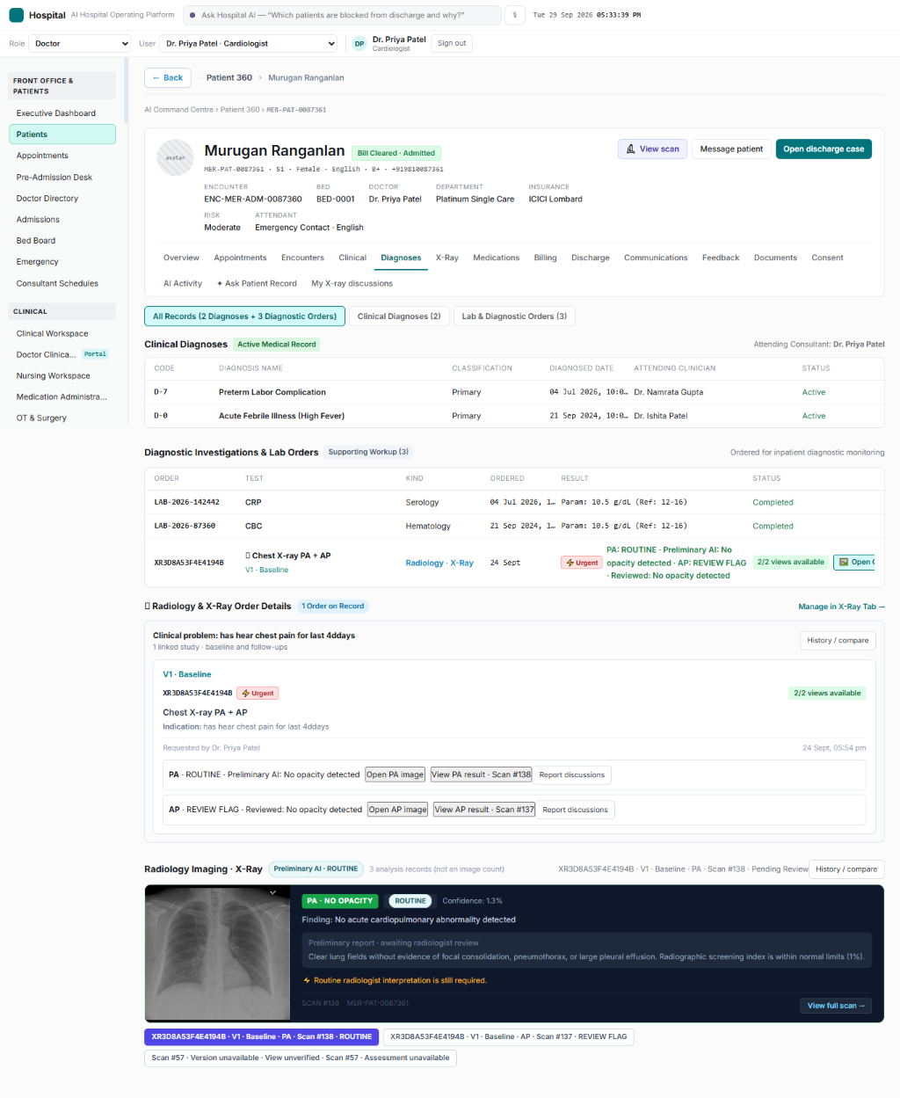
Figure 4 Reviewed imaging result and longitudinal comparison in the patient record

Follow Up Comparison
- A new order may be linked to an earlier order for the same patient and clinical problem.
- The workflow assigns a baseline root and sequential study version.
- Cross-patient links, cycles, out-of-order links, and removal that would break later history are prevented.
- The comparison view returns prior and current images, reports, views, dates, and review states.
- The system does not declare that disease has improved or deteriorated; that judgement remains clinical.

Report Clarification
A treating doctor may open a clarification only after a radiologist-reviewed report exists. The thread is attached to a report snapshot and fingerprint so a question cannot silently refer to changed report content. It routes to the reporting radiologist where available or to the shared radiology queue.
Clarification action | Owner and rule
Request | Treating doctor opens a question against the current reviewed report.
Assign or claim | Reporting radiologist receives it where available; otherwise a radiologist may claim it from the shared queue.
Discuss | Messages, sender roles, timestamps, reads, and assignment events are retained.
Resolve or reopen | The treating doctor resolves or reopens the discussion based on the response.
Clinical boundary | The discussion does not amend or version the signed report; formal addenda require a separate governed capability.

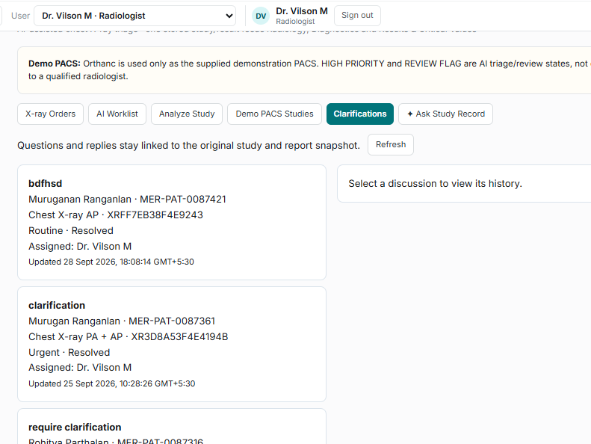
Figure 5 Report clarification remains linked to the study and reviewed report

End to End Exceptions and Recovery
Exception | Safe system response | Operational follow up
Duplicate request retry | Return the existing request when substantive details match. | Investigate only conflicting reuse.
Unknown DICOM patient identifier | Pause and require explicit radiologist confirmation with audit context. | Review mapping frequency and training.
Wrong patient accession or view | Reject before PACS attachment and analysis. | Correct acquisition or order selection.
PACS storage failure | Reset upload claim for same-file retry. | Monitor archive health and retry age.
One view missing in PA plus AP | Keep examination incomplete. | Acquire or upload the outstanding view.
AI analysis failure | Record failure and keep the study visible for retry or manual workflow. | Use degraded-mode procedures; do not infer a category.
Model or service unavailable | Do not present a stale or fabricated triage result. | Continue radiologist review under the documented manual queue process.
Report changes before clarification | Reject the stale clarification draft. | Refresh and open the question against the current report.
Incorrect follow-up link | Allow audited separation when later links do not depend on it. | Record the reason and preserve reports.

Audit and Accountability Across the Journey
The workflow retains order and accession identifiers, uploaded study references, analysis timestamps, category inputs and outputs, review provenance, follow-up link events, clarification messages, assignment events, read receipts, and lifecycle states. Production governance should define retention, access review, report-signing authority, incident handling, and audit review responsibilities.

Operational Problem
Radiology teams receive studies with different clinical urgency and imaging characteristics. A purely chronological queue can leave a suspicious study behind routine work, while an uncontrolled alerting system can create fatigue. The design therefore uses a small, explicit category set and keeps the radiologist as the final decision-maker.
Problem | Consequence | Triage response
Studies arrive faster than they can be read | Potentially important studies wait in arrival order. | Rank eligible studies by category before probability.
One model signal may miss or overcall a finding | A single score can be brittle. | Use classification and localisation as complementary signals.
Alerts can become diagnoses in practice | Users may over-rely on an AI label. | Use triage-only language and require radiologist interpretation.
A read study can continue to dominate the queue | Pending work becomes harder to see. | Show unread studies first while retaining the original category.
Priority value is not measured | A visually impressive queue may not improve care. | Track turnaround, agreement, false-alert workload, and missed findings.

Primary Actors
- Radiologist: reviews the prioritised worklist, opens images, interprets the examination, and records the clinical result.
- Clinical AI owner: approves intended use, thresholds, validation evidence, monitoring, and changes.
- Radiology operations lead: sets turnaround expectations and monitors queue performance.
- Technology team: maintains image ingestion, inference, worklist availability, auditability, and degraded-mode procedures.

Triage Prioritisation Flow
1 Study becomes eligible A verified, order-linked chest X-ray reaches the analysis workflow.
2 Both AI components run DenseNet produces an opacity screening probability and YOLO identifies candidate regions.
3 Signals are normalised Configured thresholds convert each output into a positive or absent screening signal.
4 Decision service assigns category The fixed rule produces High Priority, Review Flag, or Routine.
5 Worklist sorts studies Unread studies appear first; within each group, High Priority precedes Review Flag and Routine; probability breaks ties.
6 Radiologist reviews The reader sees the image, highlighted regions, screening values, patient context, and reason for the category.
7 Review outcome is recorded The radiologist confirms or changes the clinical interpretation; the AI category remains an auditable triage input.
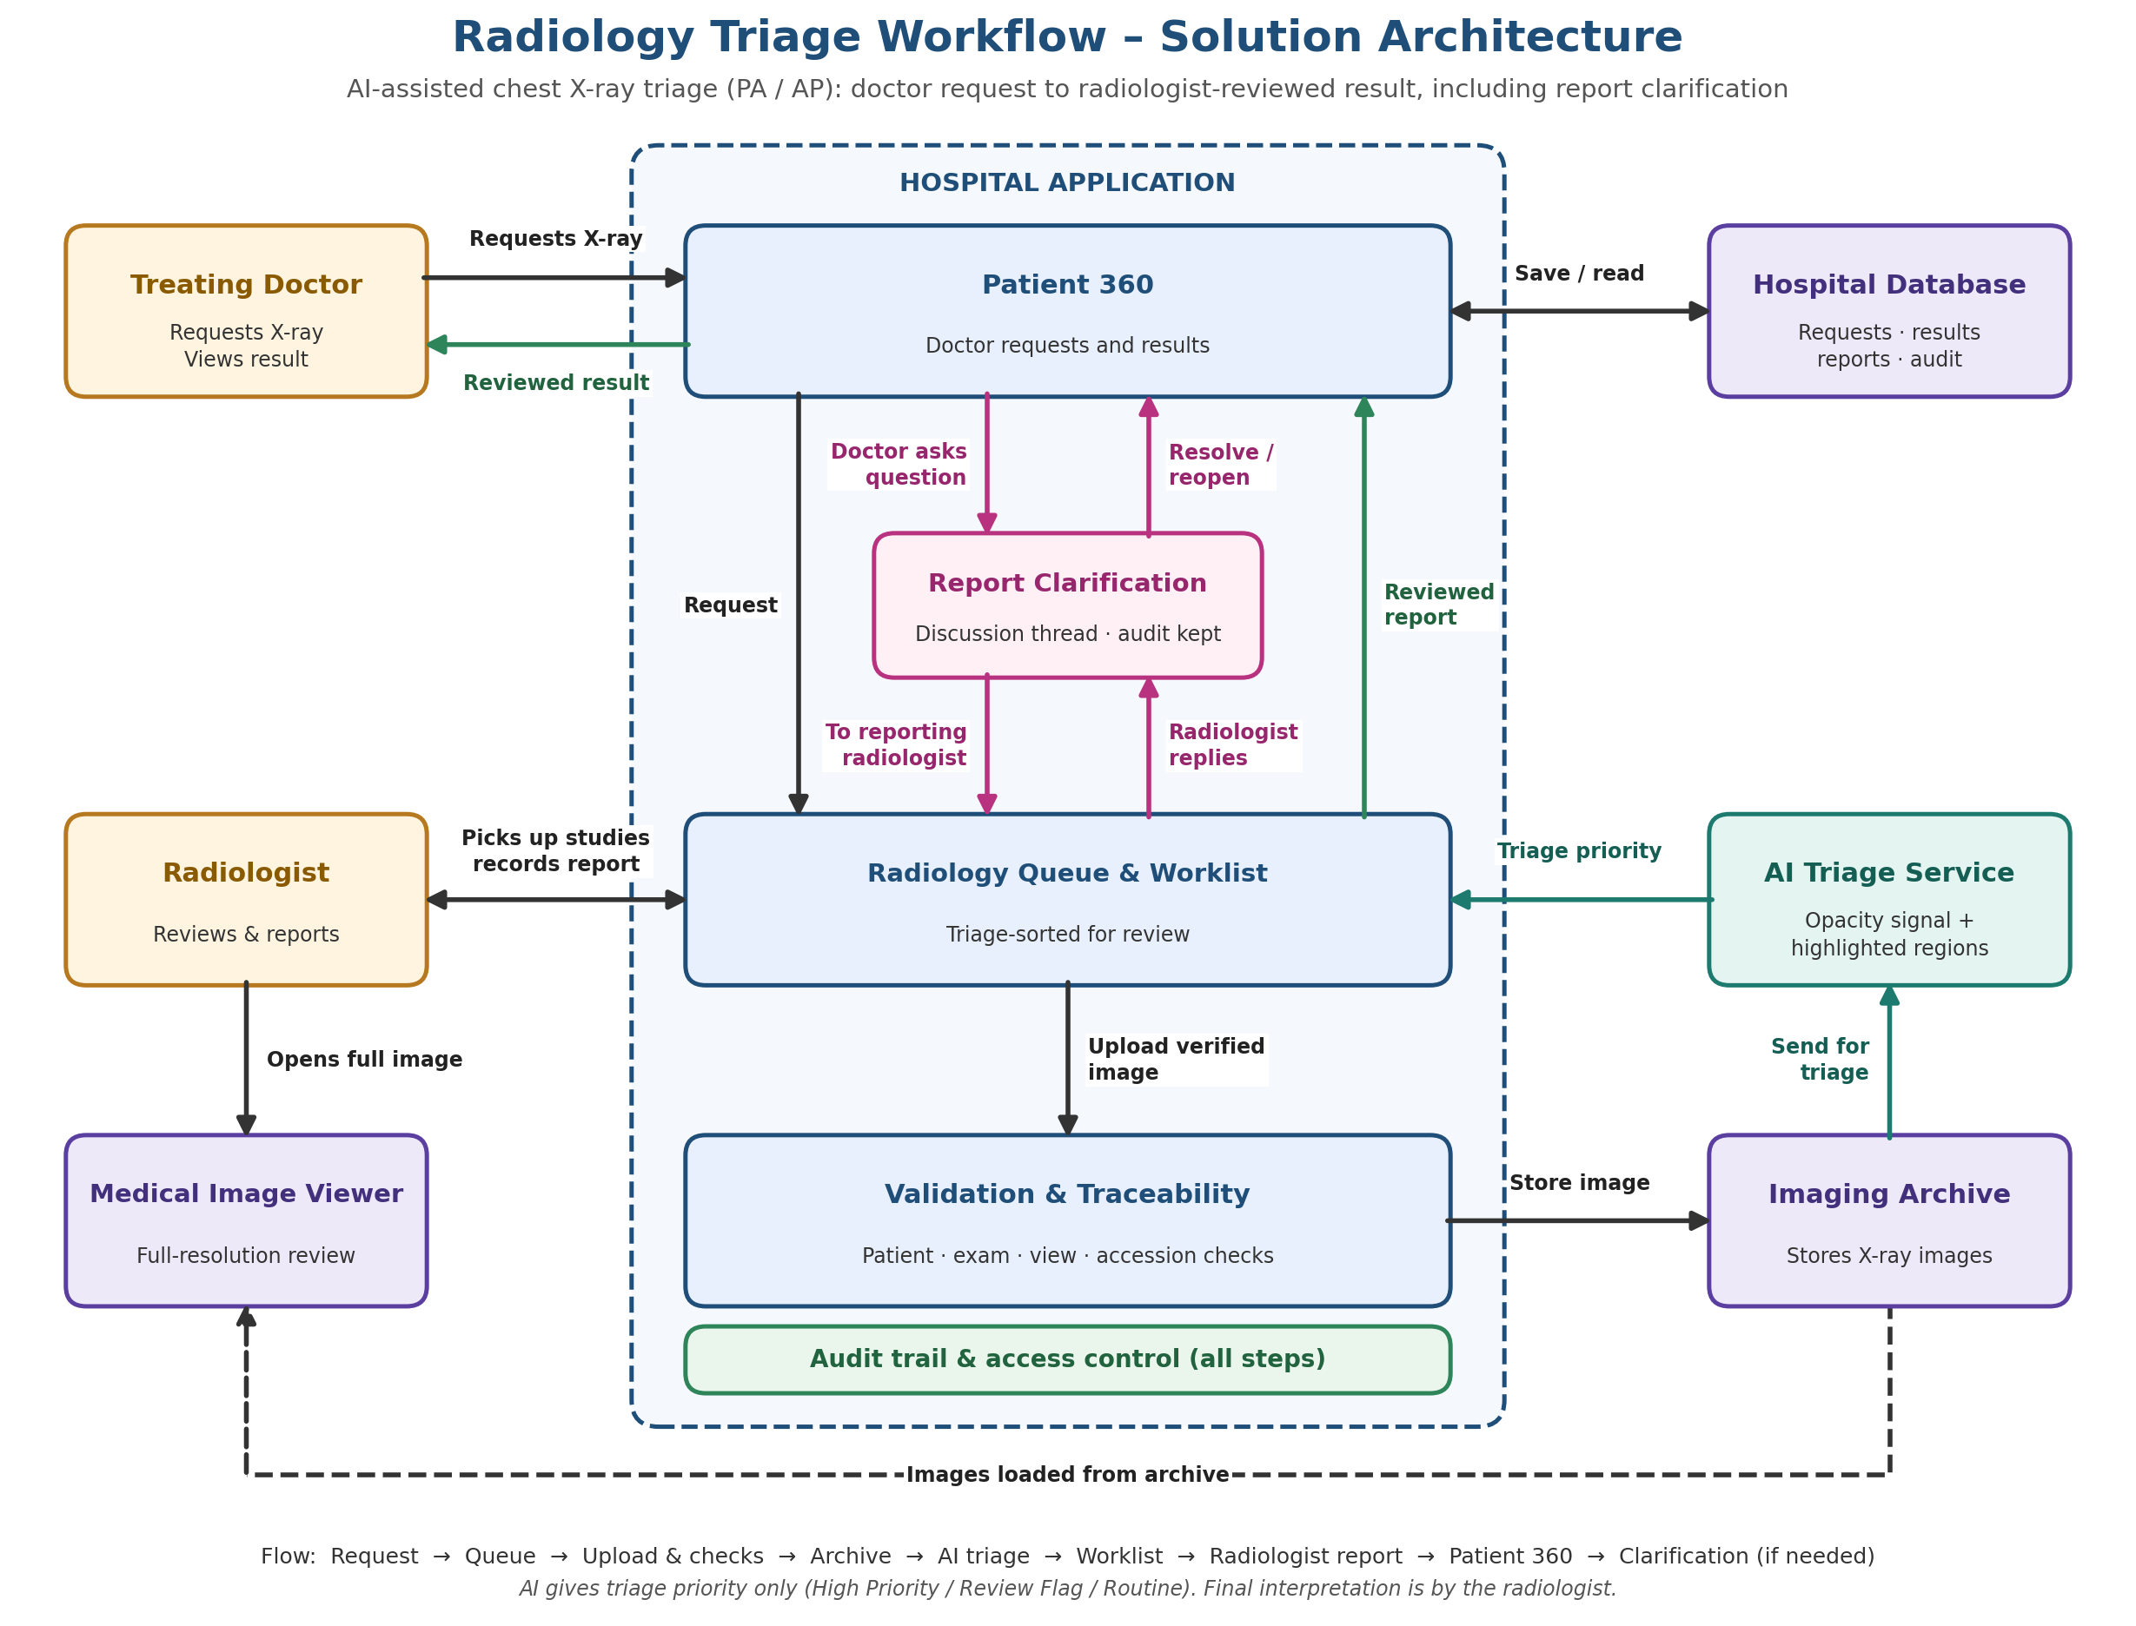
Figure 1 The wider workflow supporting triage prioritisation

AI Decision Logic
The decision is deterministic. It does not use a language model and does not infer a diagnosis. DenseNet is positive when its screening probability is at or above 0.20. YOLO is positive when at least one candidate region is at or above 0.10 confidence.
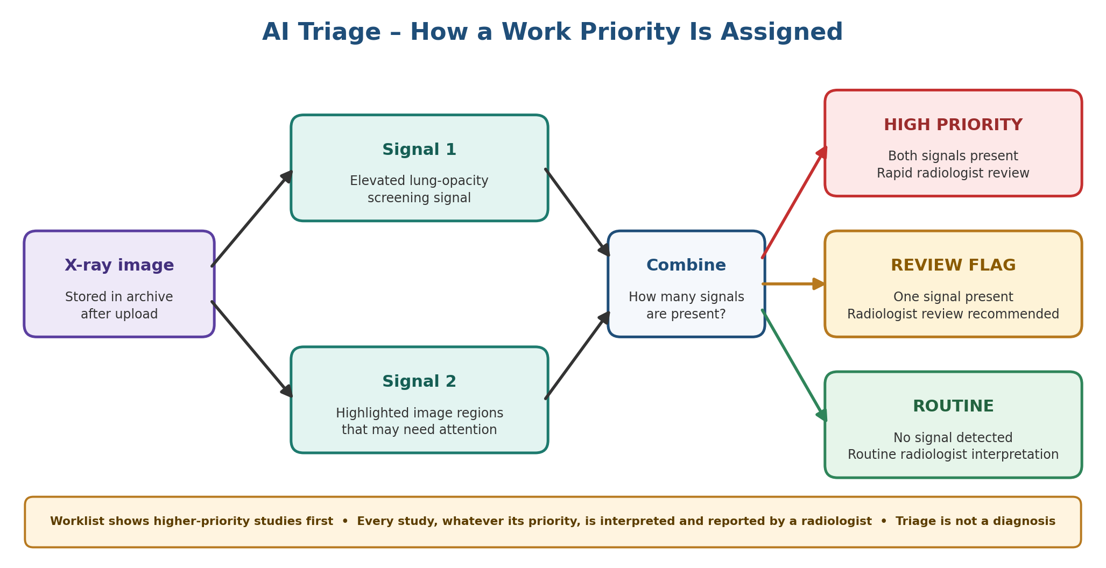
Figure 2 How two screening signals produce a worklist category
DenseNet | YOLO | Category | Meaning in the queue
Positive | Present | High Priority | Both signals support earlier attention; prompt review is recommended.
Positive | Absent | Review Flag | The screening index is elevated without a qualifying localised region.
Absent | Present | Review Flag | A qualifying region is localised despite a baseline classification score.
Absent | Absent | Routine | No screening signal is detected; routine radiologist interpretation remains required.

Worklist Behaviour
The worklist turns the category into an operational sequence. It does not change the category after a study is viewed; it changes only where the study appears so pending work remains visible.
Sort level | Rule | Purpose
1 Review state | Unread before viewed | Keep pending studies visible.
2 Triage category | High Priority, then Review Flag, then Routine | Place studies with stronger screening signals earlier.
3 Screening probability | Higher DenseNet probability first within the category | Provide stable ordering among similar studies.

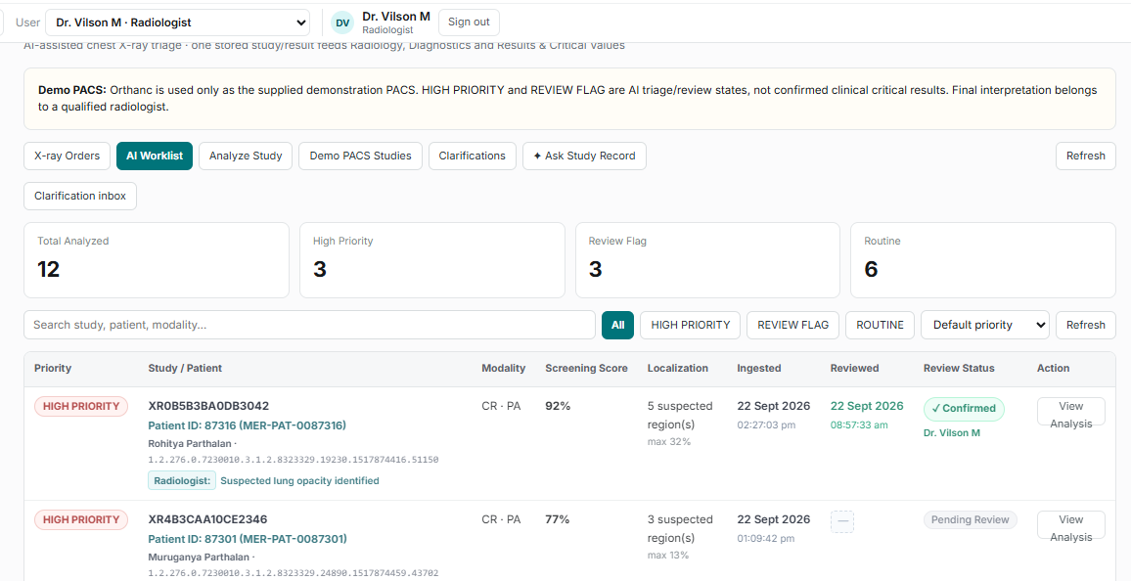
Figure 3 AI worklist showing priority categories and review state

Information Available to the Radiologist
- Triage category and screening probability.
- Number of qualifying localised regions and highest region confidence.
- Original image and annotated image for candidate-region review.
- Patient, accession, requested view, modality, indication, and study timing.
- Review status and access to the full medical image viewer.
- A clear statement that AI output is screening support and not a clinical diagnosis.

Clinical Safety Boundary
The assistant does | The assistant does not
Prioritises eligible studies in the worklist. | Diagnose disease or issue the final radiology report.
Highlights candidate opacity regions. | Confirm a critical result or replace image interpretation.
Explains which signals produced the category. | Page, text, or notify clinicians autonomously.
Retains the category as part of the review context. | Decide treatment, discharge, or escalation.
Supports measurement of queue performance. | Prove clinical effectiveness from development metrics alone.

Controls That Protect the Triage Use Case
Control | Why it matters to prioritisation
Only order-linked eligible studies enter the patient worklist | Prevents unrelated PACS studies from receiving a clinical-looking priority.
PA plus AP readiness waits for both requested views | Avoids presenting an incomplete paired examination as ready.
Patient, accession, view, modality, and duplicate checks | Protects the relationship between the category and the intended examination.
Radiologist review remains mandatory | Prevents a queue label from becoming the clinical conclusion.
Review provenance is retained | Supports audit of who reviewed the study and when.

Performance Evidence and Validation
The repository records development evaluation values including a DenseNet ROC AUC of 0.85, YOLO localisation on 143 of 200 positive test images at IoU 0.50, and 54 false alerts among 200 negative test images. These figures describe the development evaluation set. They are not evidence of local clinical sensitivity, specificity, patient outcome, or production effectiveness.
The 27 percent false-alert count in the stated negative test set is operationally important. Before priority categories influence a live queue, the organisation should measure how often Review Flag and High Priority studies are not confirmed by radiologists and whether that burden changes reading behaviour.

Minimum Local Validation
- Use representative local chest X-rays across PA and AP views, equipment, wards, acquisition quality, and relevant patient subgroups.
- Compare AI categories with blinded radiologist review and a defined reference process.
- Measure category-level sensitivity, false-alert burden, positive predictive value, calibration, and time-to-read impact.
- Review false negatives and high-confidence false positives clinically, not only statistically.
- Document threshold approval, intended use, excluded use, version, and change-control criteria.
Decision question | Evidence required
Can categories reorder the live queue? | Shadow-mode evidence that earlier attention improves without unsafe delay to other studies.
Are thresholds acceptable? | Local detection performance and reader workload at the configured operating points.
Can the service run continuously? | PACS, inference, database, monitoring, retry, downtime, and recovery tests.
Can users interpret the output safely? | Usability testing confirming that category, reason, and disclaimer are understood.

Pilot Measures
The pilot should evaluate whether prioritisation changes workflow performance, not merely whether the model produces scores.
Measure | Definition | Management question
Time to first read by category | Elapsed time from study readiness to first radiologist review for each category. | Do stronger signals receive earlier attention?
Queue age distribution | Waiting time percentiles for High Priority, Review Flag, and Routine. | Does prioritisation reduce long waits without starving routine work?
Radiologist agreement | Proportion of categories aligned with radiologist findings under the agreed definition. | Is the triage signal useful in local practice?
False-alert workload | High Priority or Review Flag studies not supported after review. | Is alert burden acceptable?
Potential misses | Routine studies later found to contain a target finding. | Is the routine category being over-trusted?
Category override behaviour | Reader actions and comments when the category appears inconsistent. | Are users applying judgement rather than automation bias?
Service reliability | Failed analyses, retry age, PACS downtime, and worklist availability. | Can the prioritisation pathway be trusted operationally?

Guardrails for Interpreting Results
- Report category-level results with sample sizes and confidence intervals.
- Analyse performance by view, device, ward, image quality, and relevant patient subgroup.
- Track routine-study turnaround so prioritisation does not create hidden delay.
- Separate model performance, workflow effect, usability, and service reliability in governance reviews.

Pilot Plan
Stage | Triage-focused exit criteria
1 Technical verification | Every eligible study receives one reproducible category; worklist order matches the specified sort rule; failures are visible and retryable.
2 Retrospective local validation | Thresholds and category performance meet predefined clinical and workload acceptance criteria.
3 Shadow mode | Categories are recorded but do not change reading order; prospective agreement, workload, and latency are measured.
4 Limited prioritised queue | Approved users apply categories during defined hours with monitoring, manual fallback, and rollback authority.
5 Scale decision | Leadership reviews safety, turnaround, routine-study delay, reader behaviour, reliability, and operating cost.

Go Live Decisions
- Who owns the clinical meaning and approval of each category?
- What maximum waiting time applies to High Priority, Review Flag, and Routine?
- Can High Priority reorder the queue immediately, or only after local validation?
- What false-alert and potential-miss thresholds trigger review or rollback?
- How will the service behave when PACS, a model, or the worklist is unavailable?
- How will model and threshold changes be versioned, revalidated, and communicated?

Supporting Workflow Capabilities
The following capabilities make prioritisation safe and usable, but they are secondary to the primary triage use case.
Supporting capability | Contribution to triage
Doctor order and accession | Provides patient, indication, urgency, requested view, and a traceable examination identity.
DICOM verification and PACS storage | Ensures the prioritised result belongs to the intended patient and study.
OHIF image viewer | Allows the radiologist to inspect the full stored image before reporting.
Radiologist report and review state | Closes the loop from AI priority to clinical interpretation.
Patient result view | Returns the reviewed result to the treating doctor.
Follow-up comparison | Preserves longitudinal context without automatically judging improvement or deterioration.
Report clarification | Keeps questions linked to the reviewed report; it does not change the triage category.

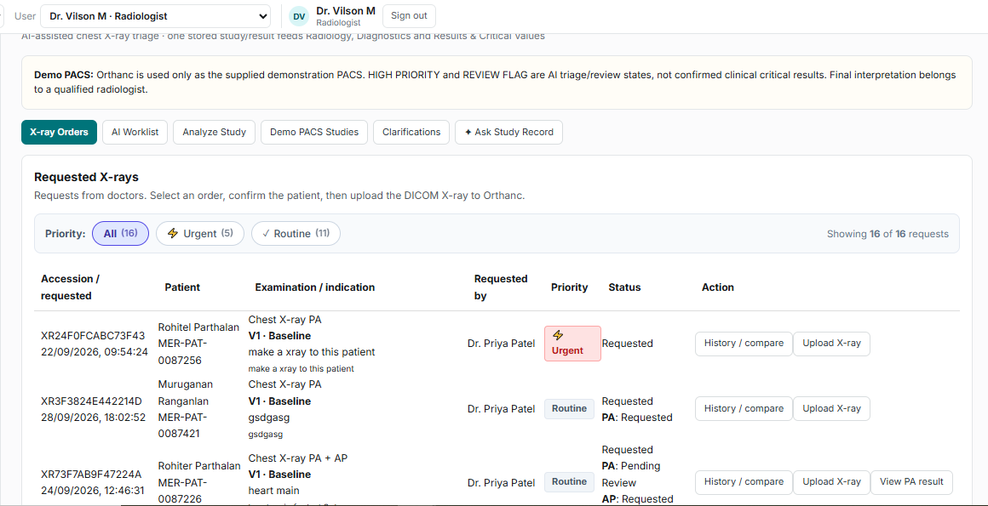
Figure 4 The radiology order queue supplies the studies that enter triage

Analysis Status Visibility
PACS monitoring helps operations confirm that eligible studies have been analysed and made available to the prioritised worklist. This is supporting operational visibility rather than the prioritisation decision itself.
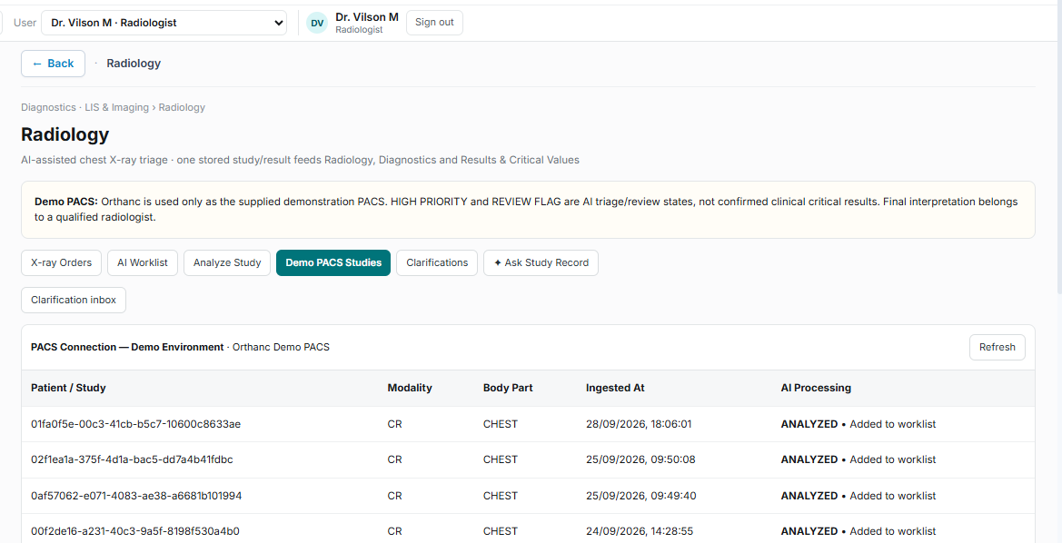
Figure 5 PACS monitoring supports visibility of study analysis state

Conclusion
The AI Diagnostic and Radiology Screening Triage Assistant should be evaluated first as a study-prioritisation system. Its core value proposition is simple: when radiologists face a queue of chest X-rays, the system uses two screening signals and a transparent rule to move studies with stronger signals closer to the top, while keeping the radiologist responsible for the final interpretation.
The next decision is therefore not whether the platform can support every adjacent radiology workflow. It is whether triage categories improve time to review at an acceptable false-alert burden, without delaying routine studies or encouraging automation bias. A shadow-mode pilot with explicit thresholds, queue metrics, reader feedback, and rollback criteria is the appropriate next step.

Current Scope
Chest X-ray PA, AP, and paired PA plus AP studies. Other modalities, autonomous diagnosis, automated emergency paging, patient notification, billing, and formal report addenda remain outside the current scope.

