Radiology Triage Business Context
Management report for Meridian Healthcare Platform

Purpose and management message
The Radiology Triage System provides a single business journey for chest X-rays. It connects the clinical request, image acquisition, AI-assisted prioritisation, radiologist review, treating-doctor access, and follow-up discussion in one patient-linked record.
The system is intended to help the radiology service organise work and improve traceability. AI assists with prioritisation only. It does not diagnose, replace a radiologist, or create an emergency escalation on its own. Final clinical interpretation remains with the qualified radiologist.

Business objective
Current workflow challenge | Business response
Requests, images, and reports can become disconnected | One request reference follows the examination from doctor order to reviewed result.
The wrong image can be associated with a patient | The radiologist verifies the patient, request, and required image view before the image is accepted.
Urgent-looking studies can wait in the general queue | AI categories help the radiologist identify cases that should be considered first.
Doctors need a reliable channel for report questions | An in-system clarification discussion keeps the question and response with the report context.
Earlier X-rays are difficult to compare | Related studies are grouped as baseline and follow-up examinations for comparison.

End to end business flow
1 | Doctor requests the examination The treating doctor selects the patient, chooses PA, AP, or PA plus AP views, records the clinical reason and priority, and identifies whether the request is a new problem or follow-up.

2 | System creates a traceable request The request receives a unique accession reference. A PA plus AP request is one examination with two required image views.

3 | Radiologist receives and verifies the request The radiologist sees the requested examination, patient, clinical indication, urgency, and current status in the radiology queue.

4 | Radiologist uploads the acquired image Before acceptance, the image is checked against the selected patient, request reference, and requested PA or AP view. A new identifier requires explicit radiologist confirmation.

5 | System stores and screens the study Once the image is stored, the system prepares an AI-assisted screening result and makes it available to the radiology worklist. Both images are required before a paired PA plus AP examination is ready.

6 | Radiologist reviews and confirms the result The radiologist reviews the original image, highlighted areas, AI screening information, and patient context, then records the clinical review and report.

7 | Treating doctor uses the reviewed result The doctor sees the patient-linked imaging result, including the report and study status, within the clinical workspace.

8 | Care team compares and clarifies when needed The doctor can compare a follow-up X-ray with earlier studies and raise a report question for the radiology team. The discussion remains linked to the report context.

Business Architecture Overview
The architecture below shows the business path for a chest X-ray. The treating doctor initiates the request, the radiology team verifies and reviews the study, and the reviewed result returns to the patient record. The image archive, AI triage service, and medical viewer support this workflow while the hospital database retains the clinical record and audit history.
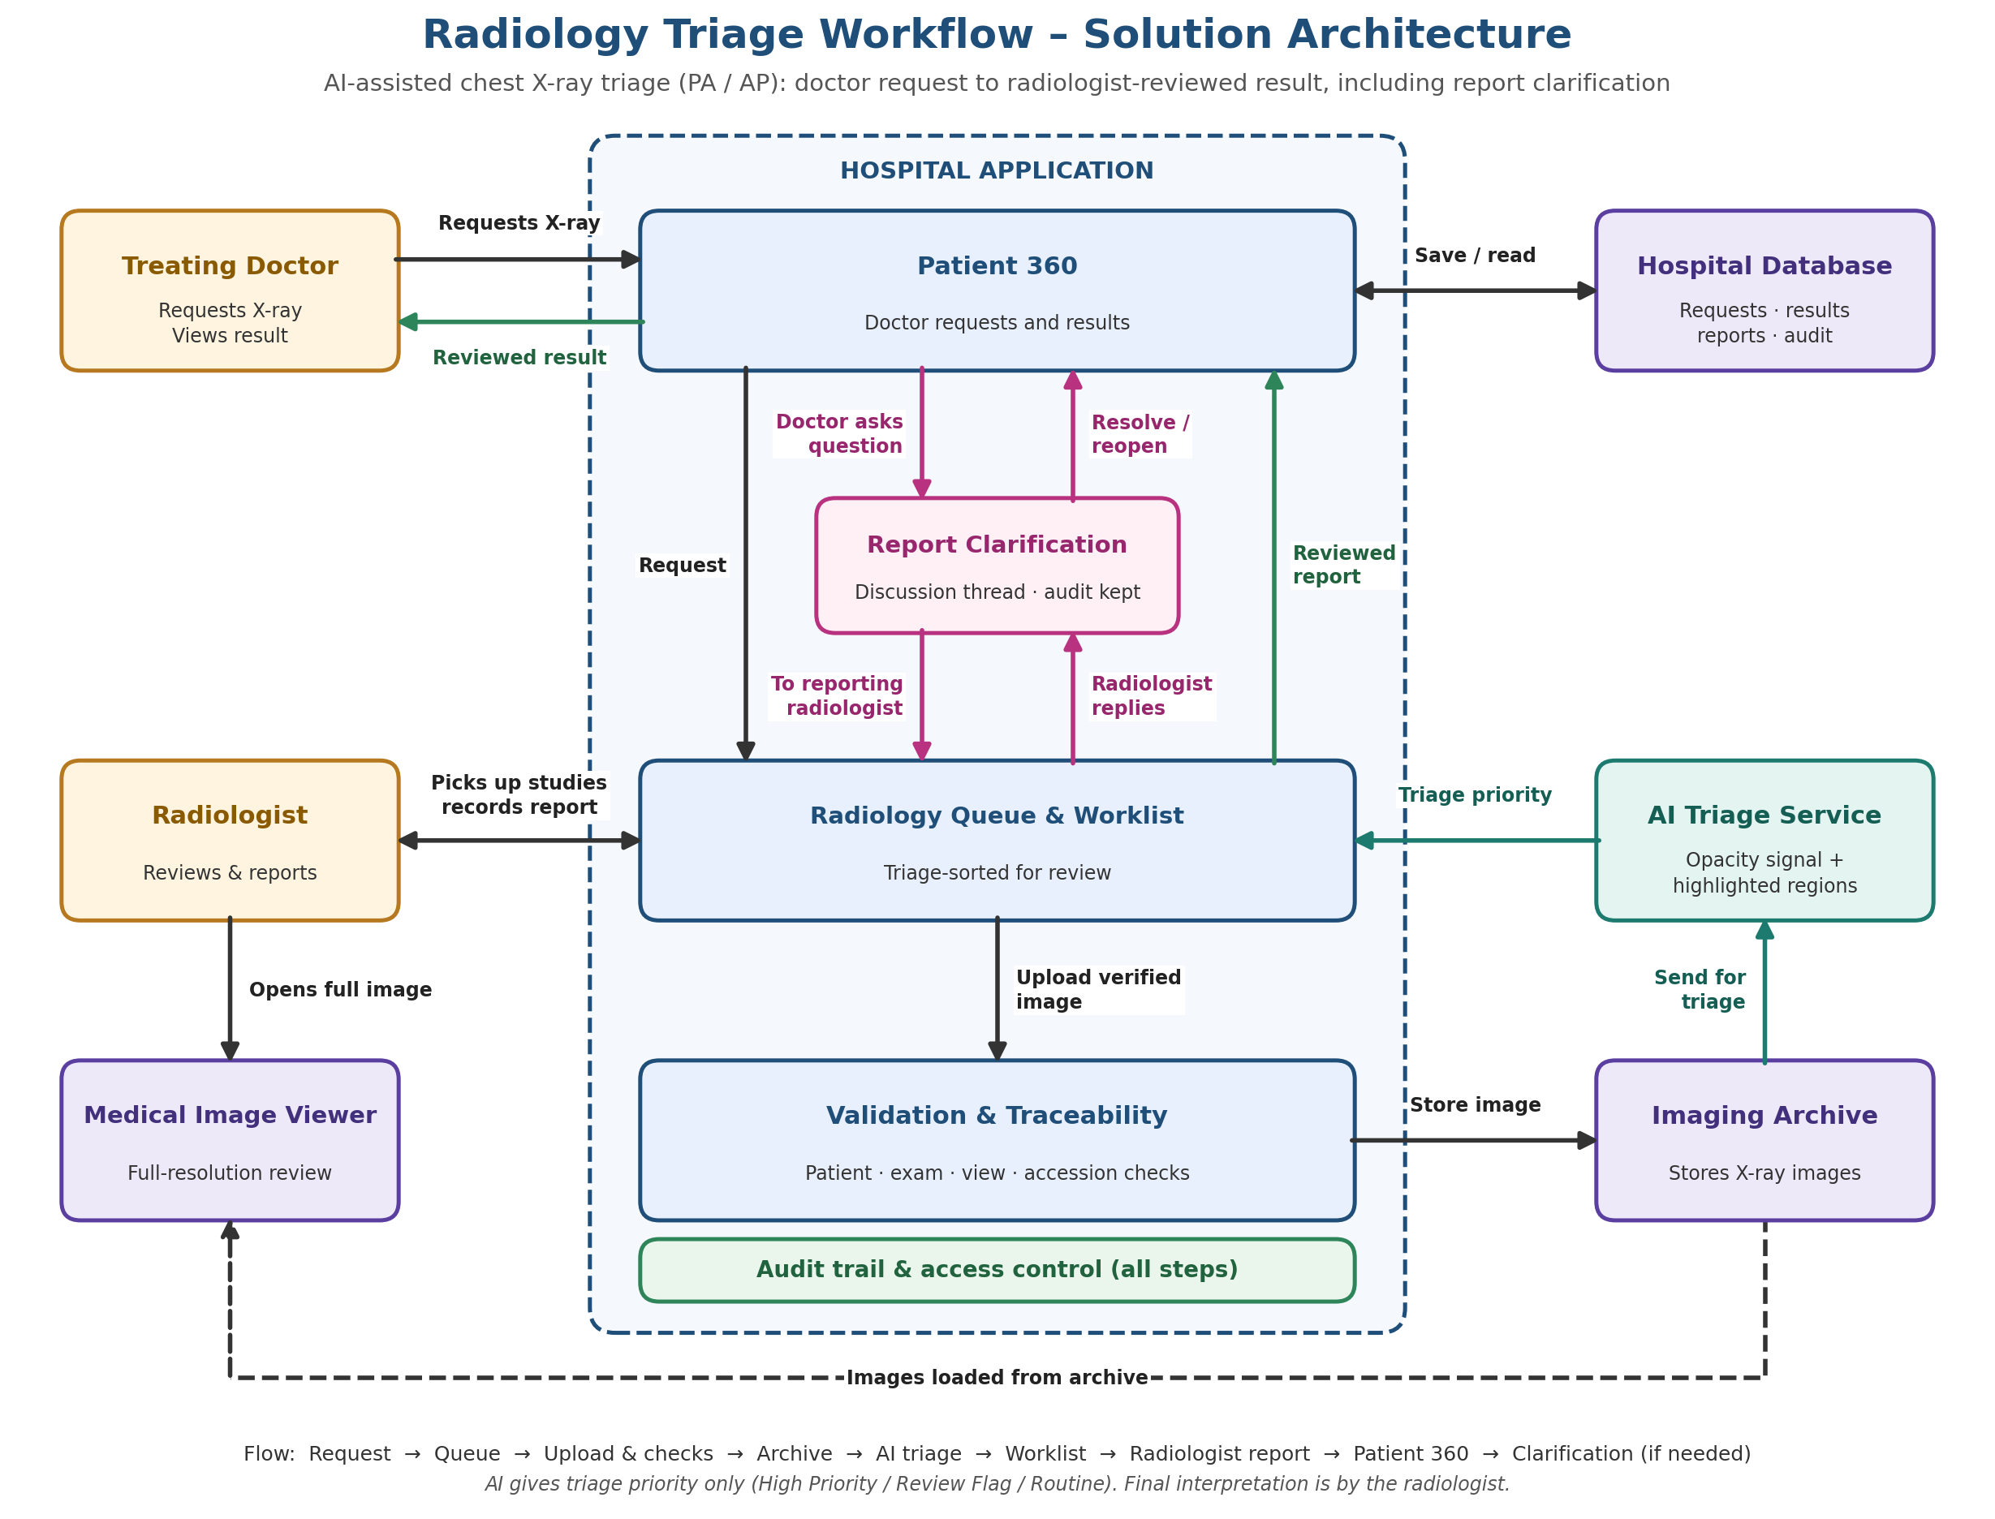
Figure 1 Radiology triage business architecture
For management, the key point is that the system keeps the request, image, prioritisation, review, report, and clarification process connected. The radiologist remains responsible for the final interpretation, and the treating doctor remains responsible for acting on the reviewed result.

AI Triage Priority Logic
The AI service uses two screening signals from the uploaded X-ray. It combines the signals into a work priority so that the radiology queue can show studies requiring attention first. This is a prioritisation step only; every study continues to require radiologist interpretation and reporting.
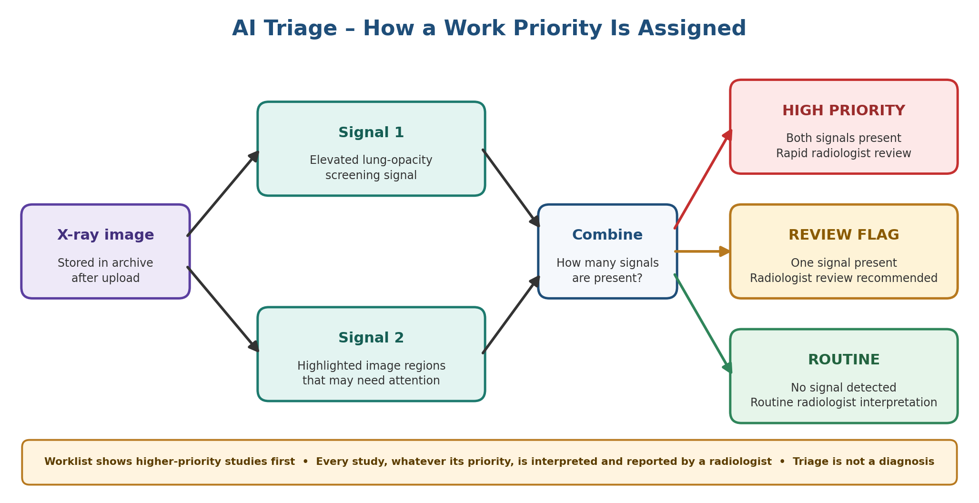
Figure 2 How AI triage assigns a work priority

How AI supports the service
Every eligible chest X-ray is screened using two complementary AI signals: one estimates the likelihood of a lung opacity and the other highlights image regions that may need attention. The system combines these signals using fixed business rules.

Worklist category | Meaning for the radiologist
High Priority | Both screening signals indicate a possible finding. Prompt radiologist review is recommended.
Review Flag | One screening signal indicates a possible finding. Radiologist review is recommended.
Routine | No screening signal was detected. A radiologist must still interpret the X-ray.

The category is an aid to work prioritisation. It is not a diagnosis, a confirmed critical result, or a substitute for clinical judgement. Local clinical validation and governance are required before the category is relied on in routine patient care.

Roles and accountability
Role | Business accountability
Treating doctor | Requests imaging, records clinical need and urgency, reviews the result, compares relevant history, and resolves clarification requests.
Radiologist | Verifies image-to-patient matching, uploads the image, reviews the study, records the final clinical interpretation, and responds to questions.

Patient safety and continuity controls
- Every clinical result is linked to a named patient and a doctor request.
- Patient identity, accession reference, requested image view, and duplicate image use are checked before upload.
- A radiologist must explicitly confirm an unfamiliar patient identifier before it is used for the selected patient.
- A PA plus AP examination is not considered complete until both requested views are available.
- A failed image-storage attempt can be retried without creating a second request.
- Follow-up links and report clarification activity are retained as part of the clinical workflow.

Operational views and expected use
Business view | Primary use
X-ray orders | Create, receive, and track requested examinations and their acquisition status.
Radiology worklist | Review available studies, focus attention using the AI category, and complete radiologist review.
Patient clinical workspace | Allow the treating doctor to see the patient-linked result and current examination status.
Diagnostics and results views | Provide a cross-imaging and priority-focused operational view of the same result.
History and comparison | Bring together relevant baseline and follow-up examinations without making an automatic clinical comparison.
Clarification discussion | Keep questions and responses about a reviewed report in one auditable care-team conversation.

Scope and operating assumptions
The current business scope is chest X-ray triage for PA and AP views, including a paired PA plus AP examination. The intended operating context is admitted-patient care, with a licensed radiologist reviewing each study. The workflow relies on trained clinical users, a dependable image archive and viewer, available AI services, and agreed turnaround procedures.
Other imaging modalities, patient notifications, email or SMS alerts, automated emergency paging, billing integration, and formal report addenda are outside this current business scope.

Measures for management oversight
Measure | Why it matters
Time from request to image upload | Shows how efficiently ordered studies reach radiology.
Time from upload to radiologist review | Measures the core reporting turnaround.
High Priority versus Routine time to first read | Shows whether prioritisation is helping the worklist.
AI categories confirmed by radiologists | Shows the practical value and workload impact of the triage aid.
PA plus AP examinations awaiting a view | Highlights incomplete examinations that cannot yet be fully reviewed.
Open clarification discussions and response time | Shows the quality and responsiveness of doctor-radiologist communication.
Upload and analysis failures | Shows service reliability and the need for operational follow-up.

Management decisions for the next stage
- Confirm whether the next stage is a controlled demonstration, an internal pilot, or a clinically governed limited rollout.
- Assign the clinical owner for AI governance, local validation, threshold approval, and ongoing performance review.
- Agree turnaround expectations for urgent and routine examinations.
- Decide how AI prioritisation should be used in daily work until local validation is complete.
- Confirm the sequencing for any future scope such as other modalities, notifications, report addenda, or billing.

Conclusion
The Radiology Triage System creates a coherent business route from a doctor request to a radiologist-reviewed chest X-ray result. It strengthens examination traceability, supports safer image matching, gives the radiology team a structured worklist, and keeps follow-up comparison and report questions within the patient care workflow. Its value is as a clinically governed triage and coordination service, with the radiologist retaining responsibility for the final interpretation.

