Automated Clinical Discharge Summary Generator
Project Context Document
LLM-assisted discharge summaries with billing clearance checks and mandatory doctor approval.

1. Purpose
The Automated Clinical Discharge Summary Generator simplifies and standardizes the hospital discharge process. It uses a Large Language Model (LLM) to draft a structured discharge summary from the patient's verified clinical and billing data. A doctor reviews and approves the draft before the patient is discharged.
The system reduces manual documentation effort, improves accuracy, and gives healthcare providers, patients, and insurance officers a clear, consistent record.

2. What the System Does
Before a discharge summary is generated, the system checks three things about the patient:
- Bill clearance: whether the patient's bill and insurance coverage are cleared.
- Diagnosis: the confirmed diagnosis and the treatment provided.
- Current vital status: the patient's most recent vital signs and overall condition at the time of discharge.
Once these inputs are available, an LLM generates the discharge summary. The doctor then reviews it. If the doctor approves, the final summary is issued as a PDF and the patient is discharged. If the doctor rejects it, the summary is corrected and regenerated.

3. Workflow Overview
- Hospital Staff Login. Staff log in and initiate a discharge request with the patient's treatment and billing details.
- Discharge Request Submission. Patient data is securely stored in the system, including diagnosis, treatment, medications, and current vitals.
- Bill and Insurance Clearance. The insurance/billing officer checks coverage and bill status, then approves or rejects clearance. If not cleared, the billing or coverage issue is resolved first.
- LLM Summary Generation. Once cleared, the LLM drafts the discharge summary from the patient record, diagnosis, and current vital status.
- Doctor Approval. The treating doctor reviews the draft and approves it or sends it back for changes.
- Final Discharge. After approval, the final PDF is produced, the patient is marked as discharged, and the patient receives the summary.
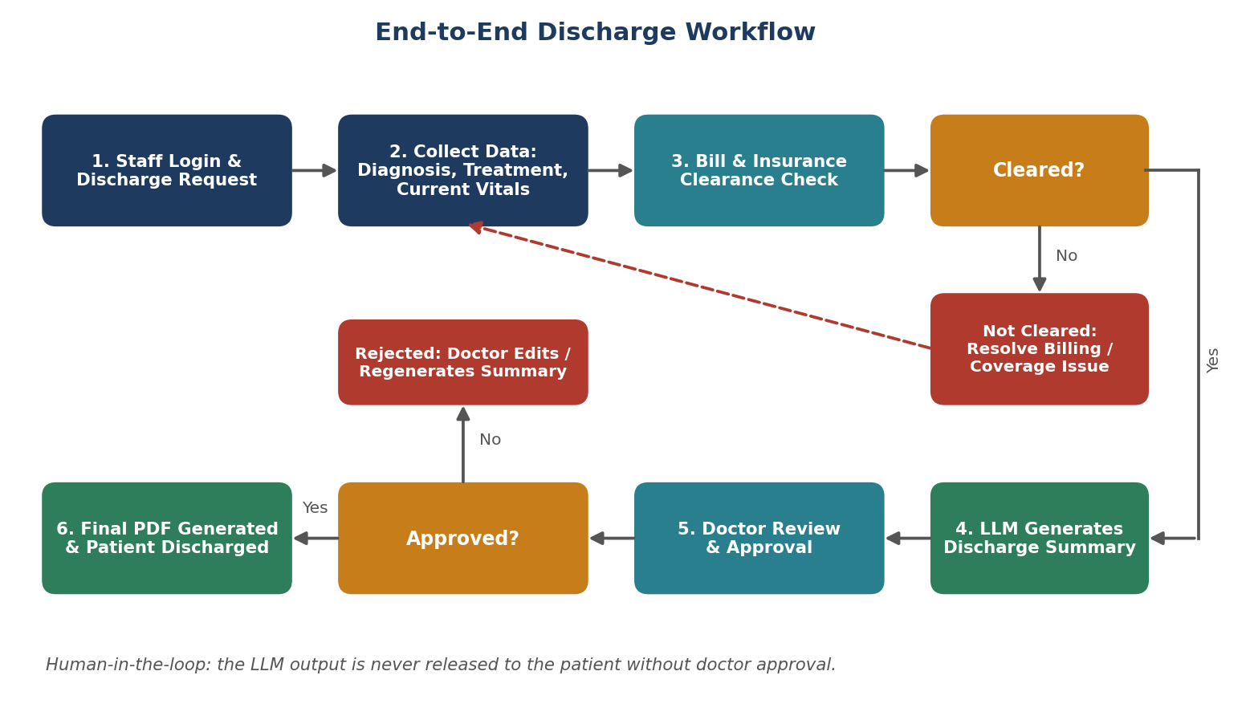
Figure 1: End-to-end discharge workflow

4. Key Features
- Automated summary generation from verified patient records using an LLM.
- Bill and insurance clearance check before any summary is generated.
- Mandatory doctor approval: no summary is released to the patient without it.
- Role-based access for hospital staff, insurance/billing officers, and doctors.
- Secure data handling and storage.
- Fewer errors and delays in discharge.
- Clear, structured summaries for patients, exported as PDF.

5. System Architecture
The system is organised into four layers. The diagram shows how requests move from users through the application logic, to the data stores, and out as the final discharge document.
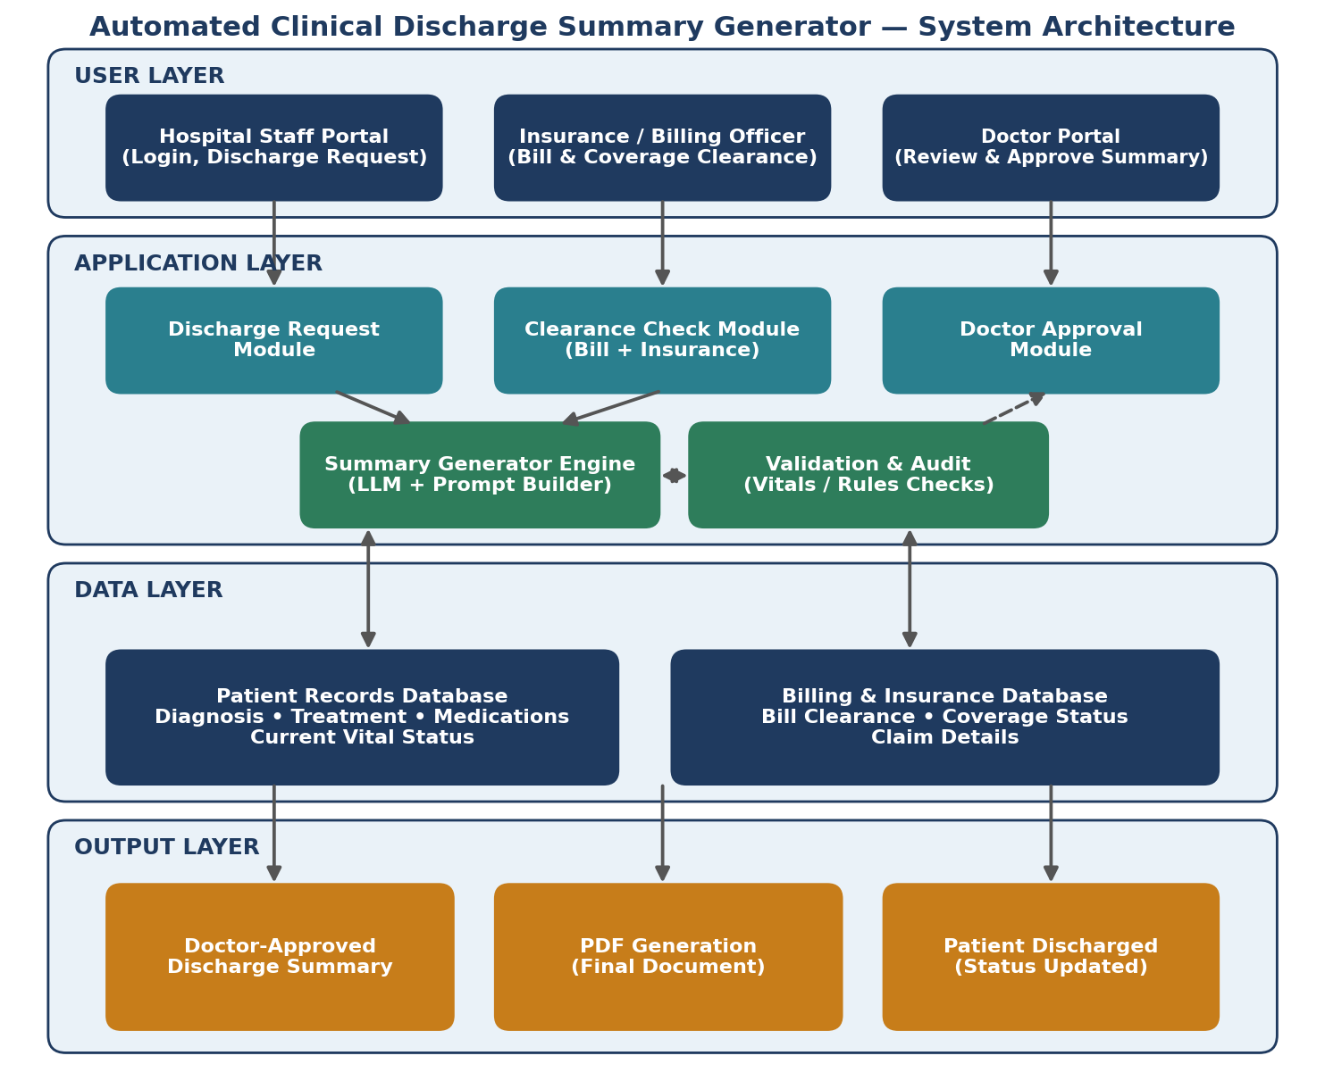
Figure 2: System architecture (conceptual)

5.1 Layer Details
Layer | Component | Responsibility
User Layer | Hospital Staff Portal | Staff login, create and submit discharge requests, enter treatment and billing details.
User Layer | Insurance / Billing Officer | Verify bill clearance and insurance coverage; approve or reject.
User Layer | Doctor Portal | Review the generated summary; approve or send back for correction.
Application Layer | Discharge Request Module | Receives and validates discharge requests and tracks request status.
Application Layer | Clearance Check Module | Confirms bill clearance and insurance approval before generation starts.
Application Layer | Summary Generator Engine | Builds the prompt from patient data and calls the LLM to draft the summary.
Application Layer | Validation & Audit | Checks the draft against source data (vitals, medications, diagnosis) and logs actions.
Application Layer | Doctor Approval Module | Holds the draft until the doctor approves; handles rejection and regeneration.
Data Layer | Patient Records Database | Patient details, diagnosis, treatment, medications, current vital status.
Data Layer | Billing & Insurance Database | Bill clearance, coverage status, and claim details.
Output Layer | Discharge Summary (PDF) | Doctor-approved summary generated as a PDF and the patient status set to discharged.

6. Discharge Summary Contents
The generated summary includes:
- Patient details
- Diagnosis and treatment provided
- Current vital status at discharge
- Medications prescribed
- Billing and insurance details, including clearance status
- Follow-up instructions

7. Roles and Access
Role | Permissions
Hospital Staff | Log in, create discharge requests, enter treatment and billing details, view request status.
Insurance / Billing Officer | View billing and coverage details; approve or reject clearance.
Doctor | Review the generated summary, edit if needed, approve or reject. Approval triggers discharge.

8. Example Use Case
A patient completes treatment. Hospital staff enter the treatment details, billing information, and current vitals, then raise a discharge request. The insurance officer verifies that the bill is cleared and coverage is approved. The LLM then generates the discharge summary from the patient's diagnosis, treatment, medications, and current vital status. The treating doctor reviews the summary and approves it. The system produces the final PDF and the patient is discharged.

9. Safety and Controls
Because the summary is generated by an LLM and concerns patient care, the design includes these controls:
- Human approval: A doctor must approve every summary before it is released. The LLM output is a draft only.
- Grounded generation: The LLM is given only verified data from the patient and billing records, so it summarizes rather than invents.
- Validation: Diagnosis, medications, and vitals in the draft are cross-checked against the source records.
- Access control and security: Access is limited by role, and patient data is stored and transmitted securely.
- Audit trail: Requests, generated drafts, edits, and approvals are logged with user and time.

10. Benefits
- Efficiency: Saves time for hospital staff and speeds up discharge.
- Accuracy: Cross-checks against source records and doctor review reduce documentation errors.
- Transparency: Patients receive clear information about their treatment and billing.
- Integration: Can connect with hospital databases and insurance systems.

11. Discharge Request Status Flow
Status | Meaning
Submitted | Staff have submitted the discharge request with treatment and billing details.
Pending Clearance | Waiting for the insurance/billing officer to verify bill and coverage.
Cleared | Bill and insurance are cleared; summary generation can start.
Pending Doctor Approval | The LLM draft is ready and waiting for the doctor's review.
Approved | The doctor has approved; the final PDF is generated.
Discharged | The patient has been discharged and receives the summary.
Rejected / Returned | Clearance failed or the doctor sent the draft back; the request returns for correction.

