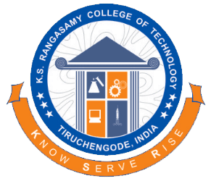 | SERVICE MOTTO VOLUNTEERS  MINUTES OF MEET | 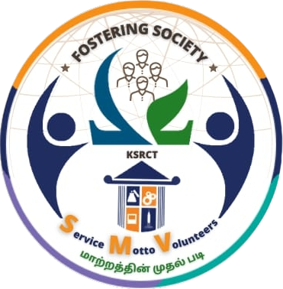

DATE: 17-02-2026 | TIME: 04.00 PM

S.NO | NAME | YEAR | DEPARTMENT
1 | ARUN NITHEES T | 2 | AI&DS
2 | DHARSHANA E V | 2 | AI&DS
3 | NIVETHITHA S | 2 | AI&DS
4 | SIVASRI C | 2 | AI&DS

Discussed in Today's SM Room Meeting:
Point : 1 | asfsfs
Discussion | • frfgergergergr
Point : 2 | erge
Discussion | • rgerg

CONVENER | PRINCIPAL

