**ASSIGNMENT # 1**

**Name:** Ahmad Hashim Farooq

**Reg No:** FA21-BCS-138

**Date:** 25/03/2024

**Course:** AI Lab

**Implement A*/Heuristics on  5 different graphs.**

**A*/Heuristics Algorithm:**

**Graph 1:**

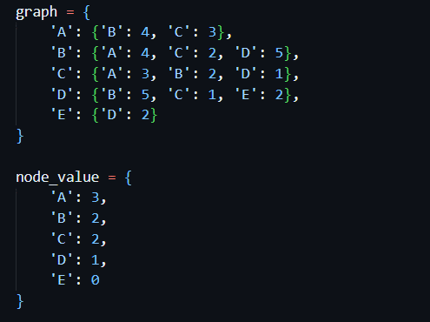

**Graph 2:**

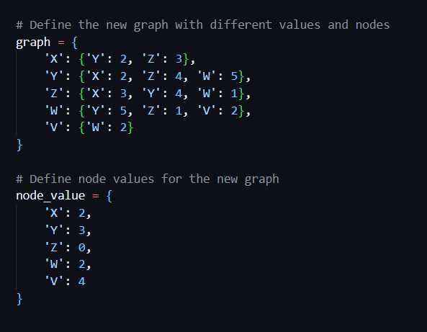

**Graph 3:**

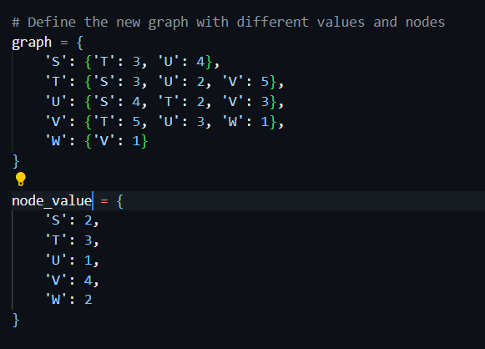

**Graph 4:**