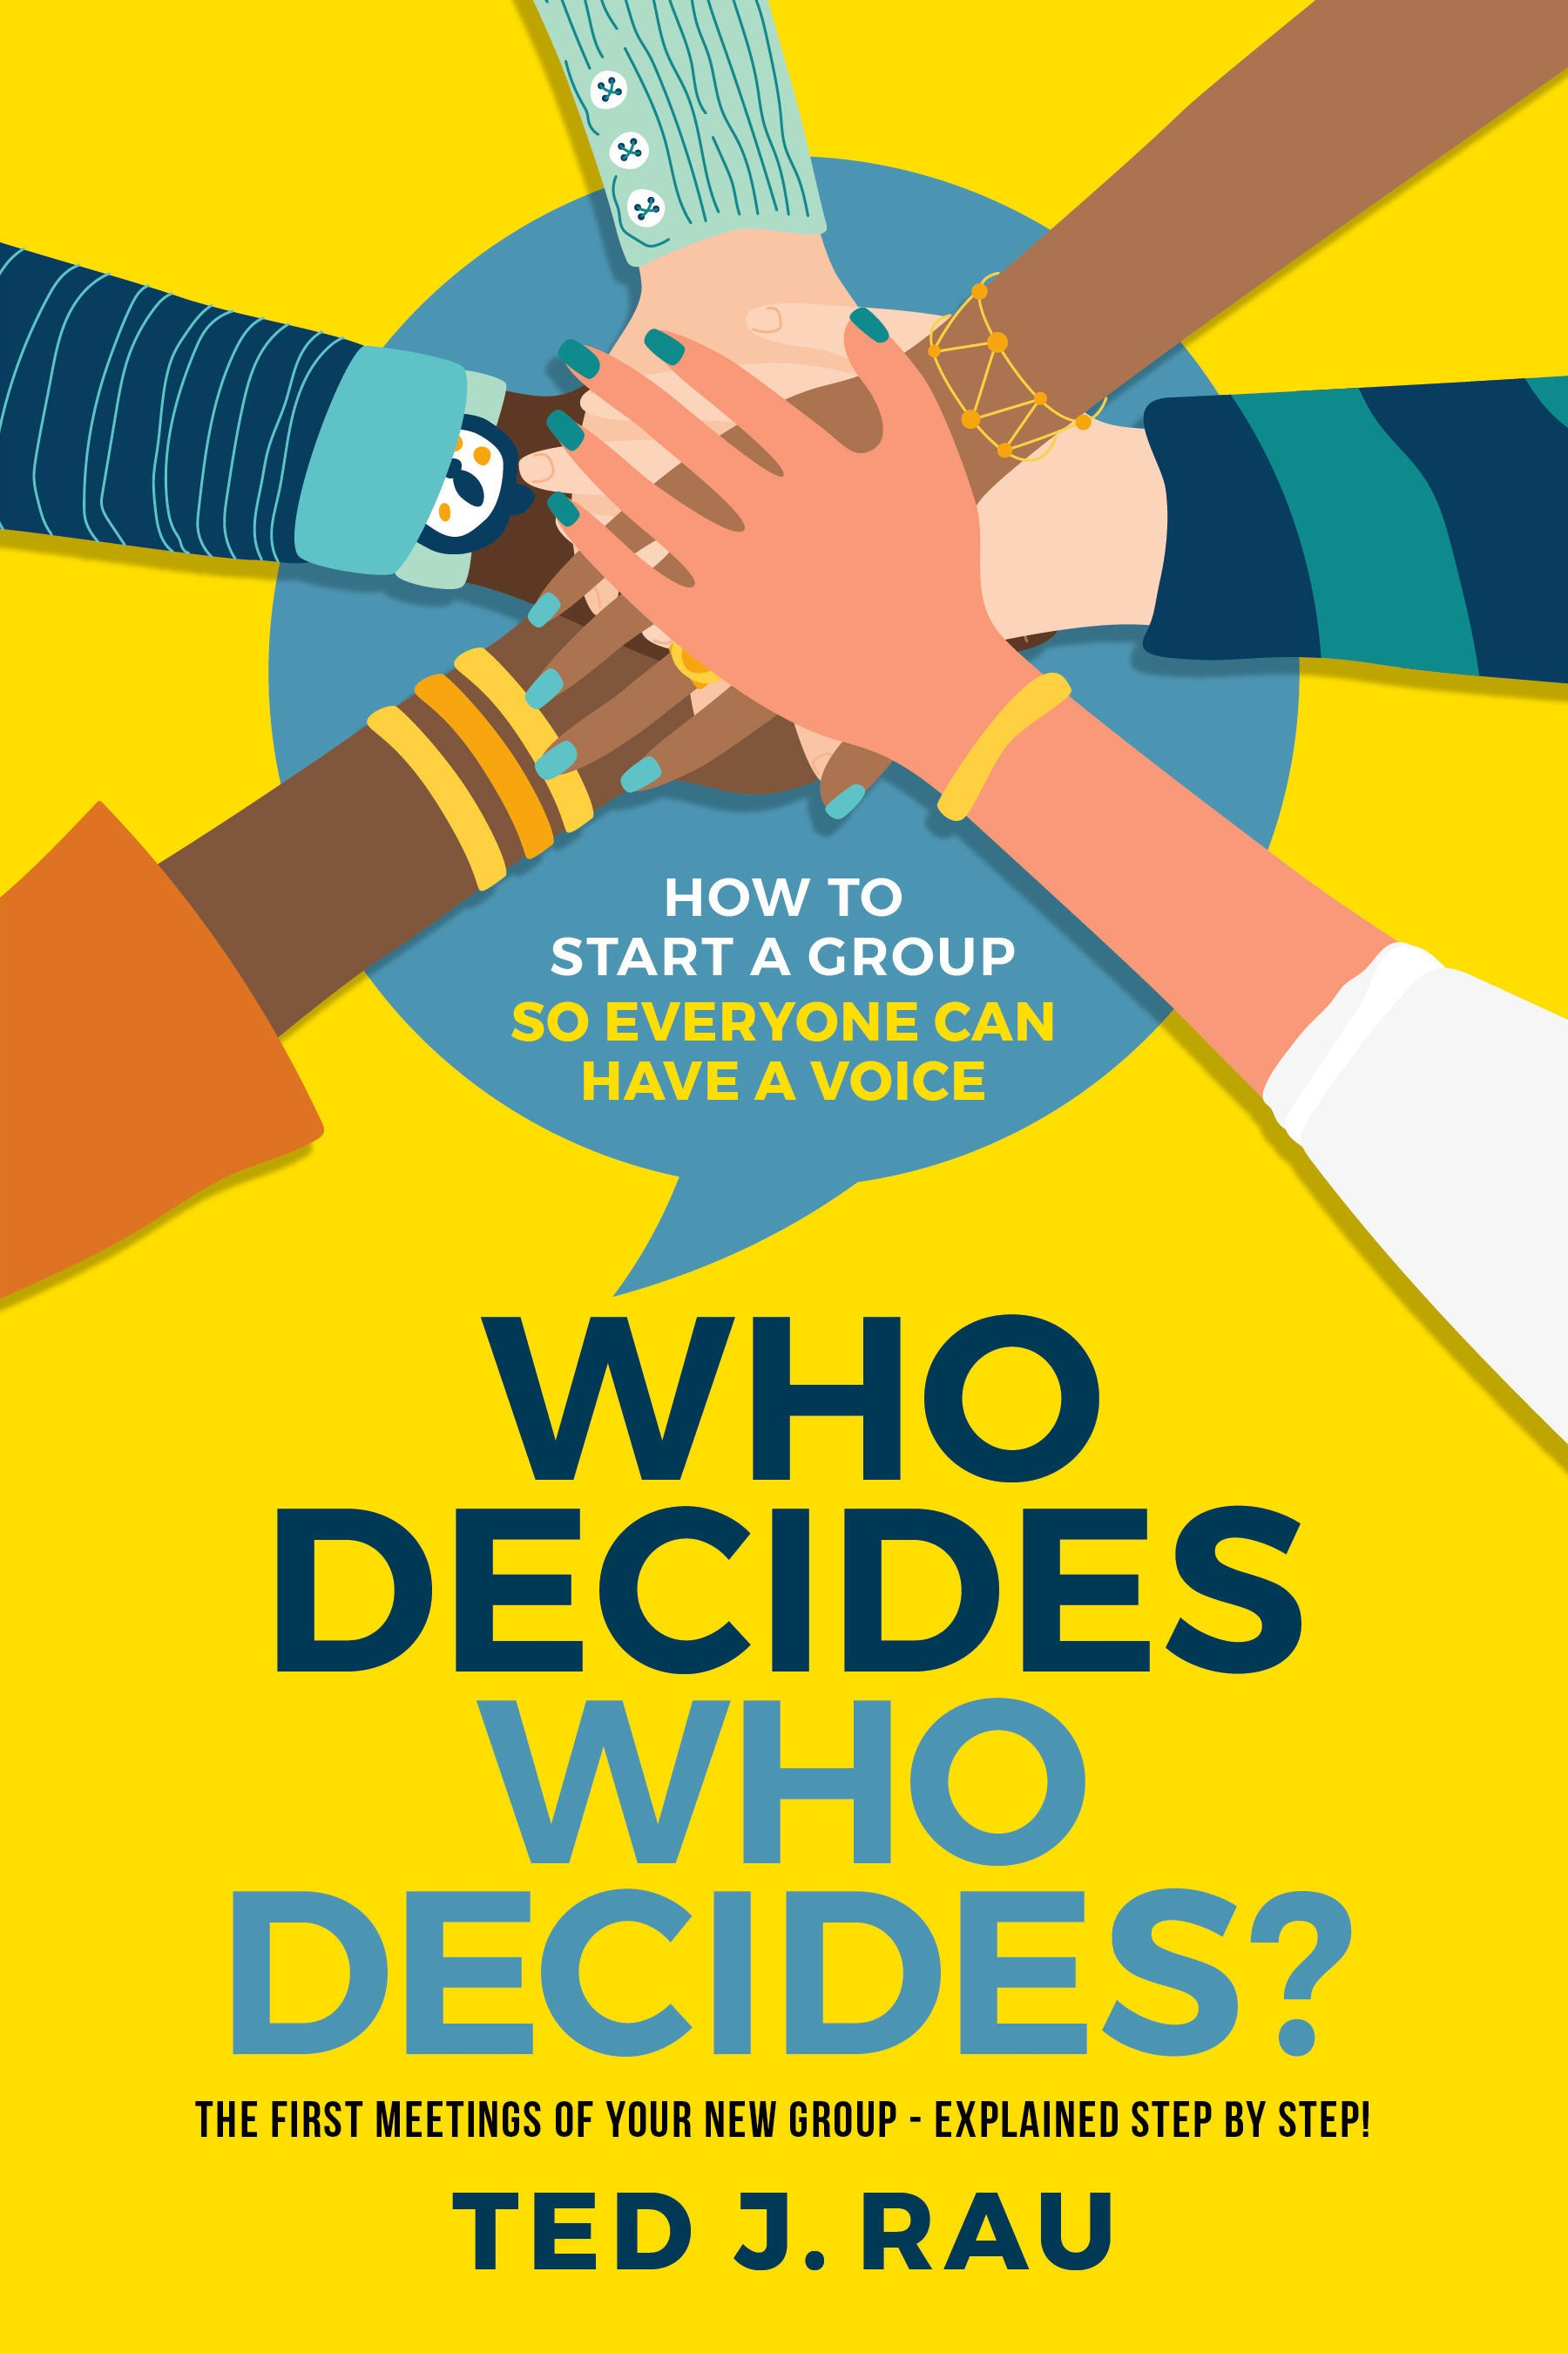

**Who Decides Who Decides?**

**How to start a group so everyone can have a voice**

by Ted J. Rau

Sociocracy For All Amherst, MA USA sociocracyforall.org



#### Sociocracy For All

#### 120 Pulpit Hill Road, Unit 8

#### Amherst MA, 01002 United States of America

[info@sociocracyforall.org](mailto:info@sociocracyforall.org)

#### Published by Sociocracy For All. Sociocracy For All is a project of Institute for Peaceable Communities (IPC), an incorporated 501(c)(3) non-profit organization in Massachusetts, USA.

#### © by Ted J. Rau. All words in this volume are available under a Creative Commons Attribute-ShareAlike Non-commercial

#### License.

#### https://creativecommons.org/licenses/by-sa/3.0/deed



Rau, Ted J., 2021 Who decides who decides? How to start a group so everyone can have a voice*/*Ted J. Rau.

Includes diagrams, illustrations and references. ISBN 978-1-949183-04-7

Cover design: Klassic Designs Illustrations: Ian Massey

**Contents**

###### Introduction 7

Why this book? 7

Who: new groups and early ‘make-overs’ 9

About the author 10

###### Context 12

What could possibly go wrong?! 12

The question of legitimacy 16

Additional trouble? 18

The essence of sociocracy 19

###### Invitation to the 1st meeting 24

Must-have: the proposed aim 24

A manageable group size 28

Explain your process 29

###### The first, founding meeting 31

Opening and consent to agenda 31

Agenda items 35

Committing to consent 36

Committing to rounds 41

Approving the aim 43

Exploration of experiences related to the aim 46

Getting to know each other 47

Defining the founding members 48

Next meeting 51

Backlog items? 51

Check out (meeting evaluation) 52

Summary table for meeting #1 53

* + 1. The second meeting 54

Opening and ADMIN 55

Consent to agenda 56

Selecting roles 56

Infrastructure and communication 60

Gather items for the backlog 61

Prioritize the backlog 62

Add new members? 63

Summary table for meeting #2 65

* + 1. The third meeting 66

Meeting overview 66

Integrate new members 67

Form sub-circles or roles? 67

Operationalize priority item #1 72

Operationalize priority item #2 and #3 74

Review the process so far 75

Update the backlog 76

Check-out 76

Summary table for meeting #3 77

* + 1. The building blocks of self-governance 78

Structure, content, review 78

How to start a sub-circle 79

The inversion point to decentralization 89

Network & community gatherings 91

Planning long term: the Mission Circle 92

Additional tools: review processes 93

Facilitation training 95

Your documents 98

* + 1. Now and forever 100

Prosocial’s Core Design Principles. 100

Additional tools 105

Let the circle be unbroken 106

*“Humanity is undergoing a species level rite of passage. We can choose to disagree on how to address the problems of climate change, cascading ecosystems collapse, obscene levels of inequality, etc., or we can manifest our evolutionary potential and mature into new ways of collaboration for the common good of people and planet. This will happen place by place, community by community, bioregion by biore- gion. It requires paying attention to the biocultural uniqueness of places and people. We are capable of moving from a culturally do- minant story of competitive scarcity to co-creating a world of collab- orative abundance and in the process heal the Earth and her people. In order to do so we need to work on inclusion, participation and collaborative decision making. Sociocracy offers effective ways to ac- complish just that. Ted Rau’s book makes its practice and processes easy to understand and apply for any group ready to step into the adventure of co-creating diverse regenerative cultures everywhere.”*

Daniel Christian Wahl, Author, Speaker, Advisor

*“Powerful, tangible, and empowering organizing has never been more needed. Here is a gentle, stepwise guide for how to begin. Draw- ing on many years of experience and teaching, Ted Rau takes the mys- tery out of forming effective groups.”*

Nathan Schneider, University of Colorado Boulder

*“Ted Rau has written another invaluable survival guide for groups interested in distributing power and working towards a shared pur- pose. He demystifies common and frustrating pain points of gover- nance and offers practical, down-to-earth tips for running effective meetings and clearing the path for meaningful collaboration.”*

Lisa Gill, founder of Reimaginaire and self-management coach

*“Ted Rau applies his Sociocratic brilliance to the perennial “chicken- and-egg” conundrum for emerging groups: “who decides who decides”? Having just navigated this very issue in an emerging group with Ted,*

*I can attest two things: first, Ted’s strategies work; and second, this book will be a required resource the next time I’m in such a position without Ted there! Read, enjoy, emerge, decide!”*

Bill Baue, Systems Transformation Catalyst, Senior Director r3.0

*“Ted Rau has done an outstanding job of tackling how to avoid the sneaky slide into a power struggle amongst well-meaning people who really want to cooperate and collaborate but need better tools. A practical, accessible approach to decision-making, this book is an excellent handbook for groups wanting to fulfill a mission and not spend their time stuck in a decision-making quandary.”*

Dawna Jones, author, Decision Making for Dummies

*“How does one start a completely self-governed group? Ted Rau is one of the most appropriate people to answer this question, because it is something he works on every day, not only in the organization of which he is the operational leader and co-founder, Sociocracy For All, but also accompanying groups and organizations (for profit and non- profit) that seek self-management and sharing of power. For those of us who work with him, he is a constant guide and reference due to his great knowledge, multiple experiences and the ability to explain things with clear, simple and with replicable materials. This book brings great clarity to those who accompany groups and who are part of them, since there are always common situations. Here, we will find concrete ways to be able to navigate and overcome them.”*

Nora Plaza, Consultant, leader of Sociocracia Práctica

*“What I love about Ted’s writing is that he speaks from the heart and from experience. Everything Ted discusses in this book he has tried and tested; and everything works! Our world seems to be mov- ing through a phase of increasing division and rampant self-interest. Forming small groups that embody cultures of caring, empathy and ‘power-with’ rather than ‘power-over’ is a way for each of us to prac- tice the skills that the world needs to move toward greater harmony. Well functioning small groups are a powerful piece of the more net- worked world we are creating. Ted is a gift to the world, and this book is a fantastic, practical guide to creating groups with the culture we need.”*

Paul Atkins, Prosocial.world

**Gratitude**

I am feeling gratitude to my fellow travelers in Content Circle, in particular, Rodger Mattlage, who has made a huge contribution to this book. Joe Brewer gave the impulse that made me sit down and write. Marcus Petz made substantial early edits.

I am grateful to the Publishing Circle of Shala Massey, Russell Baldwin, Sara Rodriguez for connection, action, and companion- ship. I still don’t quite understand how the universe connected us right at the perfect moment. I guess it was meant to happen!

*Sociocracy For All* provided me with the countless interactions that have led to an understanding of the issues forming groups face. Jerry Koch-Gonzalez takes for granted what is evident to him.

Yet, he taught me so much just by being who he is.

**Why this book?**

**1**

**Introduction**

Can you launch a new group in 3 meetings and establish shared power and self-management? I think you can, if, in those three meetings, you define the purpose well and put the needed infra- structure and practices in place. This booklet shows in detail how to do that.

Any organization will have a particular DNA – power relation- ships, practices, ideas – as it starts, and that very DNA is tough to change retroactively. The best idea is to start on the right foot at the very beginning.

Any group can form itself using the template outlined in this book. It works especially well if the founders and early members want to grow and nourish an organization that gives every member a voice and that is effective. Why those two, voice and effective- ness? Because that’s what makes an organization. An organization is an organized body of people with a shared purpose. So what matters in an organization is the people, the purpose, and how we organize it.

If you are part of a group that has already formed but has strug- gled to get off the ground – in particular, if people are arguing over how to decide who decides what – you might be able to re-launch your group using this book.

Many areas of our societies need change. The issues humanity is facing are too many to list in all of our sectors: environment and climate, education, economy, health, and well-being. The agency

of one individual, no matter how powerful, is limited. The only way to change anything is to change things on a systemic level, which requires the cooperation of people, groups of people, and groups of groups of people!

So many groups form. And so many groups fade. What distin- guishes those groups that grow and flourish from those that fade and fail? The success factors are well-studied, even though the lessons learned hardly make it into the design of those who start groups. That makes sense – groups form because people feel the urgency for change in an area of their attention, not because they are experts in how to start a group.

Someone who wants to start a school might be an expert in teaching, not in starting organizations. Yet, much about starting a school is unique to *starting an organization*, not pedagogy. Am I saying that only “experts” should start groups or that every new group should have a consultant to help? Not at all! Quite the oppo- site. I intend to give everyone just enough guidance to start groups that get off on the right foot. That way, everyone can focus on their strengths and expertise, may it be pedagogy, coding, gardening, writing, forming a community, or making things. My dream is to bring the skill of self-governance into every corner of society.

In writing this book, I am making the assumption that we start a group aligned with the principles of sociocracy, also known as Dy- namic Governance. Sociocracy is a governance system born in the late 1970s in the Netherlands. It has not yet become the “new nor- mal,” and it is still relatively uncommon in mainstream organizing. However, this is changing quickly right now!

Sociocracy combines the roots of consensus decision-making from the Quakers with insights from natural systems and cyber- netics, forming a robust and simultaneously flexible system that is extremely adaptable to any organization. It builds on consent as decision-making, a way to make decisions without coercion. It also builds on small groups of “human scale”. Sociocracy has a strong focus on increasing the flow of information and connection – the elixir that makes us understand each other.

Only if we work in a decentralized, flexible, and deeply respect- ful way can we address our realities’ complexities. And more and more people see that.

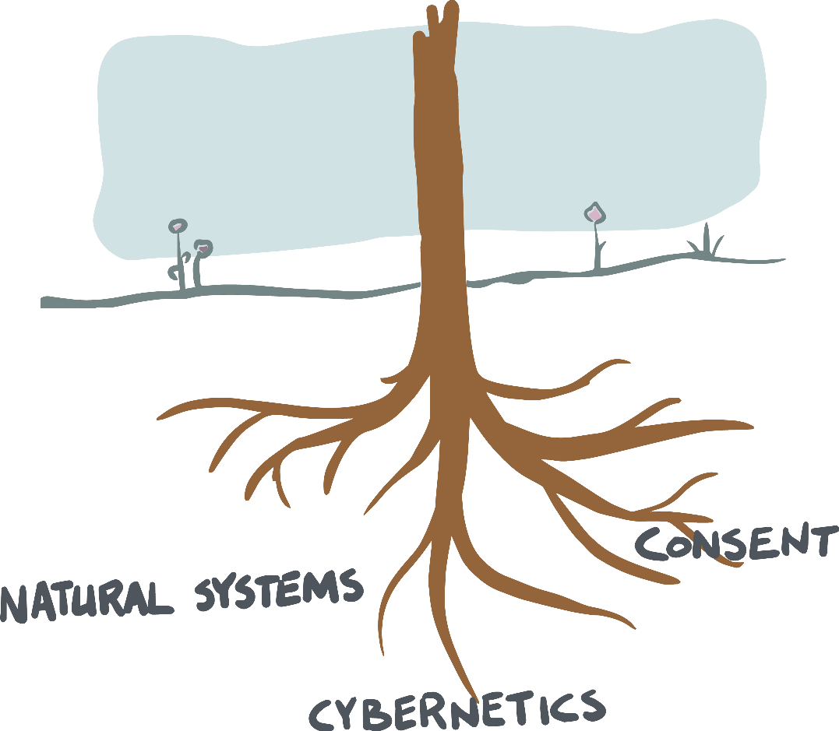

**Who: new groups and early ‘make-overs’**

I wrote this book for everyone who deeply cares about a cause, and about collaboration as peers. Your cause might be the environ- ment, equality, education. You might want to start learning pods, you might want to buy a store with others, or you might want to organize an online conference. Whatever your cause – if you are founding a group, this book will help you to set it up.

If you are part of a group that started a while ago and has been floundering, you can use this book to “re-launch” the group in a make-over with more clarity. For example, when I gave a copy of this book to a dear friend of mine who worked for a nonprofit or- ganization of five staff that had been around for two years, he said, “Can I share this with my team? I think we still need to go through this process to understand how we’re setting things up.”

So if you’re in this “operational but somehow not quite clear who decides” stage, you can use this book to give yourself a re-boot. However, you can only use the process in this book if the number of people actively involved in decisions or operations is ten people or less. If there are more than ten or twelve people involved already, and you do not know who decides and how, then this process will

*not* be right for you. Note: if there are more people *tangentially* involved, it might still work. What matters here are the people who are under the impression that they are decision-makers and players in the group.



**About the author**

I am a full-time sociocracy trainer and consultant. Although I’ve had my share of starting groups – more often, I watch and support groups founded by others.

I myself do not join any group that doesn’t meet my baseline:

* It has to be run sociocratically.
* It has to have a clear purpose that I find meaningful.
* It has to be with people I like.

Why would anyone do anything else? Without sociocracy, we will spend hours re-inventing governance, or we might re-invent top-down organizing. Without a purpose, we might disappoint each other or waste our time, and why do anything if it’s not mean- ingful? Spending time with people I enjoy is a big motivator. With

all the different directions we find ourselves pulled towards, con- nection is what adds the magic sauce.

A bit more about me: Born and raised in Germany, I hold a Ph.D. in linguistics (I wrote about on the interface of syntax and semantics). I live in an intentional community in Massachusetts that runs sociocratically. I am transgender and parent of 5 queer kids. I write music.

I enjoy where I am right now. I am content doing something that I am good at in an organization where I can be of service, to- gether with mission-aligned people, for something that is needed and that is in increasing demand: supporting effective and egali- tarian governance.

Born in 1979, I was born into a generation that was still pro- cessing the collective experience and traumas of fascism. I realized around the age of 13 that if so many people in a society can be so out of integrity, I myself couldn’t be sure that I would do anything differently had I been in their situation. The mercy of having been born later was very real to me. I was able to grow up ‘non-guilty’ (at least of injustices of the past) only because I was born into a time when I didn’t have to make those choices. It was then, as a young teenager, that I understood that systems are more potent than good intentions. In order to be who we want to be, we need systems around us that *support* our integrity, best intentions and allow for us to act accordingly. That’s what governance is.

**2**

**Context**

**What could possibly go wrong?!**

To get tuned into that early stage of an organization, let me tell you stories about organizations that *didn’t* make it.

I was talking in a Zoom call with two members of a group in Michigan. They had been part of an initiative for about two years that wanted to combine farming and living together. The handful of founding members had welcomed new members with open arms, and the “family” grew and grew. They decided things together. The group members deeply loved and respected each other – that was palpable even for me in listening to their story.

Over time, the more people joined, the harder and harder it got to hear everyone, despite everyone’s friendship and best intentions. It was simply too many people. It became obscure who knew what, who wanted what for what reason, and who was doing what. It was nobody’s fault; it was just a matter of bandwidth. As a result, deci- sions were slowed down. People weren’t able to track each other’s needs as well anymore. Little things were dropped here and there. And it was just a matter of time until some people started to in- terpret malicious intent into that unanswered email, that forgotten agenda item, that phone call that was never returned, that slightly misrepresented report. Tensions grew, and all of a sudden, love was not the answer to everything anymore. A system was needed. That’s when they contacted me. But that didn’t diminish the chaos. In that phone call, they told me this: “We all agree that we want to hire you to help us with our decision-making. But we don’t know

how to decide who decides to hire you.” I never heard from them again.

The catch-22 nature of the problem made me squirm. They knew what I knew: that there was hardly any hope. Note again that everyone had the best intentions. The complexity of their problem had outgrown them. It was a checkmate kind of situation. I don’t know how their story ended but having seen many similar stories, it is easy to imagine what happens next. Some people leave, in par- ticular, those who want to help make things happen. Some people stay because they like the people or simply don’t have a similar project in their lives that fills the gap. No new members join be- cause everyone can easily sense that this organization is in trouble. It will fade away and die.

I find these situations disheartening. It is baffling that good intentions and affection don’t seem to be enough to hold an orga- nization together through growth. I wish it would, but evidence shows me that it simply is not true. An organization brings a level of complexity and dynamic that most of us are not prepared for. And that way, we walk into a trap – at least if we prefer to work in non-hierarchical ways.

That group could have been a growing family business, a non- profit, an activist group, a consulting firm – the dynamics are just what happens, like a play where all the roles are already set. It is pre-scripted because everyone does what makes sense in their posi- tion. The dynamics at play are bigger than what any one individual can change.

In some organizations, things play out differently. They slide down the slippery slope of ‘more order means more hierarchy.’ Let’s look at an example.

A group of activists is forming a consumer co-op. Five families start buying almonds and tropical fruit together. They are well or- ganized. Other families join in, and the group grows. Every other Saturday is busy now, sorting and packing and delivering. There’s bookkeeping to do, and there are emails to send. Now those five families hold regular jobs, and some of them have children. They love their project, and they are proud of how successful and attrac- tive it is as operations get more and more draining – a ‘problem’ of success. One group member happens to lose their day job, and they

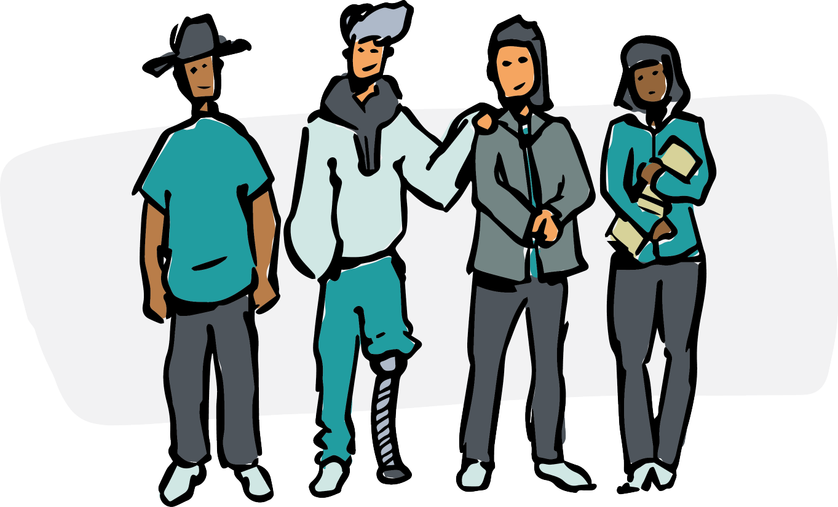

finally decide that she could be in charge of leading operations. The project manager is now paid, and as she gets overloaded, more peo- ple get hired, starting with a bookkeeper. What started as a group of equals turns into a hierarchical organization like any other. After all, what other way was there, given that things needed to get taken care of? Five years later, some of the original members might still be around. But over time, the organization hardly even resembles what they so dearly cared for in the beginning.

(The plot might have changed slightly had the group set up a co- operative ownership structure early. But in the end, even big coop- eratives very much resemble corporate structures in their decision- making. Although their ownership structure is different, their gov- ernance system for day-to-day operations looks the same.)

Another story. It was a group of people doing good work to create more local connections and infrastructure. Everyone was experienced, dedicated, and interested in the best for the group. Because everyone trusted each other, it seemed like not a lot of structure was needed. Similar to the first story, they ran on good intentions. So far, this group very much resembles the first story, but there is one big difference. One of them, Brian, was the founder. A charismatic and peer-oriented leader, he had gathered his friends around this project, who then brought friends. But in the group’s

origin story, it was clear that this was “Brian’s group” because of the effort and care he put into the project. Brian knew about so- ciocracy and knew that he wanted to give the project structure. He announced there would be teams (aka circles), and a lot of energy came from that. Yet, he wanted the group to have a say on the circle structure, which created a slowdown because it was hard to wran- gle the group into giving feedback on the proposed structure. I am not quite sure what happened next. Maybe there were some hurt feelings. Something was said that wasn’t received the way it had been intended. The next time Brian and I talked, resistance had started to form. People were demanding a say in what the struc- ture would be and that Brian would not be the one who decides about the structure. But unfortunately, there was no structure in which to decide whether Brian could decide. Brian’s proposal for a circle structure was met with rebellion. The group fell apart. I was shocked. In my view, Brian had done everything right. He saw the need for structure, and he made sure to implement it. He had asked for feedback. He was respected and experienced and not at all a power-grab kind of person. Quite the opposite! He had worked so hard to develop a suitable structure to distribute power because he had no interest in holding power. But he had waited too long. The group did not see that the only way to have power was to receive and accept it from the willing founder. The whole project withered away within weeks.

A lesson we can learn from this story is that **leadership is needed to distribute power.** Another national organization suf- fered the same dynamics, with an intense level of pain and suf- fering for everyone involved. The centralized organization leaders were not willing to distribute power, but they were also not hold- ing it. Their excuse: “We’re not holding on to power, quite on the contrary! There are so many decisions we didn’t make that there’s plenty of room for groups to step up.” Yet, of course, that’s not how groups step up. Distribution of power does not come from leaving a vacuum or letting things fall how they fall. Distributing power is an active process that requires listening, alignment, and skill. And that’s what this book is about.

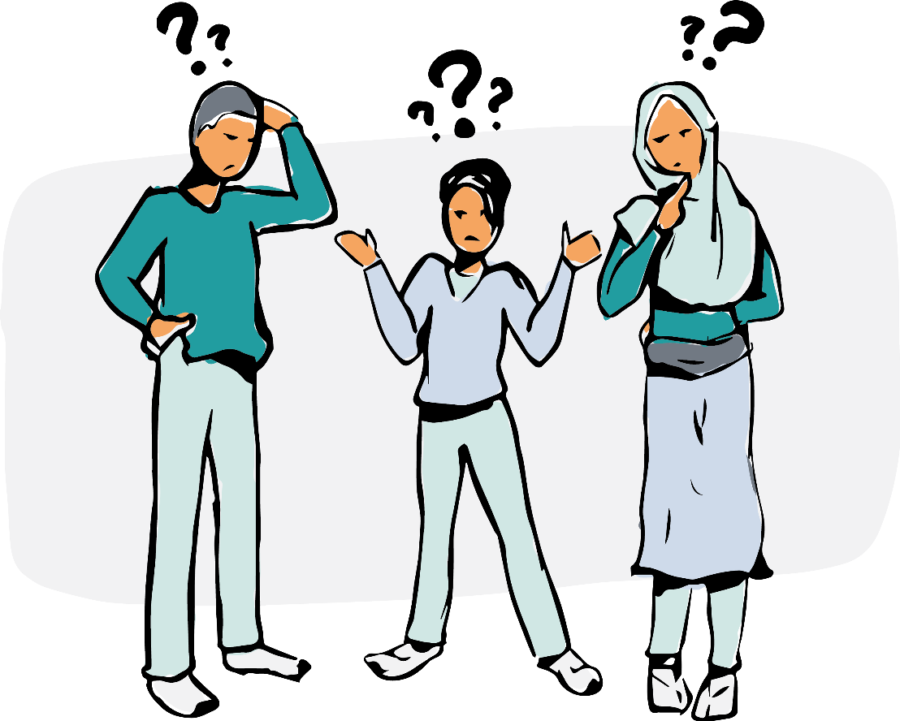

**The question of legitimacy**

Legitimacy is a sticky concept, especially in self-governance. If a group wants to self-govern, who decides that it will, and how?

In some models, it is the founder, or the owner of a company that puts the constitution in place to “make everyone equal under the constitution.” Yet, could the person who puts it into place also take it away, like a parliament that operates at the mercy of a king?

Real self-governance is by the people and for the people. It is not put in place by anyone except the collective – otherwise, it could be taken away again.

A group of people needs to give itself a governance system, and the group needs to own and approve the governance system itself. Yet, there’s a severe chicken-egg issue here – how can we take an unordered group of people and get them to follow a process to accept an orderly governance system?

Don’t get me wrong – some groups manage. Yet, retrofitting an organization requires training, reflection, and conversation to collectively come to the insight that it’s necessary and desirable to make the switch together. If just one person – in a consensus model

* or one person with absolute power – in a hierarchical model – says no, then the way to self-governance is blocked.



So while retrofitting an organization with a collective organiz- ing effort is possible, it’s a bit of a gamble. That’s why this booklet is taking an alternative approach. The idea is not to disregard those efforts – transforming organizations is still useful. But the more promising approach is this: can we plant the seed in a way so we can avoid all of these issues altogether? How does one *start* an entirely self-governed group?

A sociocratic organization holds a balance between all the dif- ferent bodies – the circle members are balanced through consent. No one circle member can overpower another. The same is true for two circles in relation to each other – as we will see, linking and consent as well as aims (that are decided by consent) keep the bal- ance between circles. No circle can ever overpower another circle. Yet, if there is no organization yet, who decides who can join?

The question of where to start is a bit like asking, “how do you get two people onto a see-saw when they can’t both get on at the same time?” Ultimately, one side might start and then let the other side get on. That’s when the game begins. Alternatively, both can agree to hold the see-saw and coordinate to get on simultaneously. Both paths are combined in this book. The group of founders gets on together, creating balance for future members.

If there is one initial “creator” of the organization, then the le- gitimacy comes from there. That might happen if,

