RESULTS

Abundance and seasonal distribution
A total of 2,921 marine-litter items were recorded across the 24 transects. Praia Brava accounted for 2,677 items (91.6%), whereas Ilha do Pontal accounted for 244 items (8.4%). The largest seasonal total occurred in winter, when 2,183 items were recorded across both beaches (74.7% of the complete dataset). At Praia Brava, winter had the highest mean abundance (687.7 ± 564.3 items per transect), while autumn had the lowest (29.7 ± 28.2). At Ilha do Pontal, winter also had the highest mean (40.0 ± 24.3), whereas summer had the lowest (2.7 ± 2.5) (Table A; Figure A).
Table A. Seasonal abundance of marine-litter items at Praia Brava and Ilha do Pontal. Values summarize three transects per beach and season.
Beach | Season | n | Total | Mean ± SD | Median (range)
Ilha do Pontal | Autumn | 3 | 68 | 22.7 ± 25.4 | 15.0 (2–51)
Ilha do Pontal | Spring | 3 | 48 | 16.0 ± 13.0 | 9.0 (8–31)
Ilha do Pontal | Summer | 3 | 8 | 2.7 ± 2.5 | 3.0 (0–5)
Ilha do Pontal | Winter | 3 | 120 | 40.0 ± 24.3 | 27.0 (25–68)
Praia Brava | Autumn | 3 | 89 | 29.7 ± 28.2 | 17.0 (10–62)
Praia Brava | Spring | 3 | 364 | 121.3 ± 77.4 | 87.0 (67–210)
Praia Brava | Summer | 3 | 161 | 53.7 ± 35.0 | 36.0 (31–94)
Praia Brava | Winter | 3 | 2063 | 687.7 ± 564.3 | 443.0 (287–1333)
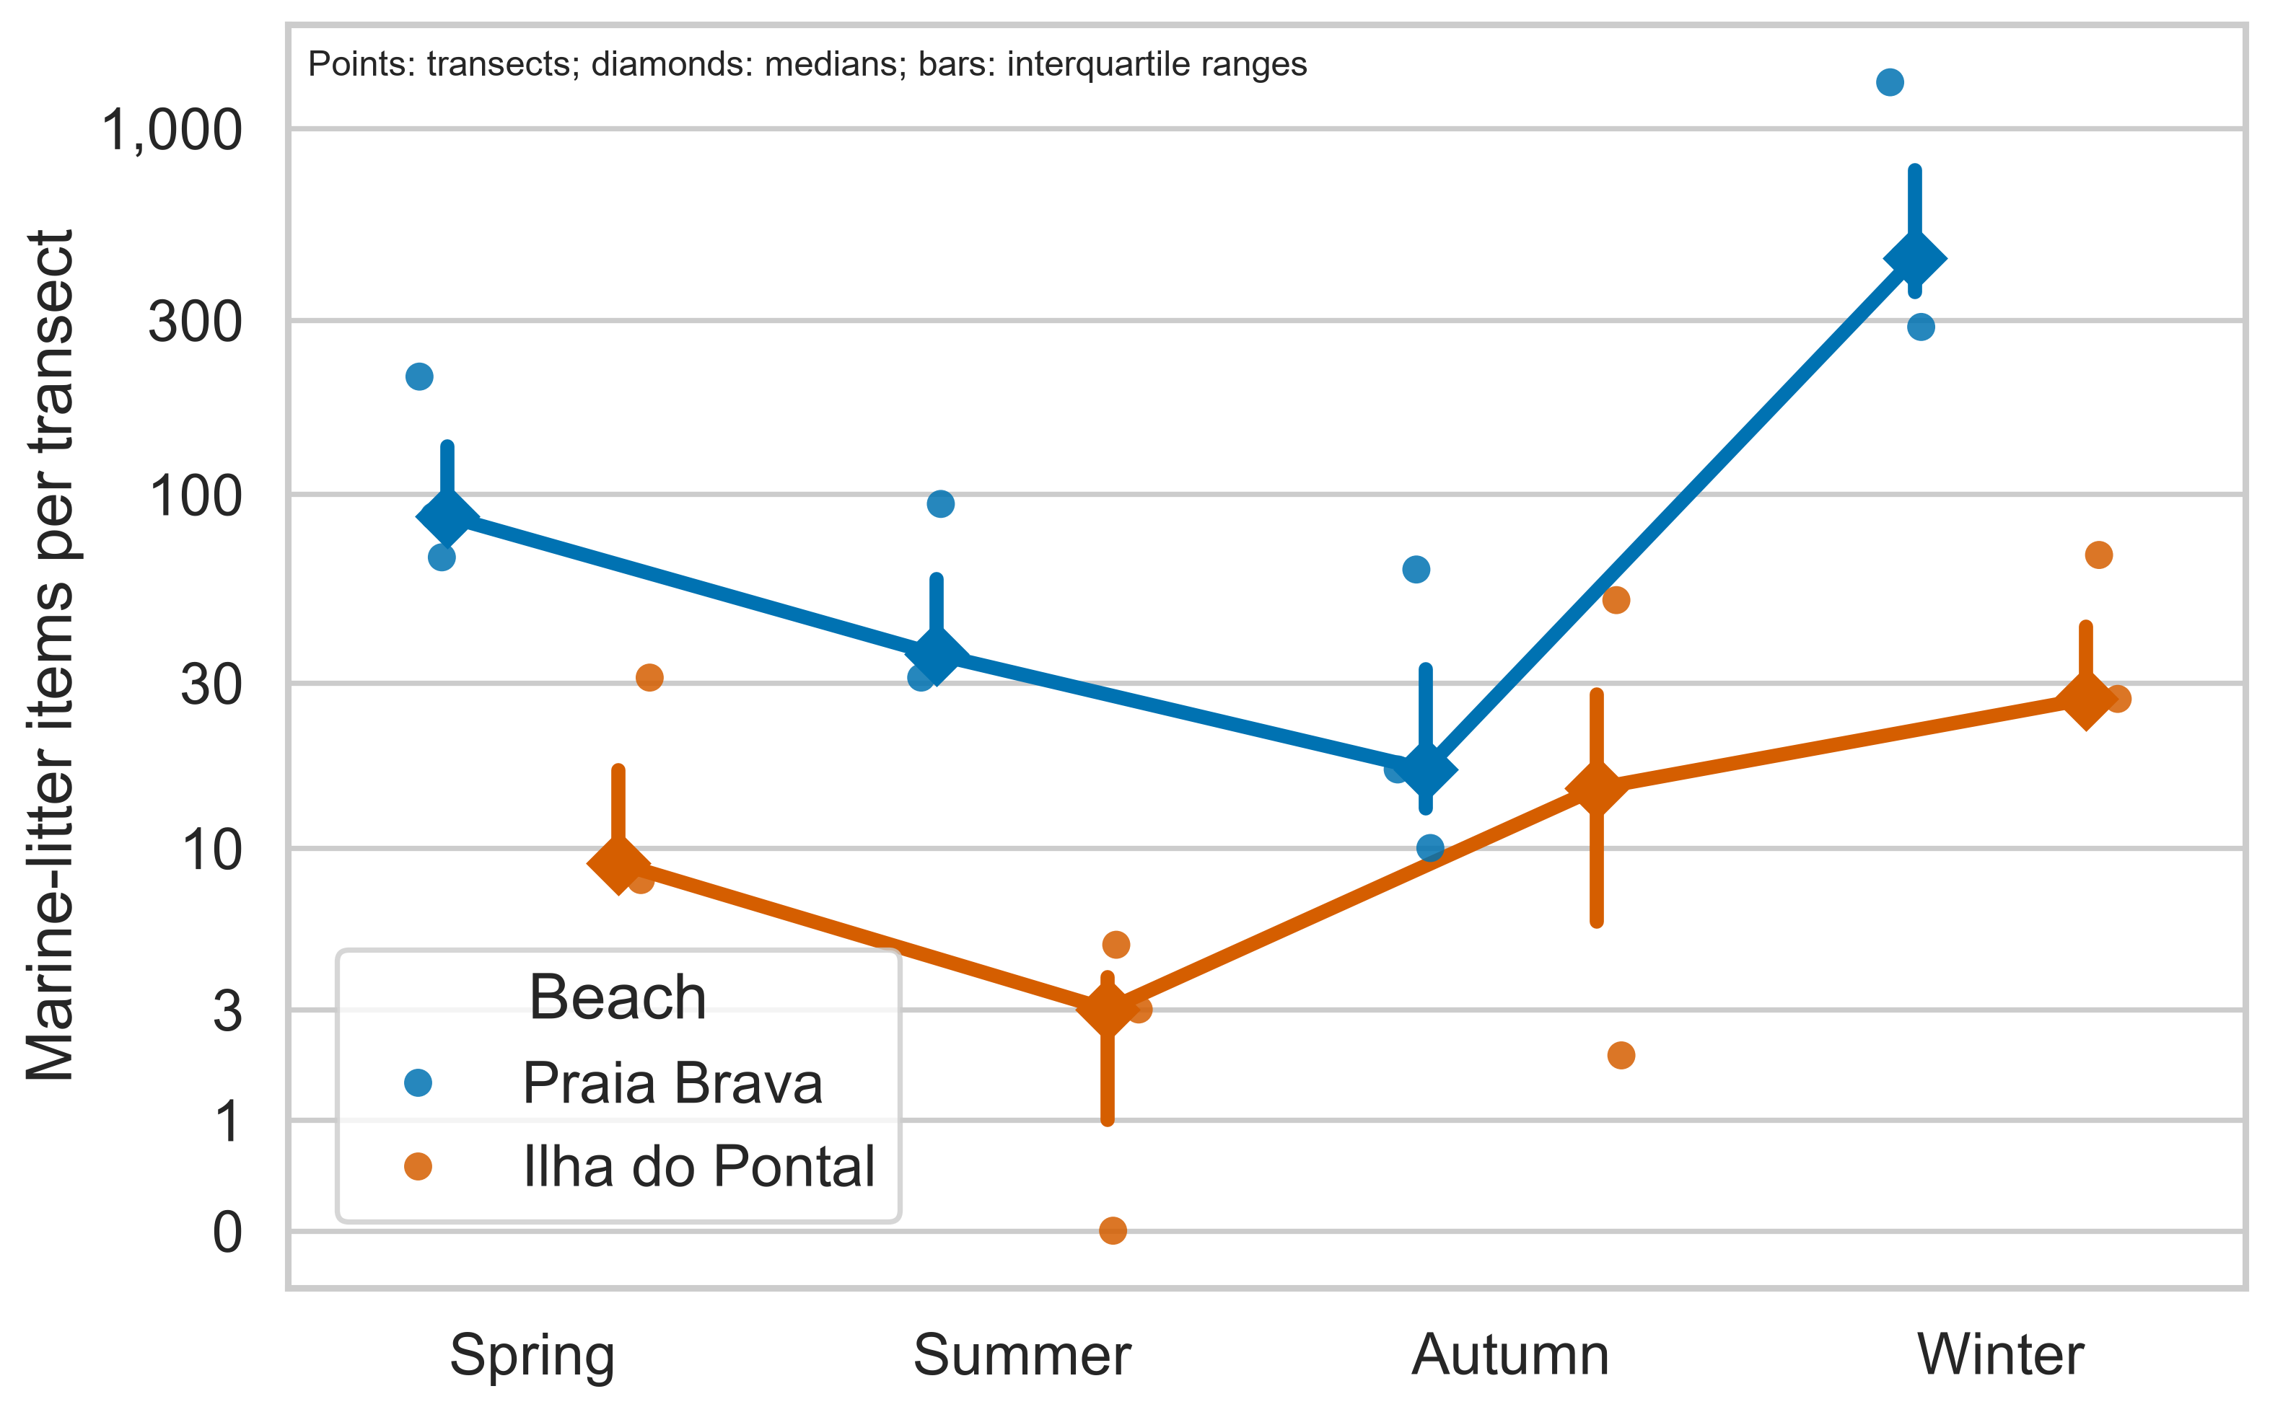
Figure A. Marine-litter abundance by beach and season. Points and error bars represent transect-level summaries generated by the reproducible workflow.

Material composition
Expanded polystyrene was the most abundant category (1,432 items; 49.0%), followed by plastic (1,059 items; 36.3%) and fragments (145 items; 5.0%). Together, expanded polystyrene and plastic represented 85.3% of all recorded items. Praia Brava contained 1,395 expanded-polystyrene items and 899 plastic items, whereas Ilha do Pontal contained 37 and 160, respectively. The remaining categories each contributed less than 3% of the overall total (Table B; Figures B and C).
Table B. Composition of marine litter by category and beach, showing the eight most abundant categories; less abundant categories are pooled as Other.
Category | Praia Brava | Ilha do Pontal | Overall | Composition (%)
Expanded Polystyrene | 1395 | 37 | 1432 | 49.0
Plastic | 899 | 160 | 1059 | 36.3
Fragments | 133 | 12 | 145 | 5.0
Processed Wood | 69 | 11 | 80 | 2.7
Unidentified | 39 | 16 | 55 | 1.9
Rubber | 37 | 4 | 41 | 1.4
Fabric | 37 | 1 | 38 | 1.3
Personal Care | 24 | 0 | 24 | 0.8
Other Categories | 44 | 3 | 47 | 1.6
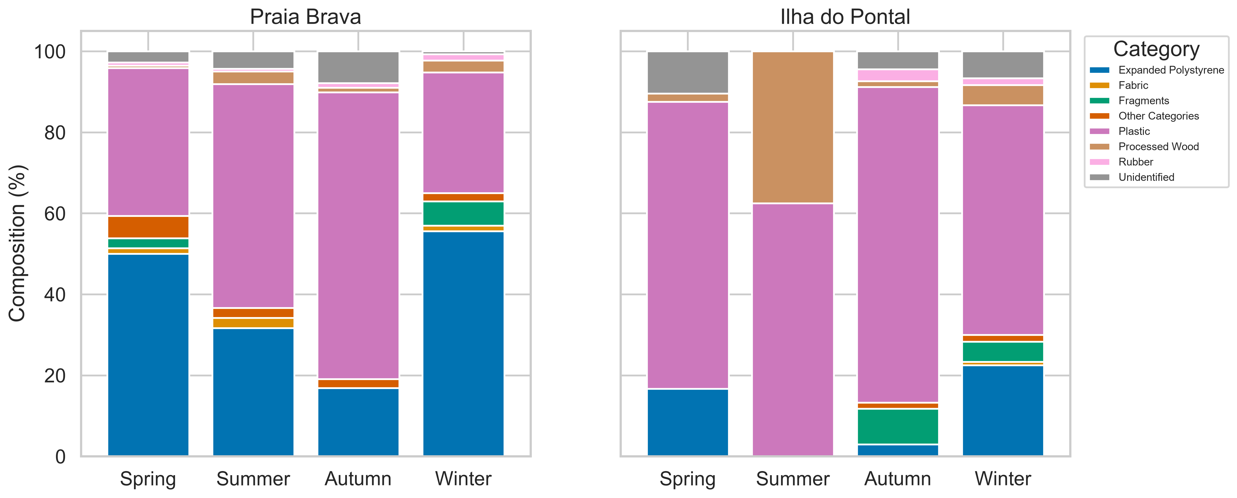
Figure B. Relative composition of marine-litter categories by beach and season.
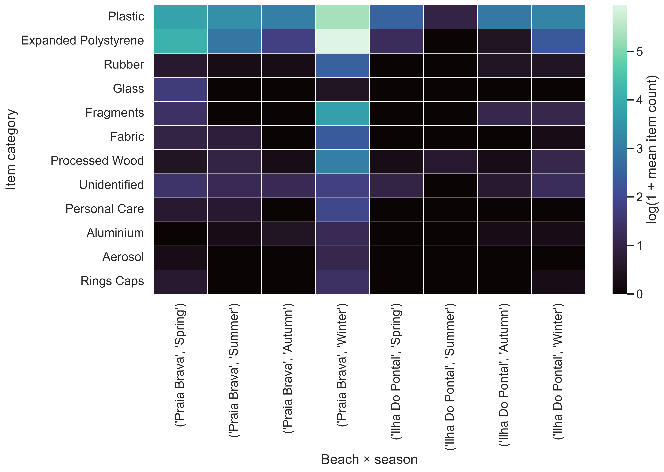
Figure C. Heatmap of mean marine-litter abundance by category, beach, and season. Values are displayed on a log(1 + mean item count) scale.

Clean Coast Index
The Clean Coast Index (CCI) showed marked variation among beach-season combinations (Table C; Figure D). Praia Brava ranged from moderately dirty in autumn (CCI = 8.40) to extremely dirty in winter (CCI = 81.87); spring and summer were classified as dirty. Ilha do Pontal ranged from very clean in summer (CCI = 0.67) to moderately dirty in autumn (CCI = 7.07) and winter (CCI = 9.07), while spring was classified as clean (CCI = 4.53).
Table C. Marine-litter density, plastic density, and Clean Coast Index (CCI) classification by beach and season.
Beach | Season | Items m⁻² | Plastic items m⁻² | CCI | Classification
Praia Brava | Spring | 2.43 | 0.89 | 17.73 | Dirty
Praia Brava | Summer | 1.07 | 0.59 | 11.87 | Dirty
Praia Brava | Autumn | 0.59 | 0.42 | 8.40 | Moderately dirty
Praia Brava | Winter | 13.75 | 4.09 | 81.87 | Extremely dirty
Ilha do Pontal | Spring | 0.32 | 0.23 | 4.53 | Clean
Ilha do Pontal | Summer | 0.05 | 0.03 | 0.67 | Very clean
Ilha do Pontal | Autumn | 0.45 | 0.35 | 7.07 | Moderately dirty
Ilha do Pontal | Winter | 0.80 | 0.45 | 9.07 | Moderately dirty
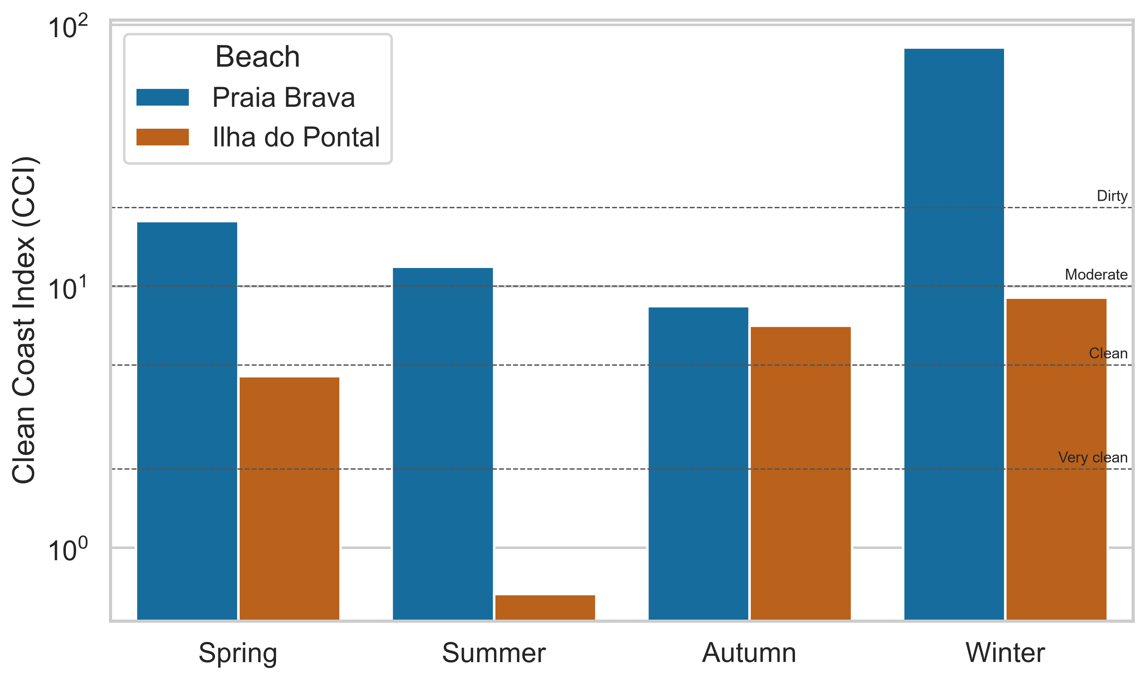
Figure D. Clean Coast Index (CCI) by beach and season. Dashed horizontal lines indicate classification thresholds.

Multivariate structure and clustering
The first two axes of the Hellinger PCA explained 63.95% of the variation in litter composition (PC1 = 41.19%; PC2 = 22.76%). Expanded polystyrene made the largest contribution to the ordination (41.28%), followed by plastic (28.32%) and processed wood (17.61%). Expanded polystyrene loaded positively on PC1, plastic loaded strongly and positively on PC2, and processed wood loaded negatively on PC2 (Table D; Figure E).
Table D. Largest category contributions to the first two axes of the Hellinger-transformed principal component analysis.
Category | PC1 loading | PC2 loading | Contribution (%)
Expanded Polystyrene | 0.896 | 0.152 | 41.28
Plastic | -0.294 | 0.693 | 28.32
Processed Wood | -0.164 | -0.570 | 17.61
Unidentified | 0.053 | 0.358 | 6.53
Fragments | 0.194 | -0.087 | 2.27
Fabric | 0.105 | -0.164 | 1.90
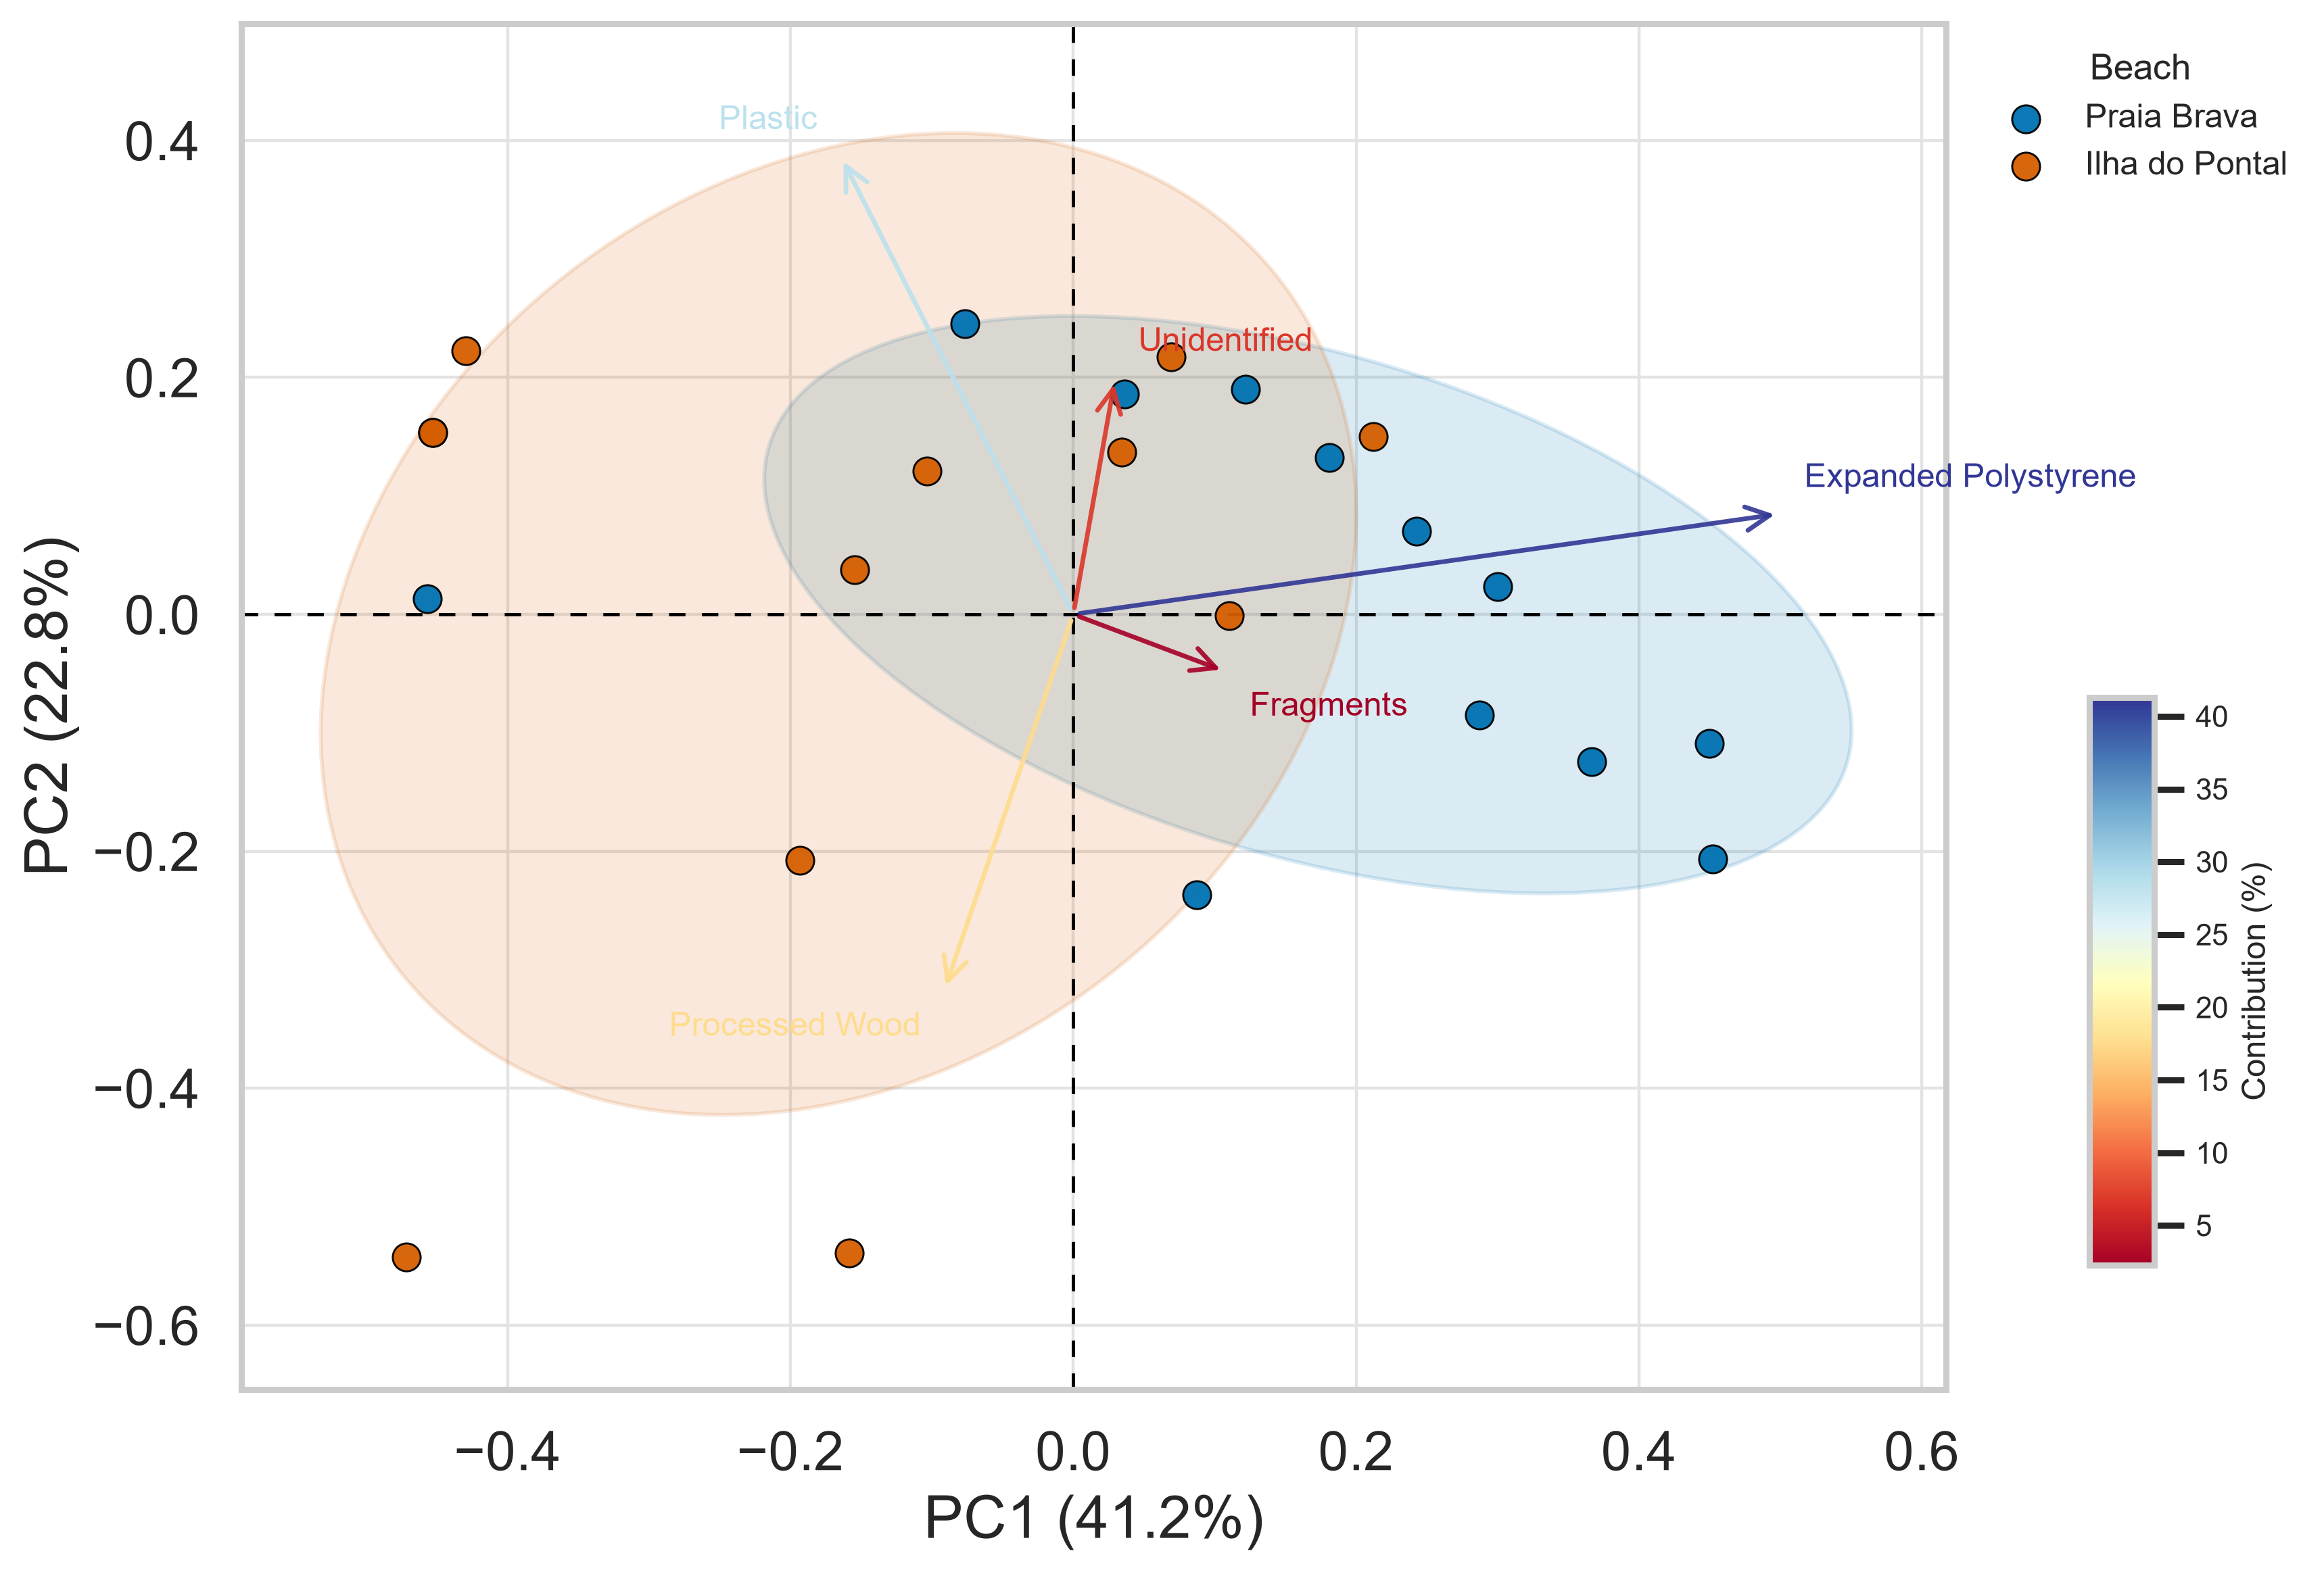
Figure E. Hellinger-transformed principal component analysis of marine-litter composition. Ellipses represent 68% group regions by beach; vectors show category loadings and are colored by contribution.
K-means clustering selected three clusters because k = 3 produced the highest silhouette score (0.331; Table E). Cluster 1 contained 16 samples, cluster 2 contained 1 sample, and cluster 3 contained 7 samples (Figure F). Because cluster 2 contained a single sample, a within-cluster confidence ellipse could not be estimated for that group.
Table E. Silhouette scores used to select the number of K-means clusters.
Number of clusters (k) | Silhouette score
2 | 0.325
3 | 0.331
4 | 0.237
5 | 0.258
6 | 0.280
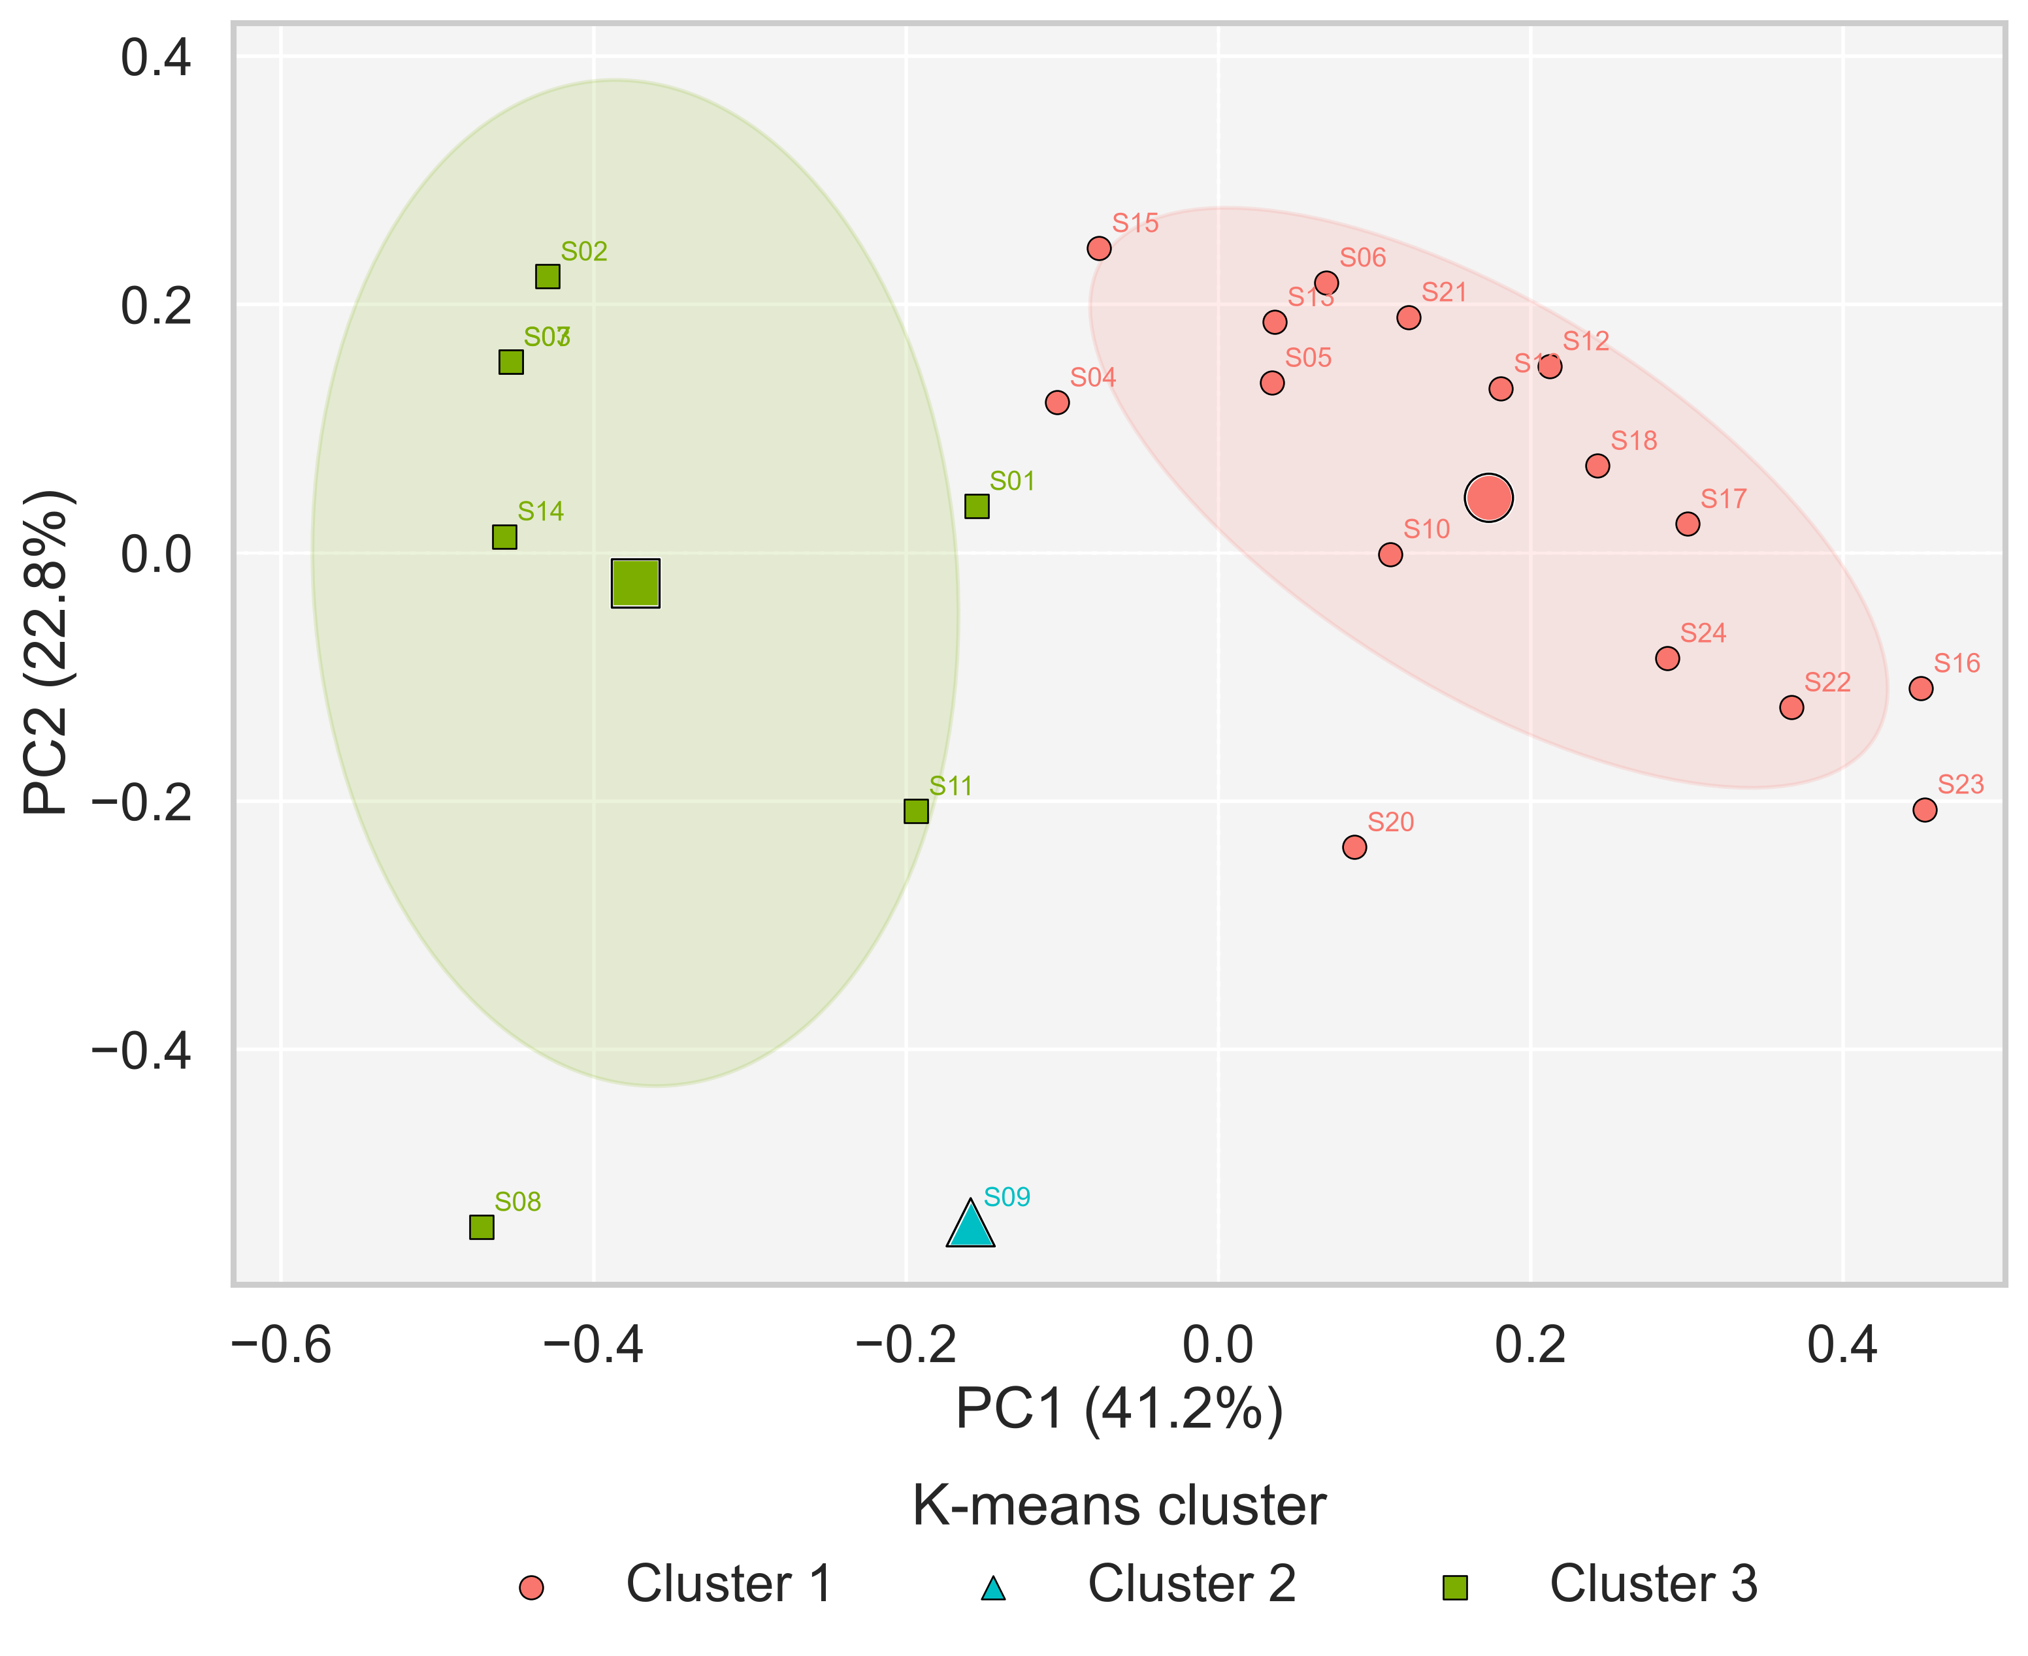
Figure F. K-means clusters projected onto the first two Hellinger PCA axes. Colors and symbols identify clusters, enlarged symbols indicate centroids, and ellipses show 68% within-cluster regions when estimable.

Differences in multivariate composition
The one-factor PERMANOVA detected a difference in composition between beaches (pseudo-F = 3.548, p = 0.0085), whereas the season-only test was not significant (pseudo-F = 1.195, p = 0.2744). PERMDISP did not detect differences in multivariate dispersion for beach (F = 0.309, p = 0.5623) or season (F = 0.891, p = 0.3441). In the factorial PERMANOVA, beach was significant (pseudo-F = 4.929, R² = 0.139, p = 0.0020), season was marginal but not significant at α = 0.05 (pseudo-F = 1.798, R² = 0.152, p = 0.0523), and the beach × season interaction was significant (pseudo-F = 3.058, R² = 0.258, p = 0.0014) (Table F).
Table F. Multivariate tests of marine-litter composition. All permutation tests used 9,999 permutations.
Analysis | Term | Statistic | R² | p
PERMANOVA | Beach | pseudo-F = 3.548 | — | 0.0085
PERMANOVA | Season | pseudo-F = 1.195 | — | 0.2744
PERMDISP | Beach | F = 0.309 | — | 0.5623
PERMDISP | Season | F = 0.891 | — | 0.3441
Factorial PERMANOVA | Beach | pseudo-F = 4.929 | 0.139 | 0.0020
Factorial PERMANOVA | Season | pseudo-F = 1.798 | 0.152 | 0.0523
Factorial PERMANOVA | Beach × Season | pseudo-F = 3.058 | 0.258 | 0.0014

