2_19_19.R

luciwilson

Tue Feb 19 09:16:39 2019

empty_mean<-rep(NA,1000)  
for(i in 1:1000){one_draw<-rnbinom(1000,mu = 2,size = 3)  
mean(one_draw)  
empty_mean[i]<-mean(one_draw)}  
  
hist(one_draw)

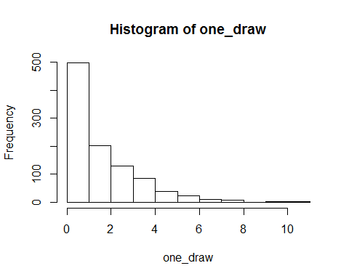

hist(empty_mean)

