Lab Report
Use this template to document your work as you complete your assignment.

Your Information
Your Name: Lucas Justiniano
Assignment Title: 5.5 ProjectPrescriptive Analytics and Final Project Submission

Screenshots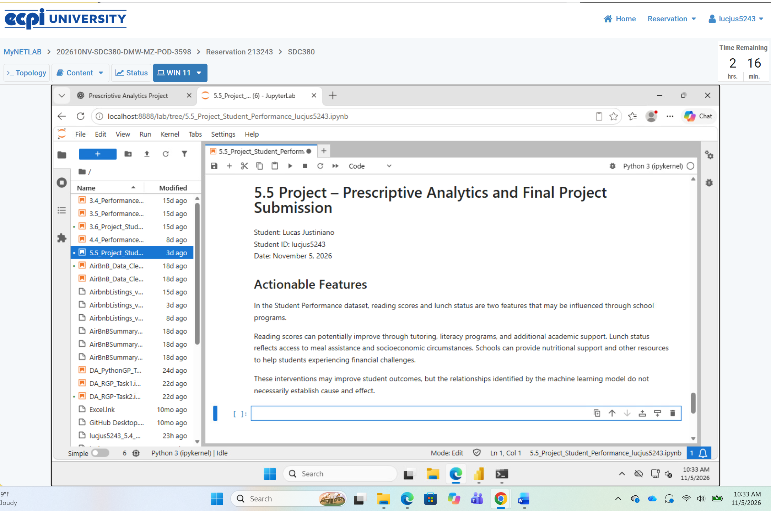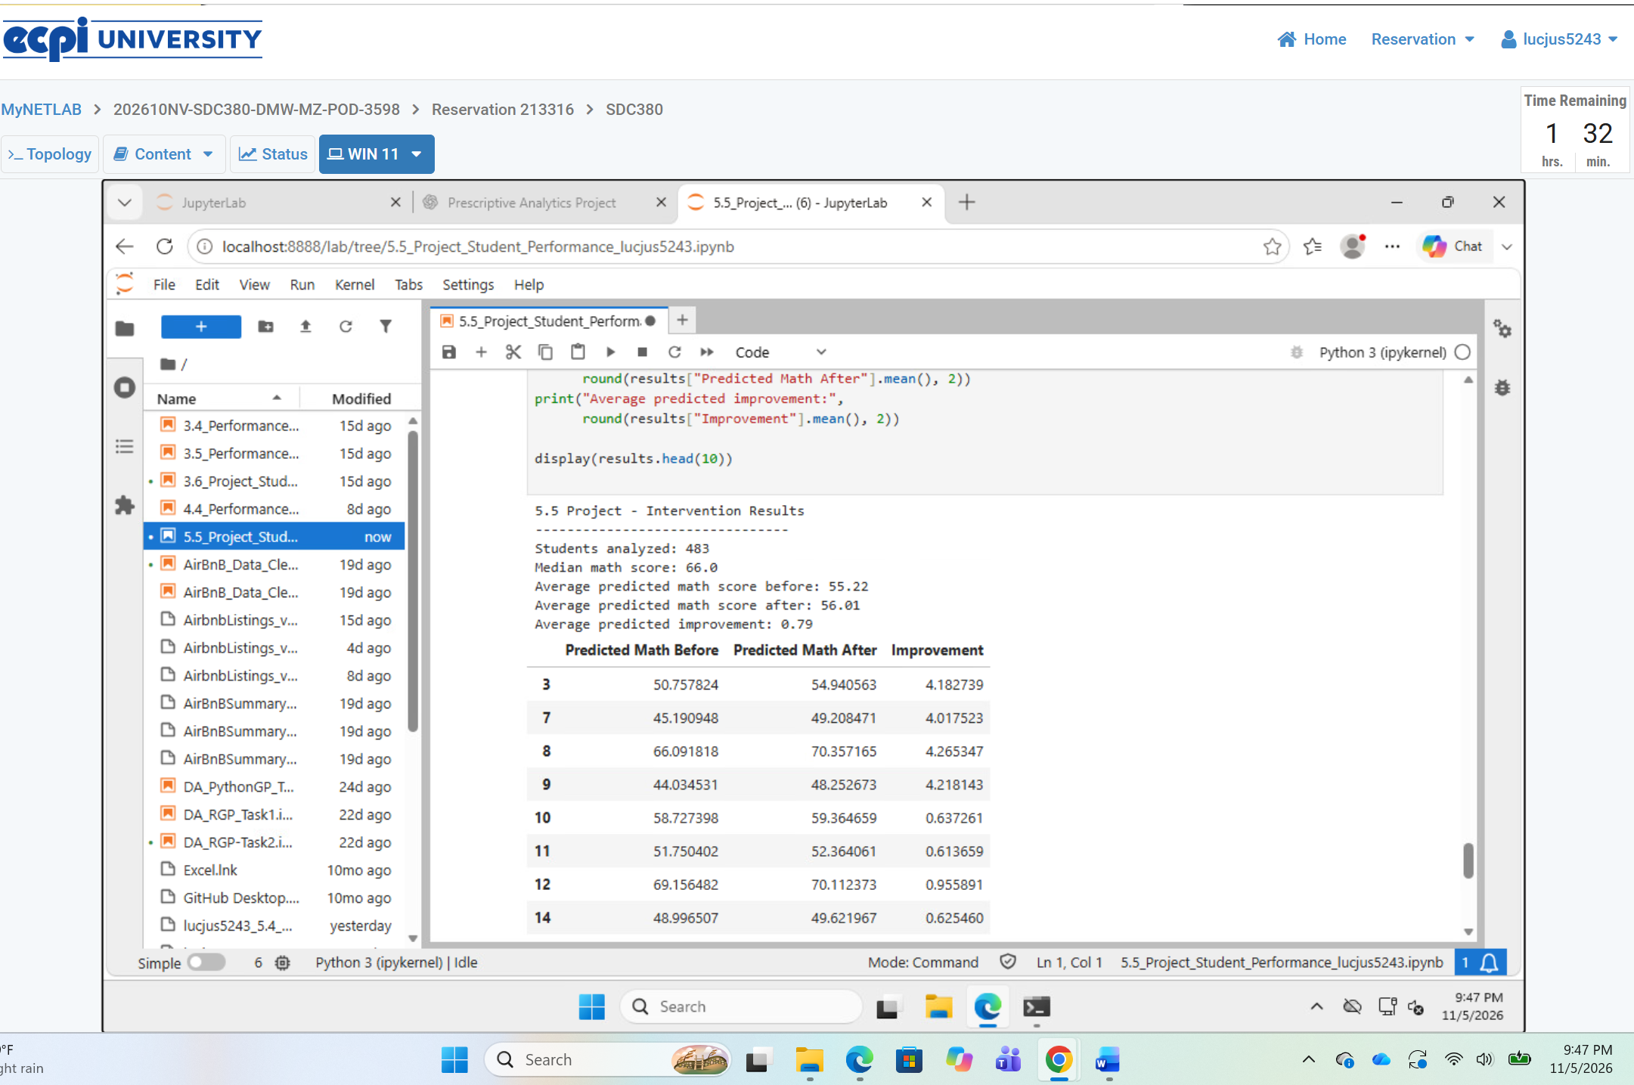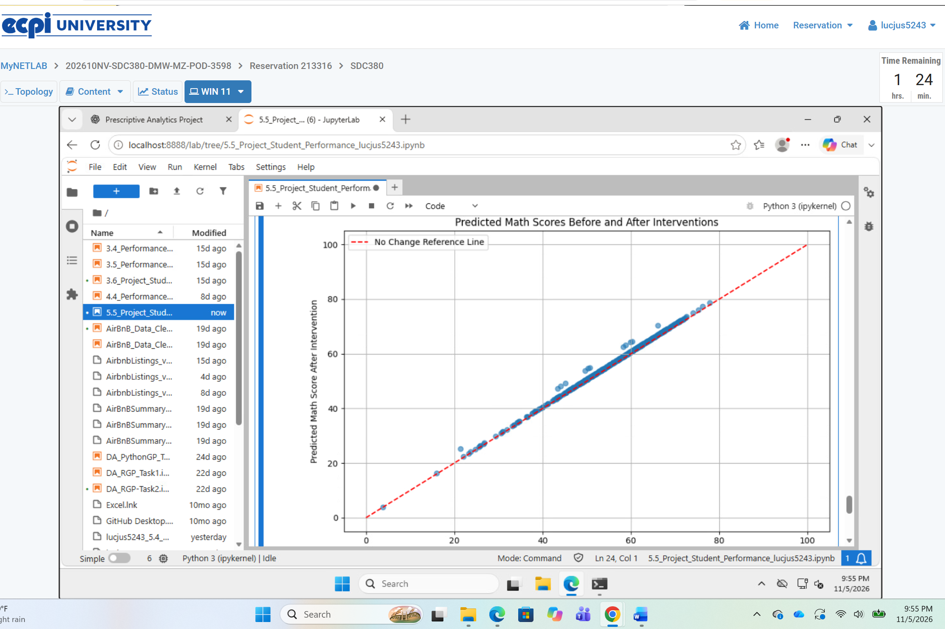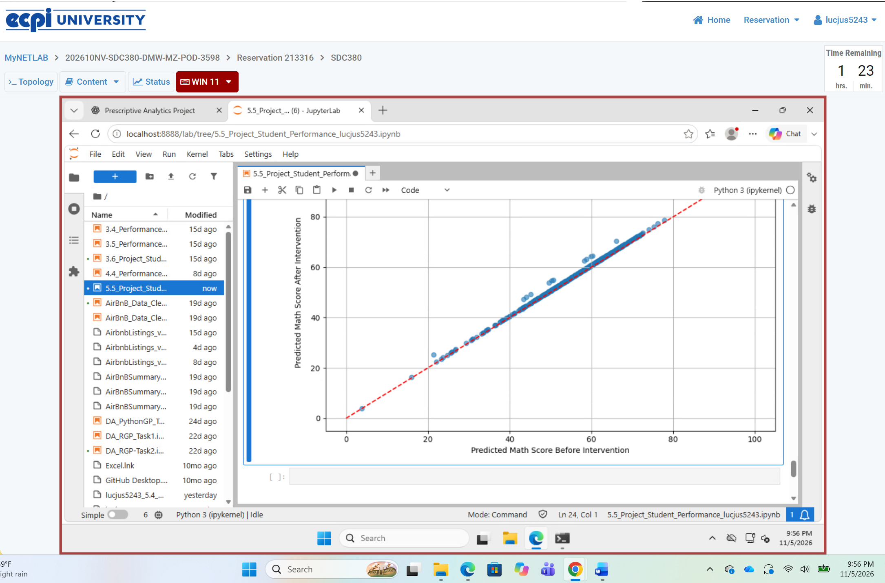
1. Based on scenario analysis, identify patterns or thresholds where interventions seem most effective.
My scenario analysis focused on 483 students whose math scores were below the median of 66. After simulating a 5% increase in reading scores and a 5% reduction in the number of students classified as receiving free/reduced lunch, the average predicted math score increased from 55.22 to 56.01, an improvement of 0.79 points. The results suggest that targeted academic support may be beneficial for students performing below the median. However, the model's predictions represent statistical relationships rather than proven causal effects.
2. Discuss potential educational programs or school initiatives that could lead to these interventions.
Schools could introduce reading tutoring, after-school literacy programs, and individualized academic support to improve reading comprehension and overall academic performance. Schools could also strengthen meal assistance programs, provide additional nutritional resources, and offer family support services to address barriers associated with economic hardship. Rather than removing students from free/reduced lunch programs, the goal should be to improve their access to resources and educational opportunities. These initiatives could help schools support struggling students while monitoring improvements in their academic performance.

