SDC250 Final Exam – SQL Queries & Output
Student Name: Lucas Justiniano
Course: SDC250
Assignment: Final Exam – Complete Submission

Question 1 – Courses cheaper than average (format cost)
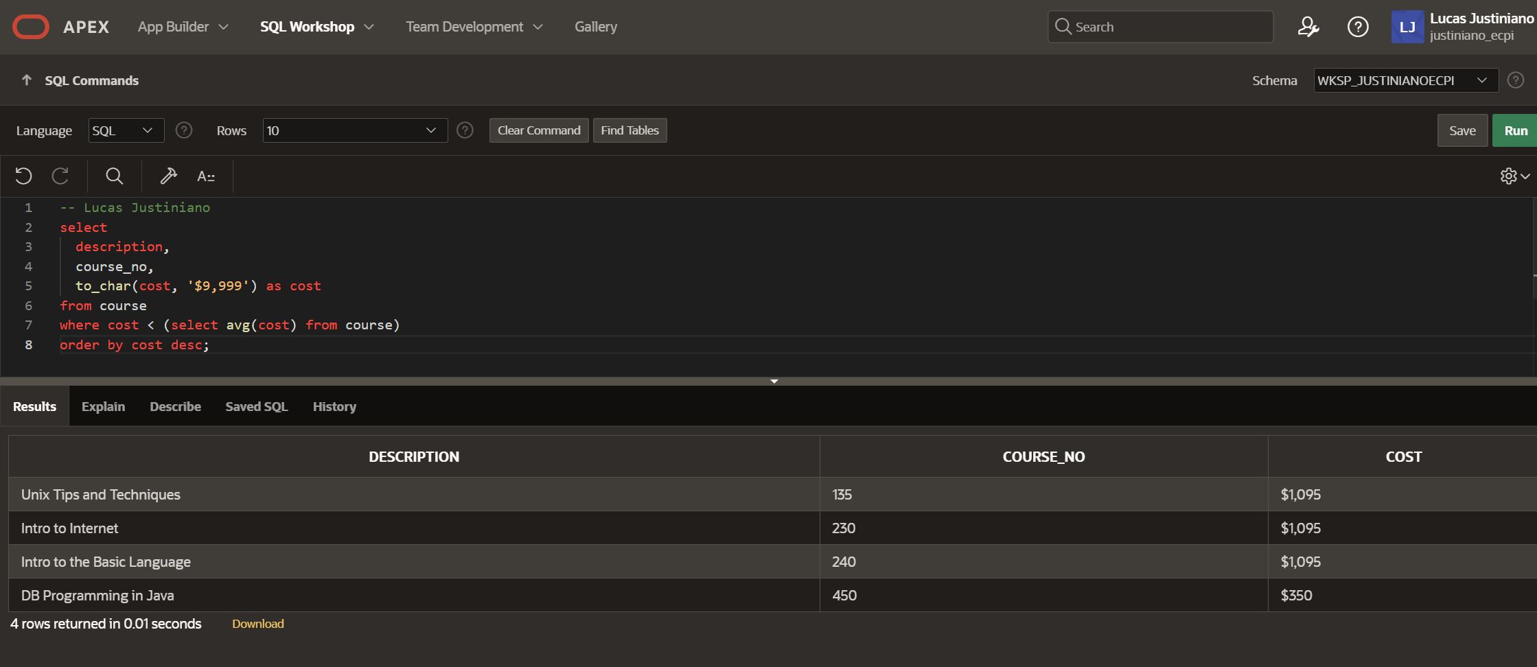

Question 2 – Courses and corresponding sections
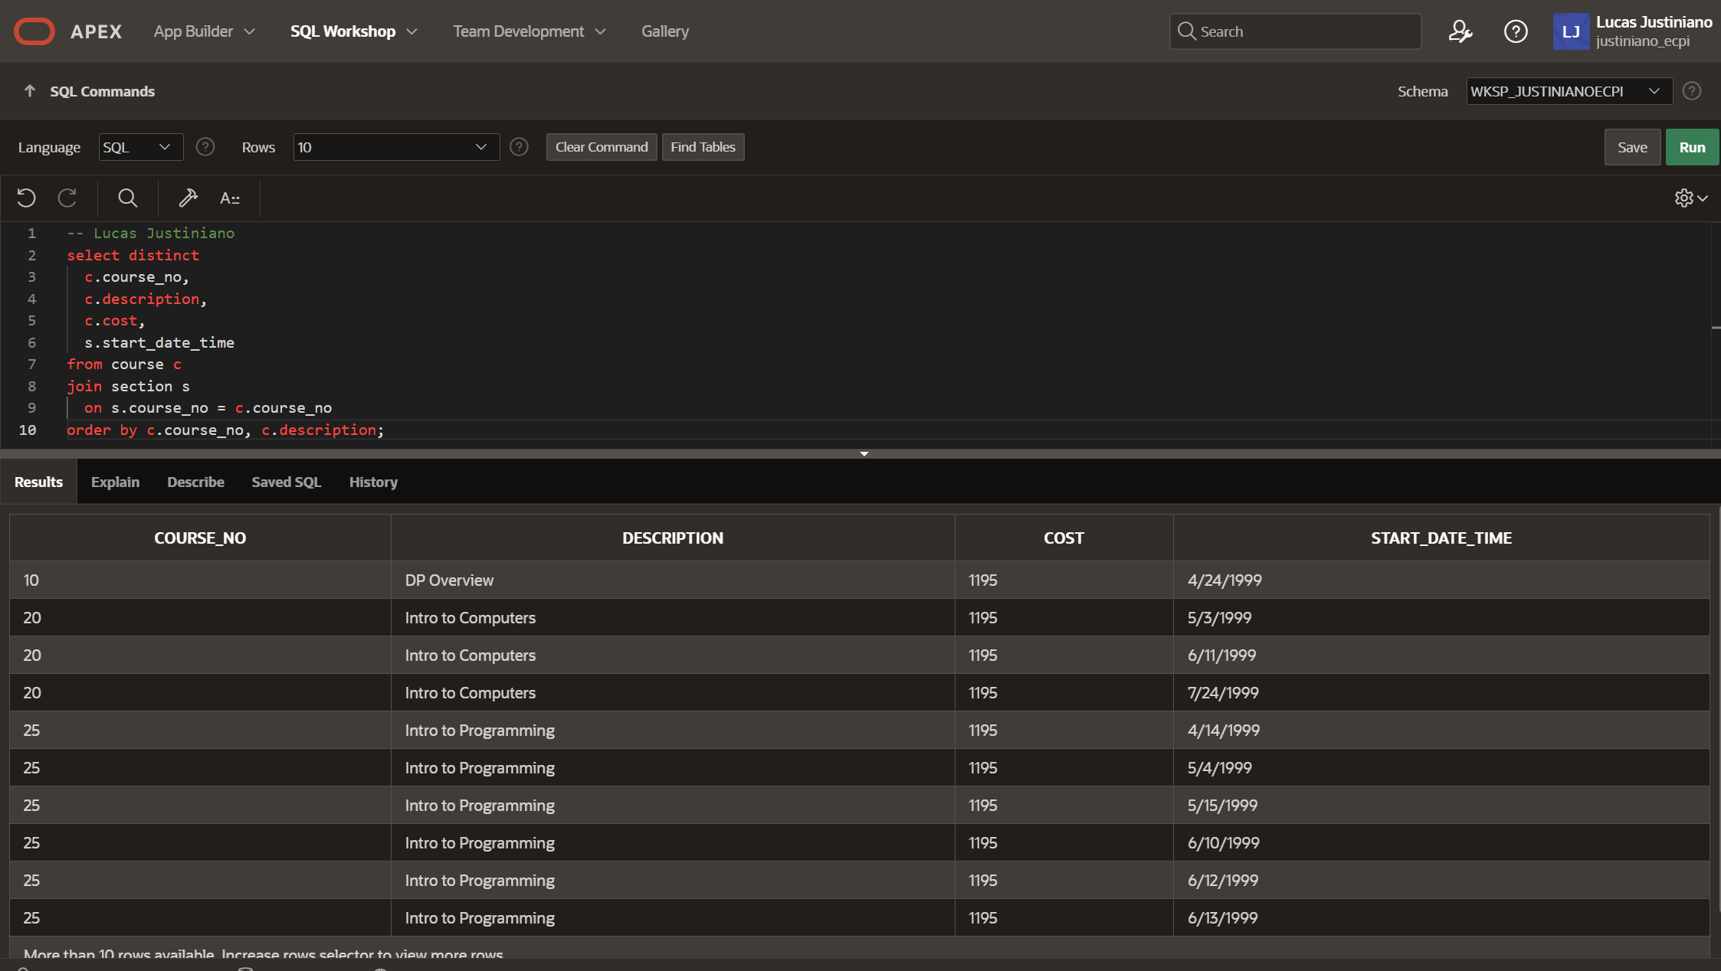

Question 3 – Zipcodes and instructor counts

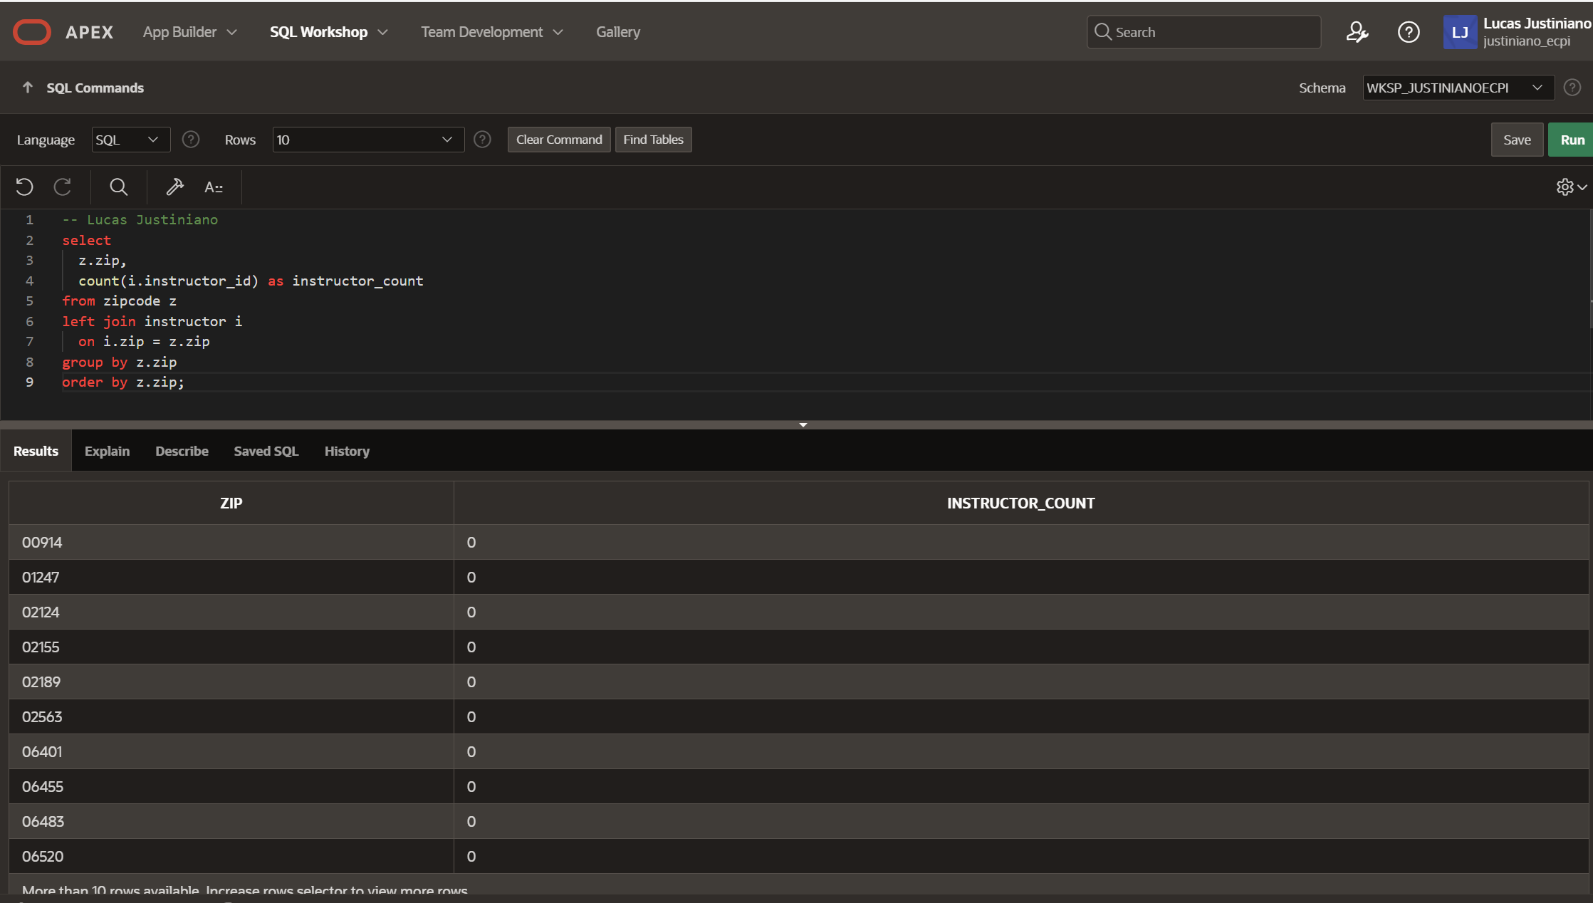

Question 4 – Brooklyn students
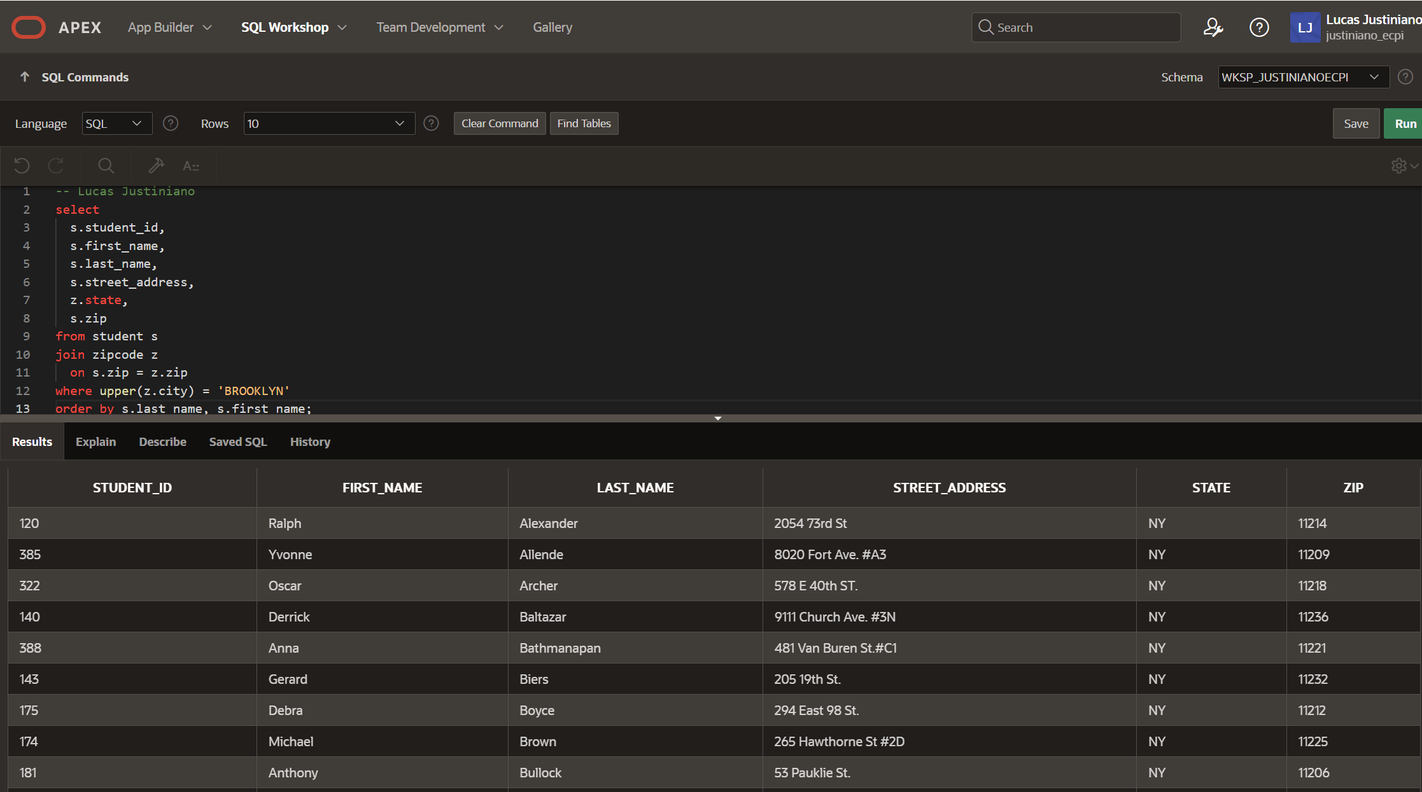

Question 5 – Instructors and number of sections taught
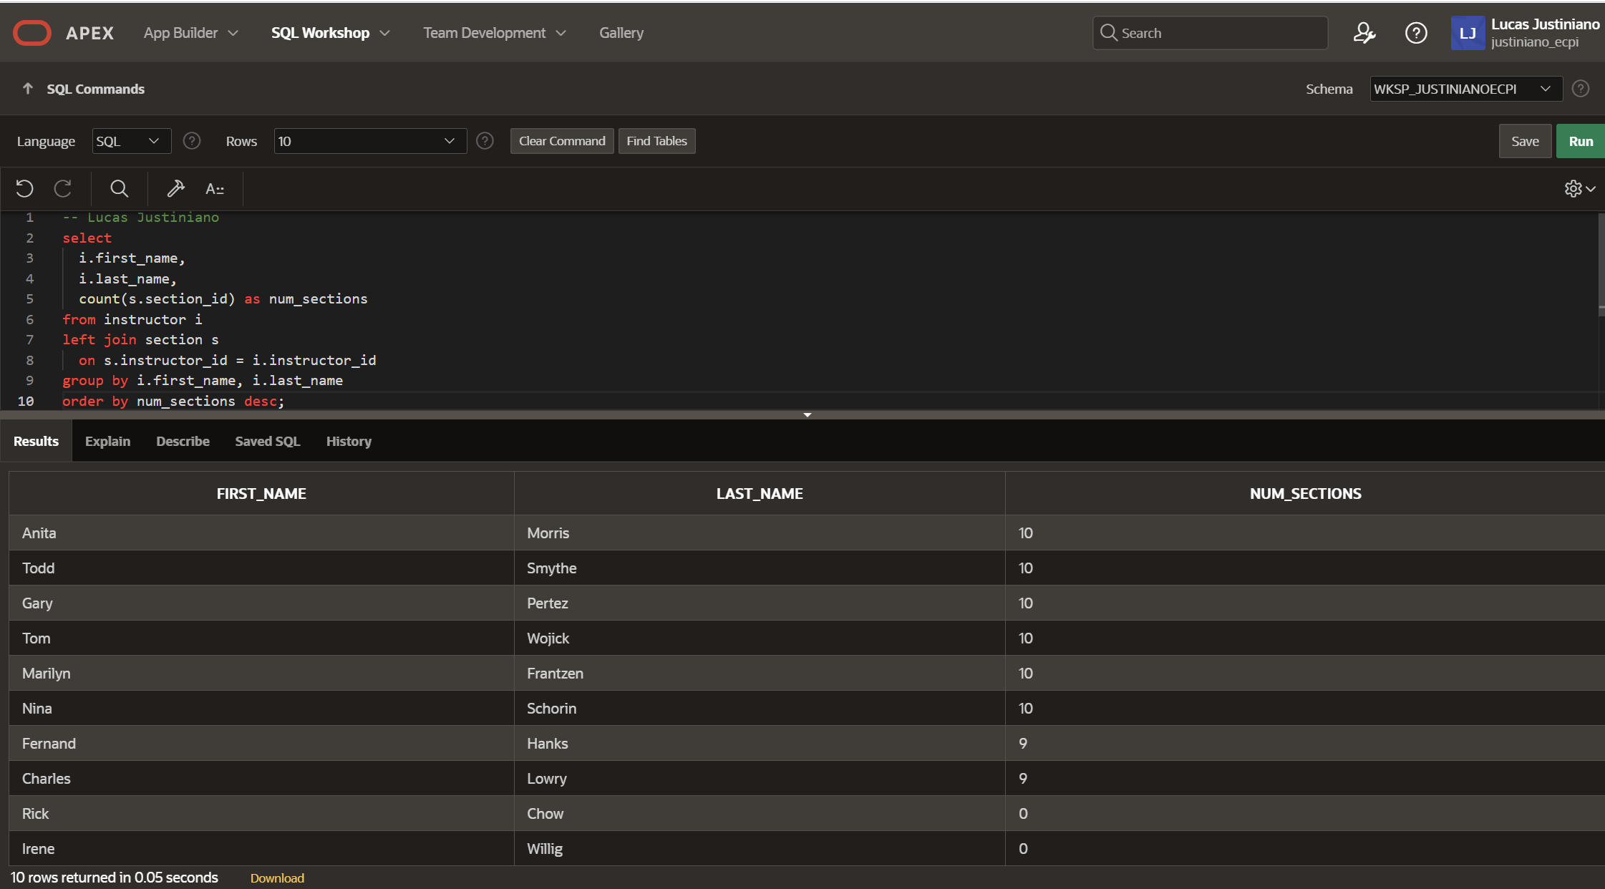

Question 6 – Students in same zipcode as Tom Wojick
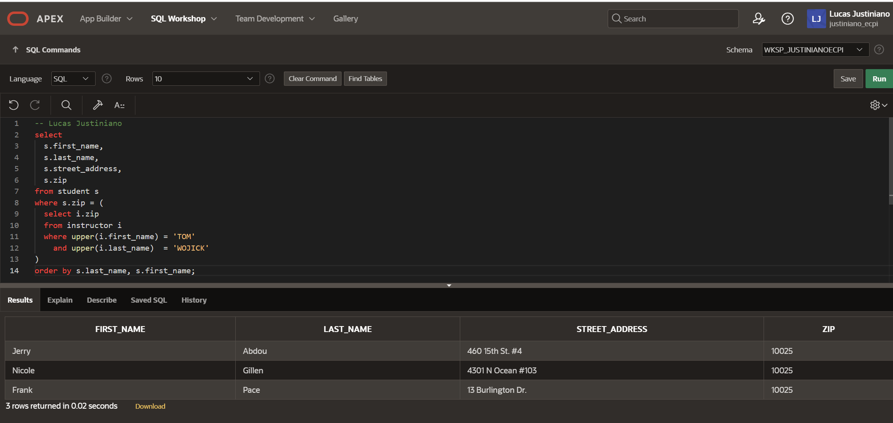

Question 7 – Students registered before Vera Wetcel
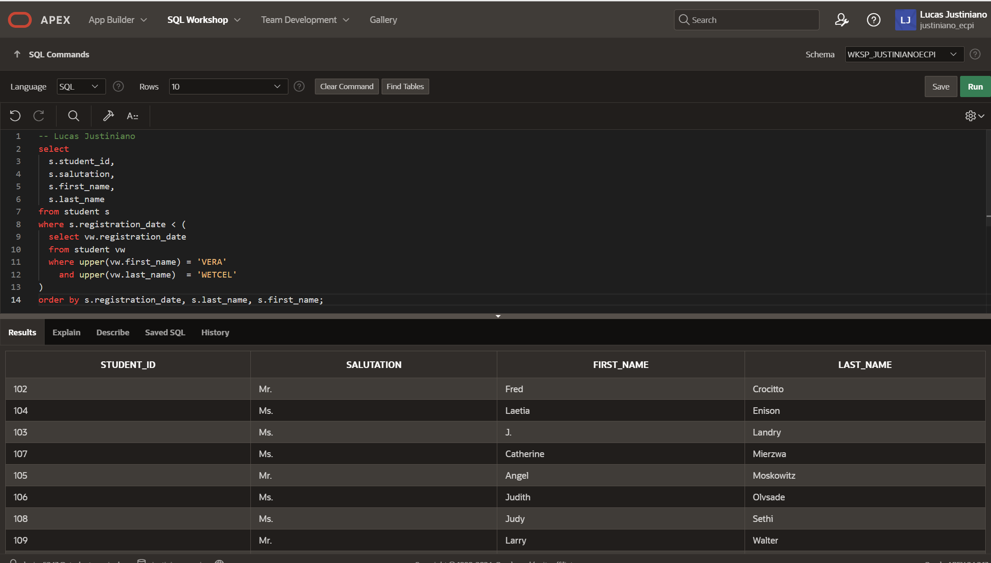

Question 8 – Students not enrolled in any classes
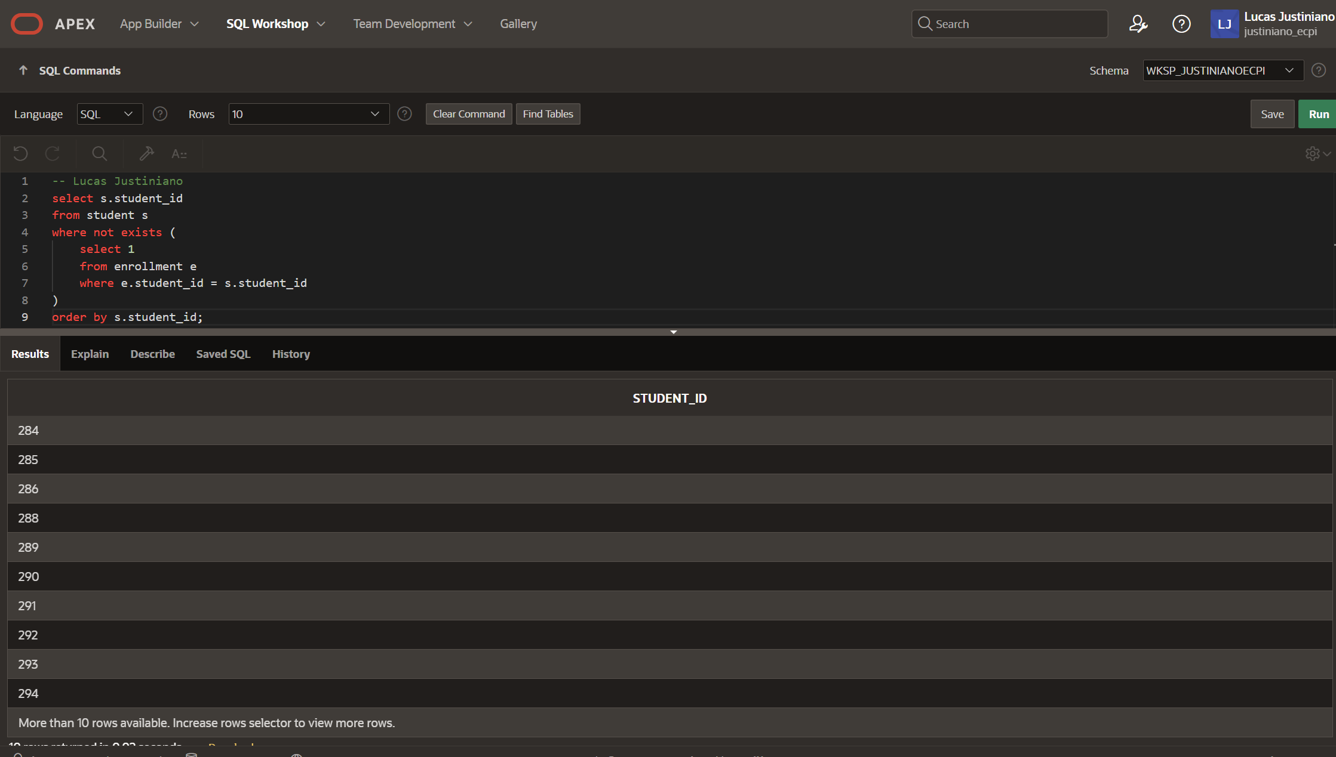

Question 9 – Create view: all_people_view
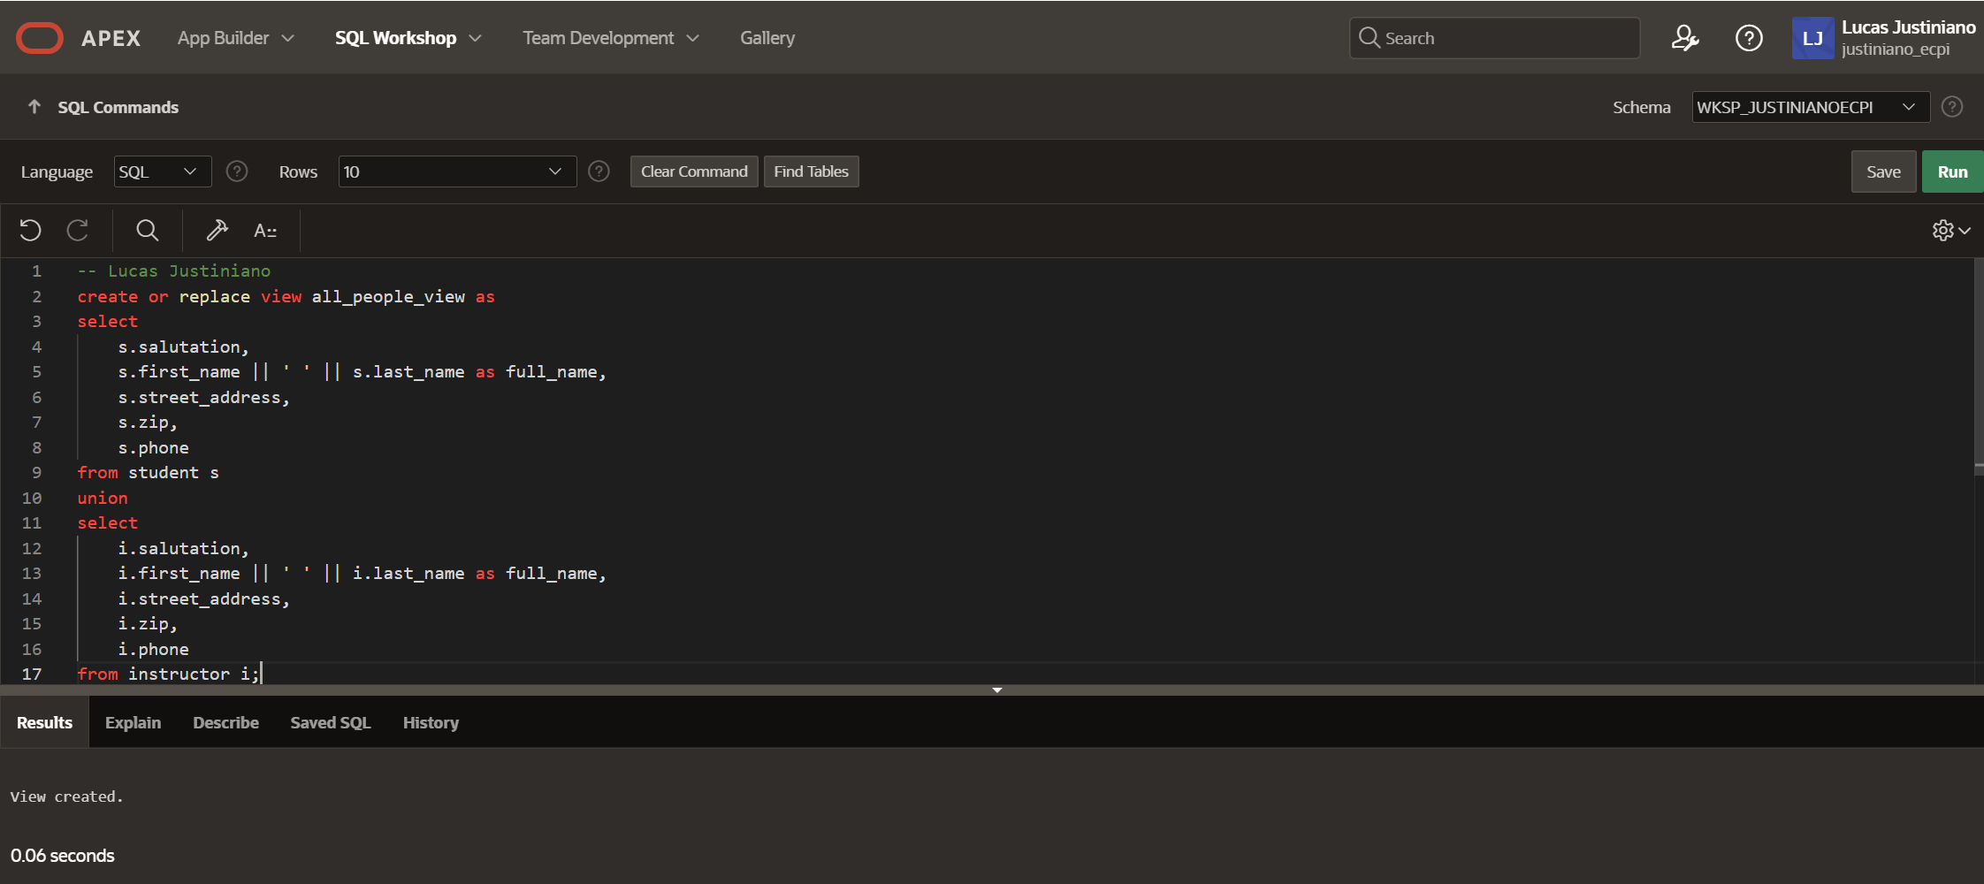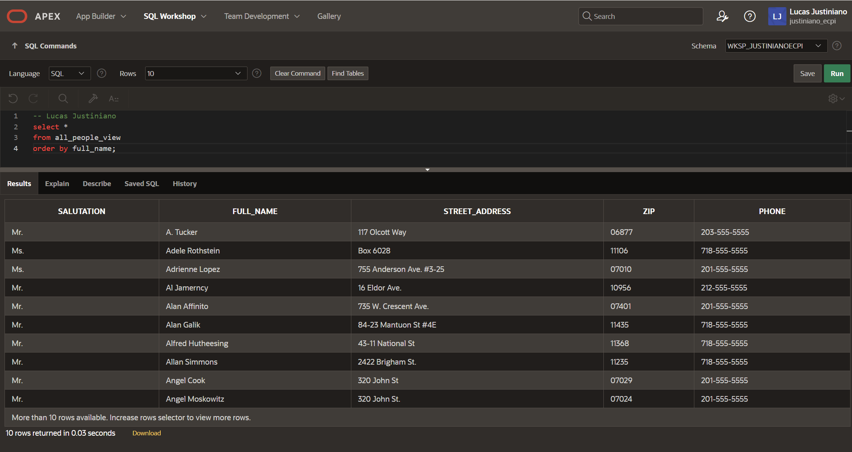

Question 10 – Student with highest grade
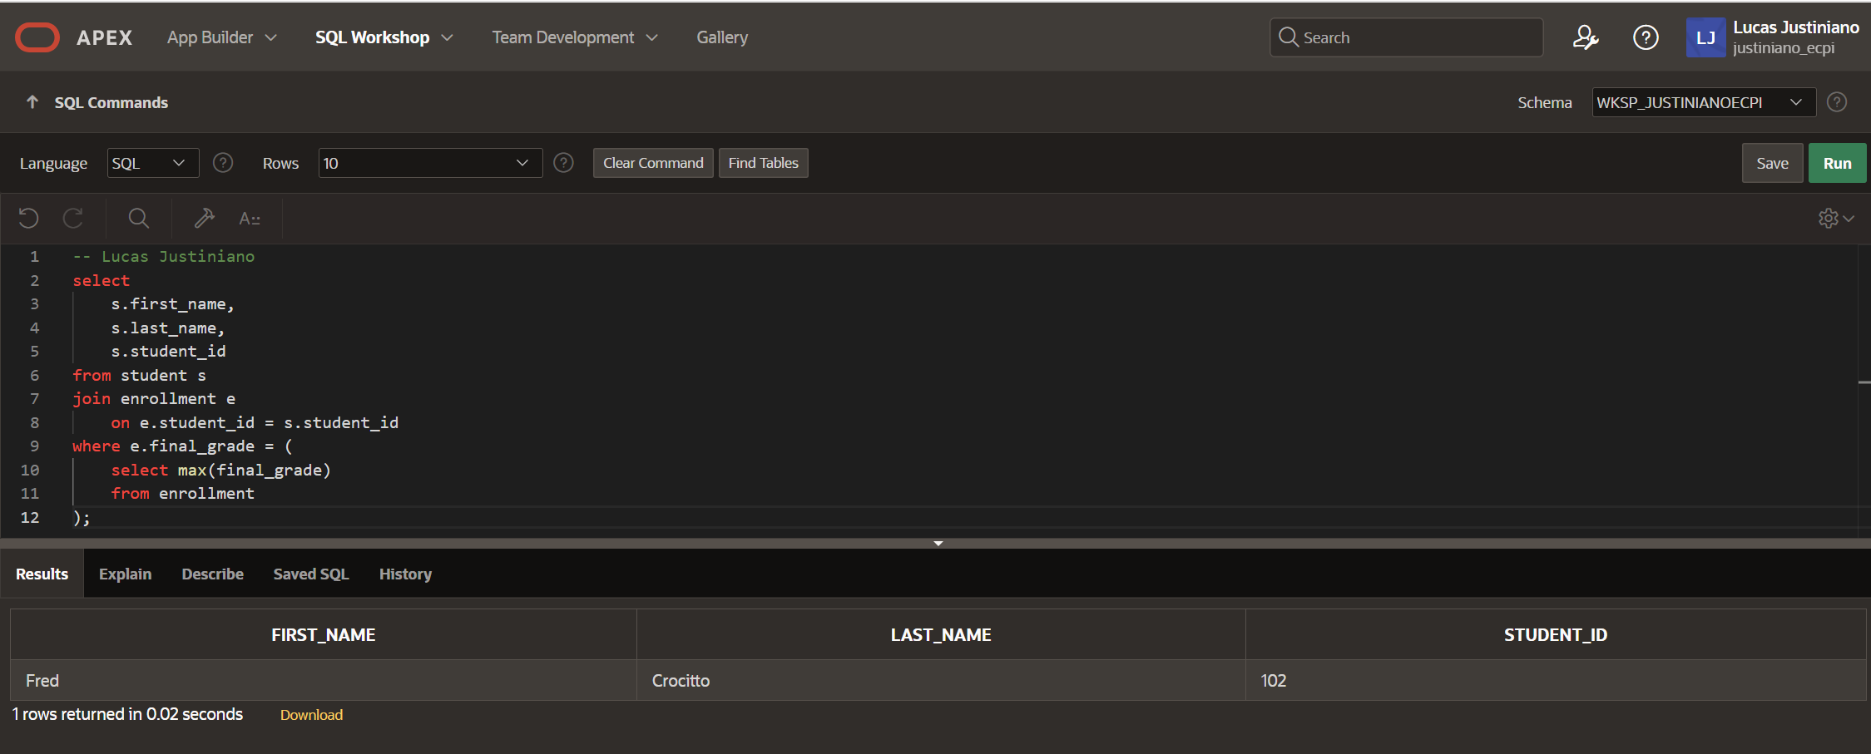

Question 11 – Courses with more than 5 sections
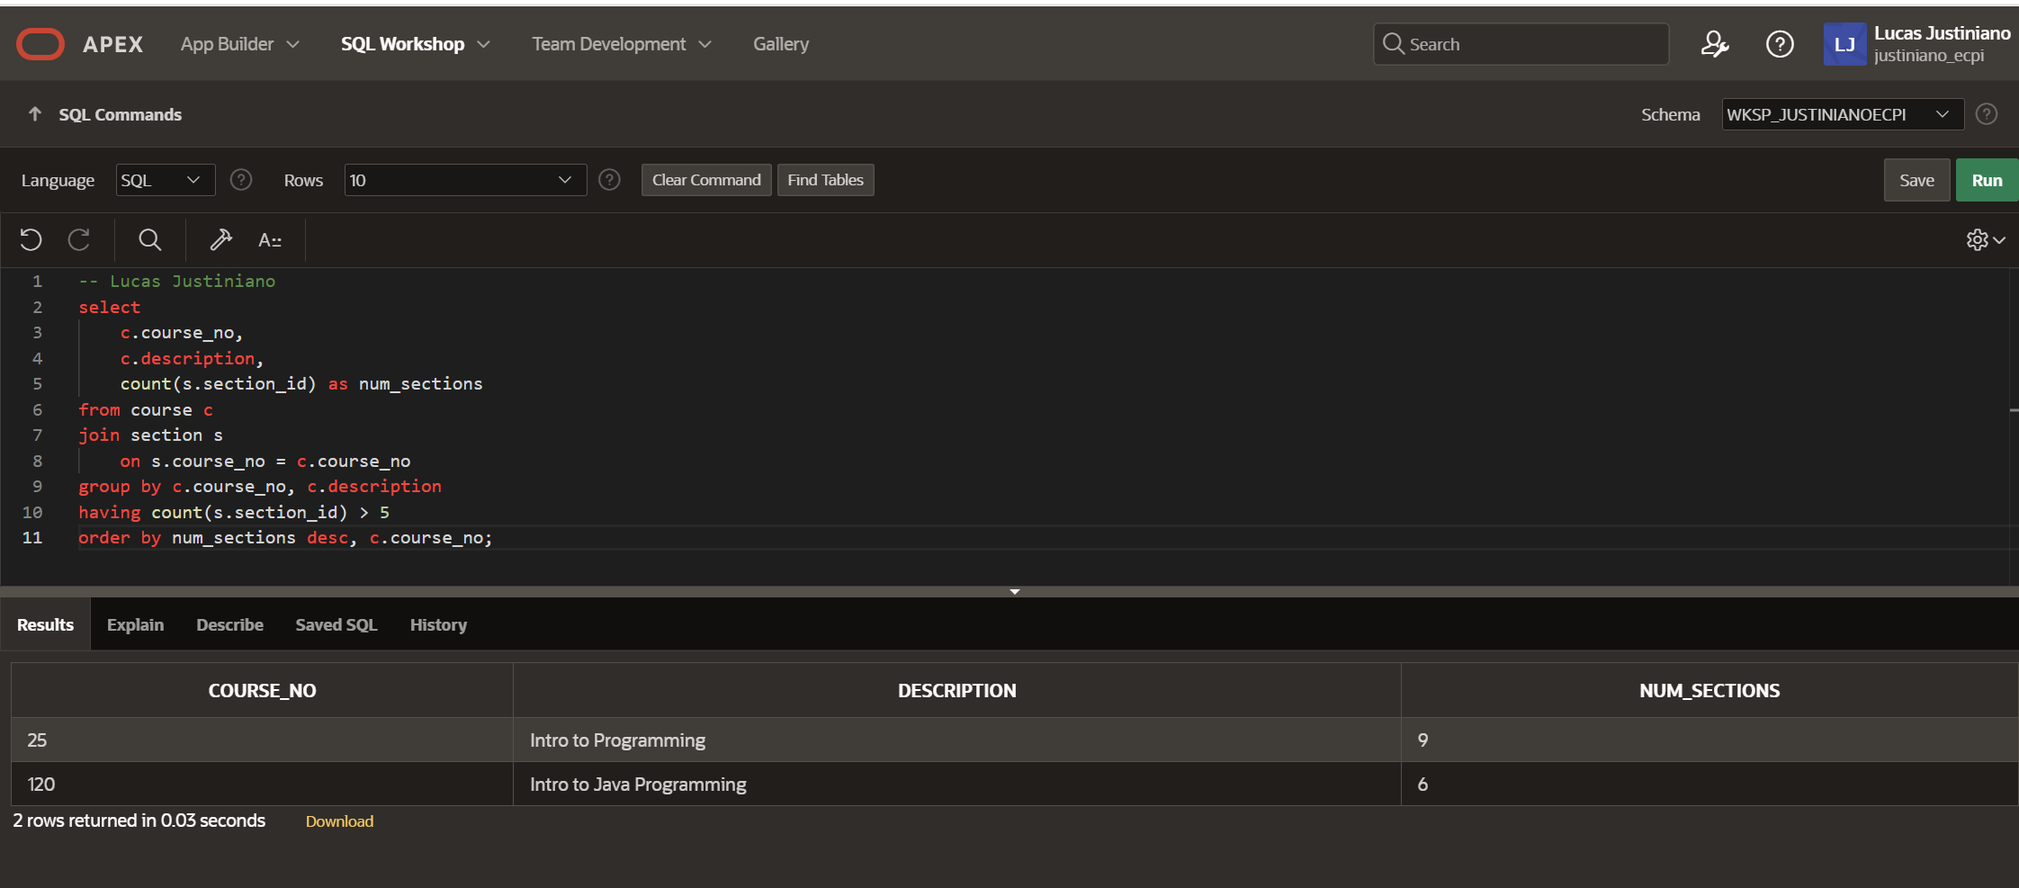

Question 12 – Courses and their prerequisites
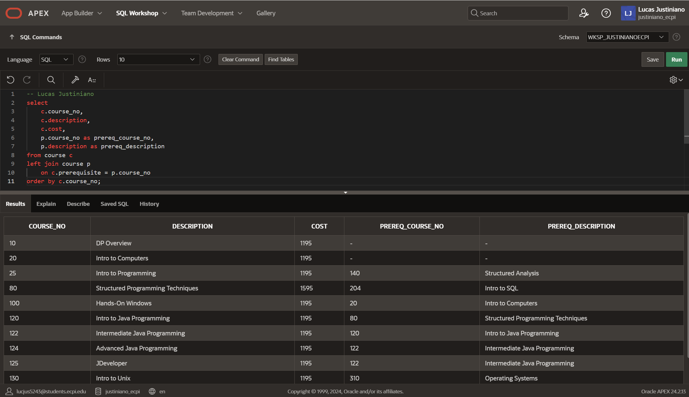

Question 13 – Course(s) with the most sections
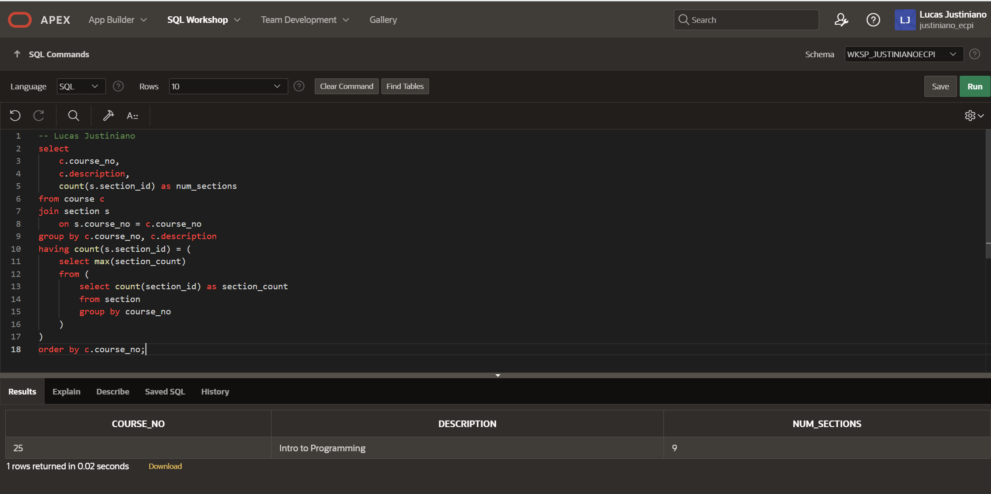

Question 14 – Courses over enrollment capacity
