# Network End Host system

Client-Server architecture vs. Peer-to-peer architecture

|  |  |
| --- | --- |
| Server | Client |
| Always on | Not always on |
| Provide service/resource to clients | Have no resource, request resources from server |

In a peer-to-peer architecture, each peer has some resources, both provide and request resources.

# Network layer model

1.1 where does data get multiplexed?

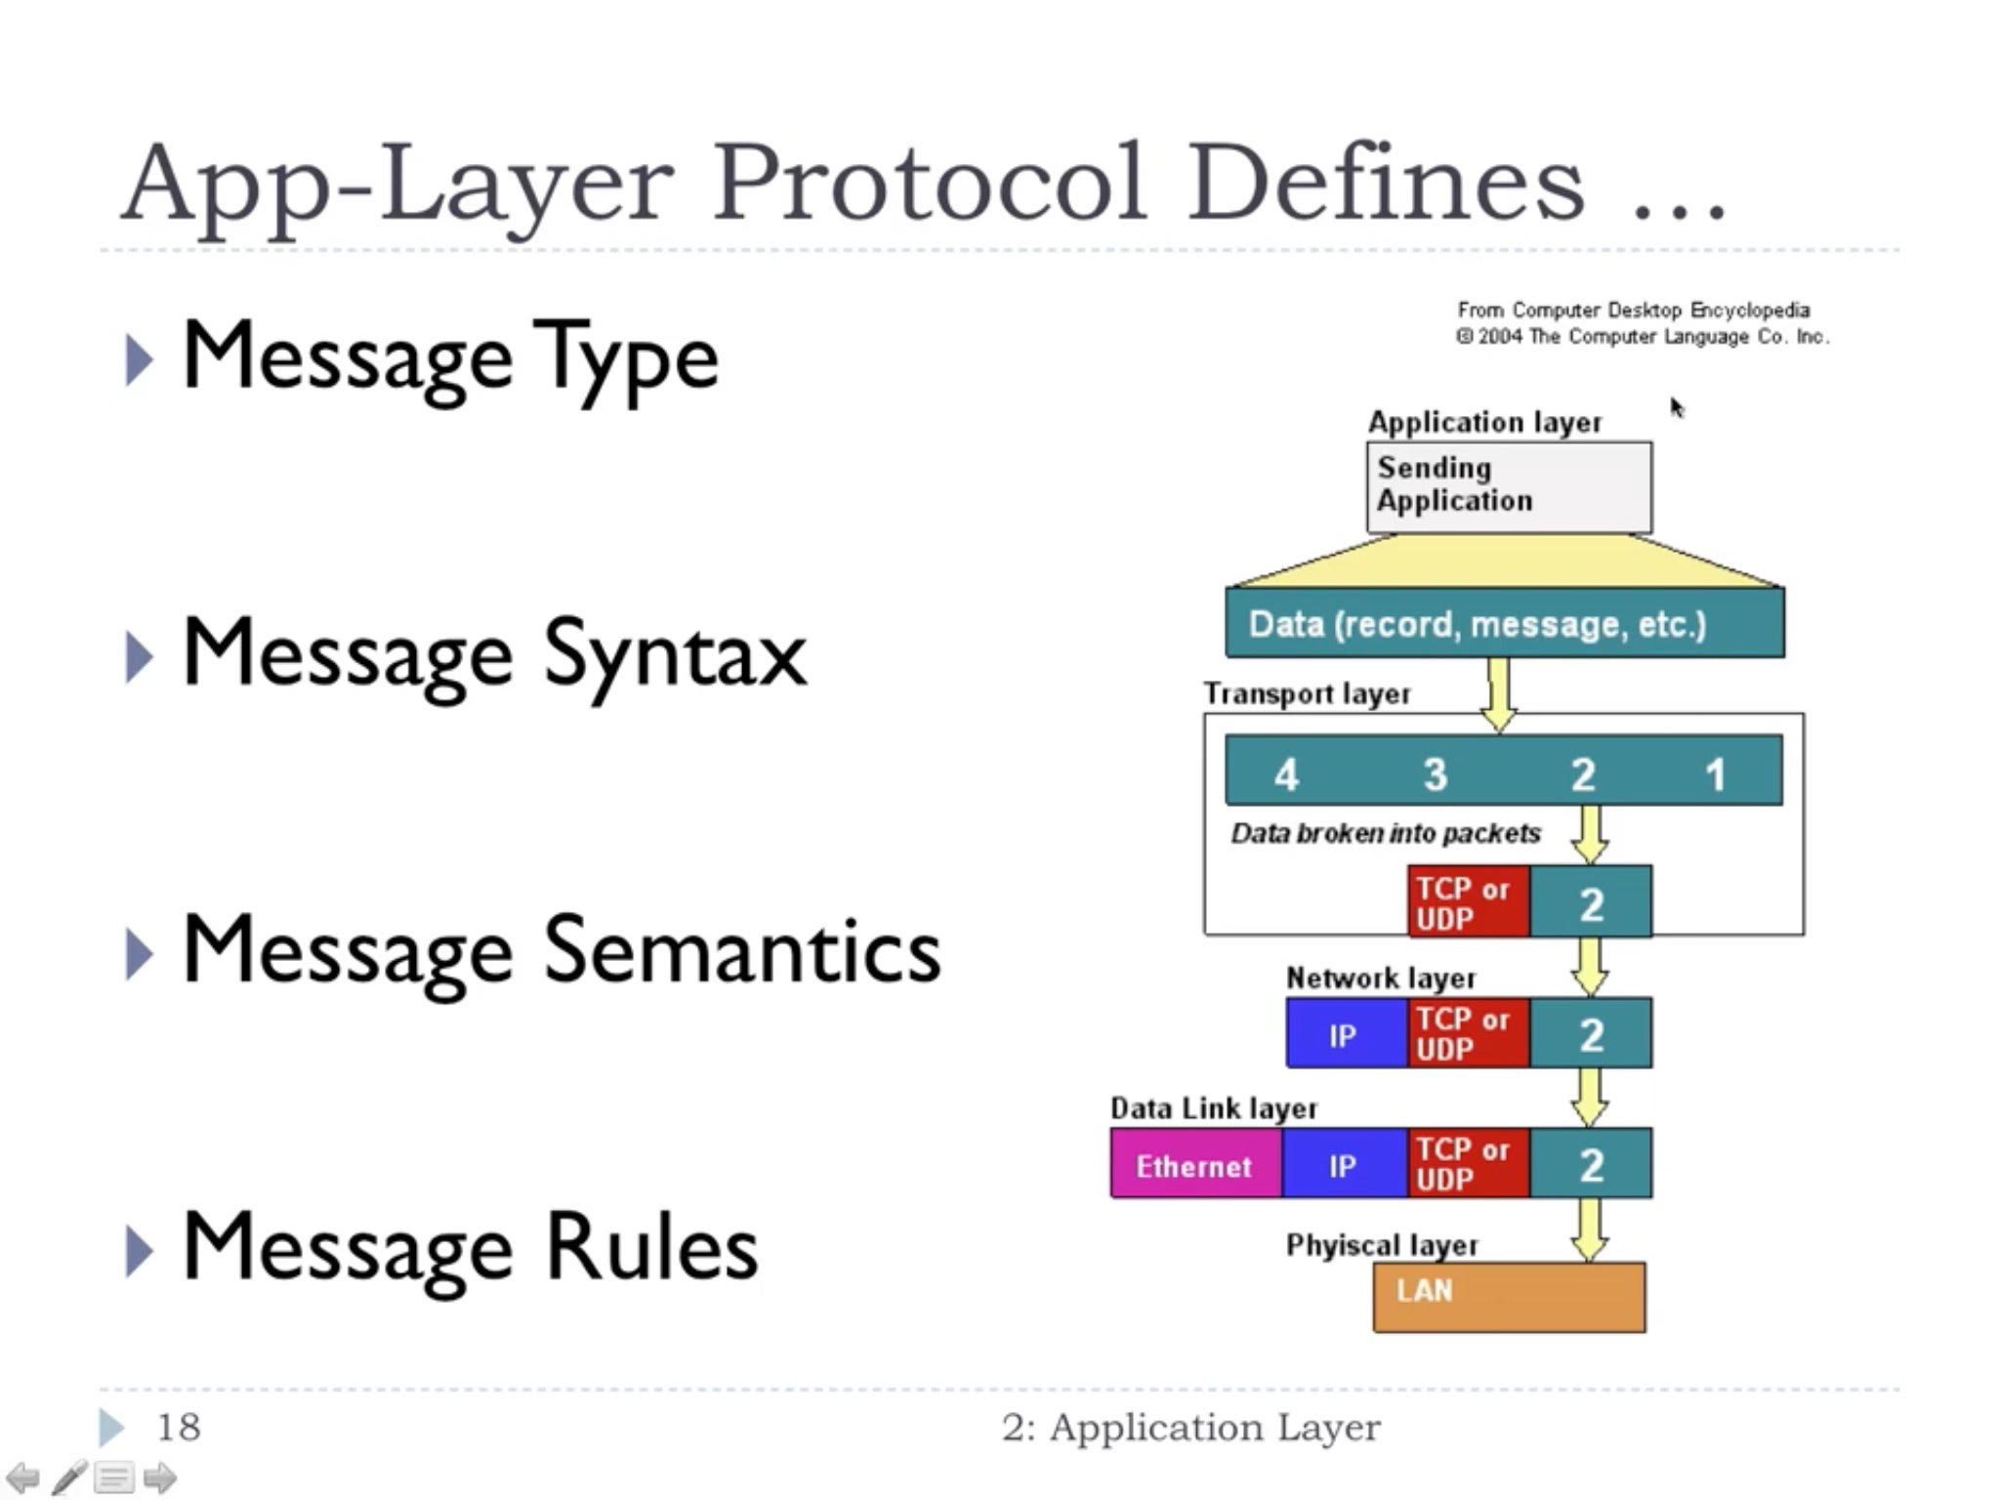

1.2 what are the layers, its protocol and address?

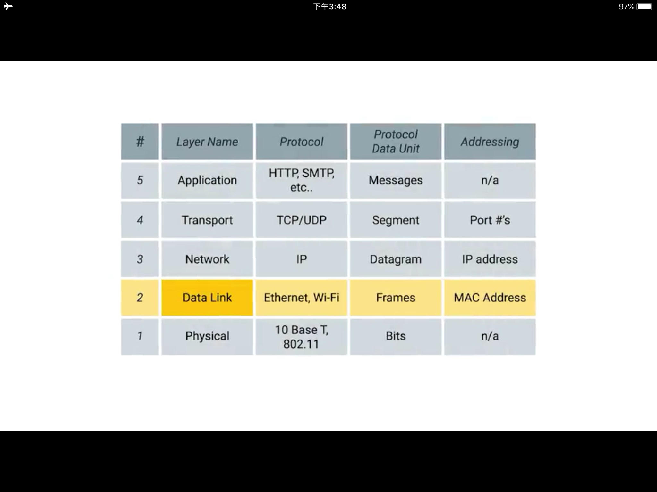

## Transport layer (logical communication between processes)

Transport layer take charge once two host found each other.

2.2 what are the differences between TCP and UDP?

|  |  |
| --- | --- |
| TCP | UDP |
| Reliable | Unreliable |
| Flow Control | No Flow Control |
| Congestion Control | No Congestion Control |

TCP: windowing, go from 1 packet to 21, 22,23…. Packets

2.3 How does TCP perform congestion control?

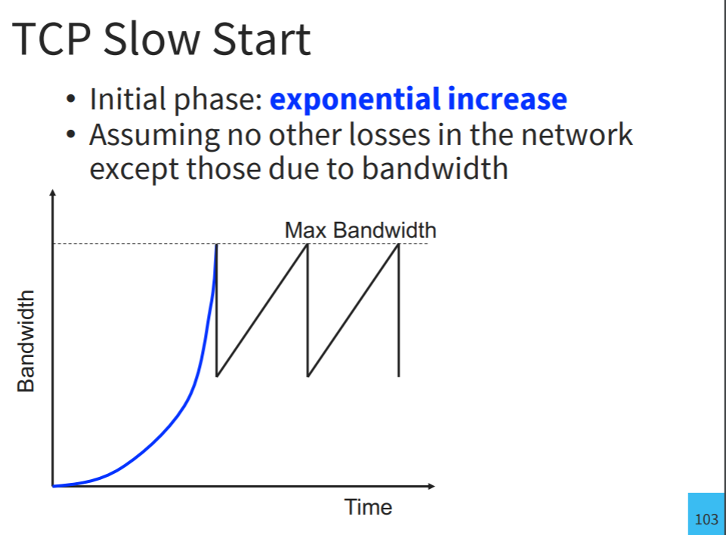

2.4 How to create a segment?

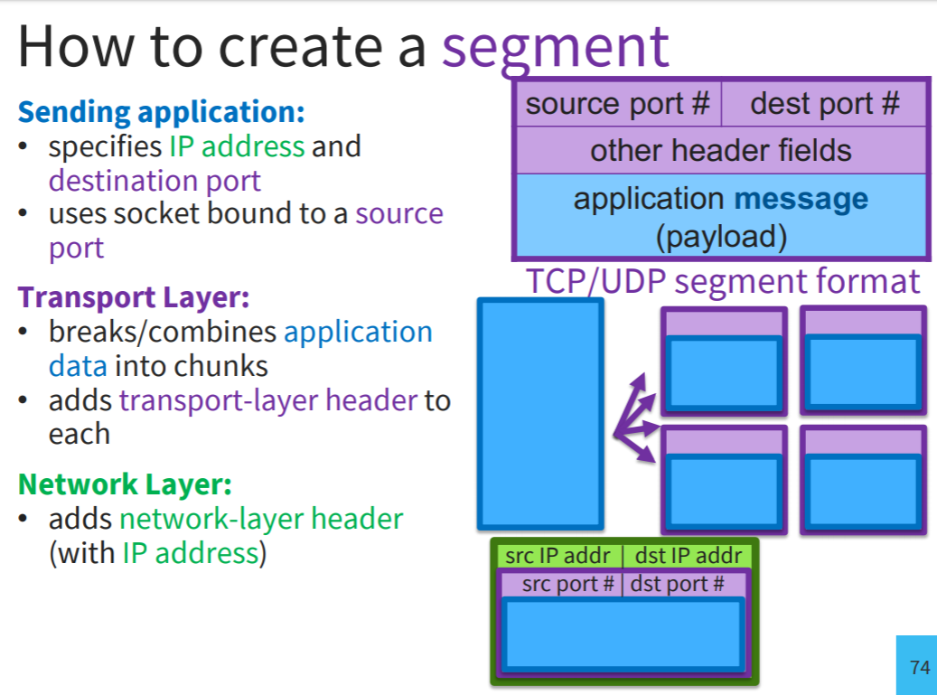

* 1. explain three-way handshake.

* 1. How to calculate TCP timeout?

NewAverageRTT = (1 - a) * OldAverageRTT + a *LatestRTT

NewAverageVar = (1 - β) * OldAverageVar + β * LatestVar

Timeout = AverageRTT + 4*AverageVar

* 1. explain bandwidth vs latency.

Bandwidth: #bytes per second

(one-way) Latency: delay in seconds

Round Trip Time (RTT): 2 x Latency

* 1. explain pipelining.

sender allows multiple, “in-flight”, yet-to-be-acknowledged packets to increase throughput.

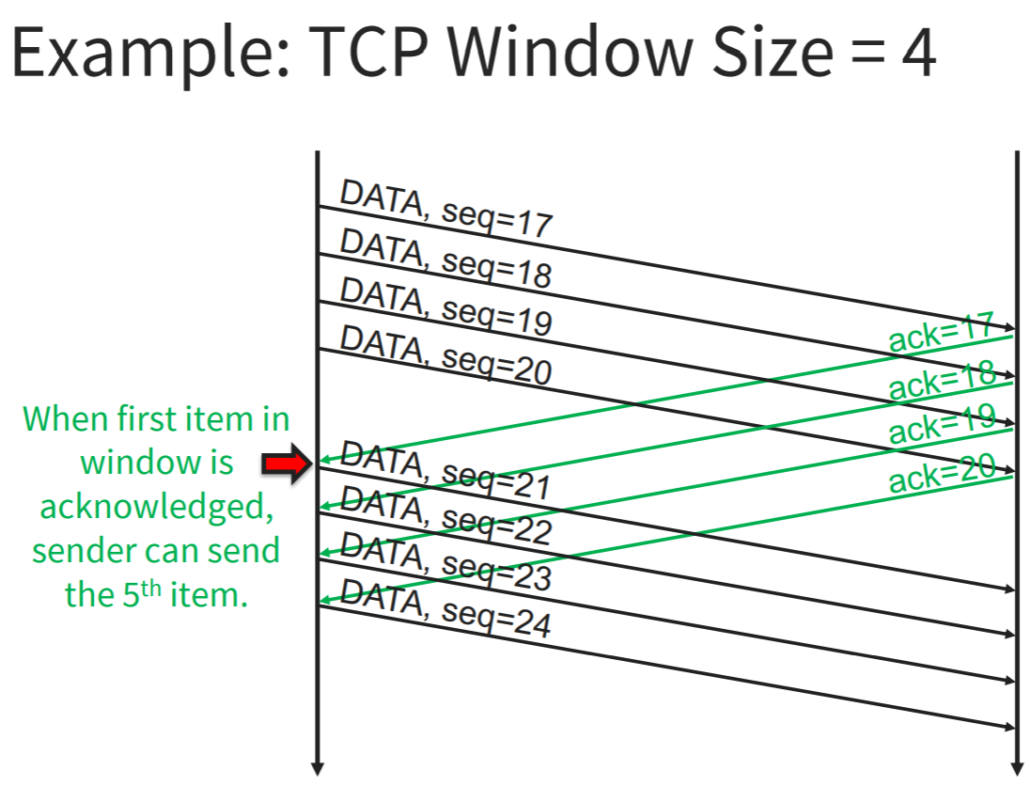

Bandwidth * RTT = the amount of data can be sent before receiving an ACK for the first byte

# Network layer (logical communication between hosts)

IP addresses are 32 bits / 4 bytes format.

IP addresses belong to the network not to the devices attached to the networks.

# Data Link layer

Ethernet uses MAC addresses to send data.

MAC address is unique to a device’s NIC.

# Other terms

DHCP: dynamic assign IP address to a device within a network with a timed lease (renewed repeatedly)

DNS: mapping to domain name to IP address

NAT: so that it is okay that two devices have the same IP address

NAT allows entire sites to use a single globally routable

IPv4 address for a collection of machines.

A “NAT box” keeps a table that maps global TCP/IP addresses into local ones

Subnet: the process of taking a large network and splitting it up into many individual subnetworks.

Option 1: Either specified by an integer, 0 <= n <= 32

-e.g., 128.84.32.00/24 or 128.84.32/24

Option 2: Or a “subnet mask”

-e.g., 255.255.255.0 or 0xFFFFFF00 (in case n = 24)

Subnet mask: mask processes in the same network from each other

Network identifier | host identifier

Class A subnet: 255.0.0.0

Class B subnet: 255.255.0.0

Class C subnet: 255.255.255.0

Devices on two subnet cannot communicate with each other even if they are connected physically

# 附录

