# 系统部署

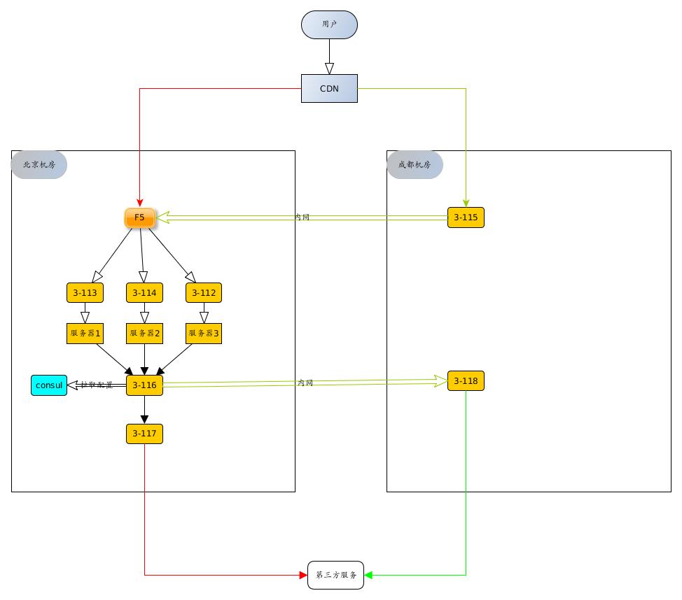

### 此次需要部署的是北京机房的3-116,3-117nginx和成都机房的3-118nginx.同时部署三台consul用来做3-116的serve动态配置.

以下为配置过程

### 安装nginx和upsync模块(3-116)

1. yum -y install zlib zlib-devel openssl openssl--devel pcre pcre-devel
2. unzip nginx-upsync-module-master.zip
3. tar zxf nginx-1.12.2.tar.gz
4. groupadd nginx
5. useradd -g nginx -s /sbin/nologin nginx
6. mkdir -p /usr/local/nginx/conf/servers
7. chown nginx /usr/local/nginx/conf/servers
8. mkdir -p /usr/local/nginx
9. cd ~/nginx-1.12.2
10. ./configure --prefix=/usr/local/nginx --user=nginx --group=nginx --with-http_stub_status_module --with-http_gzip_static_module --with-http_realip_module --with-pcre --add-module=/root/nginx-upsync-module-master
11. make && make install
12. /usr/local/nginx/sbin/nginx
13. ps -ef|grep nginx

### 安装nginx(3-117)

1. yum -y install zlib zlib-devel openssl openssl--devel pcre pcre-devel
2. tar zxf nginx-1.12.2.tar.gz
3. groupadd nginx
4. useradd -g nginx -s /sbin/nologin nginx
5. mkdir -p /usr/local/nginx
6. cd ~/nginx-1.12.2
7. ./configure --prefix=/usr/local/nginx --user=nginx --group=nginx
8. make && make install
9. /usr/local/nginx/sbin/nginx
10. ps -ef|grep nginx

### 安装nginx(3-118)

1. yum -y install zlib zlib-devel openssl openssl--devel pcre pcre-devel
2. tar zxf nginx-1.12.2.tar.gz
3. groupadd nginx
4. useradd -g nginx -s /sbin/nologin nginx
5. mkdir -p /usr/local/nginx
6. cd ~/nginx-1.12.2
7. ./configure --prefix=/usr/local/nginx --user=nginx --group=nginx
8. make && make install
9. /usr/local/nginx/sbin/nginx
10. ps -ef|grep nginx

### 安装consul:（在lixincui服务器上安装相关服务，3台集群）

下载安装文件:https://www.consul.io/downloads.html   
将文件放在指定的文件夹下:mkdir /usr/local/consul && mv consul /usr/local/consul/   
后台启动:consul:nohup /usr/local/consul/consul agent -server -bootstrap-expect 1 -data-dir /usr/local/data/consul -client 0.0.0.0 -bind=172.16.3.116 -ui -node=3-116 -datacenter=upstream -config-dir /etc/consul.d/ &

为consul添加key-value,把服务器信息放置在节点上   
添加后端服务:curl -X PUT <http://172.16.3.116:8500/v1/kv/upstreams/172.16.3.118:80>   
开启后端服务:curl -X PUT -d ‘{“weight”:2, “max_fails”:2, “fail_timeout”:10, “down”:0}’ <http://172.16.3.116:8500/v1/kv/upstreams/172.16.3.118:80>

# nginx配置

| **服务器名称** | **机房** | **服务器地址** |
| --- | --- | --- |
| 3-116 | 北京 | 172.16.3.116 |
| 3-117 | 北京 | 172.16.3.117 |
| 3-118 | 成都 | 172.16.3.118 |

下边是容易催系统调用扣款接口的nginx配置,在做线上配置时,需要根据线上服务器地址,对以上测试机器IP做替换:

# 3-116

1. user nginx;
2. worker_processes 1;
3. error_log logs/error.log;
4. events {
5. worker_connections 1024;
6. }
7. http {
8. include mime.types;
9. default_type application/octet-stream;
10. sendfile on;
11. keepalive_timeout 65;
12. upstream 116-web {
13. server 127.0.0.1:11111;
14. upsync 172.16.3.116:8500/v1/kv/upstreams upsync_timeout=6m upsync_interval=500ms upsync_type=consul strong_dependency=off;
15. upsync_dump_path /usr/local/nginx/conf/servers/servers_list.conf;
16. }
17. server {
18. listen 80;
19. listen 443 ssl;
20. server_name localhost;
21. location /api/rpc {
22. proxy_pass http://116-web/api/rpc;
23. proxy_connect_timeout 1800s;
24. proxy_read_timeout 1800s;
25. proxy_send_timeout 1800s;
26. proxy_buffer_size 16k;
27. proxy_buffers 16 128k;
28. proxy_busy_buffers_size 256k;
29. proxy_temp_file_write_size 256k;
30. proxy_next_upstream error;
31. proxy_set_header X-Real-IP $remote_addr;
32. proxy_set_header Host $http_host;
33. client_max_body_size 30m;
34. client_body_buffer_size 256k;
35. }
36. location = /upstream_show {
37. upstream_show;
38. }
39. location = /upstream_status {
40. stub_status on;
41. access_log off;
42. }
43. }
44. }

# 外网出口(117)

1. user nginx;
2. worker_processes 1;
3. error_log logs/error.log;
4. events {
5. worker_connections 1024;
6. }
7. http {
8. include mime.types;
9. default_type application/octet-stream;
10. sendfile on;
11. keepalive_timeout 65;
12. upstream 117-web {
13. server api.kuaishanxianjin.com max_fails=3 fail_timeout=10s;
14. }
15. server {
16. listen 80;
17. server_name localhost;
18. location /api/rpc{
19. proxy_pass http://117-web//api/rpc;
20. proxy_connect_timeout 1800s;
21. proxy_read_timeout 1800s;
22. proxy_send_timeout 1800s;
23. proxy_buffer_size 16k;
24. proxy_buffers 16 128k;
25. proxy_busy_buffers_size 256k;
26. proxy_temp_file_write_size 256k;
27. proxy_next_upstream error;
28. proxy_set_header X-Real-IP $remote_addr;
29. proxy_set_header Host $http_host;
30. client_max_body_size 30m;
31. client_body_buffer_size 256k;
32. }
33. }
34. }

# 内网出口(118)

1. user nginx;
2. worker_processes 1;
3. error_log logs/error.log;
4. events {
5. worker_connections 1024;
6. }
7. http {
8. include mime.types;
9. default_type application/octet-stream;
10. sendfile on;
11. keepalive_timeout 65;
12. upstream 118-web {
13. server api.kuaishanxianjin.com max_fails=3 fail_timeout=10s;
14. }
15. server {
16. listen 80;
17. server_name localhost;
18. location /api/rpc{
19. proxy_pass http://118-web/api/rpc;
20. proxy_connect_timeout 1800s;
21. proxy_read_timeout 1800s;
22. proxy_send_timeout 1800s;
23. proxy_buffer_size 16k;
24. proxy_buffers 16 128k;
25. proxy_busy_buffers_size 256k;
26. proxy_temp_file_write_size 256k;
27. proxy_next_upstream error;
28. proxy_set_header X-Real-IP $remote_addr;
29. proxy_set_header Host $http_host;
30. client_max_body_size 30m;
31. client_body_buffer_size 256k;
32. } }
33. }

**2：辛苦运维添加https相关模块相关配置，线上会进行快闪、快信业务修改配置进行验证，辛苦！**

**测试机器中的配置替换为线上ip或者域名即可**

**# 配置https请求**

**1. 对https的请求,需要在服务器配置ssl，否则会出现错误:**

**```**

**This site can’t be reached**

**172.16.3.116 refused to connect.**

**Try:**

**Checking the connection**

**Checking the proxy and the firewall**

**ERR_CONNECTION_REFUSED**

**```**

**具体的配置步骤**