# 向CDH集群添加一台主机

1. **设置修改hostname**
   1. shell> #hostname ser4-122.yooli-idc.net

shell>#vi /etc/sysconfig/network

NETWORKING=yes

HOSTNAME=ser4-122.yooli-idc.net

**添加hostname解析并检查IP联通性**

shell>#vi /etc/hosts

127.0.0.1 localhost localhost.localdomain localhost4 localhost4.localdomain4

#::1 localhost localhost.localdomain localhost6 localhost6.localdomain6

192.168.4.122 ser4-122.yooli-idc.net ser4-122.yooli-idc.net

#上行为新添加host解析

测试本地服务器到 其他各服务器连通性  
cat /etc/hosts|awk --posix '/^[0-9]{1,3}.[0-9]{1,3}.[0-9]{1,3}.[0-9]{1,3}.*/{print $1}'|fping

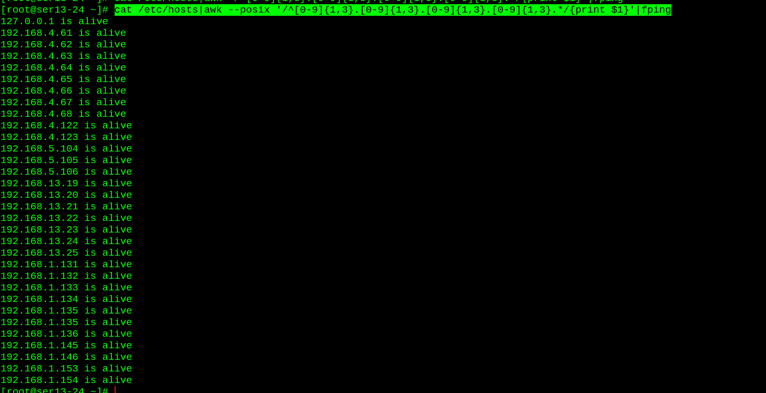

1. **禁用ipv6**

shell>#vi /etc/modprobe.d/ipv6off.conf

alias net-pf-10 off

options ipv6 disable=1

Icon

ps:禁用完ipv6后必须重启机器，重启完可以用以下方法验证ipv6是否已禁用：

ifconfig

netstat –tuln

lsmod|grep ip

**禁用selinux**

1. **service iptables stop关闭防火墙**
2. **ssh无密码验证，在cm server端执行以下命令**
   1. shell>#ssh-copy-id -i /root/.ssh/id_rsa.pub '-p 52119 [root@192.168.4.122](mailto:root@192.168.4.122)'
3. **安装JDK**

shell>#rpm -ivh jdk-8u45-linux-x64.rpm

配置环境变量

shell>#vi /etc/profile

export JAVA_HOME=/usr/java/jdk1.8.0_45

export JRE_HOME=${JAVA_HOME}/jre

export CLASSPATH==.:${JAVA_HOME}/lib:${JRE_HOME}/lib:/opt/cloudera/parcels/CDH-5.9.1-1.cdh5.9.1.p0.4/jars

export PATH=${JAVA_HOME}/bin:$PATH

export HISTTIMEFORMAT="[%Y%m%d %H:%M:%S][$(whoami)$(who am i 2>/dev/null|awk '{print "@"$1,$2,"("$3,$4")"}')]"

**安装cloudera-manage-agent**

cd /etc/yum.repos.d/

wget http://archive.cloudera.com/cm5/redhat/6/x86_64/cm/cloudera-manager.repo

sudo yum --nogpgcheck localinstall cloudera-manager-daemons-5.9.0-1.cm590.p0.249.el6.x86_64.rpm

sudo yum --nogpgcheck localinstall cloudera-manager-agent-5.9.0-1.cm590.p0.249.el6.x86_64.rpm

vi /etc/cloudera-scm-agent/config.ini

server_host=ser4-62.yooli-idc.net

server_port=7182

server_host为cloudera-manage-service的hostname

* 1. service cloudera-scm-agent start  
     用netstat –anlt查看7182端口是否已打开，如果已打开，代表正常。

1. **在CM管理页面中点击，“向集群中添加新主机”按扭，添加需要的服务即可完成。**
2. **通知用到hbase的研发，添加新主机的host配置。**
3. **配置环境跑批环境的jar包**
   1. 建立CRM文件夹mkdir /data/CRM

 解决JRE环境问题：

Icon

找到$JAVA_HOME/jre/lib/security/java.security

编辑此文件加入

security.provider.x=org.bouncycastle.jce.provider.BouncyCastleProvider

这里的 **x**为一个数字，是这个文件已有的security.provider最大的x值+1。

security.provider.1=sun.security.provider.Sun   
security.provider.2=sun.security.rsa.SunRsaSign   
security.provider.3=sun.security.ec.SunEC   
security.provider.4=com.sun.net.ssl.internal.ssl.Provider   
security.provider.5=com.sun.crypto.provider.SunJCE   
security.provider.6=sun.security.jgss.SunProvider   
security.provider.7=com.sun.security.sasl.Provider   
security.provider.8=org.jcp.xml.dsig.internal.dom.XMLDSigRI   
security.provider.9=sun.security.smartcardio.SunPCSC

 那么在其后添加

security.provider.10=org.bouncycastle.jce.provider.BouncyCastleProvider

* 1. 将bcprov-jdk16-1.46.jar复制到$JAVA_HOME/jre/lib/ext目录下,可以在其它已有的数据节点找到此jar包。