# 审计日志插件安装

最近在线上数据库动态启用审计日志插件后，导致mysql卡住，停止对外提供服务，现将目前的问题总结如下(PS:可能不是很准确)

## ****动态启用过程(会出现描述的问题)****

## 

安装审计日志插件，并检查是否安装成功

INSTALL PLUGIN audit_log SONAME 'audit_log.so'; show plugins;

动态设置变量

set global audit_log_rotate_on_size = 536870912;

set global audit_log_rotations = 10;

set global audit_log_include_commands = "create_table,create_index,alter_table,update,insert,insert_select,delete,truncate,drop_table,drop_index,grant,create_db,drop_db,alter_db,create_udf,drop_function,revoke,kill,rename_table,delete_multi,update_multi,create_user,drop_user,rename_user,revoke_all,create_procedure,create_function,drop_procedure,alter_procedure,alter_function,create_view,drop_view,create_trigger,drop_trigger,alter_tablespace,create_server,drop_server,alter_server,create_event,alter_event,drop_event,alter_db_upgrade,alter_user,alter_instance";

运行几分钟后，mysql卡住，mysql进程还在，但对外停止提供服务，连不上数据库

此时查看数据库的线程，状态均是**freeing items(查看官方文档说此状态和查询缓存有关，但把查询缓存禁了也会有该状态，也会出现该问题)**

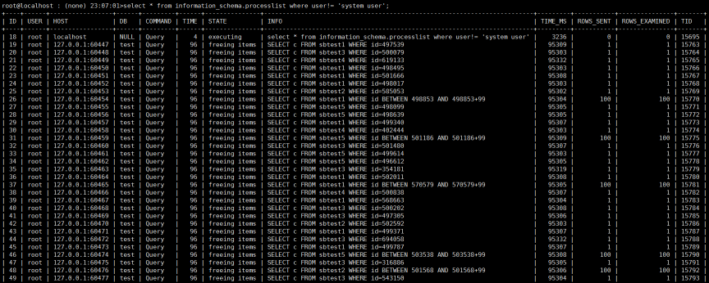

测试发现是因为set global audit_log_rotate_on_size = 536870912;语句导致的，目前在5.6.32、5.6.34、5.7.16均发现此问题

**结论**

   目前在5.6.32、5.6.34、5.7.16版本中均发现此问题，所以建议不要动态启用审计日志插件，而通过在配置文件里面进行配置的方式，择机重启，配置如下，其中 audit_log_include_commands的配置会导致数据库在stop时报错(可以正常启动),所以这里注释了,可在数据库启动后执行动态设置

plugin-load = audit_log.so

audit_log_rotate_on_size = 536870912

audit_log_rotations = 10

#audit_log_include_commands = create_table,create_index,alter_table,update,insert,insert_select,delete,truncate,drop_table,drop_index,grant,create_db,drop_db,alter_db,create_udf,drop_function,revoke,kill,rename_table,delete_multi,update_multi,create_user,drop_user,rename_user,revoke_all,create_procedure,create_function,drop_procedure,alter_procedure,alter_function,create_view,drop_view,create_trigger,drop_trigger,alter_tablespace,create_server,drop_server,alter_server,create_event,alter_event,drop_event,alter_db_upgrade,alter_user,alter_instance

Icon

## 相关的文章

页面:

[数据库服务器部署规范](/pages/viewpage.action?pageId=8094602)

页面:

[MGR集群-大家参考启航的文档，更完善 by 郑靖](/pages/viewpage.action?pageId=8094589)

页面:

[PXC源码GDB调试](/pages/viewpage.action?pageId=8094397)

页面:

[Centos下python2.7.13及pip安装说明](/pages/viewpage.action?pageId=2819228)

页面:

[PXC源码安装](/pages/viewpage.action?pageId=8094393)

Showing first 5 of 22 results